3 | 1 | Lekcija 5: Stambeno pitanje

3.1 Zadatak 14. Marijeva obitelj
You already know Mario’s family members. However, here is his family tree again for you. Listen to the questions and provide your answers in complete sentences.
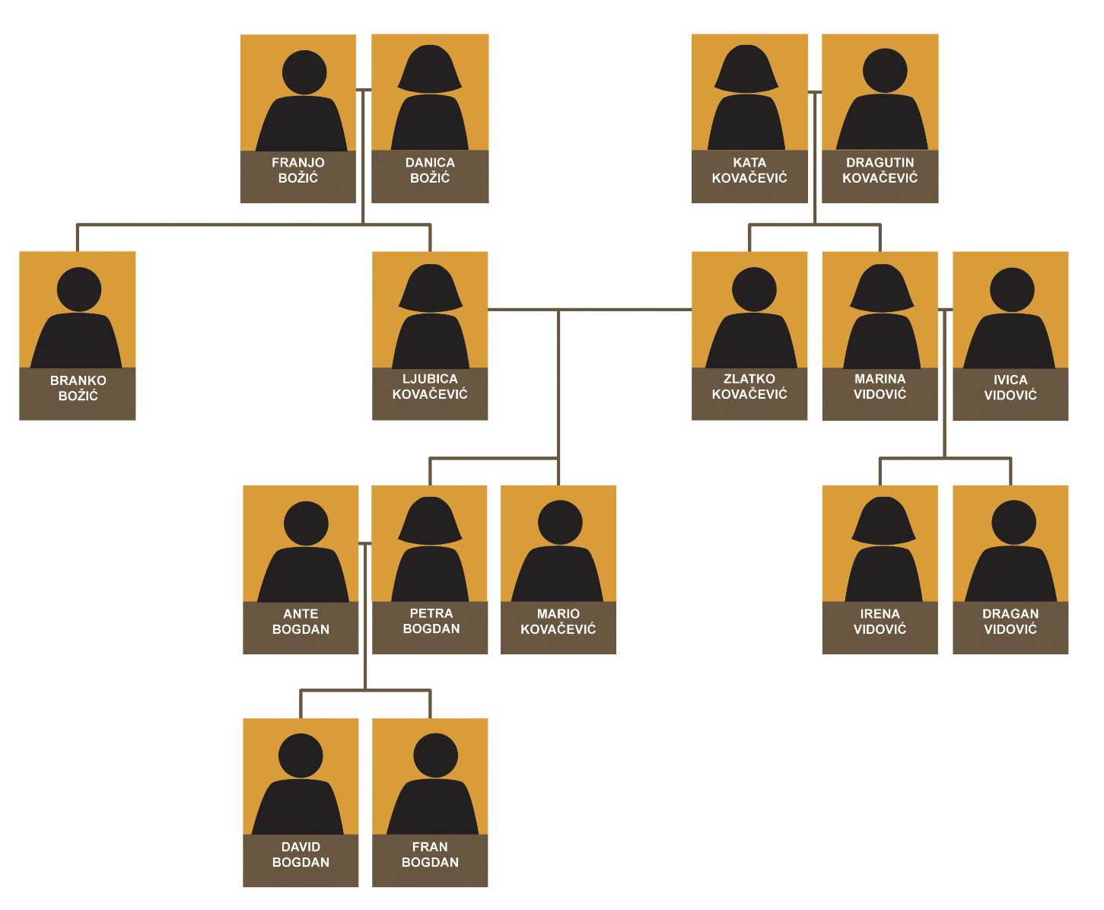

Audio: Kako se zove Marijeva sestra? / Your answer: Marijeva sestra se zove Petra.
(audio)
(audio)
(audio)
(audio)
(audio)
(audio)
(audio)
(audio)
(audio)
(audio)
(audio)
(audio)

3.1 Zadatak 15. Anina obitelj
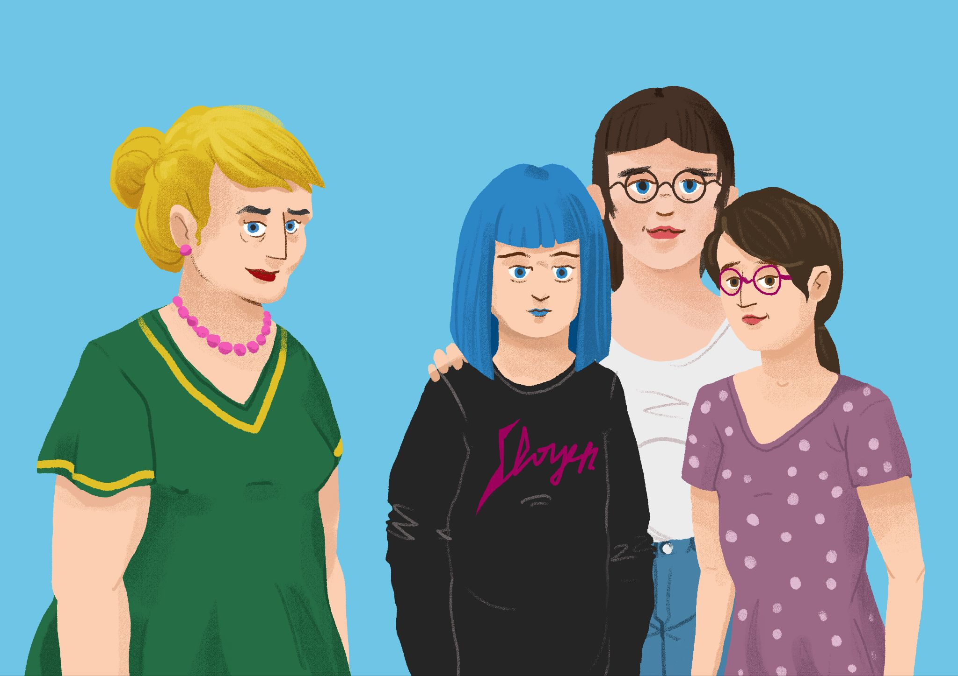
Read the text about Ana's family members. Names may be repeated so you can understand her family relations better.

Ana has a very big family. However, she is not very organized in presenting her family members. Help her organize all family members into one logical family tree.
Ovo je moja teta Ivana, moje sestrične, Josipa i Katarina i ja. Naša obitelj je velika. Moja mama se zove Tatjana, a moj tata se zove Teo. Moja mama ima stariju sestru Ivanu i stariju braću. Tatin mlađi brat se zove Joško. Mamina braća se zovu Ante i Zvonimir. Josipa je Antina kći, a Katarina je Joškova kći. Joškova žena se zove Zorana. Emanuelina i Antina djeca se zovu Josipa i Martin. Ivanin muže se zove Marko. Mamin brat Ante ima ženu Emanuelu. Teova i Joškova mama se zove Marina. Ivanin, Antin i Tatjanin brat se zove Zvonimir, a njegova žena se zove Vjekoslava. Marinin muž se zove Zlatko. Dalibor je Vjekoslavin i Zvonimirov sin. Moja baka, mamina mama, zove se Zlatka. Tatina se sestra, moja teta, zove se Ema. Ona nema ni muža ni djecu. Zlatkin muž se zove Dušan. Ja također imam i brata, zove se Mario. Moja dobra, draga, pametna sestrična, Daliborova sestra, se zove Sandra. Ivanina i Markova djeca se zovu Marija i Darko. Oni su moji rođaci.

Obiteljsko stablo (answer below):
→

3.1 Zadatak 16. Moja fiktivna obitelj
Look at the following family tree. Imagine that this is your family. You are one of the children at the very bottom of the family tree.

Part 1
Complete the family tree below by associating an appropriate Croatian name to each person (including yourself). Include also a profession for each person where applicable and at least one personal trait for each person. You can also download a fillable PDF.

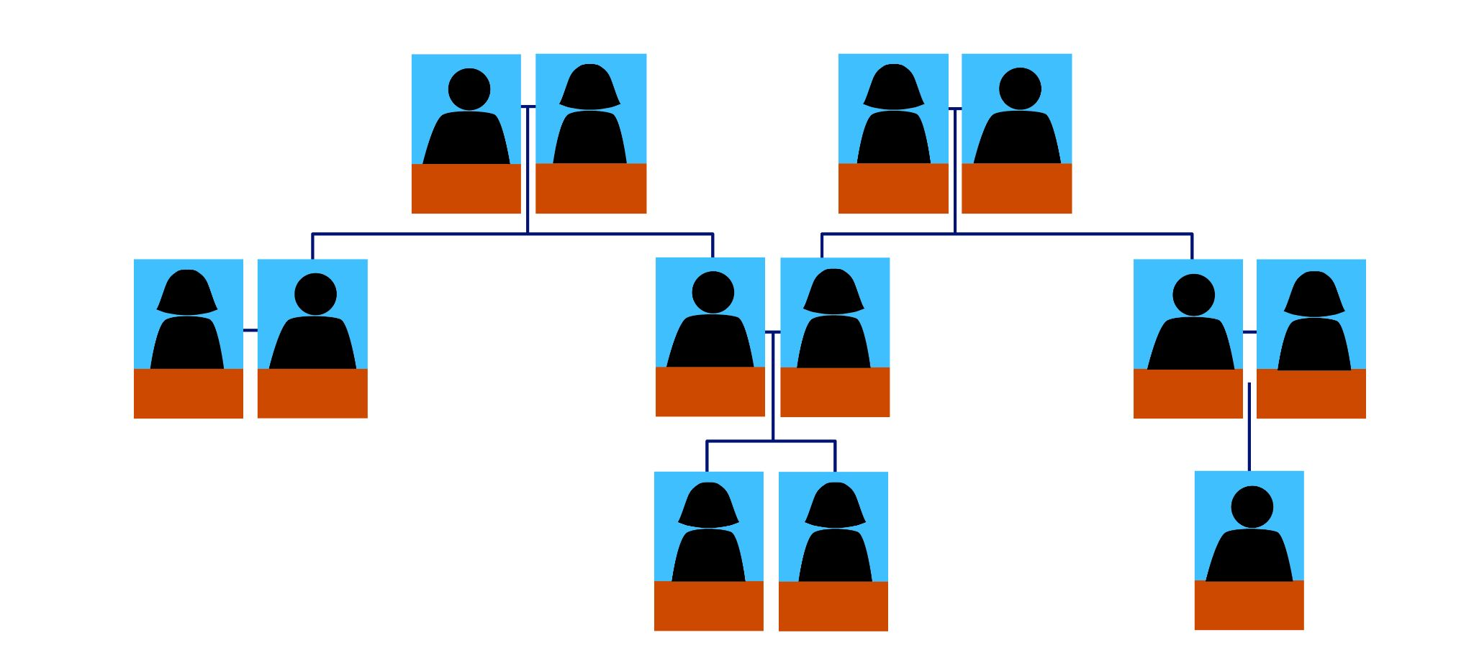

Part 2
Rad u paru. Talk with one of your classmates and make a video recording (submit online). Write down what your classmate tells you as you will need to submit written work about what your classmate says.

Scenario:
You are meeting for the very first time. Introduce yourself and make a cohesive dialogue asking each other about family members. In order to discover the names of each family member, and to complete the family tree, you need to use personal names in their possessive form (i.e. what is the name of Ana’s husband/sister/brother).

| Na primjer:
1. Ima li tvoj tata sestru?
2. Da, moj tata ima sestru. Zove se Ana.
1. Ima li ona muža?
2. Da, Ana ima muža.
1. A kako se zove Anin muž?
2. Anin muž se zove Dalibor.

Based on your findings, write a paragraph about your classmate’s imaginary family.
—

3.1 Zadatak 17. Matija i njezina obitelj
🔊 Listen to the text about Matija and her family members. Answer the questions below in English.
(audio)

| Comprehension
1 | Where do Matija’s grandparents live?
1 | -
2 | What does the house look like?
2 | -
3 | How did Matija describe her grandparents?
3 | -
4 | What does Matija usually do over the weekend?
4 | -
5 | Who else lives in the house, together with her grandparents?
5 | -
6 | Do they all live together?
6 | -
7 | How did Matija describe other family members that live in the house?
7 | -
8 | What do her grandparents usually do?
8 | -

| Location
1 | Investigate online the location where they live. Attach at least one photo that you find on the internet that you find interesting. Explain your choice(s). Would you go there? Why?
1 | -

3.1 Zadatak 18. Kultura - razgovor
In today’s lesson you learned about Davor’s family and where they live. To remind yourself about the text, listen to his presentation one more time. While listening, look at his family tree in order to determine who he is talking about.
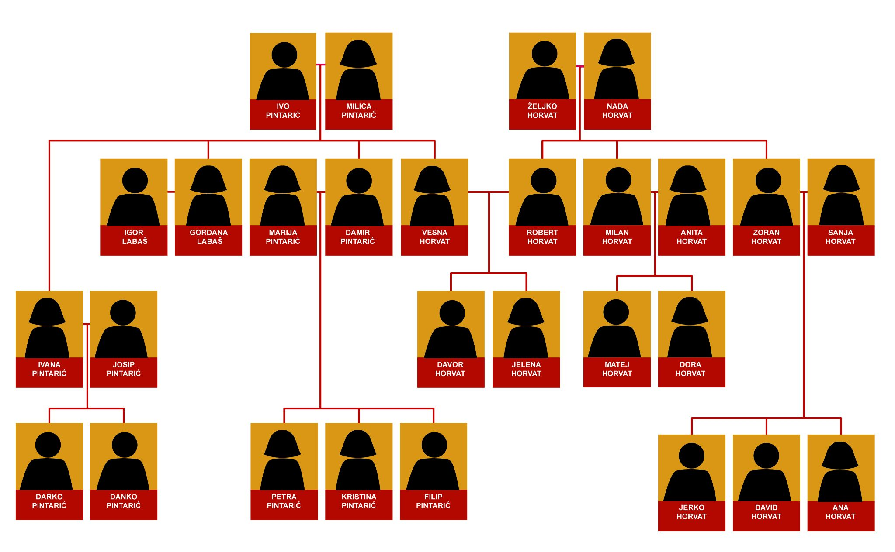
Answer the question by filling in the chart with names in the appropriate row. A few names might go in the same row. Some parts will remain empty.
Tko živi u kući?
1 | U kući živi… | Davorov …
2 | U kući živi… | Davorova…
3 | U kući živi… | Davorovo…
4 | U kući žive… | Davorovi…
5 | U kući žive… | Davorove…
6 | U kući žive… | Davorova…

1 | Kako se zovu Robertova braća?
1 | -

| Kulturološko pitanje [Cultural Question]
According to Croatian traditional standards – What do you think, who would eventually inherit the apartment on the first floor? Do you think that a three-story house was built like that on purpose? Explain your answers. What is the reasoning behind your answer? What does that tell you about Croatian values?
Answer:
Based on the reading about Davor's family – Do you find any similarities/differences between a typical Croatian and U.S. family? Why do you think this? Explain your answer and provide examples based on your own experience.
Answer:

Images used in this document are from these sources.

