10 | 1 | Lekcija 2: Poklon za rođendan

| Savezne Države SAD-a
Look at the map to learn the names of the 50 states in Croatian. As you can see, some of them will keep their English forms (Missouri, Utah, Washington, Pennsylvania, etc.), while others will be adjusted to the Croatian writing system (Taksas, Havaji, Južna Karolina, Sjeverna Karolina, Novi Meksiko, etc.).
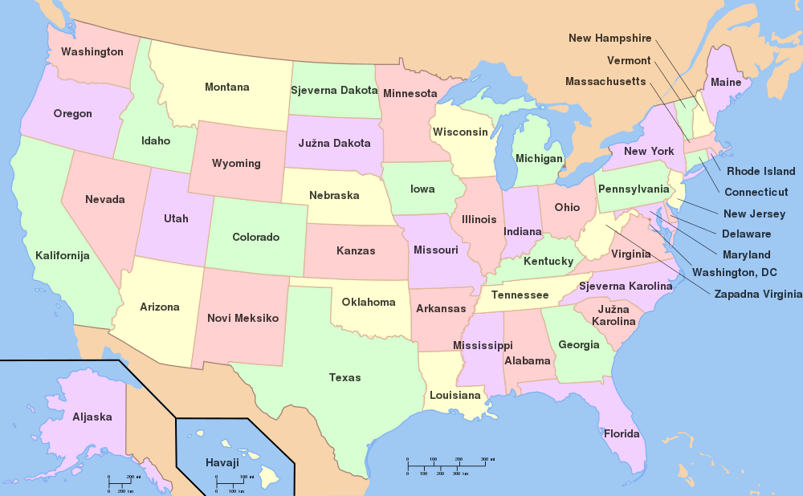

| Zemlje u Europi
Look at the map to get familiar with the countries that are (potentially) the most relevant for you and possible conversations you might have with your classmates.
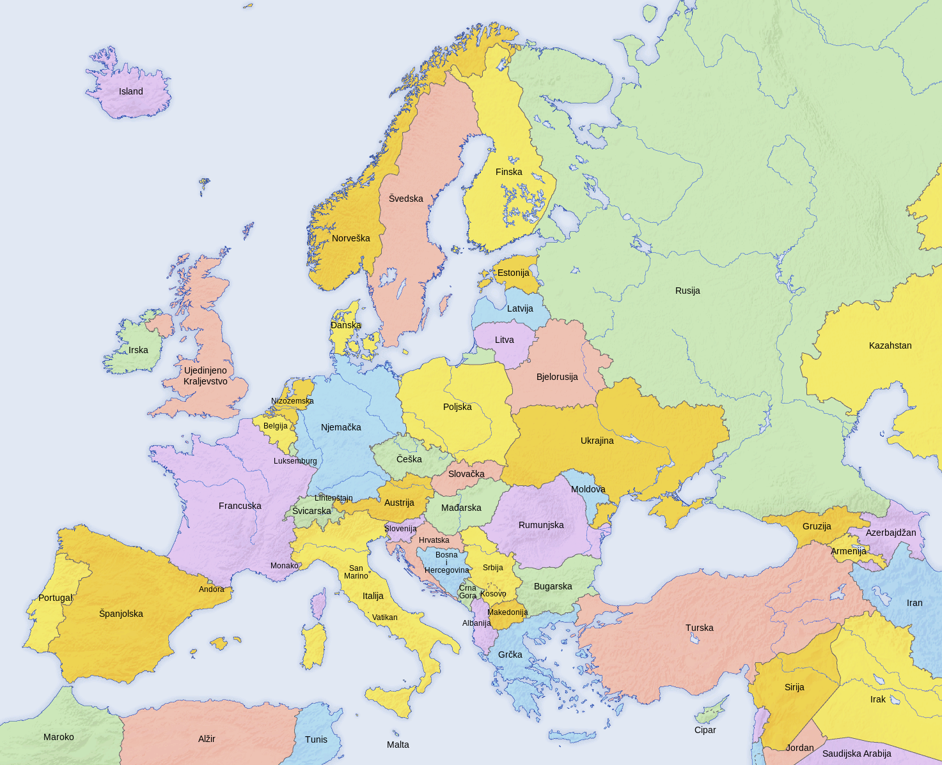

| Izreke
Phrases that you have encountered in today's lesson. You can often hear these when people talk to their close friends or relatives.
| Svakodnevni govor | Rečenice iz dijaloga
Biti crven/-a kao rak. | Ines je crvena kao rak.
Jezik brži od pameti. | Nekada ti je jezik brži od pameti.
Biti spor/-a k’o puž. | Matija je spora k’o puž.
Biti zmija. | Marina je prava zmija.
Dobar kao kruh. | On je dobar kao kruh.
Zelena grana. | Ti i ona nikako na zelenu granu.
Jednim udarcem dvije muhe. | Meni se ideja sviđa. Jednim udarcem dvije muhe.
Jezik za zube. | Drži jezik za zubima, rekla sam ti.

| Glagoli
These are verbs that we encountered today. You encountered some of these in their perfective form and some in their imperfective form. Here, you can find a complete list (perfective and imperfective pairs), with the first person singular form given as well.
English | Perfective | Imperfective
to travel | otputovati (ja otputujem) | putovati (ja putujem)
to organize* | *organizirati (ja organiziram) – the same form for both aspects
to choose | odabrati (ja odaberem) | odabirati (ja odabirem)
to mention | spomenuti (ja spomenem) | spominjati (ja spominjem)
to keep | pridržati (ja pridržim) | držati (ja držim)
to worry | pobrinuti se (ja se pobrinem) | brinuti se (ja se brinem)
to go / to start going | poći (ja pođem) | polaziti (ja polazim)
to arrive | doći (ja dođem) | dolaziti (ja dolazim)
to find | naći (ja nađem) | nalaziti (ja nalazim)
to leave | otići (ja otiđem) | odlaziti (ja odlazim)

Images used in this document are from these sources.

