1 | 1 | Lekcija 6: Roditelji

1.1 Zadatak 17. Moj tata, moja mama i ja
Video recording. Present yourself to the rest of your class. Tell us more about your parent(s) and yourself. Submit your recording online. In your presentation, be sure to include the following elements.
Kako se zove? | Odakle je?
Što je po zanimanju? | Kakav je? / Kakva je?

1.1 Zadatak 18. Moj prijatelj, moja prijateljica
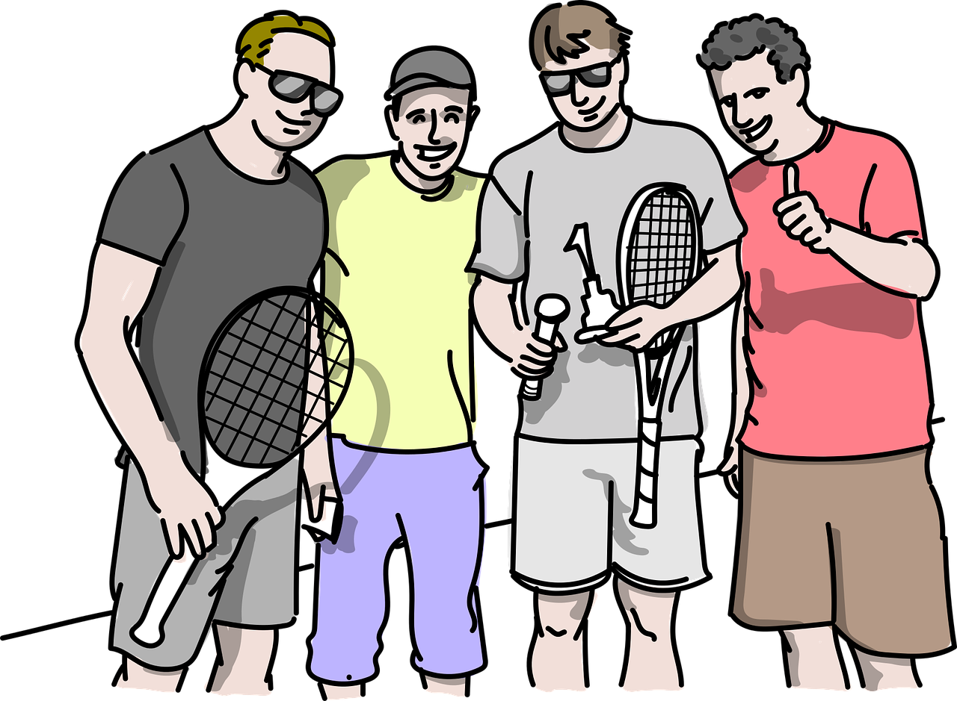 | 
Based on the previous task, pick one of your classmates and describe what you learned about him/her. Be sure to use the correct form of any possessive pronouns.

Your answer →

1.1 Zadatak 19. Pjevač i pjevačica
Read the following short texts about each person and answer the questions.
 | On je Jay Z. Njegovo ime je Shawn Corey Carter. On je Amerikanac. Jay Z je pjevač. On je reper i glumac. On je visok, zgodan i dobar.

1 | Kako se on zove?
1 | -
2 | Odakle je on?
2 | -
3 | Što je po zanimanju?
3 | -
4 | Kakav je on?
4 | -

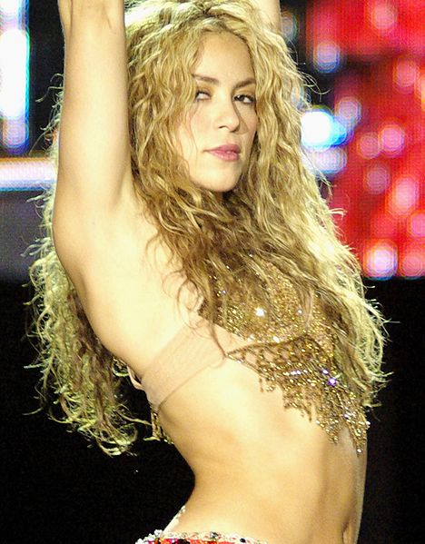 | Ona je Shakira. Njezino ime je Isabel Mebarak Ripoll. Ona je Kolumbijka i Libanonka. Shakira je pjevačica. Ona je pop pjevačica. Ona je zabavna, zanimljiva i pametna.

1 | Kako se ona zove?
1 | -
2 | Odakle je ona?
2 | -
3 | Što je po zanimanju?
3 | -
4 | Kakva je ona?
4 | -

Now, look at the following picture and answer each question below according to your opinion.
 | Kako se zove?
 | -
 | Odakle je?
 | -
 | Što je po zanimanju?
 | -
 | Kakav je?
 | -

1.1 Zadatak 20. Kako se zove?
 | 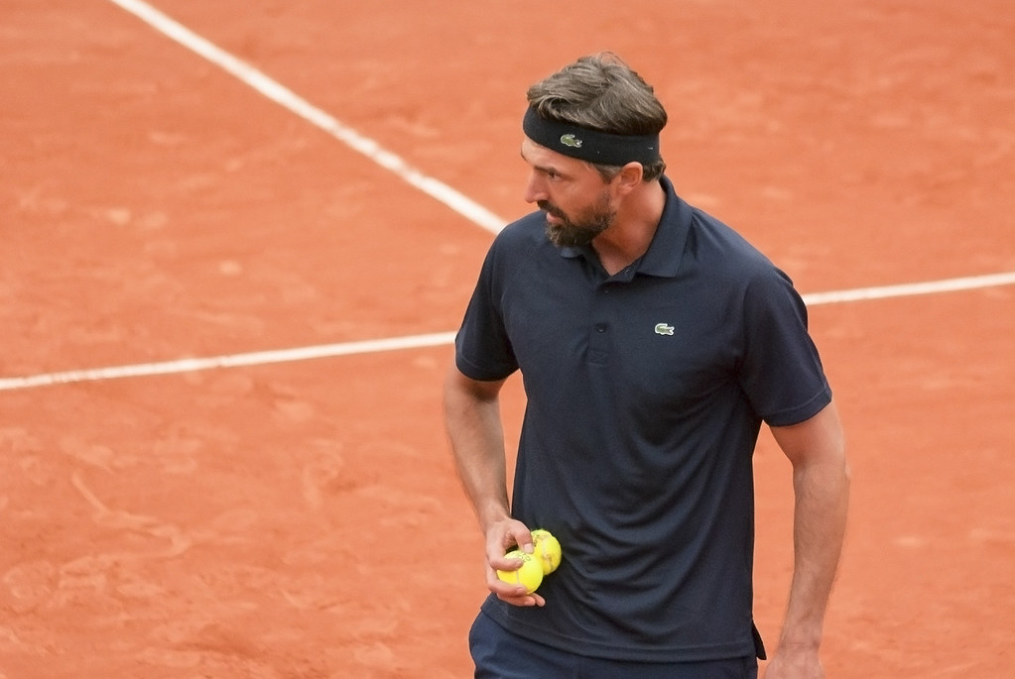 | 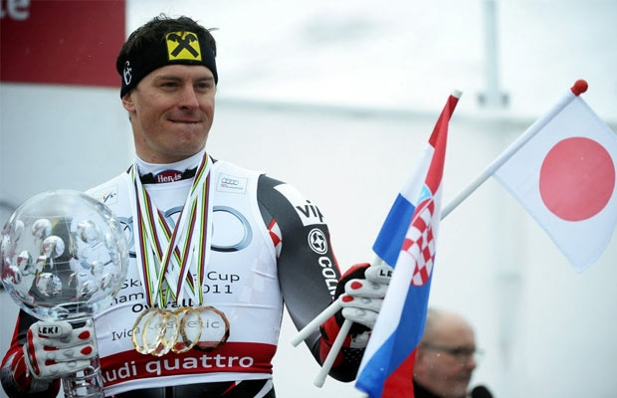
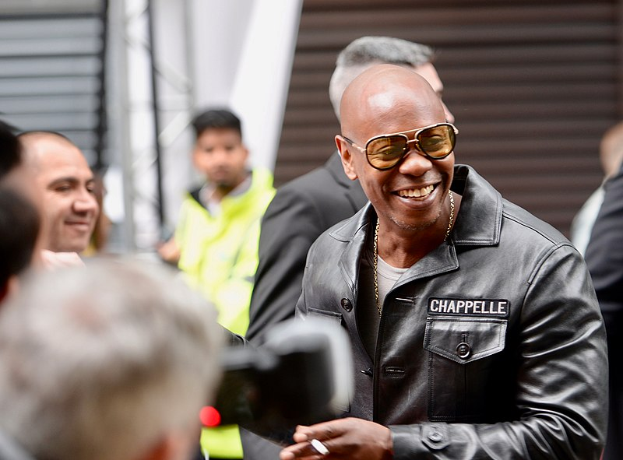 |  | 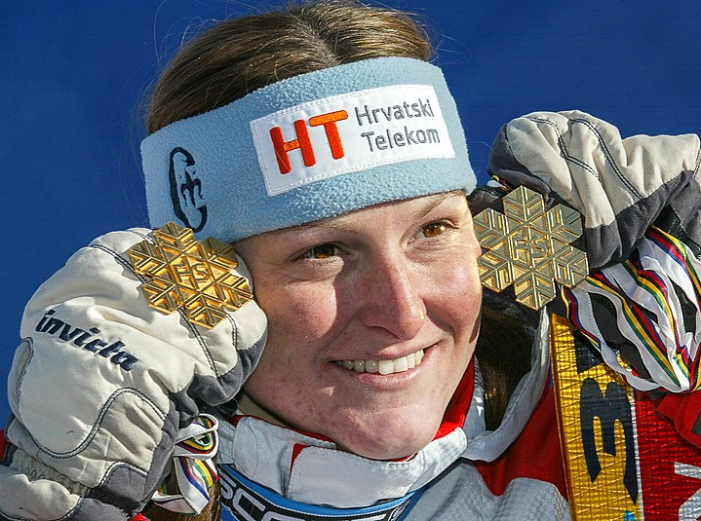
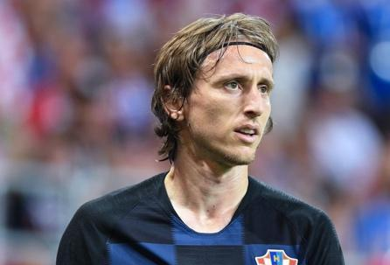 |  | 
Look at the following set of people. These are all people we have talked about in class. Choose at least four of them and present them by giving their name, nationality, profession, and what they look like (your own opinion). Be sure to include at least three adjectives when describing each person. Submit your video recording. When recording, share a picture of the person you are describing on your screen.

1.1 Zadatak 21. Dijalog
💻 Video recording

Scenario:
You are a new international student in Croatia. A new semester is starting and you are getting to know new people. Create a cohesive and meaningful dialogue with another classmate in order to get more information about them.

Things that you should ask each other are: name, how you are feeling, address, phone number, where you are from, details about your parents and friends – their names, what they look like, and their profession. You can also finish your conversation with an appropriate farewell phrase.

1.1 Zadatak 22. Kultura - razgovor
Today we talked about professions. It’s time to discuss equality and gender roles in the work environment. Look at the following information below. You will also need to do more independent online research on the following topic.
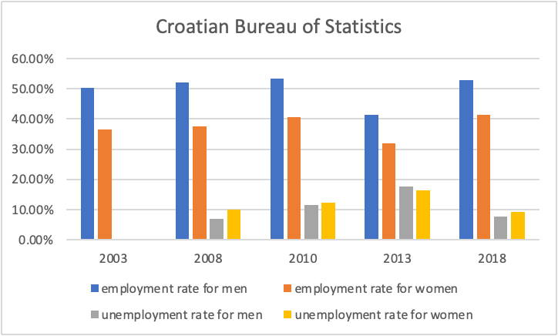
Note: information about unemployment in 2003 is missing in this graph.

| Answer the questions in English.
1 | What can you tell us about (un)employment rates in Croatia in the last 20 years?
1 | -
2 | What is your opinion on these results?
2 | -
3 | Are there any similarities with your country?
3 | -
4 | What do you think is the main reason for the given results?
4 | -

Browse also the following link.
1 | What did you find out? What did you find interesting in the results?
1 | -
2 | Can you tell us more about the current situation in your country? Provide some numbers.
2 | -
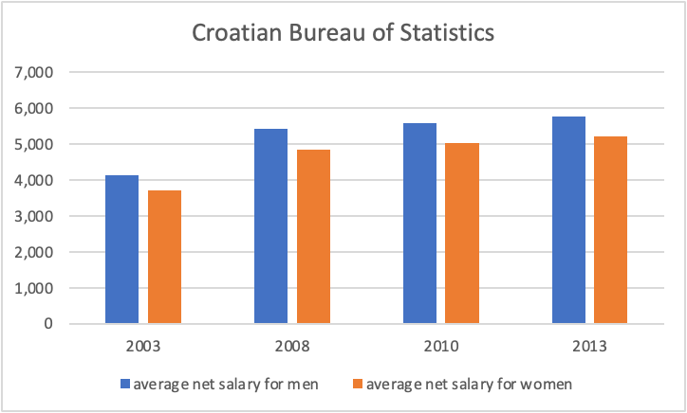
Note: numbers are expressed in former Croatian currency (kuna). This was before Croatia introduced the Euro in 2023.

1 | How do you interpret the results?
1 | -
2 | Is the situation similar in your country? What do you think why is that?
2 | -

| Further research
1 | Based on your individual research on this topic, what else did you find out? What would you like to share with other students in your group?
1 | -
2 | What else would you like to know on this topic? List your questions here. Other students will have a chance to respond if they know the information and/or your instructor will help you gather the information.
2 | -

Images used in this document are from these sources.

