1 | 1 | Lekcija 2: Kako se zoveš?

1.1 Zadatak 5. Dijalog - rad u paru
Video recording. Create a dialogue with a classmate. You are both new students and you want to get to know each other better. Include language we have covered so far. Submit your video recording online.

1.1 Zadatak 6. Kultura - razgovor

| Culture
Answer the question in Croatian:
Koje je boje zastava?
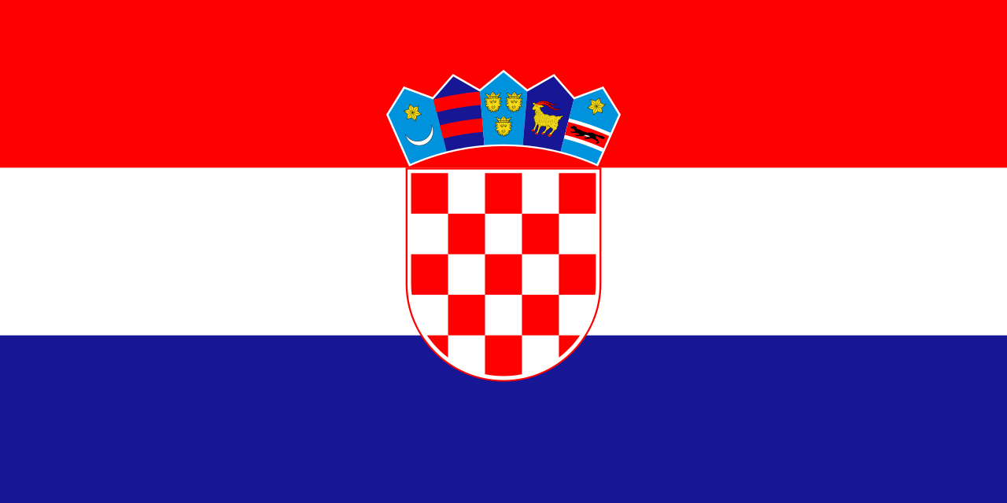 | 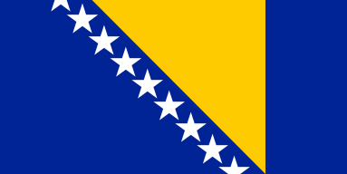 | 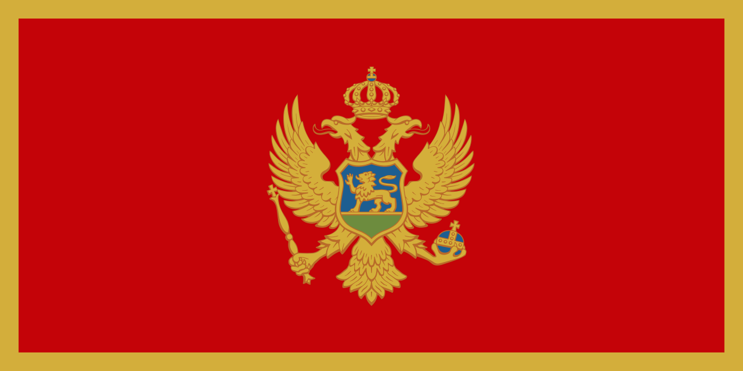 | 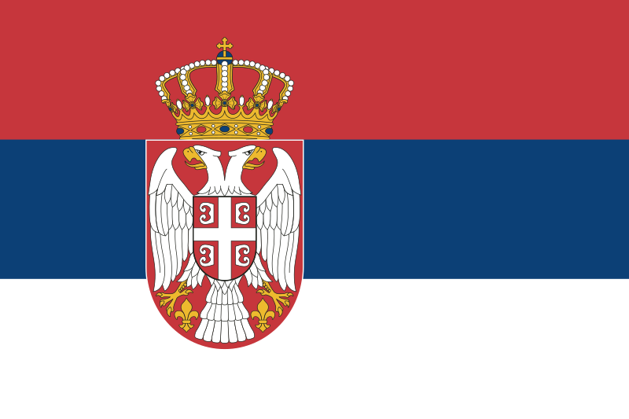
Hrvatska | Bosna i Hercegovina | Crna Gora | Srbija

Work individually on the following set of questions (first 3 parts). 🎶

Part 1.
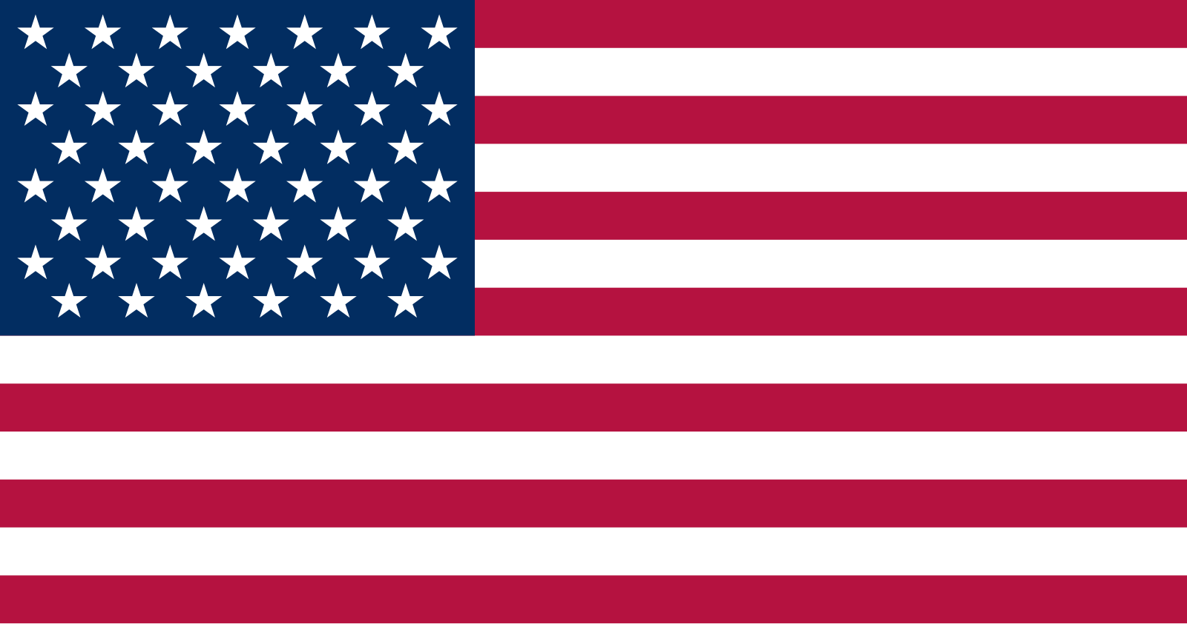 | SJEDINJENE AMERIČKE DRŽAVE  This is the flag of the United States, also known as the Stars and Stripes. The stripes represent the original thirteen British colonies, and the stars represent each of the fifty states.

1 | Describe the flag in Croatian. Kakva je zastava?
1 | -
2 | In English. Where do you usually see the flag? Maybe on government buildings, on homes, in clothing, in art?
2 | -
3 | In English. What does the flag mean to you? Does it have any personal importance?
3 | -

Part 2.
Individual, online search: Investigate the design and the meaning of the flag.
The questions will guide you to answer - what is the particular value to Croats of their flag?
H R V A T S K A
This is the flag of Croatia, also known as the tricolor (trobojnica). It is most often flown outside government buildings or by fans at sporting events in which Croatia participates. It consists of a checkerboard (šahovnica) with five shields (grbovi, or coat of arms) that represent historical regions of Croatia. You can find more information about each shield here.

Answer the questions in English.
1 | What stands out to you? Why is there a checkerboard on the flag?
1 | -
2 | Which of the five shields (grbovi) above the checkerboard (šahovnica) do you like best? Why? You can find more information about each shield here.
2 | -
3 | Why is there a checkerboard on the flag?
3 | -

Part 3.
Listen to the national anthems of Croatia and the United States. A link to a YouTube video for each anthem is provided, as well as lyrics and a background on each song’s composition and adoption as a national anthem. Try to follow the lyrics as you hear them, then answer the questions provided after each anthem (in English).

“Our Beautiful Homeland” (Lijepa naša domovino)
The lyrics for “Our Beautiful Homeland” were written by Antun Mihanović in 1835 and the music was composed by Josip Runjanin in 1846. It has been used in some form as both an unofficial and official national anthem in Croatia since the late 19th century and was declared the official national anthem for the state of Croatia in 1990.
Link no visuals // Alternate link with visuals
1 | What do you think about the anthem? What stood out to you?
1 | -
2 | What elements of the natural landscape in Croatia are in the song? (i.e., Drava, Sava, Danube, plains, mountains, fields, oak trees)
2 | -
3 | What is this anthem promoting about Croatia as a “homeland” (“domovina”)?
3 | -

“The Star-Spangled Banner ”
Francis Scott Key wrote the poem “The Star-Spangled Banner” after witnessing the Battle of Baltimore in the War of 1812, and these lyrics were set to an already popular tune composed by John Stafford Smith. The song was officially adopted as the national anthem in 1931.
Link 1 // Link 2 (1991 Super Bowl)
1 | Is this anthem very familiar to you, did you already know the lyrics? Where do you usually hear it sung?
1 | -
2 | How does the anthem describe America?
2 | -
3 | How does this anthem compare to the anthems of Bosnia and Herzegovina, Croatia, Montenegro, or Serbia?
3 | -

Part 4.
You will post a final online discussion about the anthems in English. In your discussion, you can answer the questions below, ask any questions you may still have about any of the anthems, or share information you find from additional research with your classmates. You are encouraged to bring in “The Star-Spangled Banner” as a comparison. ✍️
1 | What is the purpose of a national anthem, what are the values, and how does one or both of the anthems we listened to accomplish that?
1 | -
2 | What imagery or common themes stood out to you across both anthems? You may make connections related to descriptions of the natural landscape, the use of collective language (first-person plural “we” or possessive “our”, plural “sons” or “brothers/brethren”), gendered imagery (the nation as a mother or fatherland, its subjects as brothers and sons), military imagery, religious language, or the relative age of the anthems. You are encouraged to look up more videos of the anthems or more information about the historical context.
2 | -

All flag images are from https://commons.wikimedia.org and are in the public domain.

