1.8 - More on Fleeting -e-

Fleeting -e- is the phenomenon going to come up on words whenever some sort of ending is added to them. Here is a reference summary for you to use with nouns and their plural forms:

all words ending in -ec
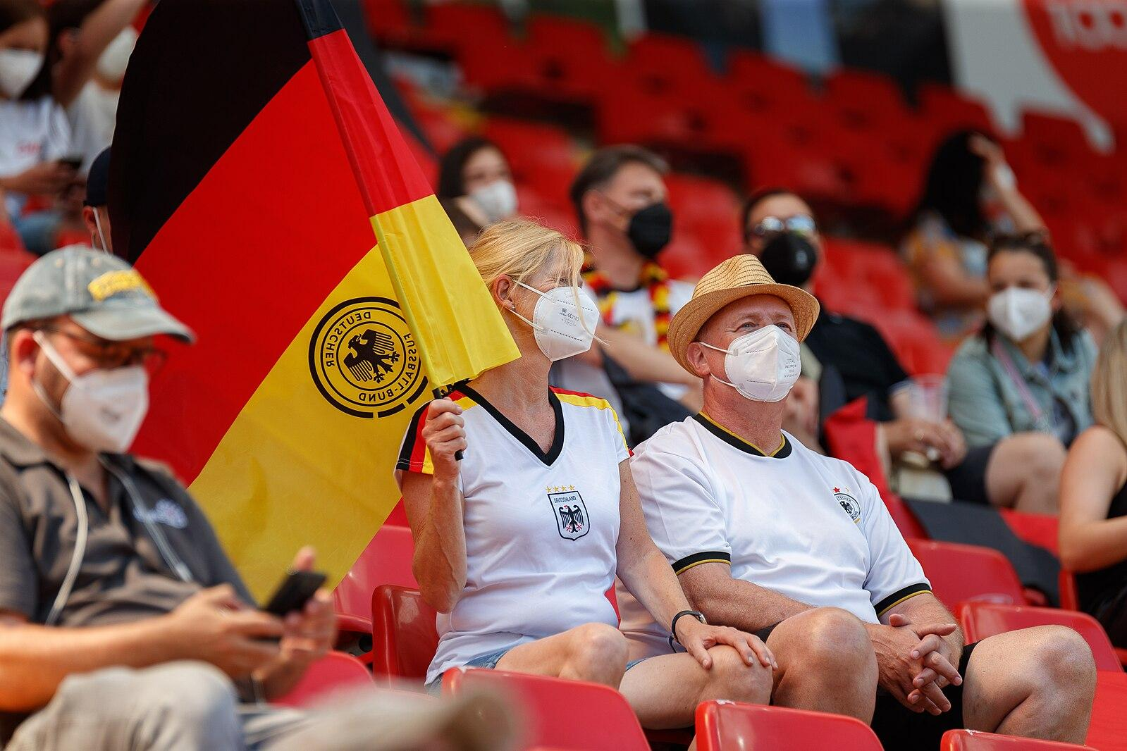  Němec ‘German’ → Němci ‘Germans’ |   kopec ‘hill’ → kopce ‘hills’ | 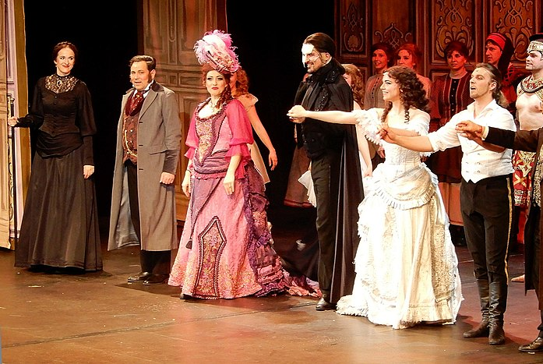  herec ‘actor’ → herci ‘actors’

all words ending in -ek
  párek ‘hot dog’ → párky ‘hot dogs’ |   hrnek ‘mug’ → hrnky ‘mugs’ |   dárek ‘gift’ → dárky ‘gifts’

some words (mainly names) ending in -el (you just have to learn them as you go)


orel ‘eagle’ → orli ‘eagles’

Karel ‘Charles’ → Karle (vocative form)
Pavel ‘Paul’ → Pavle (vocative form)

A small random assortment of words:
  píseň ‘song’ → písně ‘songs’ |   pes ‘dog’ → psi ‘dogs’

Images used in this document come from these sources.

