3.10 - pro koho - 'for who?'

So you might want to say for in Czech, such as I have a gift (dárek) for Milan or She is buying kolaches for the children. So how do you say it?

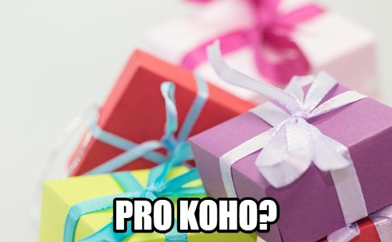

The word pro means ‘for’ in Czech. It is a preposition. Whenever we learn a preposition in Czech, we will have to learn what form follows it. The preposition pro must be followed by the accusative case:

Mám dárek pro Lenku.
I have a gift for Lenka.

Peču koláče pro studenty.
I am baking kolaches for the students.

Now what about this form koho? Koho is the accusative form of kdo - ‘who’. We will see this form more as we work more and more with Czech, but as you can see, there is already an area where we would need to use this form.

Images used in this document come from these sources.

