1 | 1 | Lekcija 1: Dobar dan!

| Abeceda
A | B | C
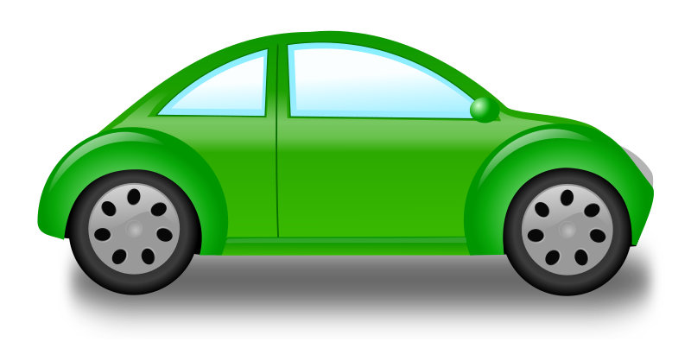 | 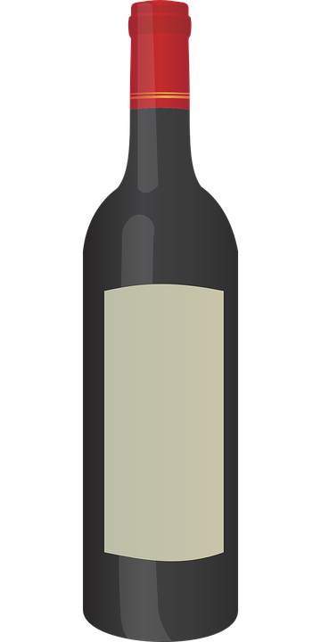 | 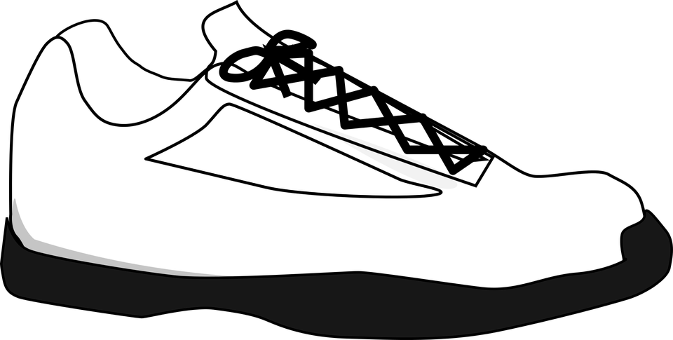
automobil  (audio) | boca  (audio) | cipela  (audio)
Č | Ć | D
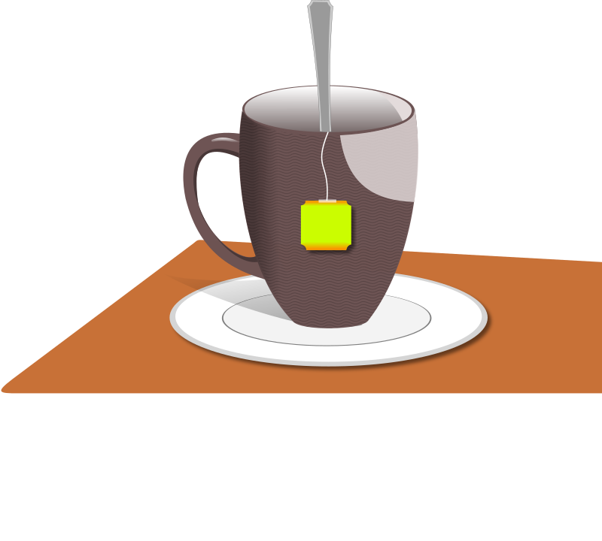 | 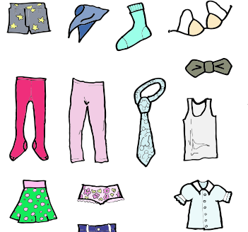 | 
čaj  (audio) | odjeća  (audio) | doktor  (audio)
DŽ | Đ | E
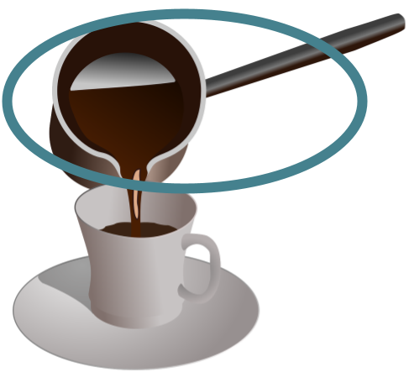 | 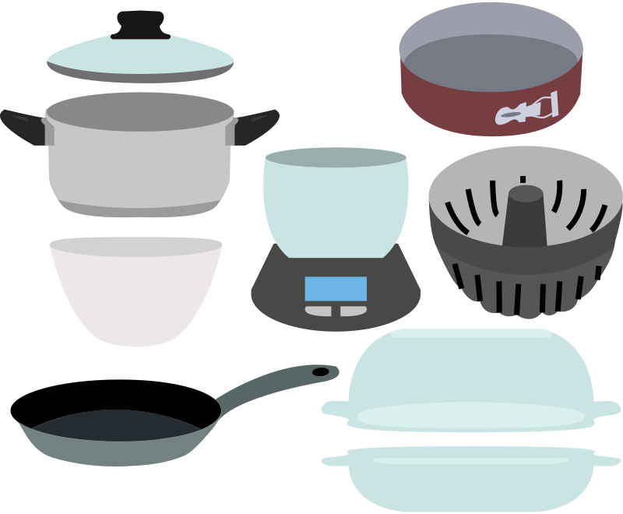 | 
džezva  (audio) | posuđe  (audio) | euro  (audio)
F | G | H
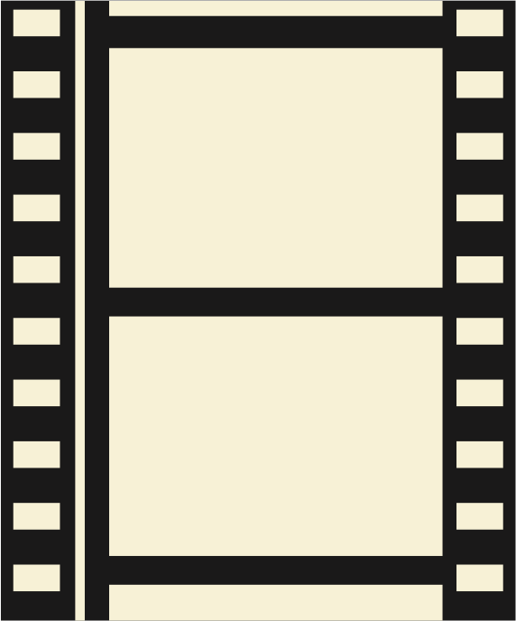 | 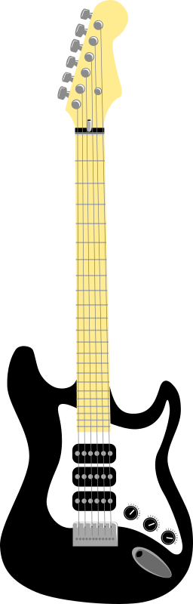 | 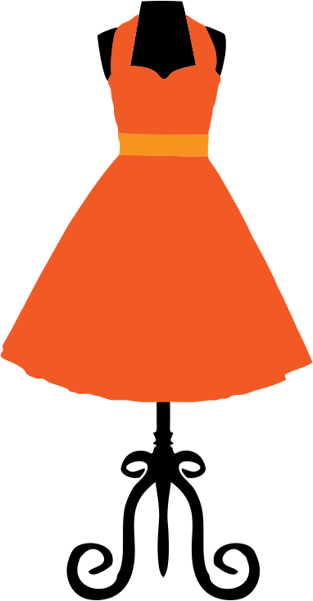
film  (audio) | gitara  (audio) | haljina  (audio)
I | J | K
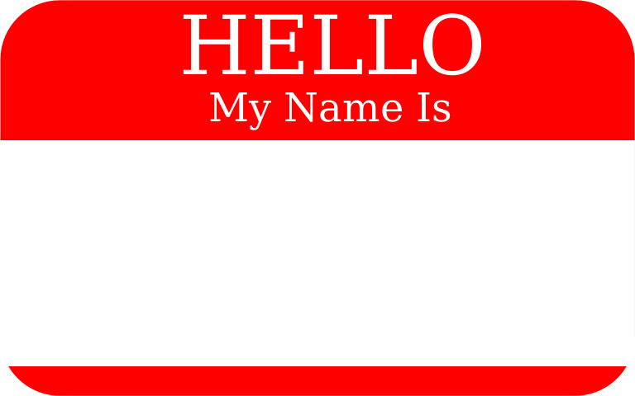 | 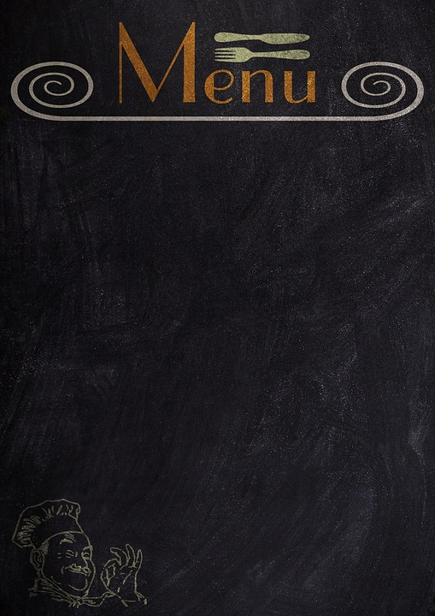 | 
ime  (audio) | jelovnik  (audio) | knjiga  (audio)
L | LJ | M
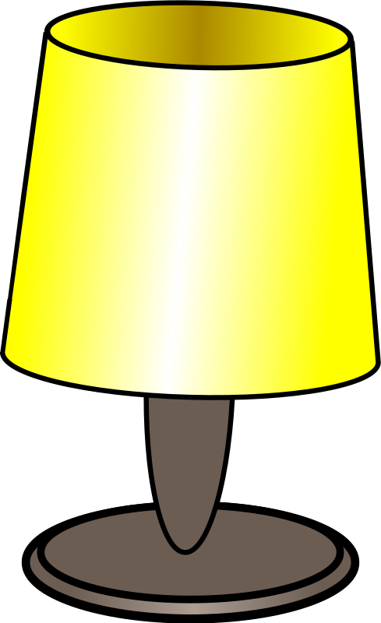 |  | 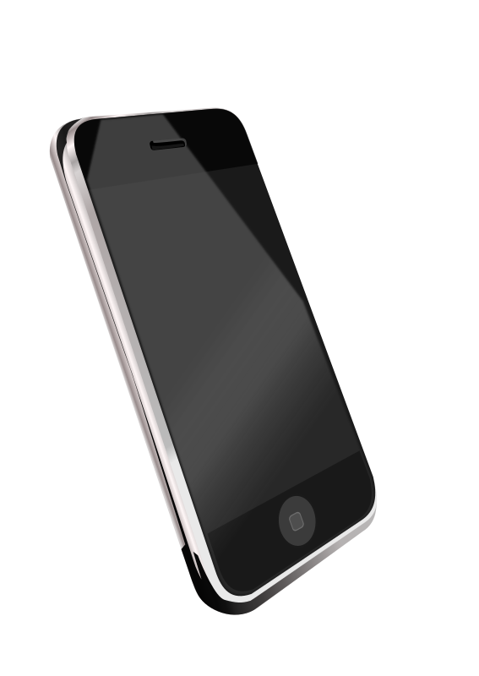
lampa  (audio) | ljekarna  (audio) | mobitel  (audio)
N | NJ | O
 |  | 
novčanik  (audio) | tanjur  (audio) | ogledalo  (audio)
P | R | S
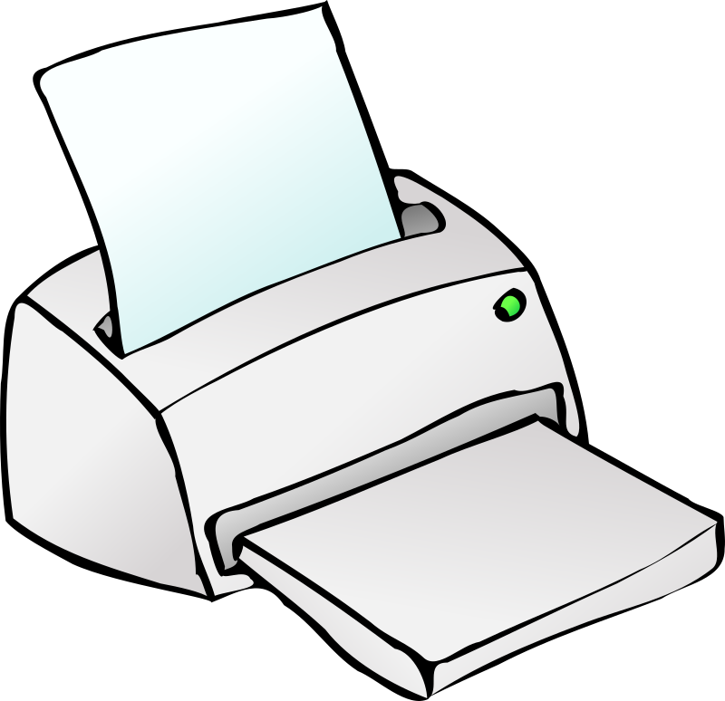 | 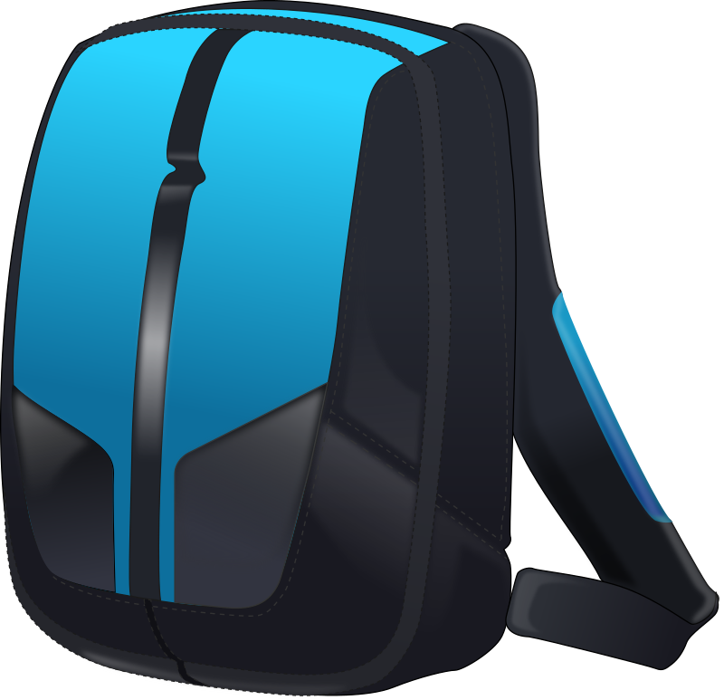 | 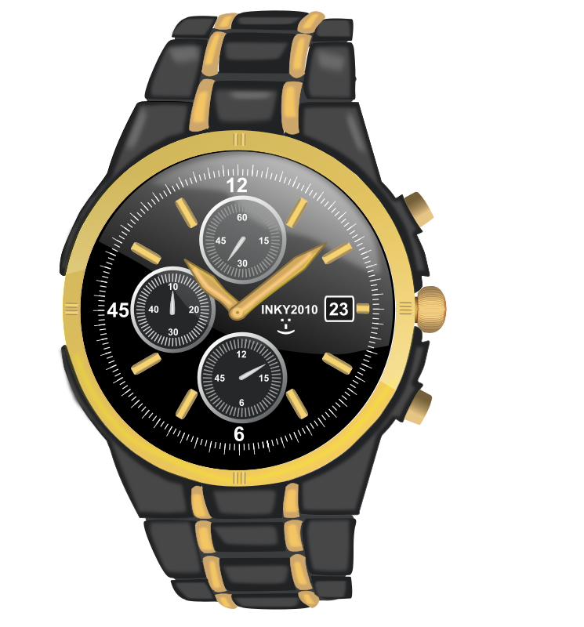
printer  (audio) | ruksak  (audio) | sat  (audio)
Š | T | U
 | 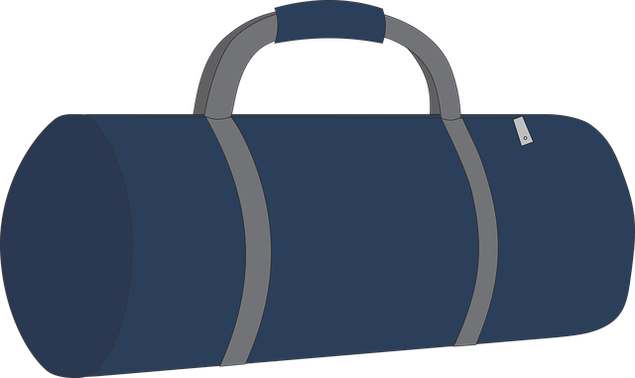 | 
šešir  (audio) | torba  (audio) | udžbenik  (audio)
V | Z | Ž
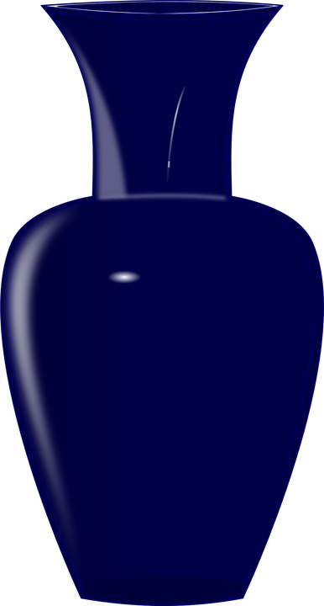 | 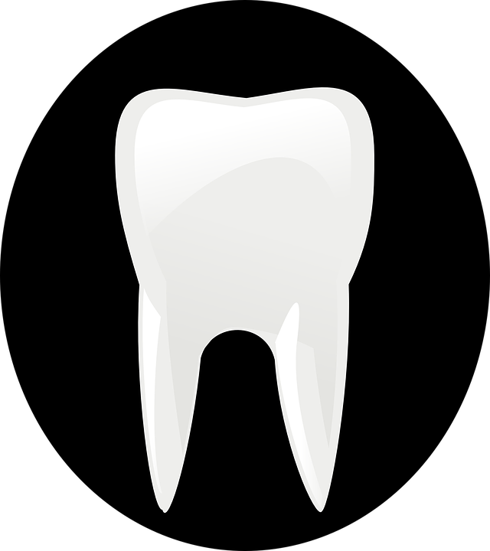 | 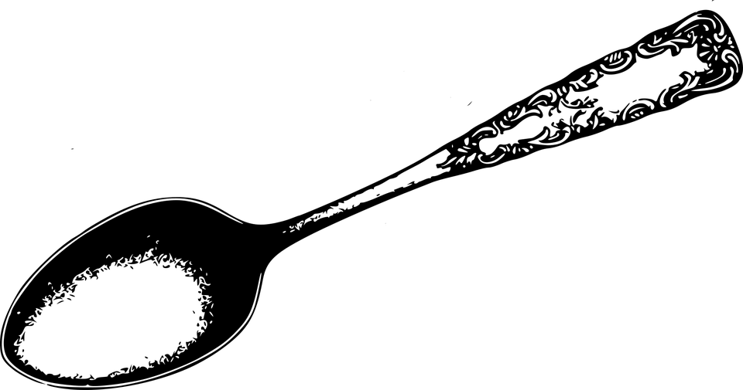
vaza  (audio) | zub  (audio) | žlica  (audio)

1.1 Zadatak 1. Abeceda
[h5p id="566"]
[h5p id="567"]

1.1 Zadatak 2. Riječ i slika

How would you say the following words in Croatian? Look at the pictures and say the correct Croatian form.
[h5p id="680"]

1.1 Zadatak 3. Osmosmjerka
Find the following words.
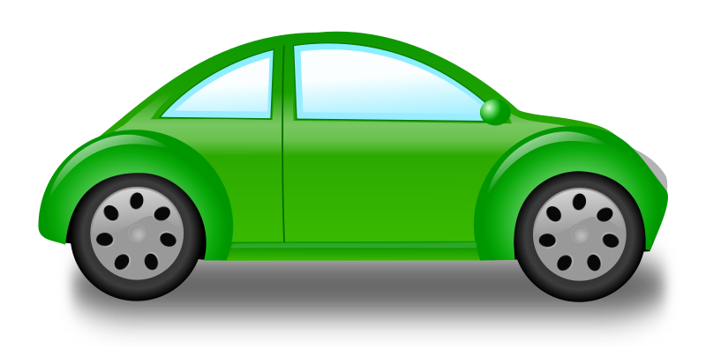 | 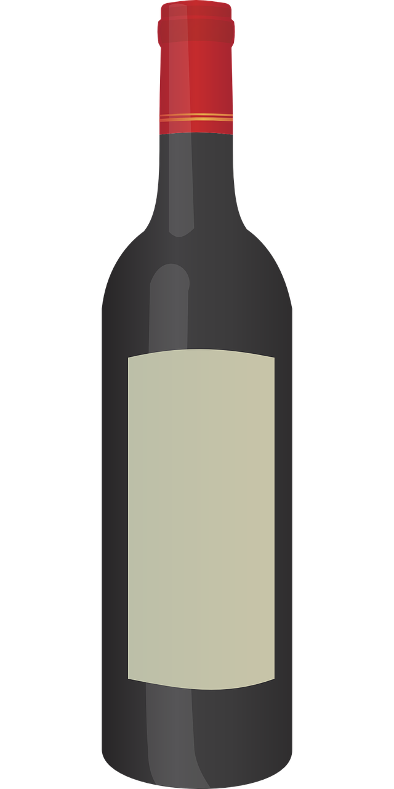 | 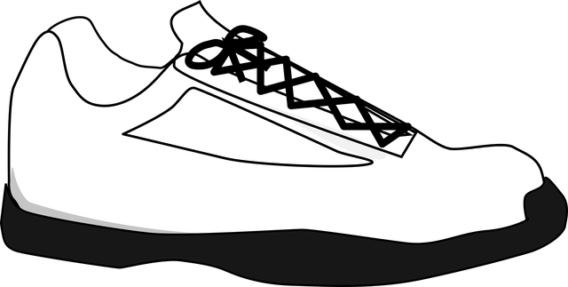 | 
 | 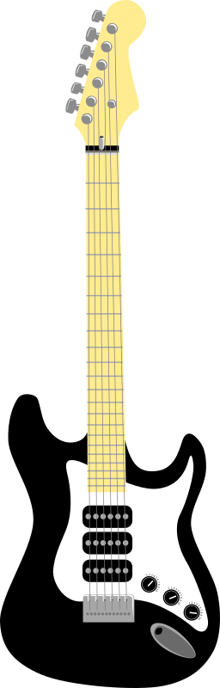 |  | 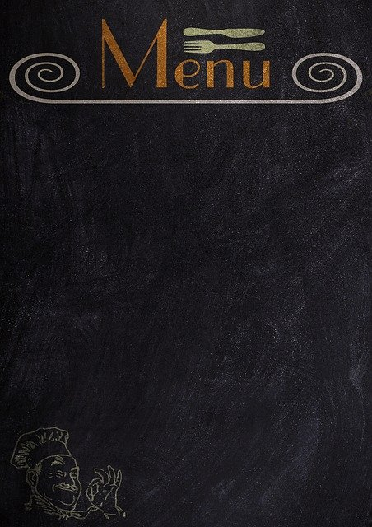
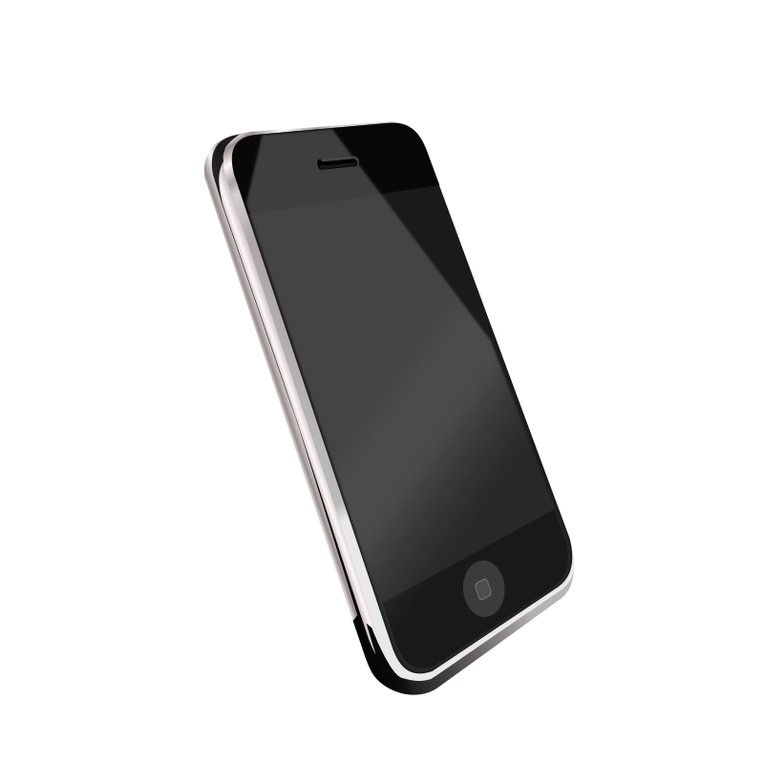 |  | 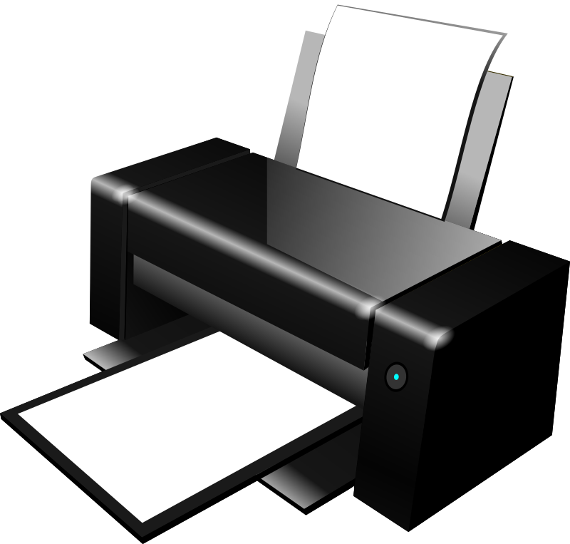 | 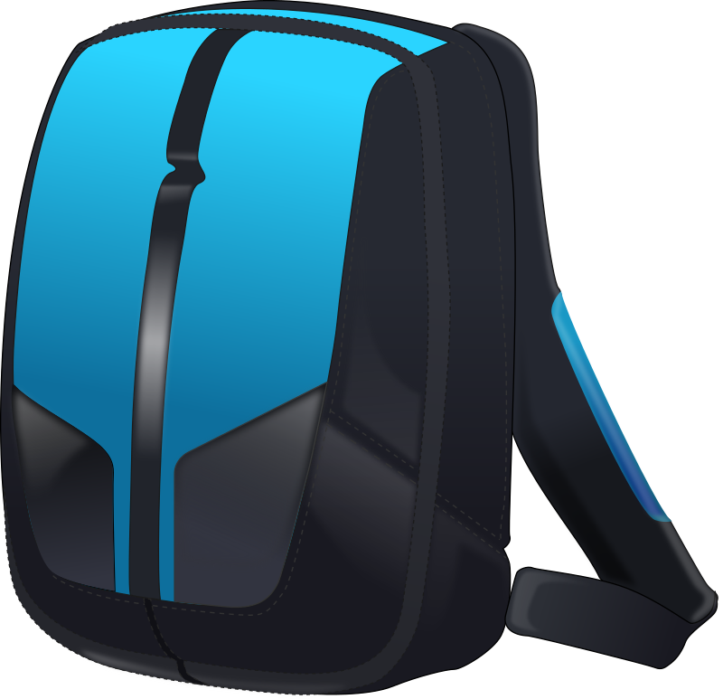 | 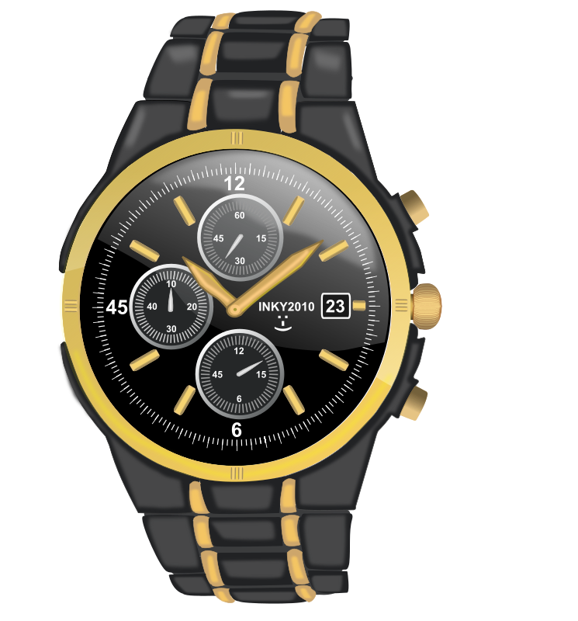
 | 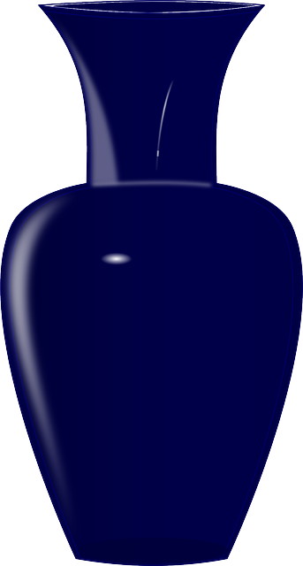 | 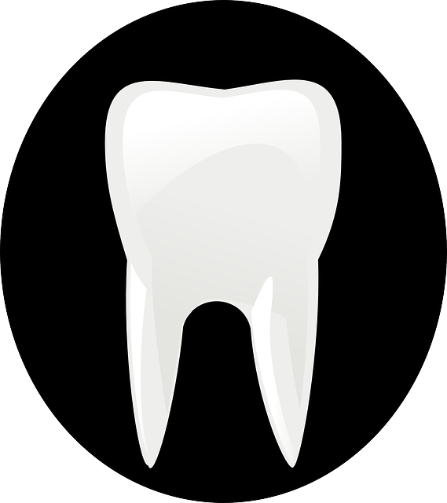 | 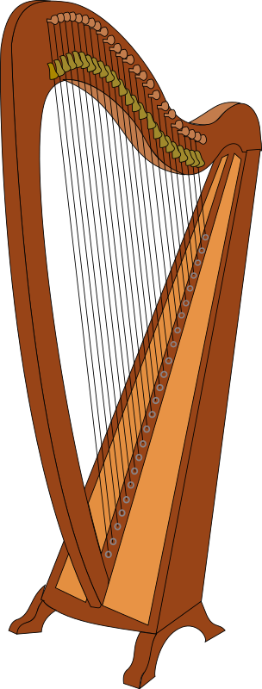 | 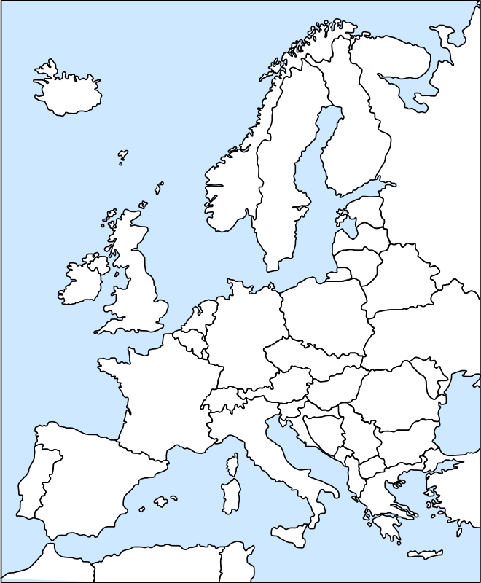
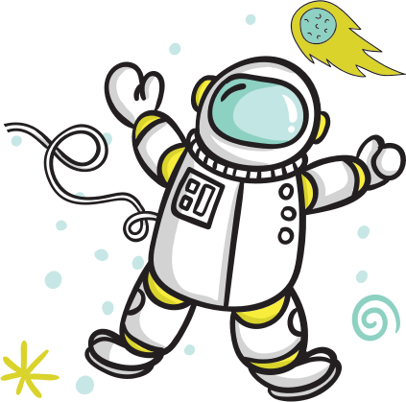 | 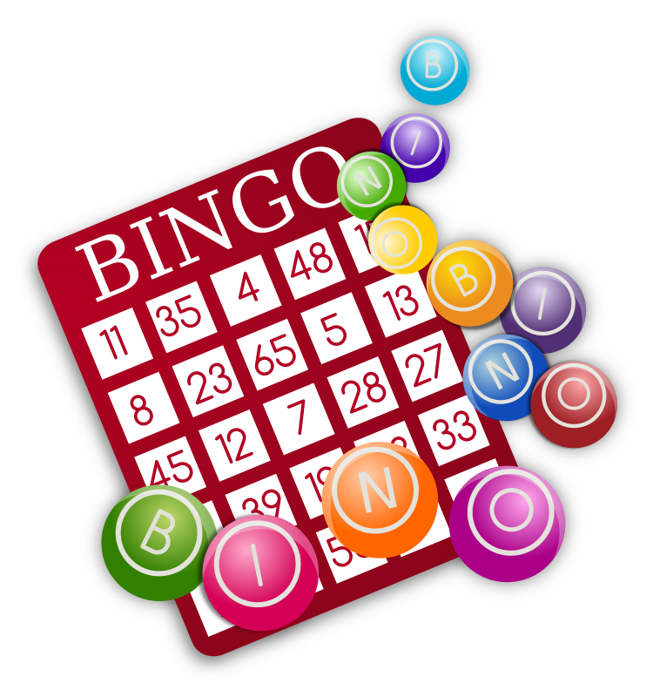 | 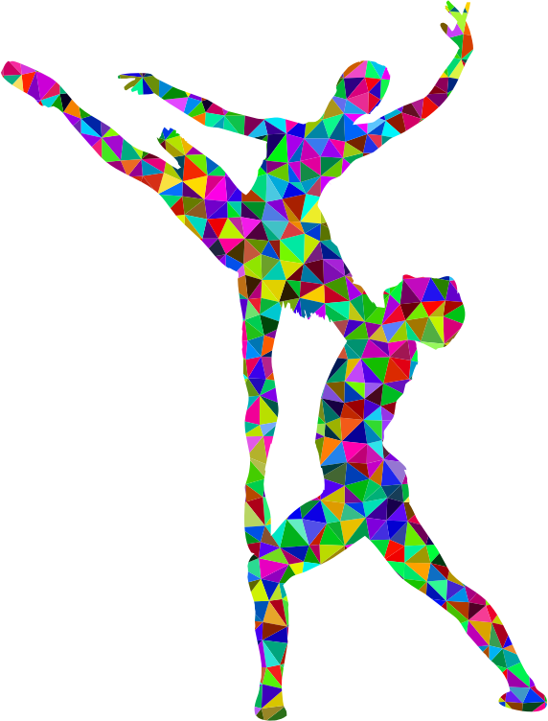
[h5p id="33"]

1.1 Zadatak 4. Što je ovo?
Practice your vocabulary. How would you say the following words/items in Croatian?
[h5p id="602"]

1.1 Zadatak 5. Kako se kaže?
Place the appropriate phrase next to the corresponding picture.
[h5p id="2"]

Images used in this document are from these sources. 🙃

