7 | 1 | Lekcija 1: Moje putovanje

| Verbs in -ovati / -evati / -ivati
In this Lesson you encountered several new verbs: napredovati (to make progress) putovati (to travel), ljetovati (to spend summer vacation), and zimovati (to spend winter vacation). What is important about these verbs is that verbs, like putovati, zimovati, ljetovati, all express an action that repeats or lasts for a longer period of time (i.e. you will spend some time traveling to a certain destination; you will spend a certain number of days in a location for your summer vacation). So far you learned verbs such as:
gled-ati | kup-iti | vol-jeti
ja gled-am | ja kup-im | ja vol-im

All new verbs introduced in this lesson will have a new conjugation pattern.
Look at their pattern in: napredovati, putovati, ljetovati, zimovati. For all these verbs, we:
- need to cut the final -ti,
- then their infix -ova- will transform into -u-, and finally
- we will add the endings:
NAPRED-OVA-TI
SINGULAR |  |  | PLURAL
(audio) | ja | napred-u-jem | (audio) | mi | napred-u-jemo
(audio) | ti | napred-u-ješ | (audio) | vi | napred-u-jete
(audio) | on/-a/-o | napred-u-je | (audio) | oni/-e/-a | napred-u-ju

PUT-OVA-TI
SINGULAR |  |  | PLURAL
(audio) | ja | put-u-jem | (audio) | mi | put-u-jemo
(audio) | ti | put-u-ješ | (audio) | vi | put-u-jete
(audio) | on/-a/-o | put-u-je | (audio) | oni/-e/-a | put-u-ju

LJET-OVA-TI
SINGULAR |  |  | PLURAL
(audio) | ja | ljet-u-jem | (audio) | mi | ljet-u-jemo
(audio) | ti | ljet-u-ješ | (audio) | vi | ljet-u-jete
(audio) | on/-a/-o | ljet-u-je | (audio) | oni/-e/-a | ljet-u-ju

ZIM-OVA-TI
SINGULAR |  |  | PLURAL
(audio) | ja | zim-u-jem | (audio) | mi | zim-u-jemo
(audio) | ti | zim-u-ješ | (audio) | vi | zim-u-jete
(audio) | on/-a/-o | zim-u-je | (audio) | oni/-e/-a | zim-u-ju

What case to use with these new verbs?
 | verb | case
 | napredovati (na) | Locative case
 | ljetovati (u/na) | Locative case (where at – your location)
 | zimovati (u/na) | Locative case (where at – your location)
 | putovati (u/na) | Accusative case (where to – your destination)

| Questions WHERE TO and WHERE AT
How do you distinguish the difference, and know when to use: kamo (where to) and gdje (where at)?
Kamo? | If you want to ask where someone is going for a vacation (a motion toward a certain destination), you will need to ask: Kamo putuješ?
Kamo? | Kamo putuješ?  - Ja putujem u Split. (Verb putovati will follow by a preposition u/na + the Accusative case)
Gdje? | If you want to ask where someone is spending their [summer] holidays (where they are located), you will need to ask: Gdje ljetuješ?
Gdje? | Gdje ljetuješ?  - Ja ljetujem u Splitu. (Verb ljetovati will follow by a preposition u/na + the Locative case)

7.1 Zadatak 1. Glagoli
Complete each sentence with the appropriate verb and in the correct form. Choose one of the following verbs:
napredovati | ljetovati | zimovati | putovati
[h5p id="763"]

7.1 Zadatak 2. Gramatika

Choose the correct statement.
[h5p id="764"]

7.1 Zadatak 3. Kamo ili gdje?
Complete each sentence by using kamo or gdje.
[h5p id="765"]

| The Verbal Noun
We already talked about verbal nouns in Croatian. Usually, a verbal noun derives from a transitive verb (a verb that is followed by the Accusative case). There are several endings that can be used to create a verbal noun. However, for now we will still look only at the most common ending in creating a verbal noun: ending –nje.

Look at the following questions from today’s lesson:
| Pitanja | | Questions
Koje je tvoje idealno putovanje? | What is your ideal trip?
Kamo putuješ na zimovanje? | Where will you spend your winter vacation?
Kamo putuješ na ljetovanje? | Where will you spend your summer vacation?

Usually, verbal nouns will still indicate a certain action involved (traveling, studying, etc.). In this lesson we encountered some vacation actions that will very often be expressed in the form of a verbal noun.

Group 1
 | 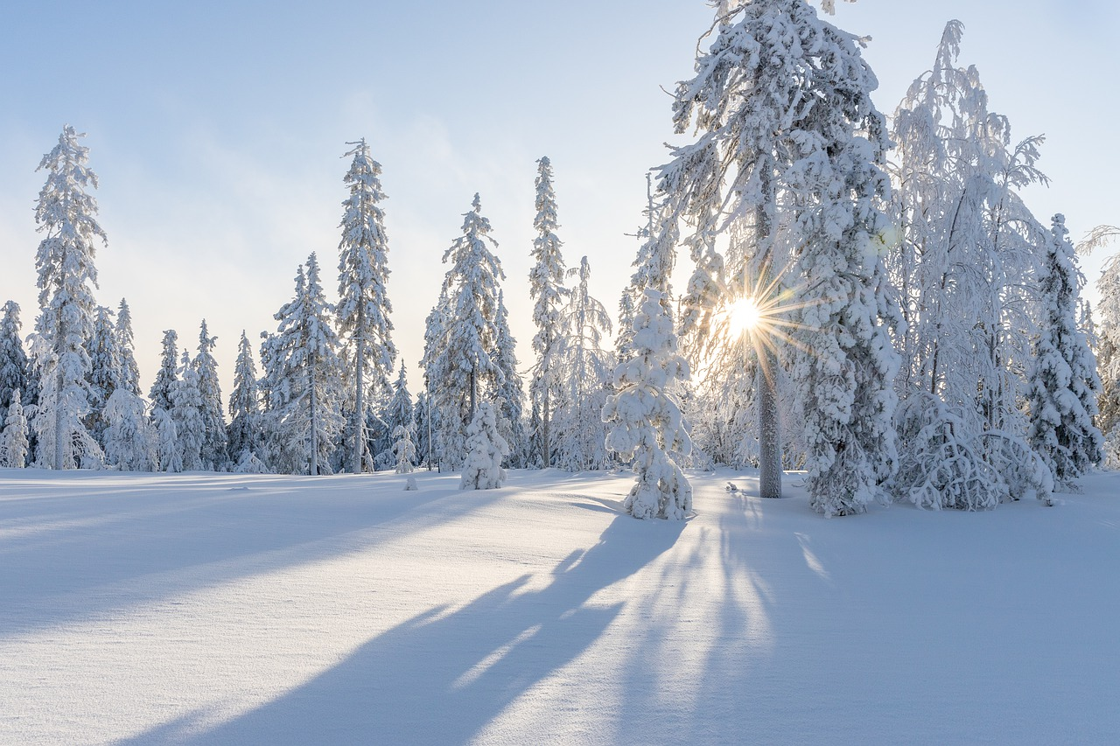 | 
putovati - putovanje | zimovati - zimovanje | ljetovati - ljetovanje
All these verbs end in -ati. Thus, the verbal nouns will have the ending -a-nje (putov-a-nje, zimov-a-nje, ljetov-a-nje).

Group 2
 |  | 
učiti - učenje | krstariti - krstarenje | paničariti - paničarenje

However, if a verb ends in -iti, the verb will have the ending -e-nje (uč-e-nje, krstar-e-nje, paničar-e-nje).

Images used in this document are from these sources.

