2 | 3 | Lekcija 6: Idemo na kavu

2.3 Zadatak 19. Što nosiš?
Look at the following set of pictures and place them in the appropriate category by writing the corresponding word of the item in the chart below.
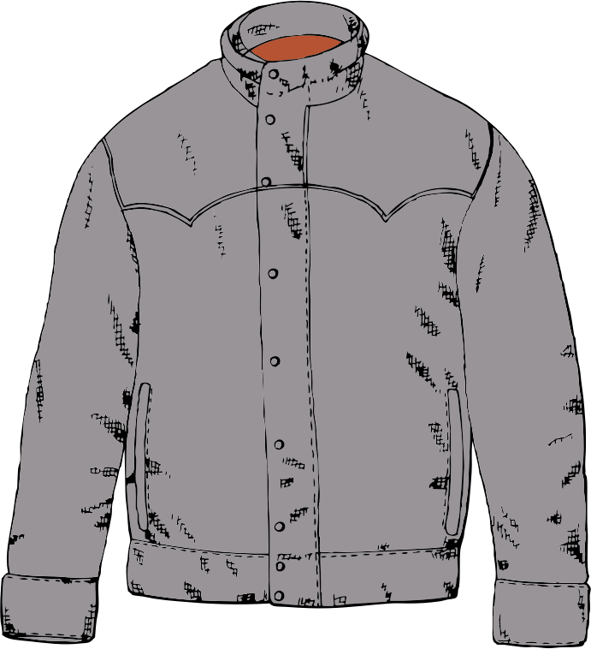 | 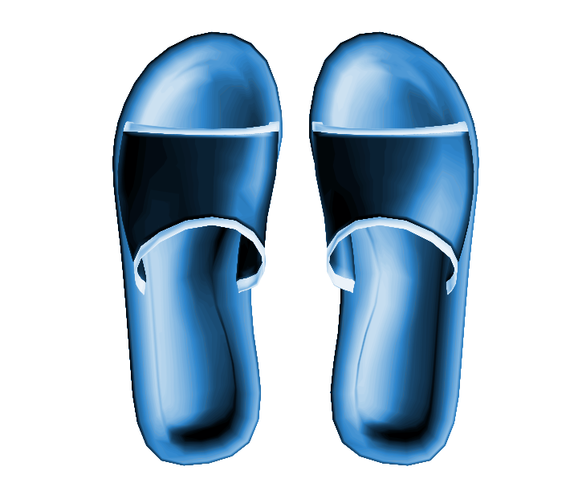 |  | 
 |  |  | 
 |  |  | 
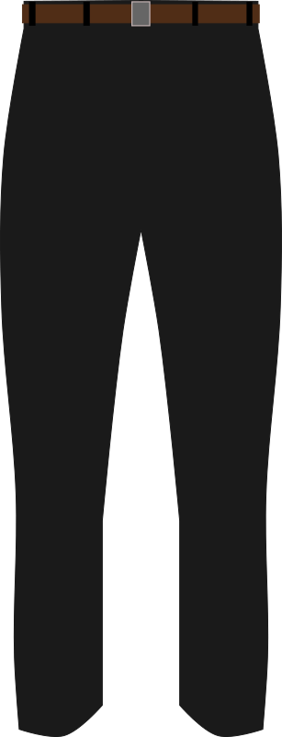 |  |  | 
 |  |  | 

Što često nosiš? | Što ponekad nosiš? | Što nikada ne nosiš?
Često nosim: | Ponekad nosim: | Nikada ne nosim:

Top 5 odjevnih predmeta.
Find pictures online of your 5 favorite clothing items. Copy and paste them into the table below. Then, tell us where (place or event) you usually wear those items.
Na primjer:
 | 👟 Ja volim nositi tenisice. Često nosim tenisice kad idem na fakultet, na kavu ili kad idem u prirodu.

1
2
3
4
5

2.3 Zadatak 20. Što imaš u ormaru?
💻 Video recording. Work with a classmate. Use this Google slide presentation or download this Powerpoint Document in order to complete the task. Submit your video recording online.

2.3 Zadatak 21. Gdje je?
💻 Video recording. Before you meet with a classmate to check their knowledge, complete the task below.

Part 1
Write at least five questions asking where a certain tourist attraction is located in Bosnia, Croatia, Montenegro, or Serbia. Use the locations that we already covered in our class. You cannot repeat the same city twice. Provide answers to your questions as well. Use full sentences.
br. | Pitanje: | Odgovor:
0 | Gdje je Dioklecijanova palača? | Dioklecijanova palača je u Splitu.
1
2
3
4
5

Part 2
When you have your questions and answers ready, meet with one of your classmates to see if they know the answers as well. If they made a mistake in any of their answers, correct them and give the right answer. Submit your video recording online.

2.3 Zadatak 22. Poziv na kavu
💻 Video recording. Invite a friend for a coffee. Negotiate at what time, what day, and where you want to go. Say why you want to go for a coffee. Use the dialogues from our class session. They will help you with necessary phrasing, new words, and/or grammar structures.
Submit your video recording online.

2.3 Zadatak 23. Kultura - razgovor

| Culture
[h5p id="546"]
In this activity, you will learn about Croatia’s two largest cities, Zagreb and Split. You will read a text about the importance of places like kavanas and cafes in the development of Zagreb society and the importance of špica, what it is and where it takes place. Your instructor will send you a handout for this task.

Social life in Croatia has long revolved around the visitation of establishments for food and drink, like kavanas and cafés, where members of the same or different social classes interact. One important example of social life in public, in which cafés and urban geography play an important role, is špica. Špica is a place, a social ritual, a state of mind, and a spectacle that connects urban residents to their city centers and each other.
Adapted from “The Phenomenon of Zagreb’s Saturday Špica as a Part of Public Life in the Eyes of Users of the Space of Bogovićeva Street“ by Tea Štefek, 2014. Translated by Samantha Farmer, 2021.

| Discussion
1 | What is the importance of kavanas and cafés in Zagreb’s public social life? Who went to kavanas, and how were cafés different?
1 | -
2 | How would you define or translate špica?
2 | -
3 | How is špica different in Zagreb and in Split?
3 | -
4 | In your opinion, what social values do the citizens of both cities cherish?
4 | -
5 | What do you think of špica as an activity? Would you attend Saturday špica?
5 | -
6 | Are there social rituals like špica in your city or country? Where do they take place?
6 | -

Images used in this document are from these sources.

