1 | 1 | Lekcija 3: Upoznajmo se.

1.1 Zadatak 10. Kako se zoveš?
1️⃣ Listen to your instructor saying a few things about themselves. Listen for information about their name, occupation, and where they’re from.
 | 
2️⃣Then, talk with your classmates and collect information from each other, including your names, occupation (including being a student), and where you’re from. Fill in the information in the chart below for each of the classmates you talk to.
Questions to ask: | Possible answers:
Kako se ti zoveš? | Ja se zovem (Tom/Ana).
Ti si lektor/lektorica? | Ne, ja sam student/studentica.
Odakle si? | Ja sam Amerikanac/Amerikanka.

ime | profesija | nacionalnost
James | student | Amerikanac
Laura | studentica | Amerikanka

3️⃣Now your instructor will ask you to share what you learned about one of your classmates.
Pitanje (question): | Odgovor (answer):
Kako se on/ona zove? | On/ona se zove…
On je lektor? Ona je lektorica? | Ne, on/ona je…
Odakle je on/ona? | On/ona je…

1.1 Zadatak 11. Kako se oni zovu?
🔊 Our international students are having their first session studying Croatian. Listen to the following dialogues between our new students and their instructors. After listening to the dialogues, you will need to complete the task about their names and occupations. 🎧
Dijalog 1 |  | Dijalog 2
Kako se ona zove? |  | Kako se ona zove?
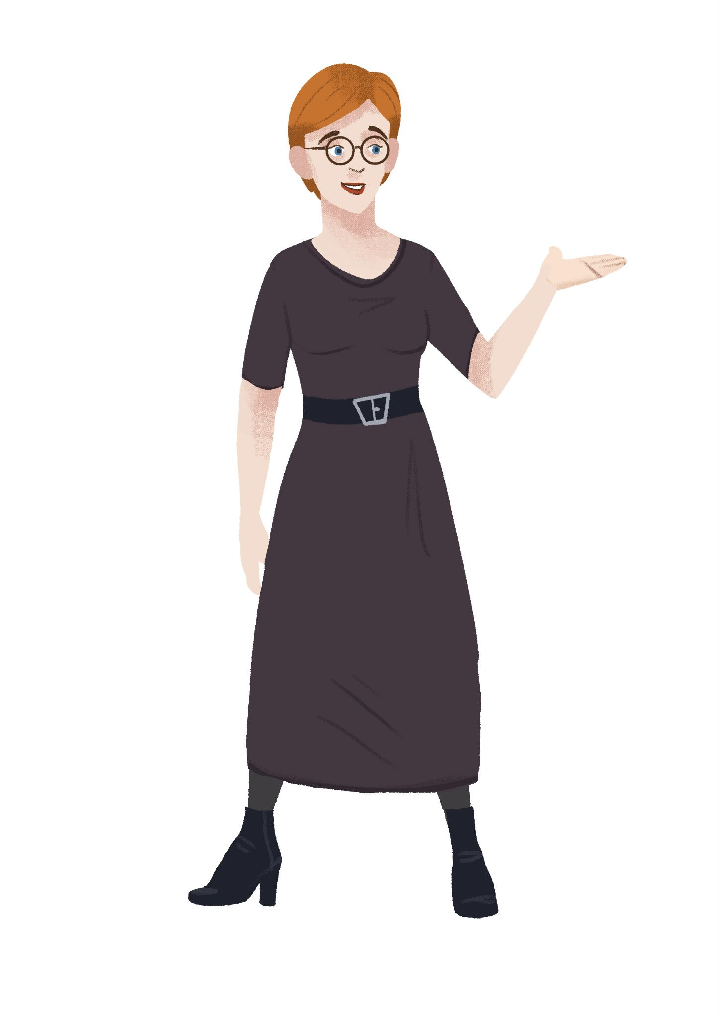 |  | 
[odgovor] → Ona se zove: |  | [odgovor] → Ona se zove:
Ona je: |  | Ona je:
□ profesor | □ profesorica | □ profesor | □ profesorica
□ lektor | □ lektorica | □ lektor | □ lektorica
□ student | □ studentica | □ student | □ studentica

Dijalog 3 |  | Dijalog 4
Kako se on zove? |  | Kako se on zove?
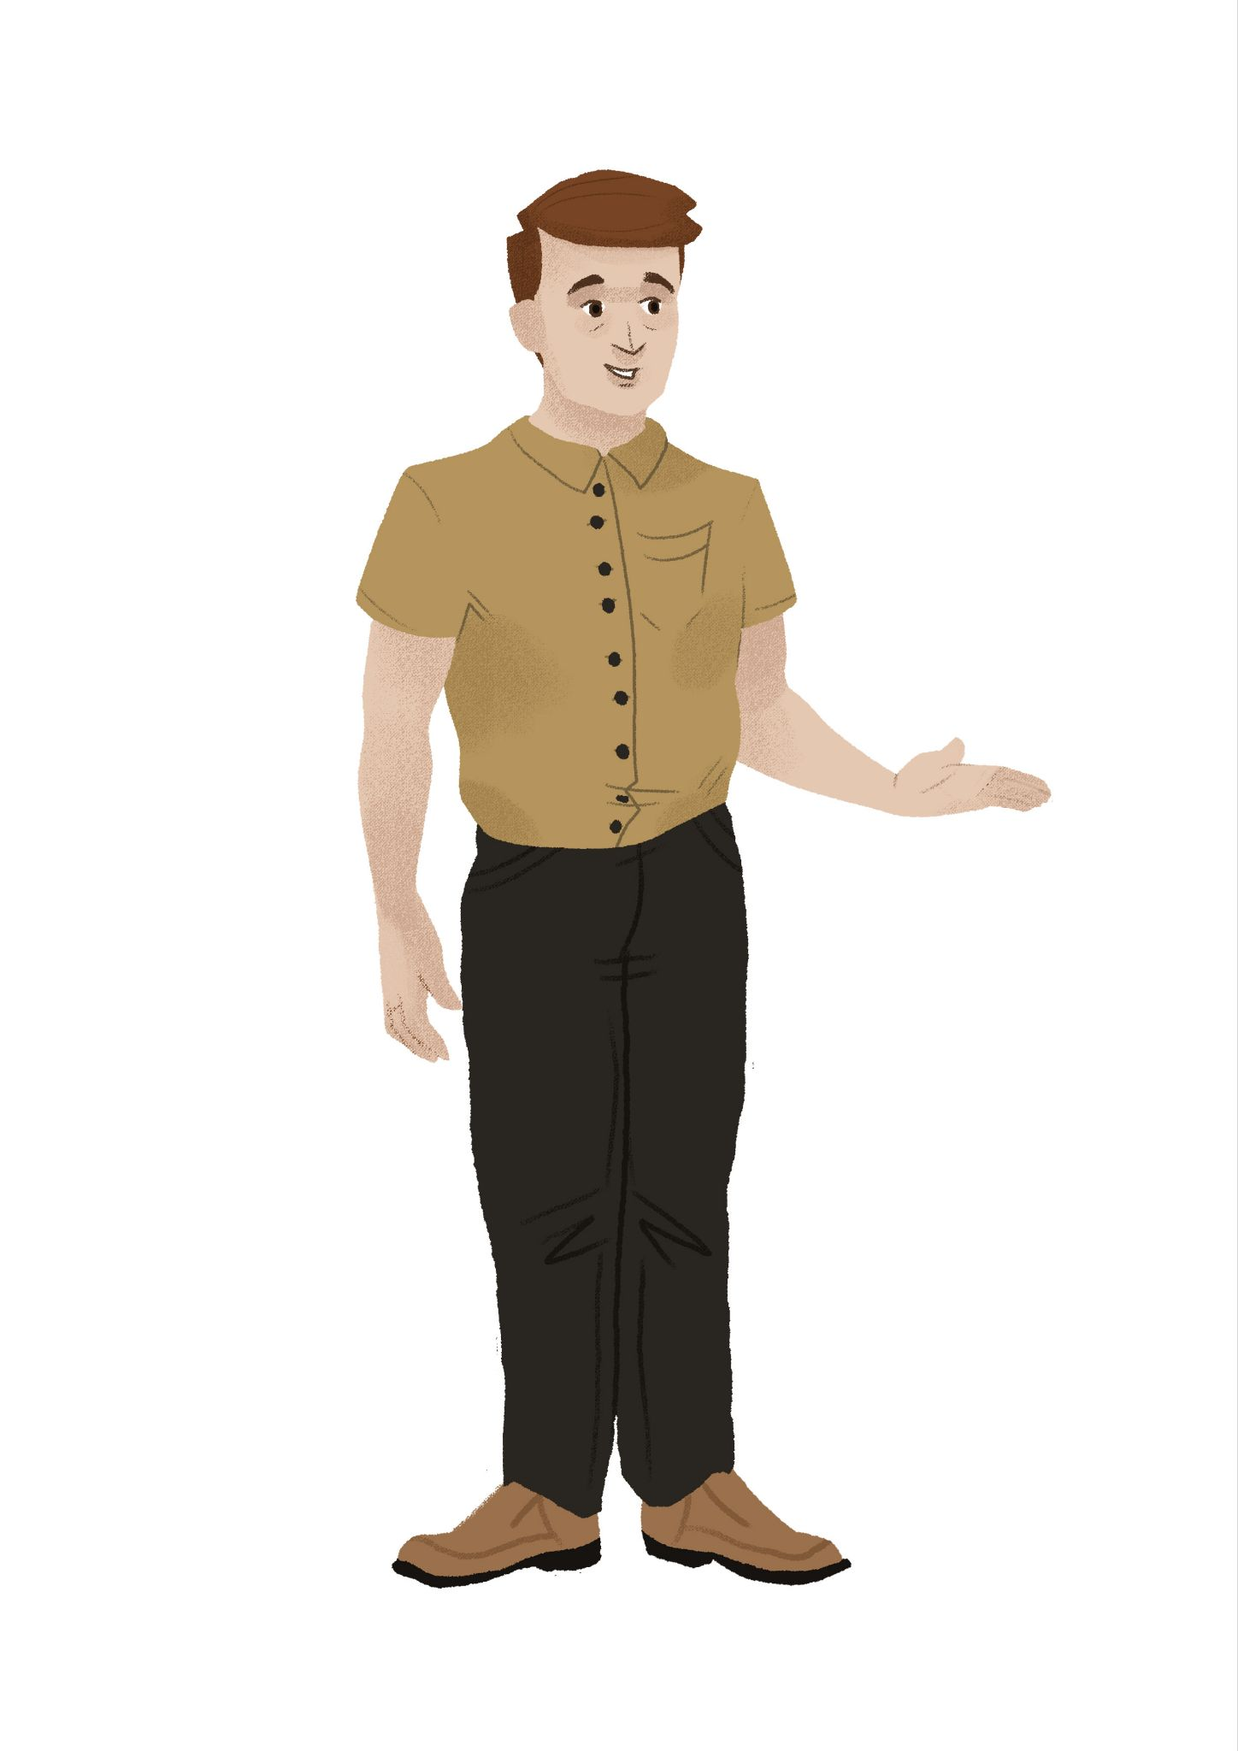 |  | 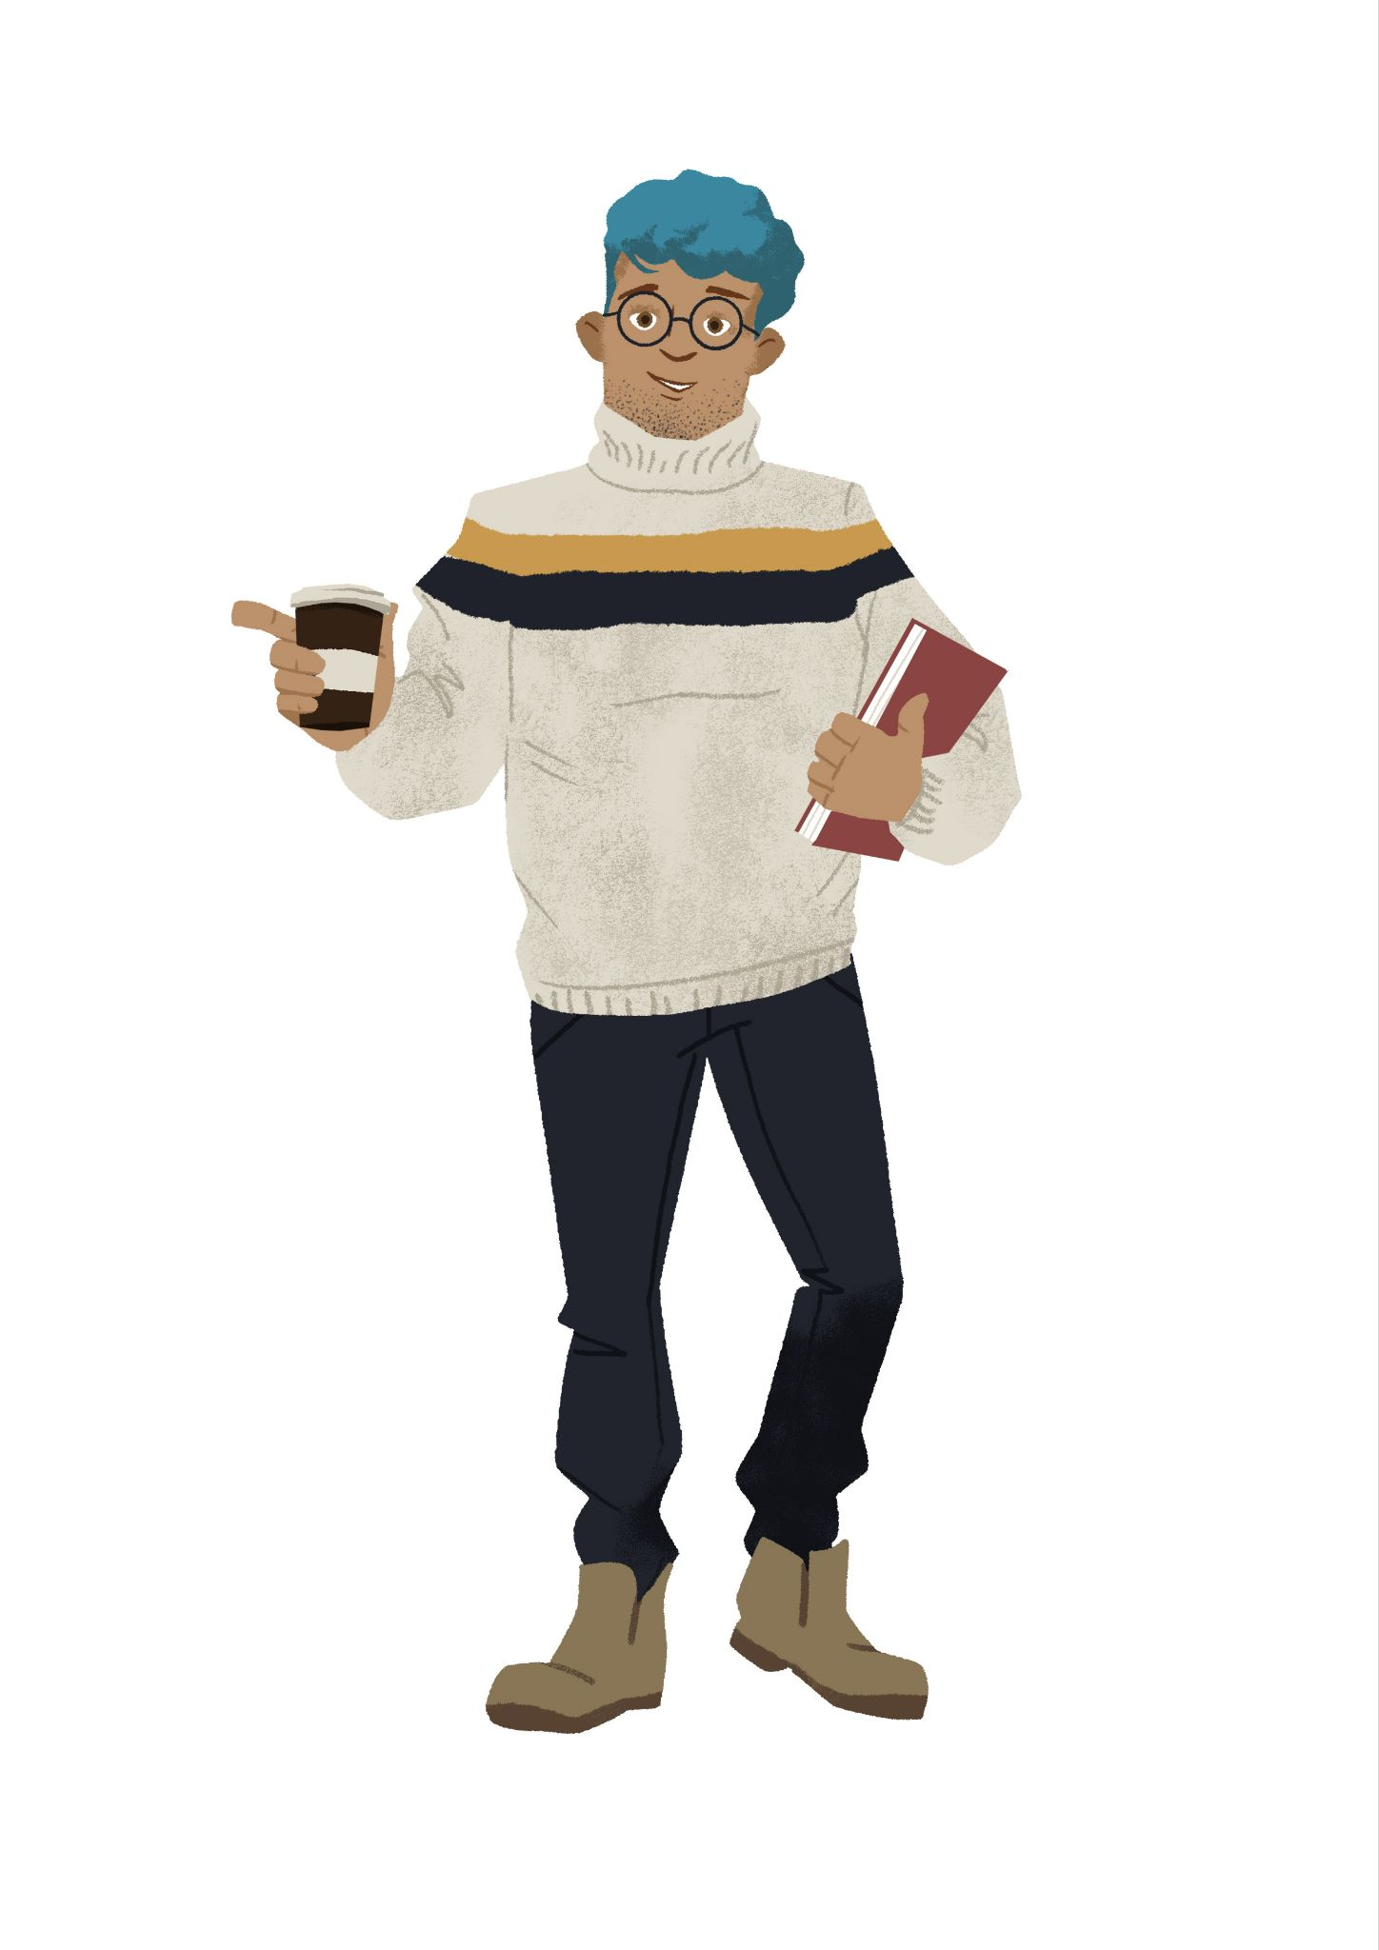
[odgovor] → On se zove: |  | [odgovor] → On se zove:
On je: |  | On je:
□ profesor | profesorica | □ profesor | □ profesorica
□ lektor | lektorica | □ lektor | □ lektorica
□ student | studentica | □ student | □ studentica

1.1 Zadatak 12. Kako se oni zovu?
🔊 Dijalog 5 i dijalog 6: The very same day, after their first language class, our students are having a conversation hour where they are paired with local students to practice their language skills. Listen to the dialogues and complete the task. When providing answers to your classmate, point out the character that you are referring to.
 | 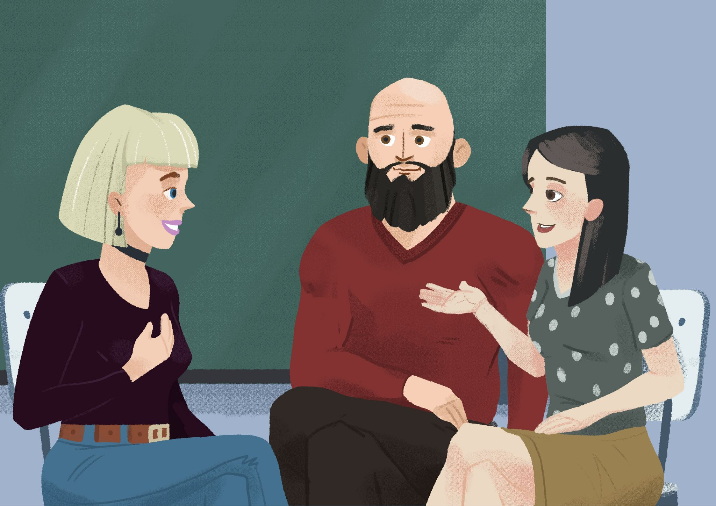

Kako se zove? | Odakle je? | Koji jezik govori/priča?
Ona se zove: | Ona je: | Ona govori:
[odgovor] → | [odgovor] → | [odgovor] →
On se zove: | On je: | On govori:
[odgovor] → | [odgovor] → | [odgovor] →
Ona se zove: | Ona je: | Ona govori:
[odgovor] → | [odgovor] → | [odgovor] →

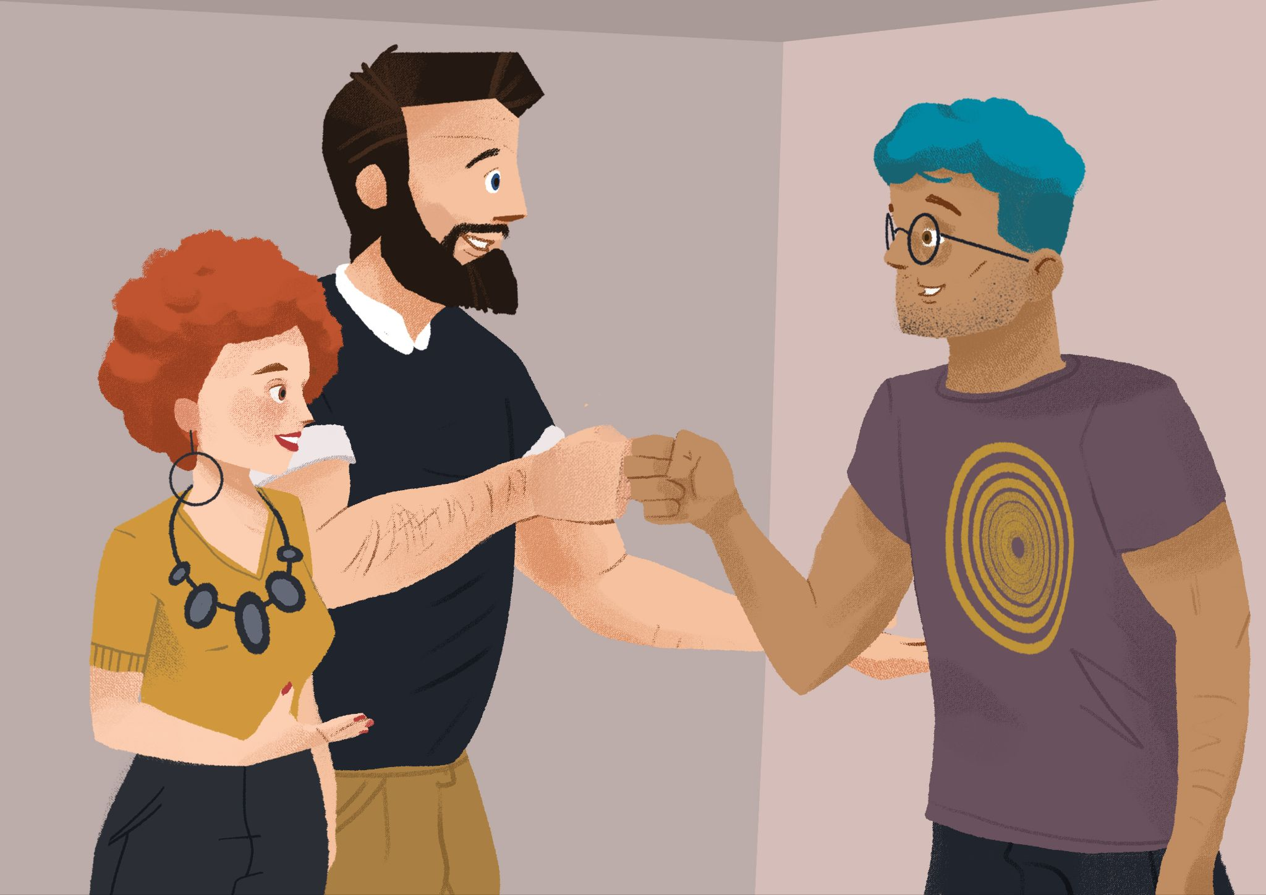 | 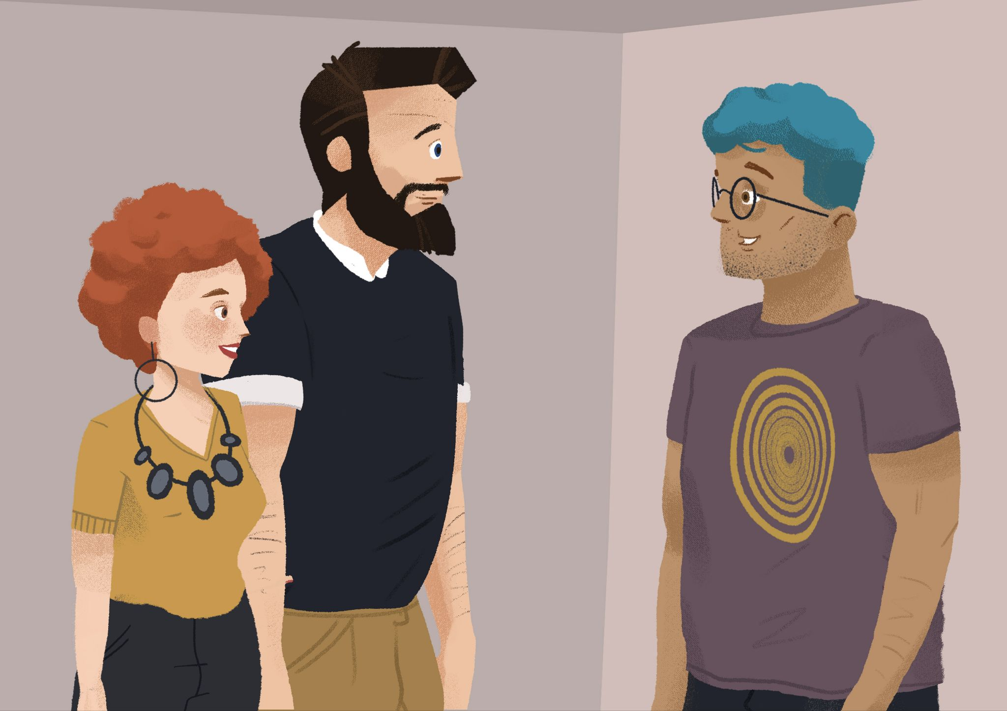

Kako se zove? | Odakle je? | Koji jezik govori/priča?
Ona se zove: | Ona je: | Ona govori:
[odgovor] → | [odgovor] → | [odgovor] →
On se zove: | On je: | On govori:
[odgovor] → | [odgovor] → | [odgovor] →
On se zove: | On je: | On govori:
[odgovor] → | [odgovor] → | [odgovor] →

1.1 Zadatak 13. Kako se (ti) zoveš?
🔊 Listen to the dialogue between students. Our American student is practicing Croatian with a new friend. Complete the task below. 🇭🇷
(audio)
Pitanje: | Student 1 | Student 2
Kako se zove?
Kako je?
Odakle je?

1.1 Zadatak 14. Tko si, odakle si?
👥 Talk with one of your classmates and make a dialogue in which you include the following elements. Before you perform the dialogue, make notes on how you will express each bullet point mentioned below in Croatian.
 | 

 | Phrases | [odgovor]
1 | Greet your new friend. | →
2 | Ask his/her name. | →
3 | Ask how he/she is doing. | →
4 | Ask about his/her nationality. | →
5 | Say that you will see each other later. | →
6 | Give an appropriate goodbye / farewell. | →
Images used in this document are from these sources. ℹ️

