6 | 3 | Lekcija 2: Sedma umjetnost

6.3 Zadatak 7. Ustav Republike Hrvatske
Watch the trailer again and complete the task. Who are the following two actors?

Kako se oni zovu?
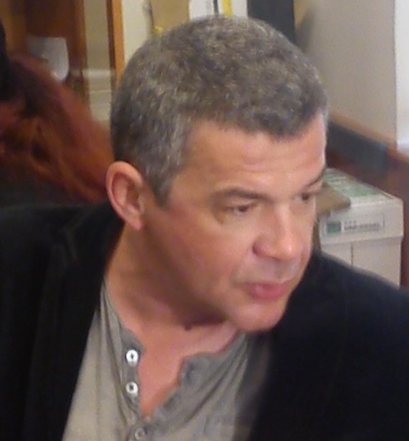 | 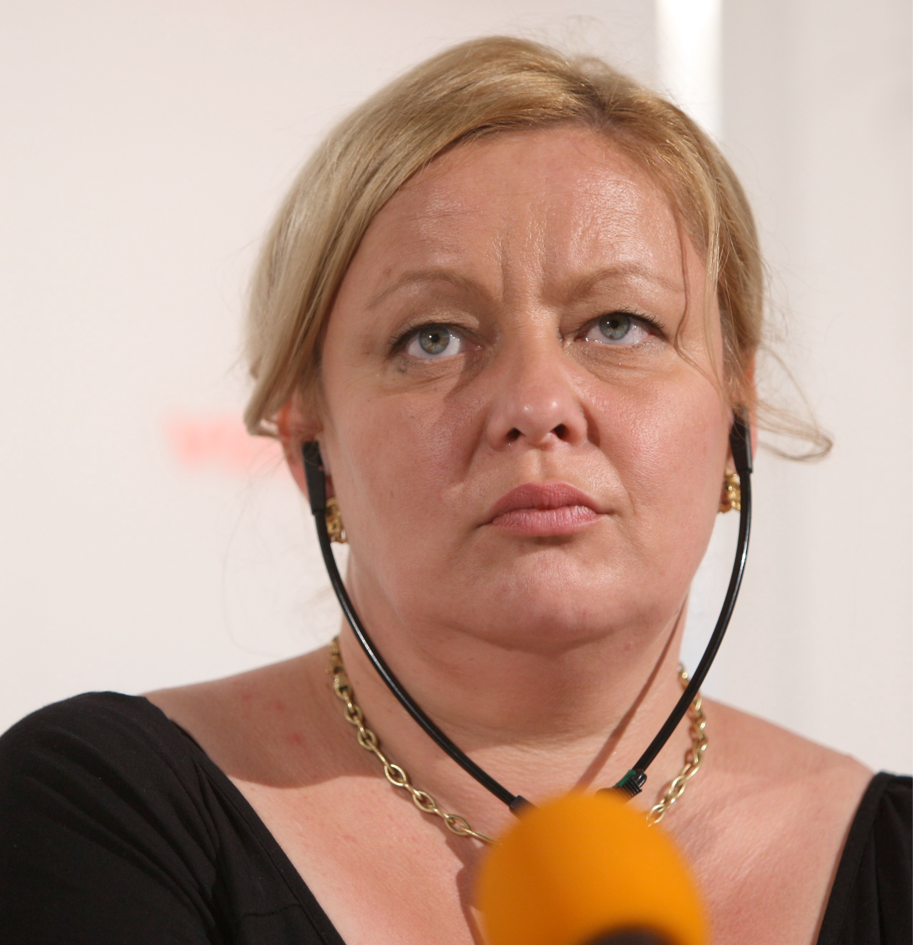
On se zove… | Ona se zove…
What can you tell us about the following actors – where they were born, what movies they played in, and anything else you might know or think about them. You will need to search online for some of this information. Use our class material to help structure your writing.

| Glumci
Nebojša Glogovac:
Dejan Aćimović:
Ksenija Marinković:

6.3 Zadatak 8. Večer filma
Pair-work. Meet with one of your classmates and create a dialogue in which one of you wants to organize a movie night. Discuss what movies you like and negotiate in Croatian which one you will actually watch. Discuss who is coming, what you will eat, and what you should bring. Use class dialogues for inspiration and necessary vocabulary.

6.3 Zadatak 9. Redateljice i redatelji
Among the many male directors, there are several female directors who find their place in a director’s chair, although they number far fewer than their male counterparts. Here are some female directors that are well-known in the region:
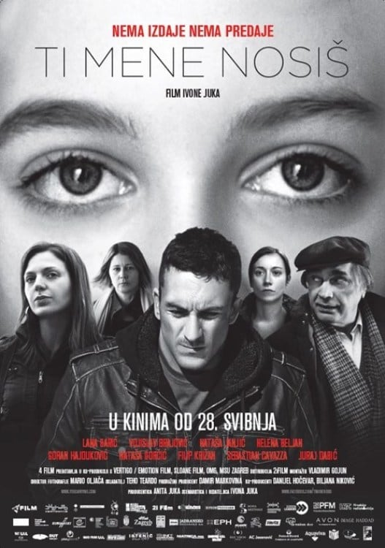 | 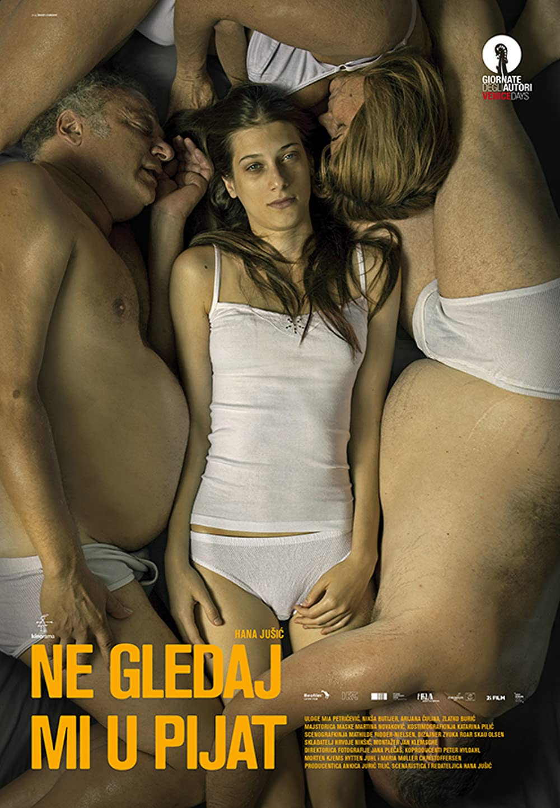 | 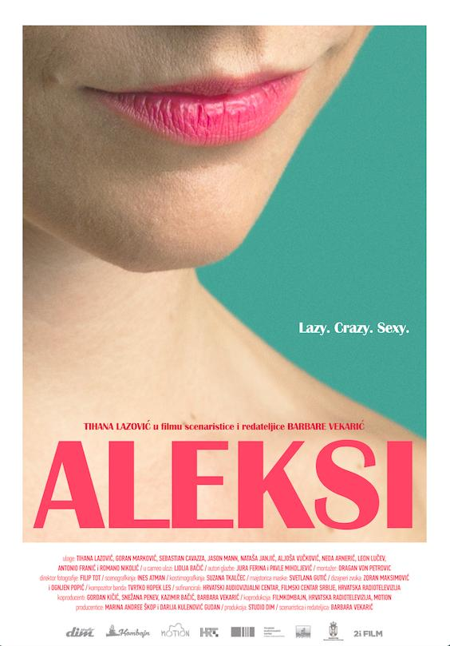
Ivona Juka:  Ti mene nosiš | Hana Jušić:  Ne gledaj mi u pijat | Barbara Vekarić:  Aleksi
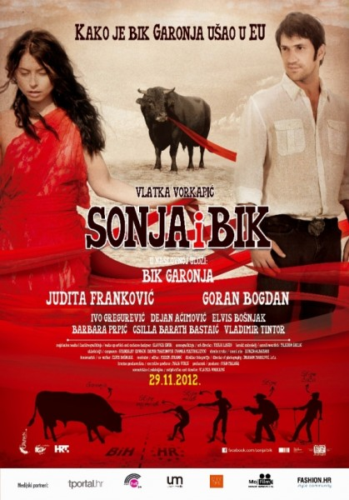 | 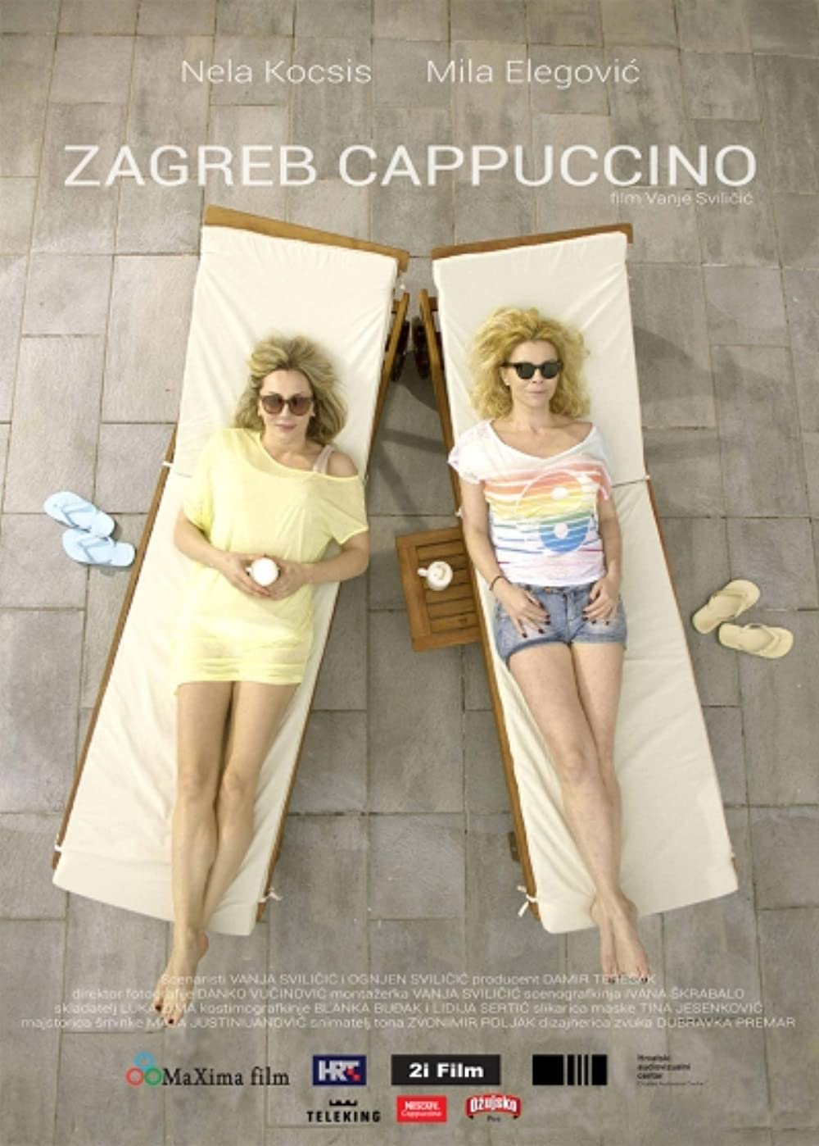 | 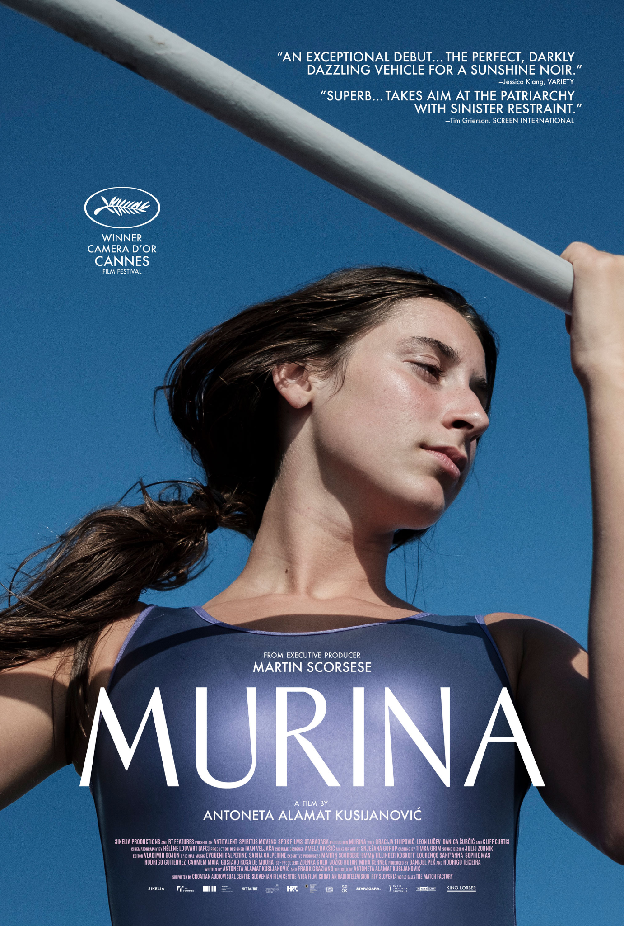
Vlatka Vorkapić:  Sonja i bik | Vanja Sviličić:  Zagreb capuccino | Antoneta Kusijanović  Murina

Very prominent Bosnian film director
Browse online about Jasmila Žbanić and her movies. Watch short clips online, read more about the movies she has made. When you are ready, answer the questions below.
 | 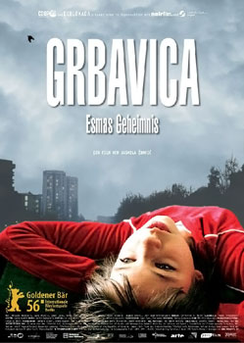
Jasmila Žbanić | Grbavica (2006.)
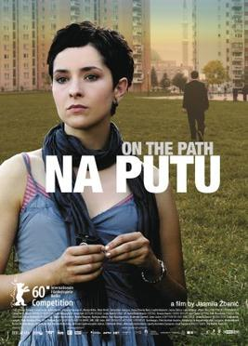 | 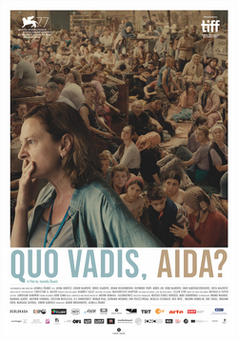
Na putu (2010.) | Quo Vadis, Aida (2020.)

| Question
Which movie would you like to watch? Why?
→

6.3 Zadatak 10. Kinematografija

| In English: Ustav Republike Hrvatske
Today in class we talked about a very important Croatian movie which talks about social problems in Croatia – The Constitution. At this point you are already familiar with the movie enough to be able to answer the following questions.
| Question
How would you interpret this description of the movie: “ljubavna priča o mržnji”?
→

Američka i hrvatska kinematografija
It is probably obvious that US blockbuster movies are different from Croatian movies.
| Questions
How would you interpret these differences? What characterizes each production?
→
What do you know about cultural (and perhaps gender) identity in Croatia? What does this movie show regarding these topics?
→

6.3 Zadatak 11. Prezentacija
For our next class session, prepare a presentation about (1) your favorite movie and (2) about a Croatian movie that you watched. When discussing a Croatian movie, include a video clip that will support your presentation. You will need to include the following information:

| Filmovi
Kako se zove film?
Zašto ti se sviđa film?
O čemu govori film?
Koji su glavni glumci?

Document for our next class session is available here as well (detailed version that you should follow).

Images used in this document are from these sources.

