6 | 1 | Lekcija 1: Planovi i želje

6.1 Zadatak 1. U budućnosti
According to your own desires, write what you want to achieve in the future (at least 5 things). Use the appropriate verb (htjeti or željeti).
| U budućnosti… [in the future]
→
→
→
→
→

6.1 Zadatak 2. Mi hoćemo…
Read the text and fill in the blanks with appropriate forms of the verb htjeti.

Moja mama ______________ da mi idemo na izlet, ali kamo ići? Tata ______________ ići na more. Ja mislim da je to odlična ideja! Ja ______________ plivati u moru, ali moja sestra ne voli more. Ona ______________ da idemo na Lovćen. Ona jako voli prirodu i ______________ planinariti. Mama također misli da je to dobra ideja. Ona __________ ići u Njegošev mauzolej. No, tata ne voli muzeje, on ______________ biti na suncu. Možda možemo ići u nacionalni park? Da, to je odlična ideja! Mi svi ______________ biti u prirodi. A ti, kamo ______________ ići za vikend? Kamo ti i tvoji prijatelji ______________ ići?
Based on the text above, write a similar story. Follow the last two questions in the text that are addressed to you.

| Odgovori na pitanja
→

6.1 Zadatak 3. Kako se kaže?
 | 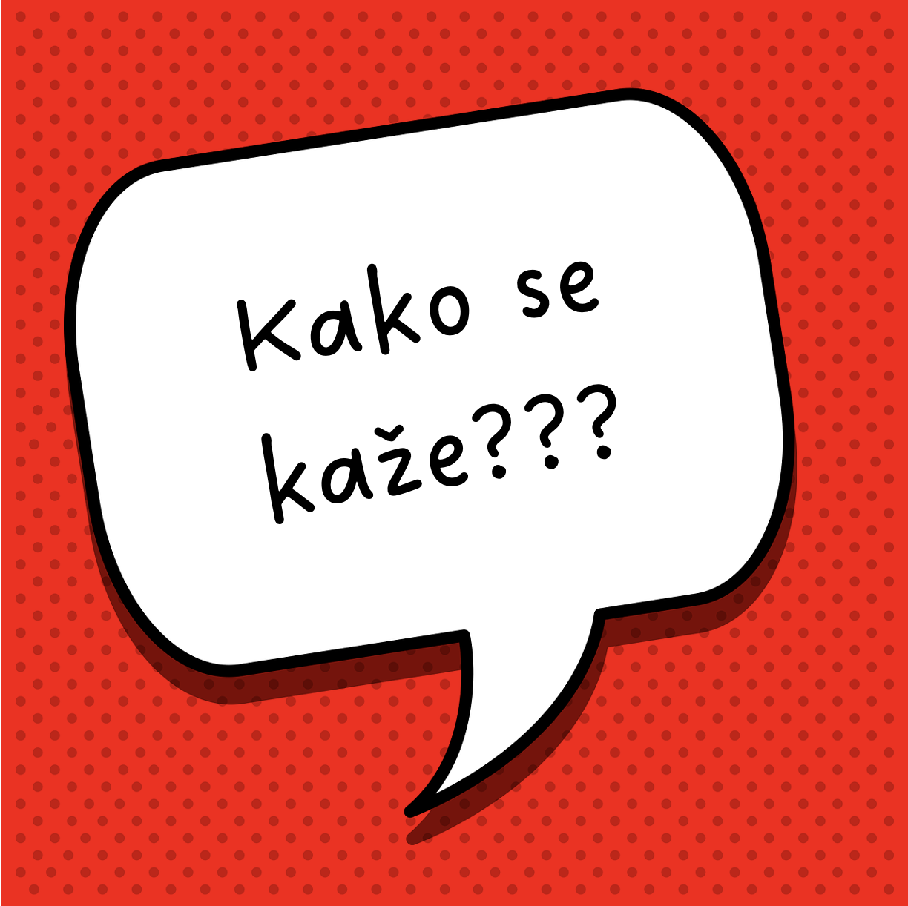
Based on today’s class dialogue, how would you formulate sentences in Croatian for the following situations?

| Informal speech among friends:
1 | How would you ask someone how they are doing? There is a phrase, not just simply asking “kako si”.
1 | -
2 | How would you tell someone that there is nothing new in your life?
2 | -
3 | How would you say that you feel the same?
3 | -
4 | How would you say that you still have no plans?
4 | -
5 | How would you say that a movie is a must see?
5 | -
6 | How would you say that a movie is available on a certain streaming platform?
6 | -
7 | How would you express your doubts about something/someone?
7 | -
8 | How would you invite someone to do something with you?
8 | -

6.1 Zadatak 4. O Ines i Marini
Read the text messages again and answer the questions below in English.
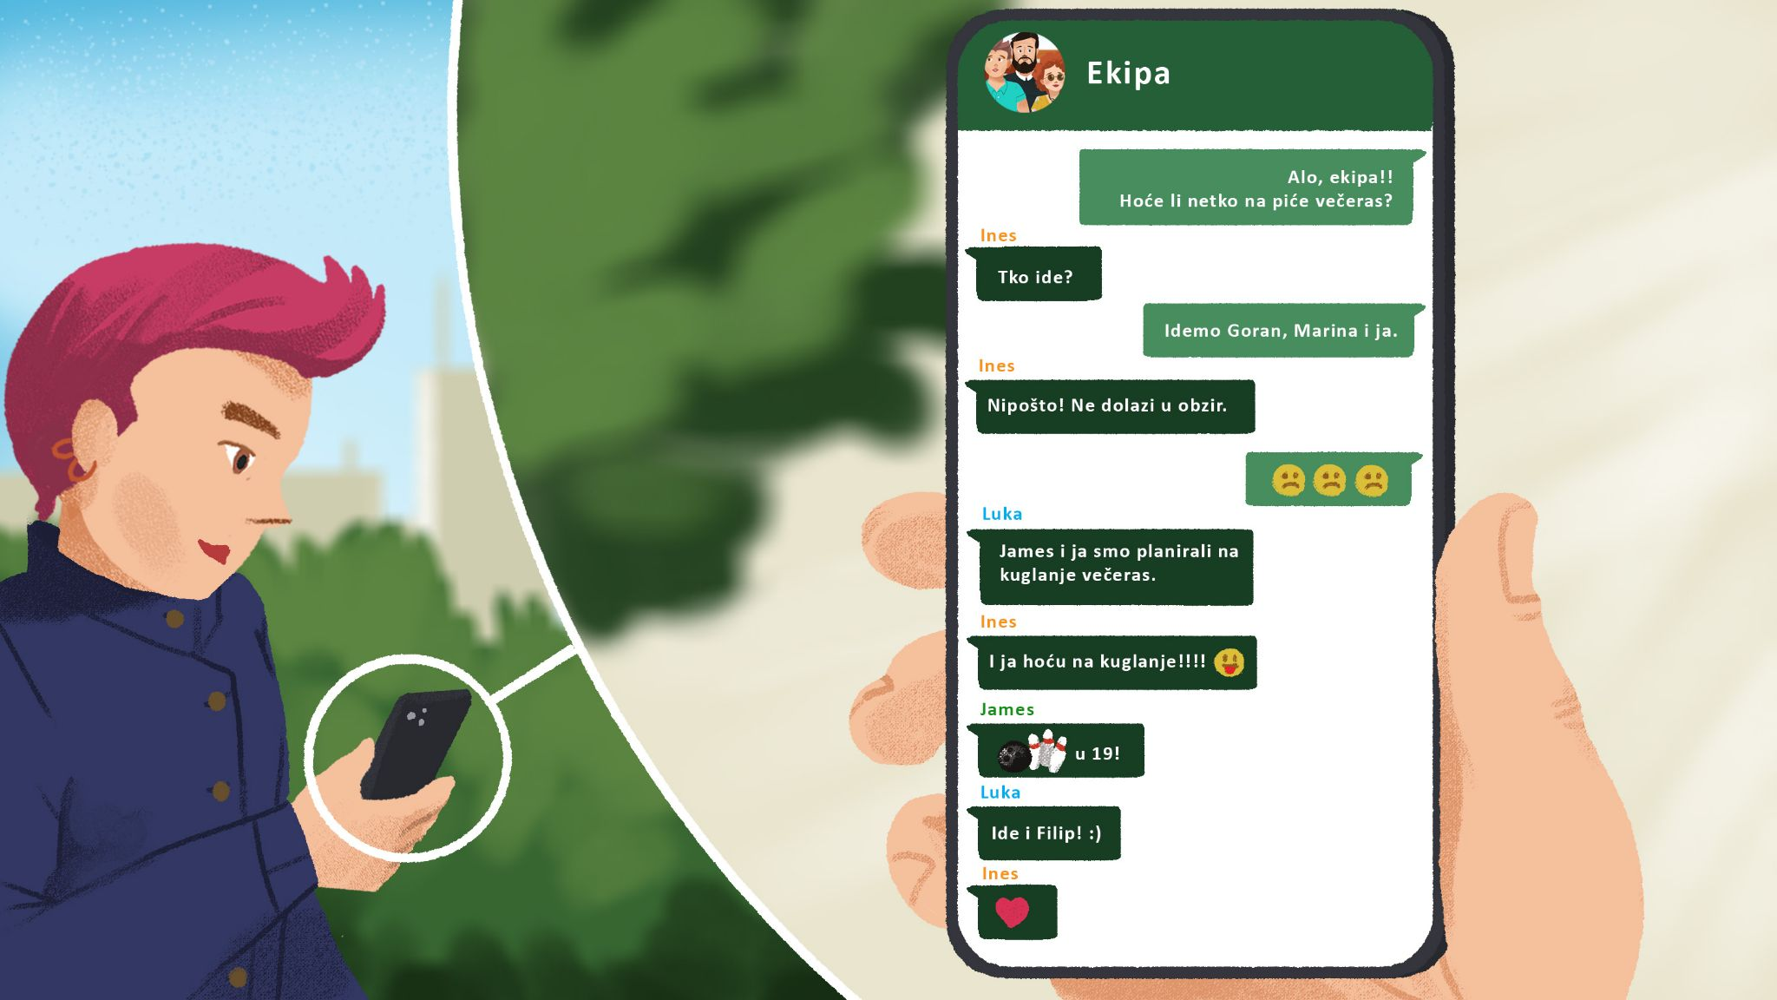
After Matija asked if anyone wants to go out for a drink – how would you interpret Ines’ answer? What does it mean?How would you appropriately translate it into English?

Why did Ines answer like that? What do you think? Do you remember the story from Unit 4?

| Your Answer
→

6.1 Zadatak 5. Koji film gledati?

Part 1
Check the following links and answer the questions below. Some possible answers are already provided for you. It might help you form your personal opinion.
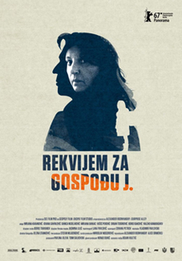 | 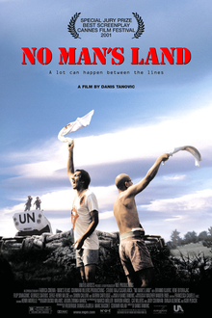 | 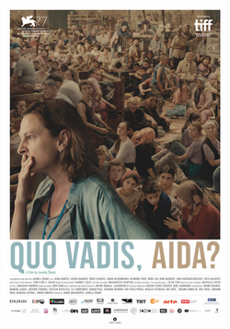
Rekvijem za gosođu J | Ničija zemlja | Quo vadis, Aida?
link | link | link
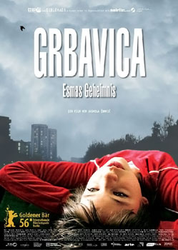 | 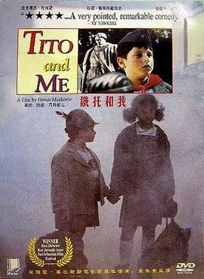 | 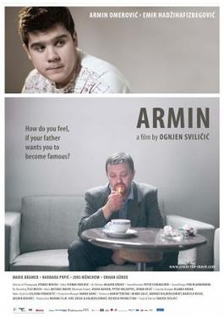
Grbavica | Tito i ja | Armin
link | link | link

pitanje | odgovor
Koji film hoćeš gledati i zašto?
Što misliš kakav je film?
Koj je žanr?

Film je:
star | nov | dosadan | zanimljiv
ima tužan kraj | ima sretan kraj | dug | spor
Film je (žanr):
komedija | drama | horror | triler

| In English
Based on your choice of the movie, search online to find more information about it. Tell us what it is about. Why do you like it? Is there a similar movie from the US that you can compare it to? What made you choose this movie and not some other?
| Answer the Questions
→

Part 2
Based on your personal preference about what movie to watch from Part 1, write a dialogue with one of your classmates. Create a Google doc and share it with your instructor. Use the dialogue covered in class as a model.

Be sure to include the following:
 | Ask your friend about his/her plans for the weekend.
 | Say that you want to watch a movie.
 | Invite your friend for a movie night.
 | Discuss what movie you want to watch.
 | If you do not agree on what movie to watch, find one that you are both OK with.
 | Make plans: where, when, and what time.

Images used in this document are from these sources.

