2 | 2 | Lekcija 1: Slobodno vrijeme

2.2 Zadatak 1. Što radiš u slobodno vrijeme?
Write a paragraph about your free time. What do you usually do and why? What is your favorite music that you often listen to, movies that you often watch, sports that you play, etc.?
1 | odgovor
1 | -

2.2 Zadatak 2. Moja obitelj, što radi?
👥 Pair-work. Talk with a classmate about your family and what each family member does in their free time. Na primjer:
1. Moja mama […].
2. Moja sestra […].
3. Moj tata […].
4. Moj brat […].

During your conversation, be sure to make comments (or ask additional questions) about your classmate’s family members and say if you have anything in common with anyone. Submit your video recording.

Before your conversation with your classmate, make notes about what you want to talk about.
1 | bilješke
1 | -

2.2 Zadatak 3. Grad i aktivnosti u gradu
You already explored what someone can see/find in one of the BCMS cities. Use already collected information about things/places in the city and write what you would do there. Suggest activities for each thing/place in the city you would visit. Na primjer:
BiH – Sarajevo: Baščaršija – tu [there] ja fotografiram spomenike, šetam, razgledavam trgovine, ručam, šopingiram i večeram.

You need to include at least 5 locations/attractions in the city and suggest activities to do at each of them. You can repeat activities when appropriate.

1 | lokacija:
1 | aktivnost:
2 | lokacija:
2 | aktivnost:
3 | lokacija:
3 | aktivnost:
4 | lokacija:
4 | aktivnost:
5 | lokacija:
5 | aktivnost:

2.2 Zadatak 4. Što rade naši studenti?
Look at the following pictures. What activities do our students perform? Write complete sentences about each character.

Što oni rade u slobodno vrijeme? Što vole raditi?
Davor | Sandra
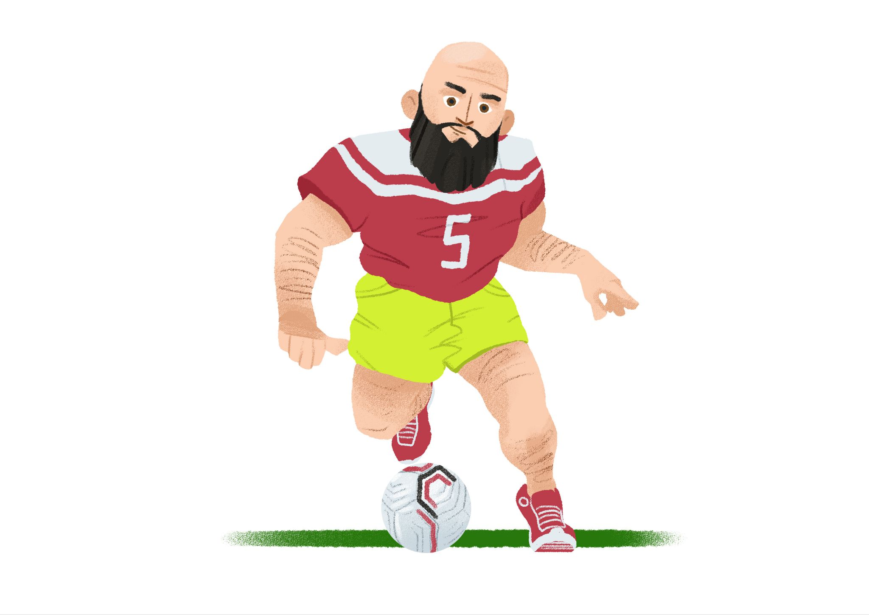 | 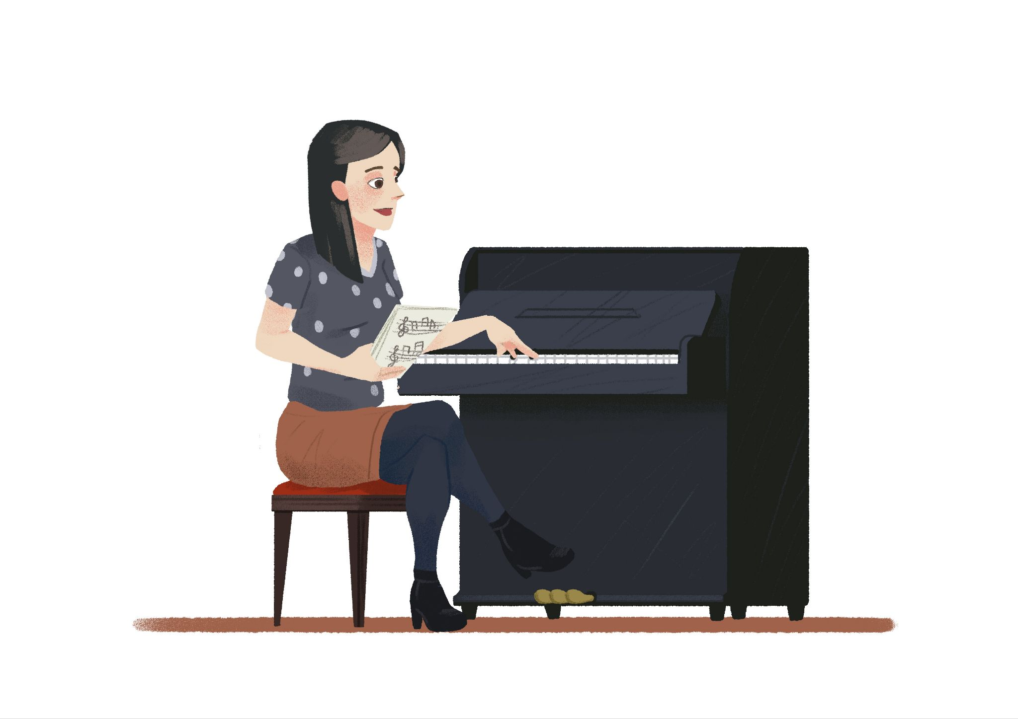
[odgovor] → | [odgovor] →
Mario | Laura
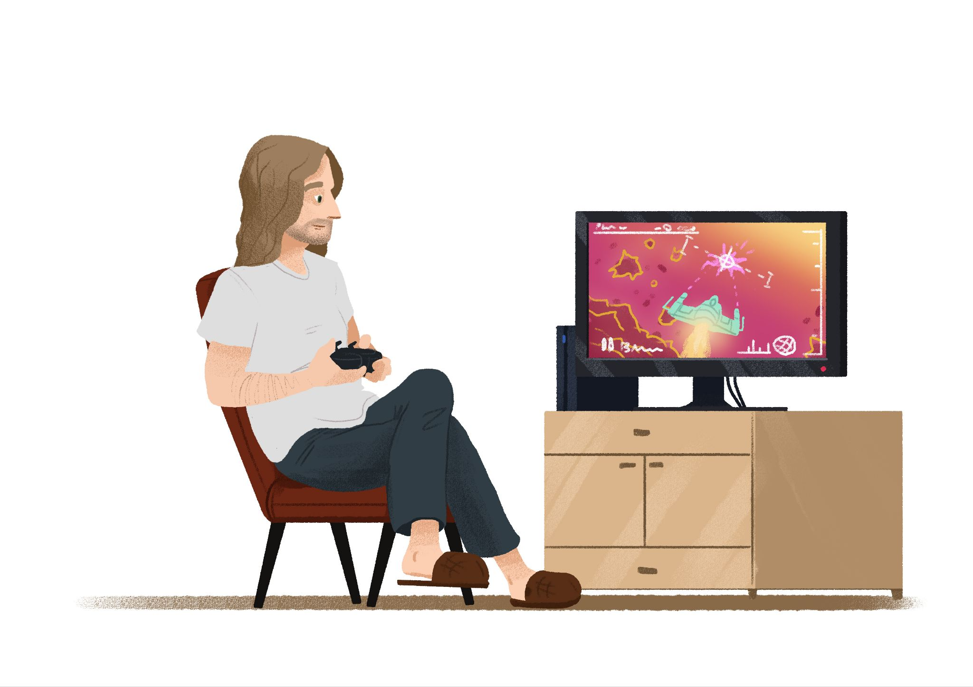 | 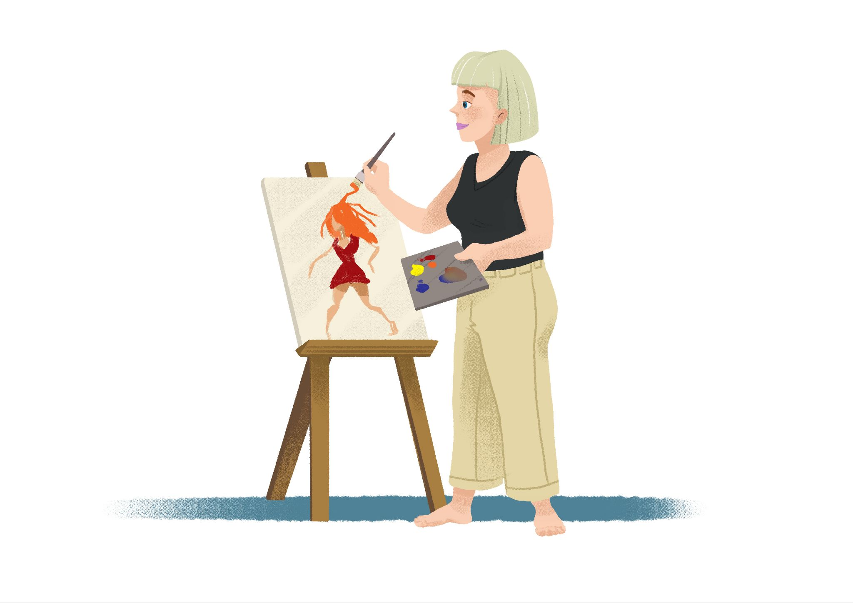
[odgovor] → | [odgovor] →
Luka | Ines
 | 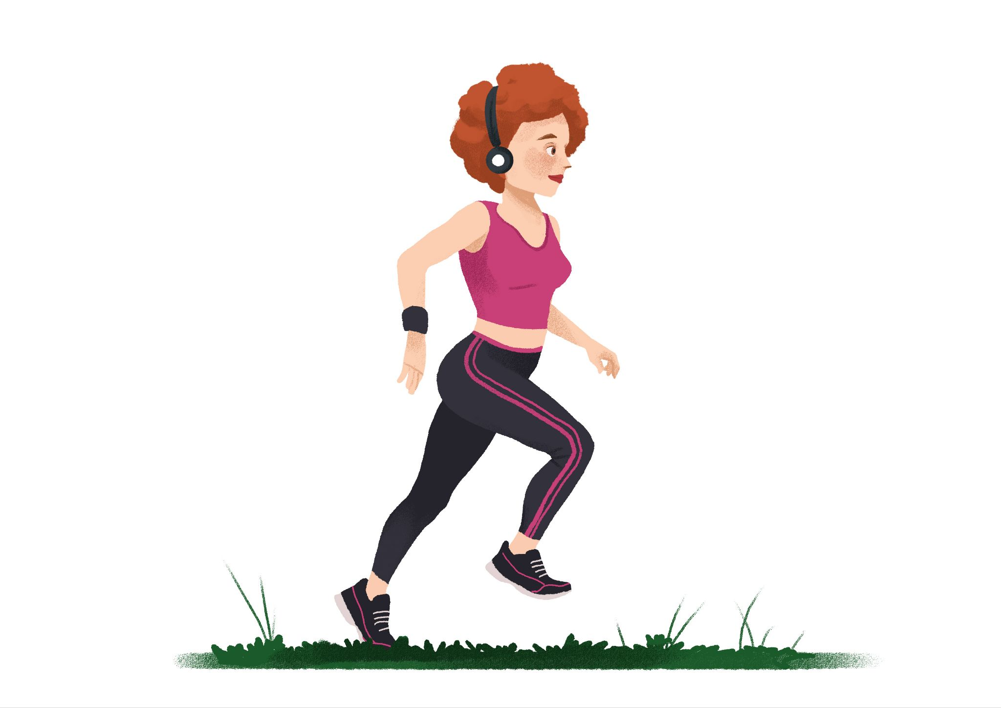
[odgovor] → | [odgovor] →
Matija | James
 | 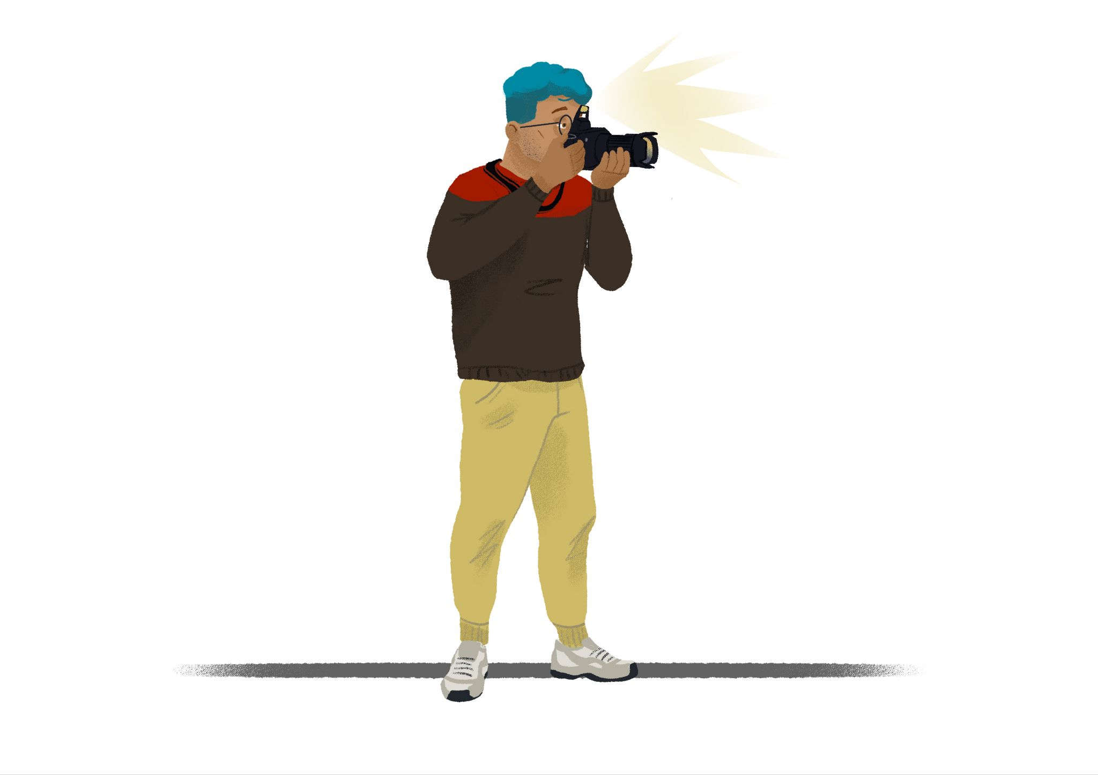
[odgovor] → | [odgovor] →

Based on the above activities, answer the following questions:
1 | Što ti voliš raditi?
1 | -
2 | Gdje voliš [trčati]?
2 | -
3 | Što ti misliš tko je dobro društvo? Laura, James ili netko drugi? Zašto? (netko drugi = someone else)
3 | -

Images used in this document are from these sources.

