2 | 3 | Lekcija 3: Izlazak

2.3 Zadatak 11. Kako se kaže?
Listen to the dialogue from our class session again. How would you express the following situations? Answer in Croatian.
 | 

1 | How would you say that you have a day off today?
1 | -
2 | How would you say that you don’t have to study?
2 | -
3 | How would you say that you are relaxing and watching TV?
3 | -
4 | How would you ask someone if they want to go to the city (downtown)?
4 | -
5 | How would you suggest to your friend to go to the theater?
5 | -
6 | What would you say that you all can go somewhere?
6 | -
7 | How would you say that a popular Croatian rock band is performing today?
7 | -
8 | How would you ask for an address?
8 | -
9 | How would you ask at what time?
9 | -

2.3 Zadatak 12. Koliko ima godina?
Look at the following pictures and information. How old are they? Write down the number.
1 | 2 | 3
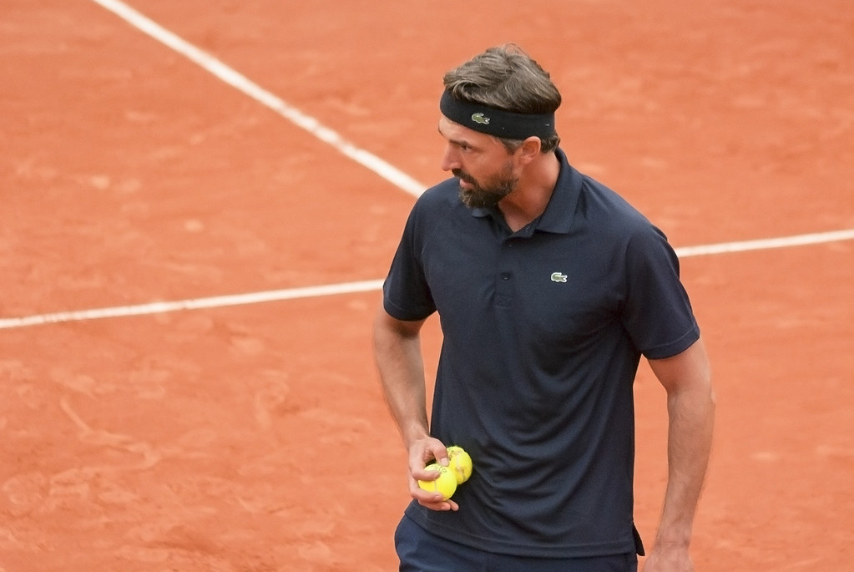 |  | 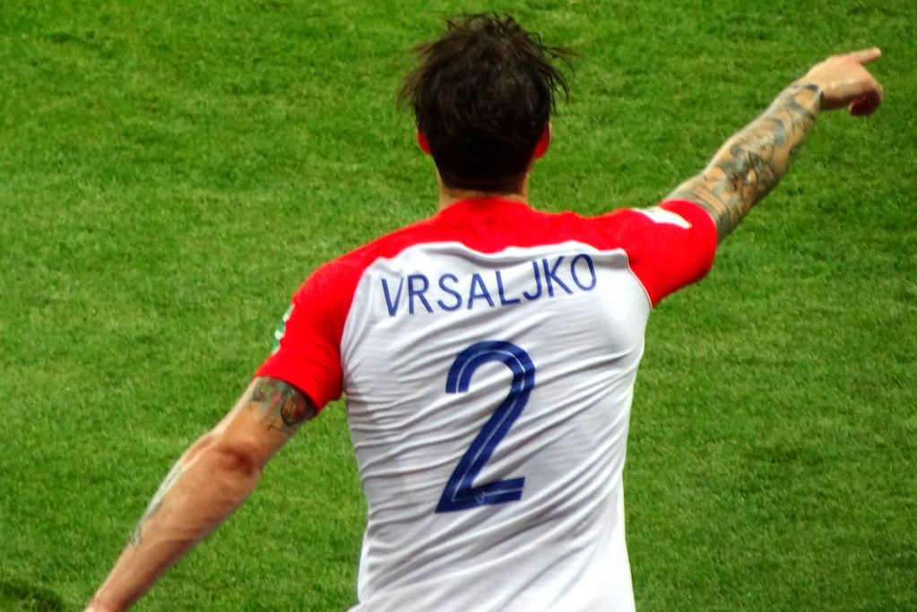
Goran Ivanisevic | Janica Kostelić | Šime Vrsaljko
4 | 5 | 6
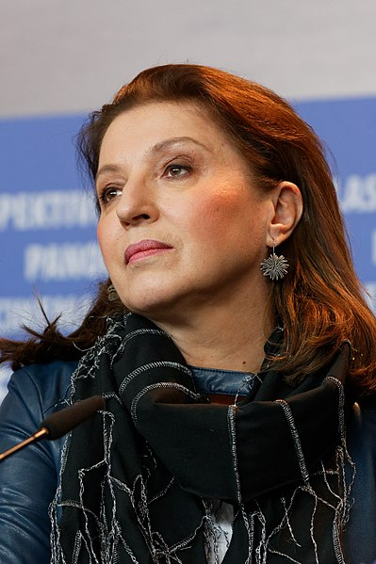 | 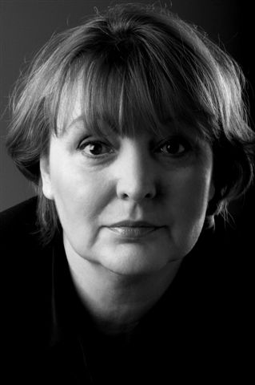 | 
Mirjana Karanović | Dubravka Ugrešić | Goran Višnjić

Use only digits in your answers.
Slika | Koliko ima godina? | Koji je datum rođenja?
1
2
3
4
5
6

2.3 Zadatak 13. Moj prijedlog
Video recording. Work with another classmate and make a video recording. Use examples from the class material to make a similar dialogue.
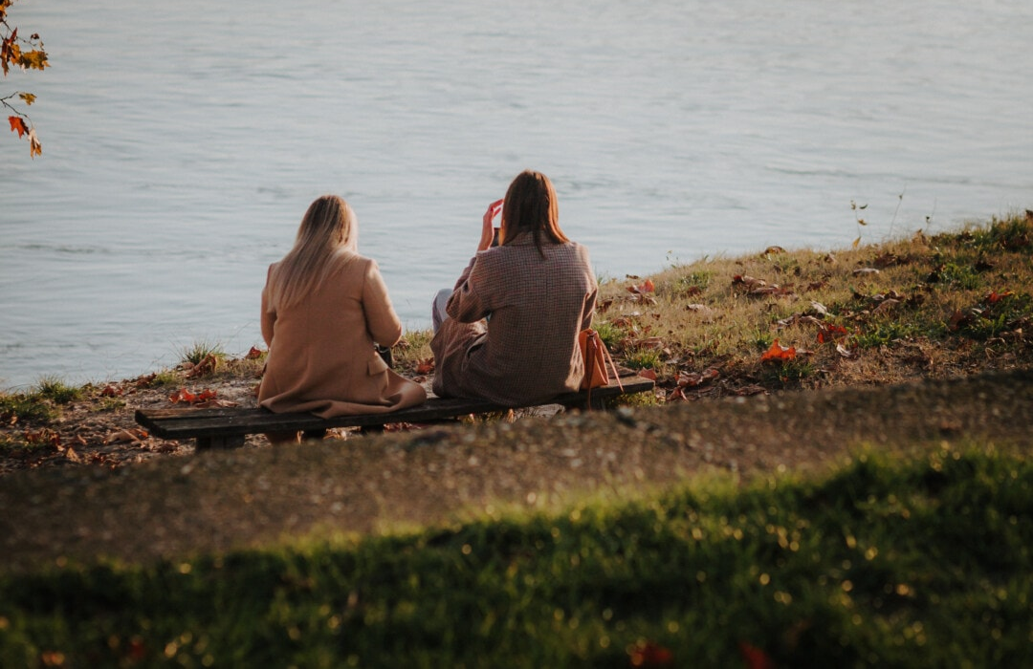 | 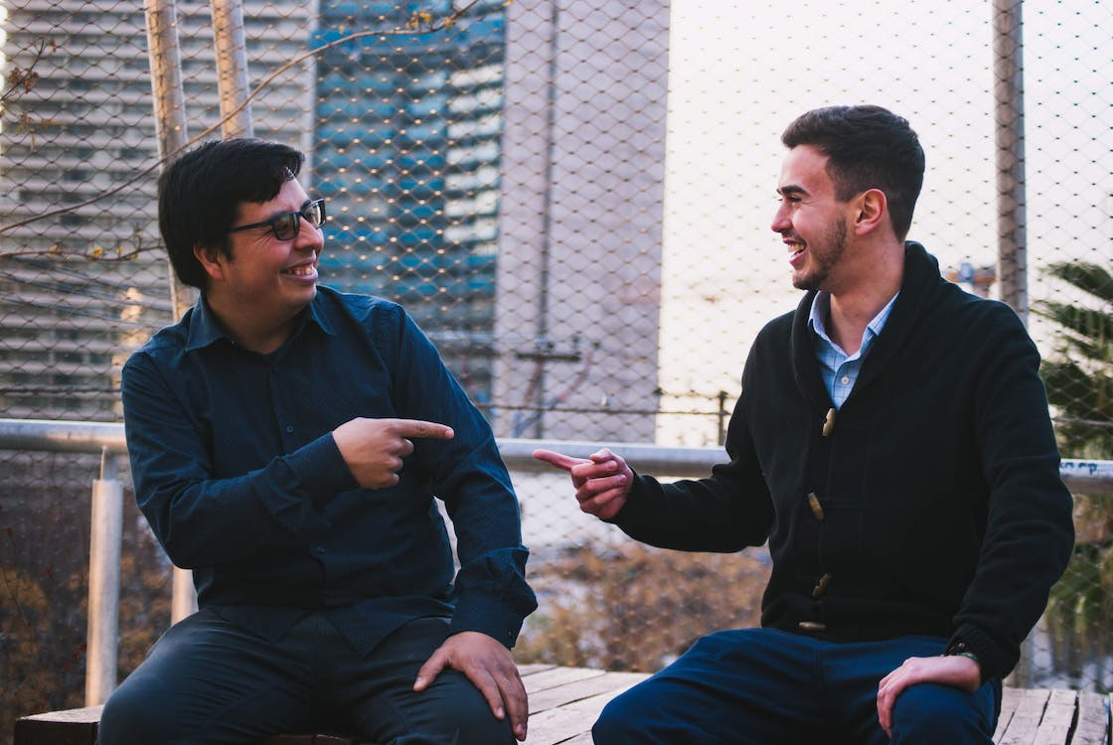 |  | 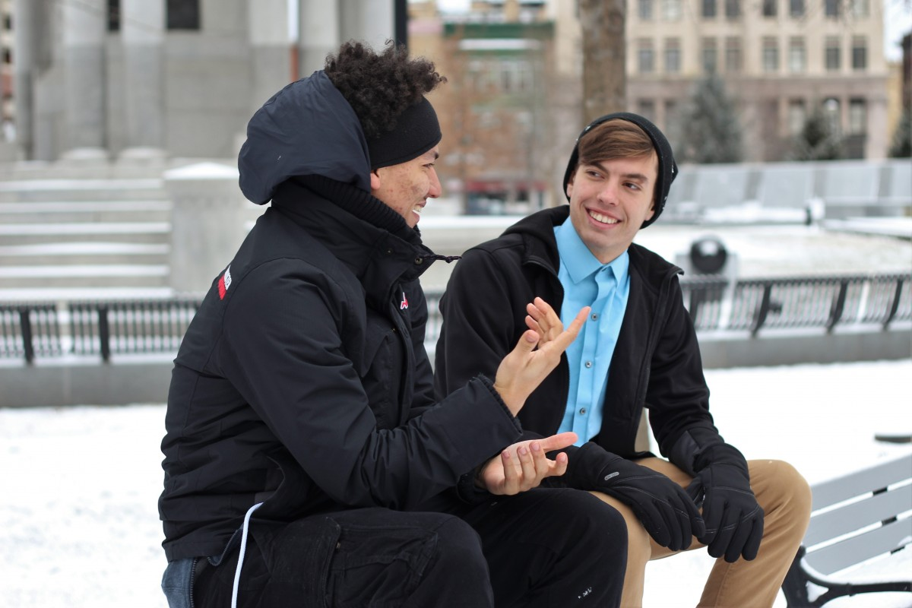 | 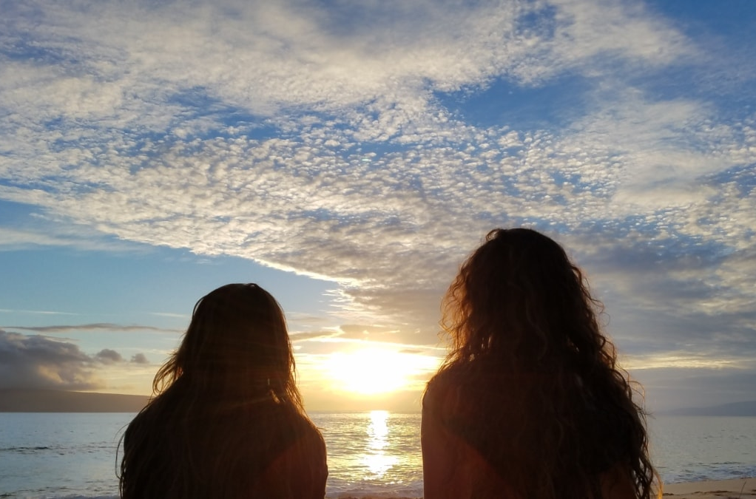

You have a free weekend and you want to go to the city and have a nice/fun time with your friend.
Step 1 | Ask your friend what he/she usually does for the weekend
Step 2 | Invite your friend to do something
Step 3 | You both have different interests (what to do and where to go)
Step 4 | Find an event online that suits both of your interests
Step 5 | Since you cannot agree on where to go, find another event
Step 6 | Say something about the event

 | što: predstava Hamlet  kamo: kazalište  kada: subota; 19:30 | 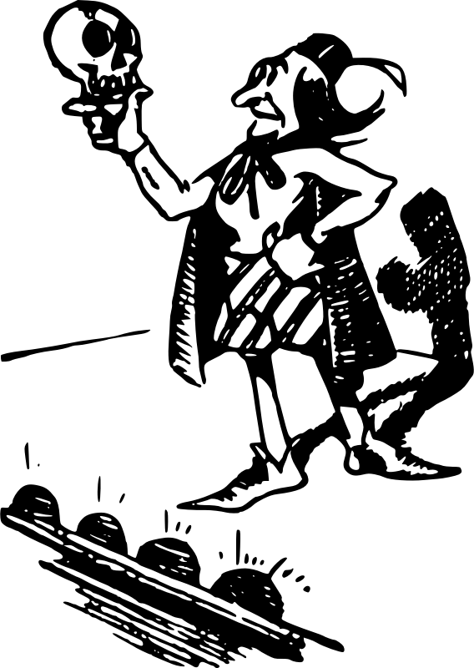
Images used in this document are from these sources.

