7 | 1 | Lekcija 2: Ljetni odmor

7.1 Zadatak 5. S kim na ljetovanje?

Part 1
🔊 In class you learned about Davor and his plans for the summer. Now listen to dialogue two on the website about Mario and his summer plans.
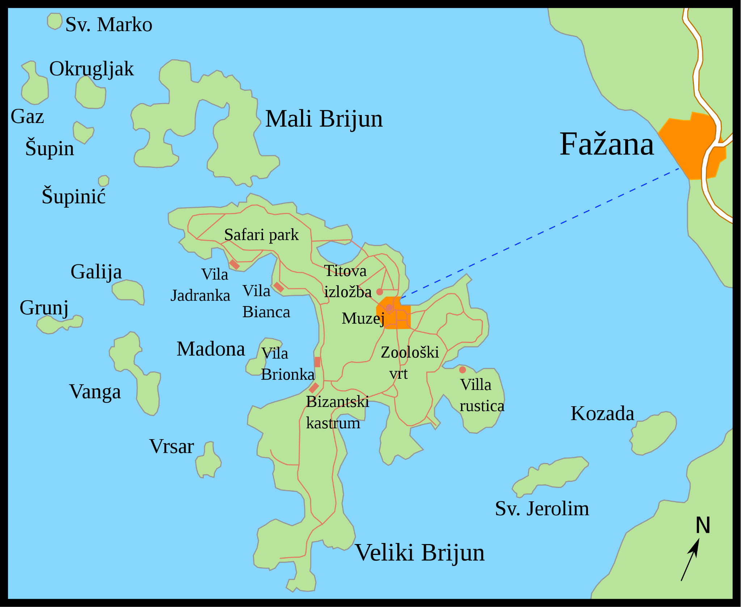 | 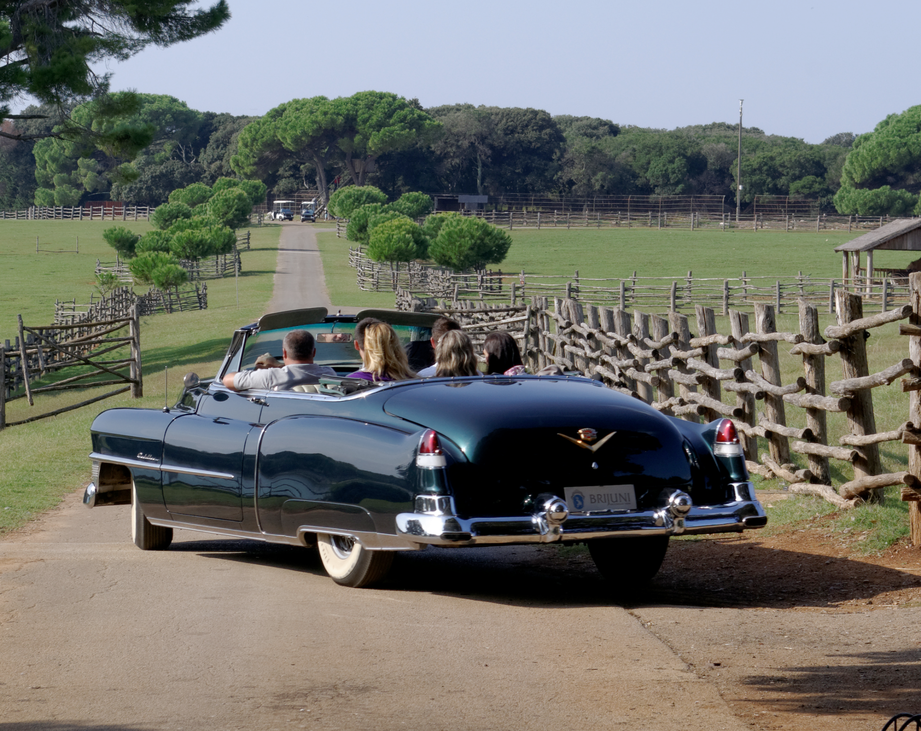

| Razumijevanje
1 | Gdje Mario želi ljetovati? Zašto?
1 | -
2 | Zašto Mario ne želi ljetovati s Davorom?
2 | -
3 | Što Mario želi raditi na ljetovanju?
3 | -
4 | Što Mario ne voli raditi?
4 | -
5 | Tko ide s Marijem na ljetovanje?
5 | -
6 | Tko još može ići s Marijem na ljetovanje?
6 | -
7 | Želi li Mario ljetovati sa Slavkom i Dorom? Zašto?
7 | -

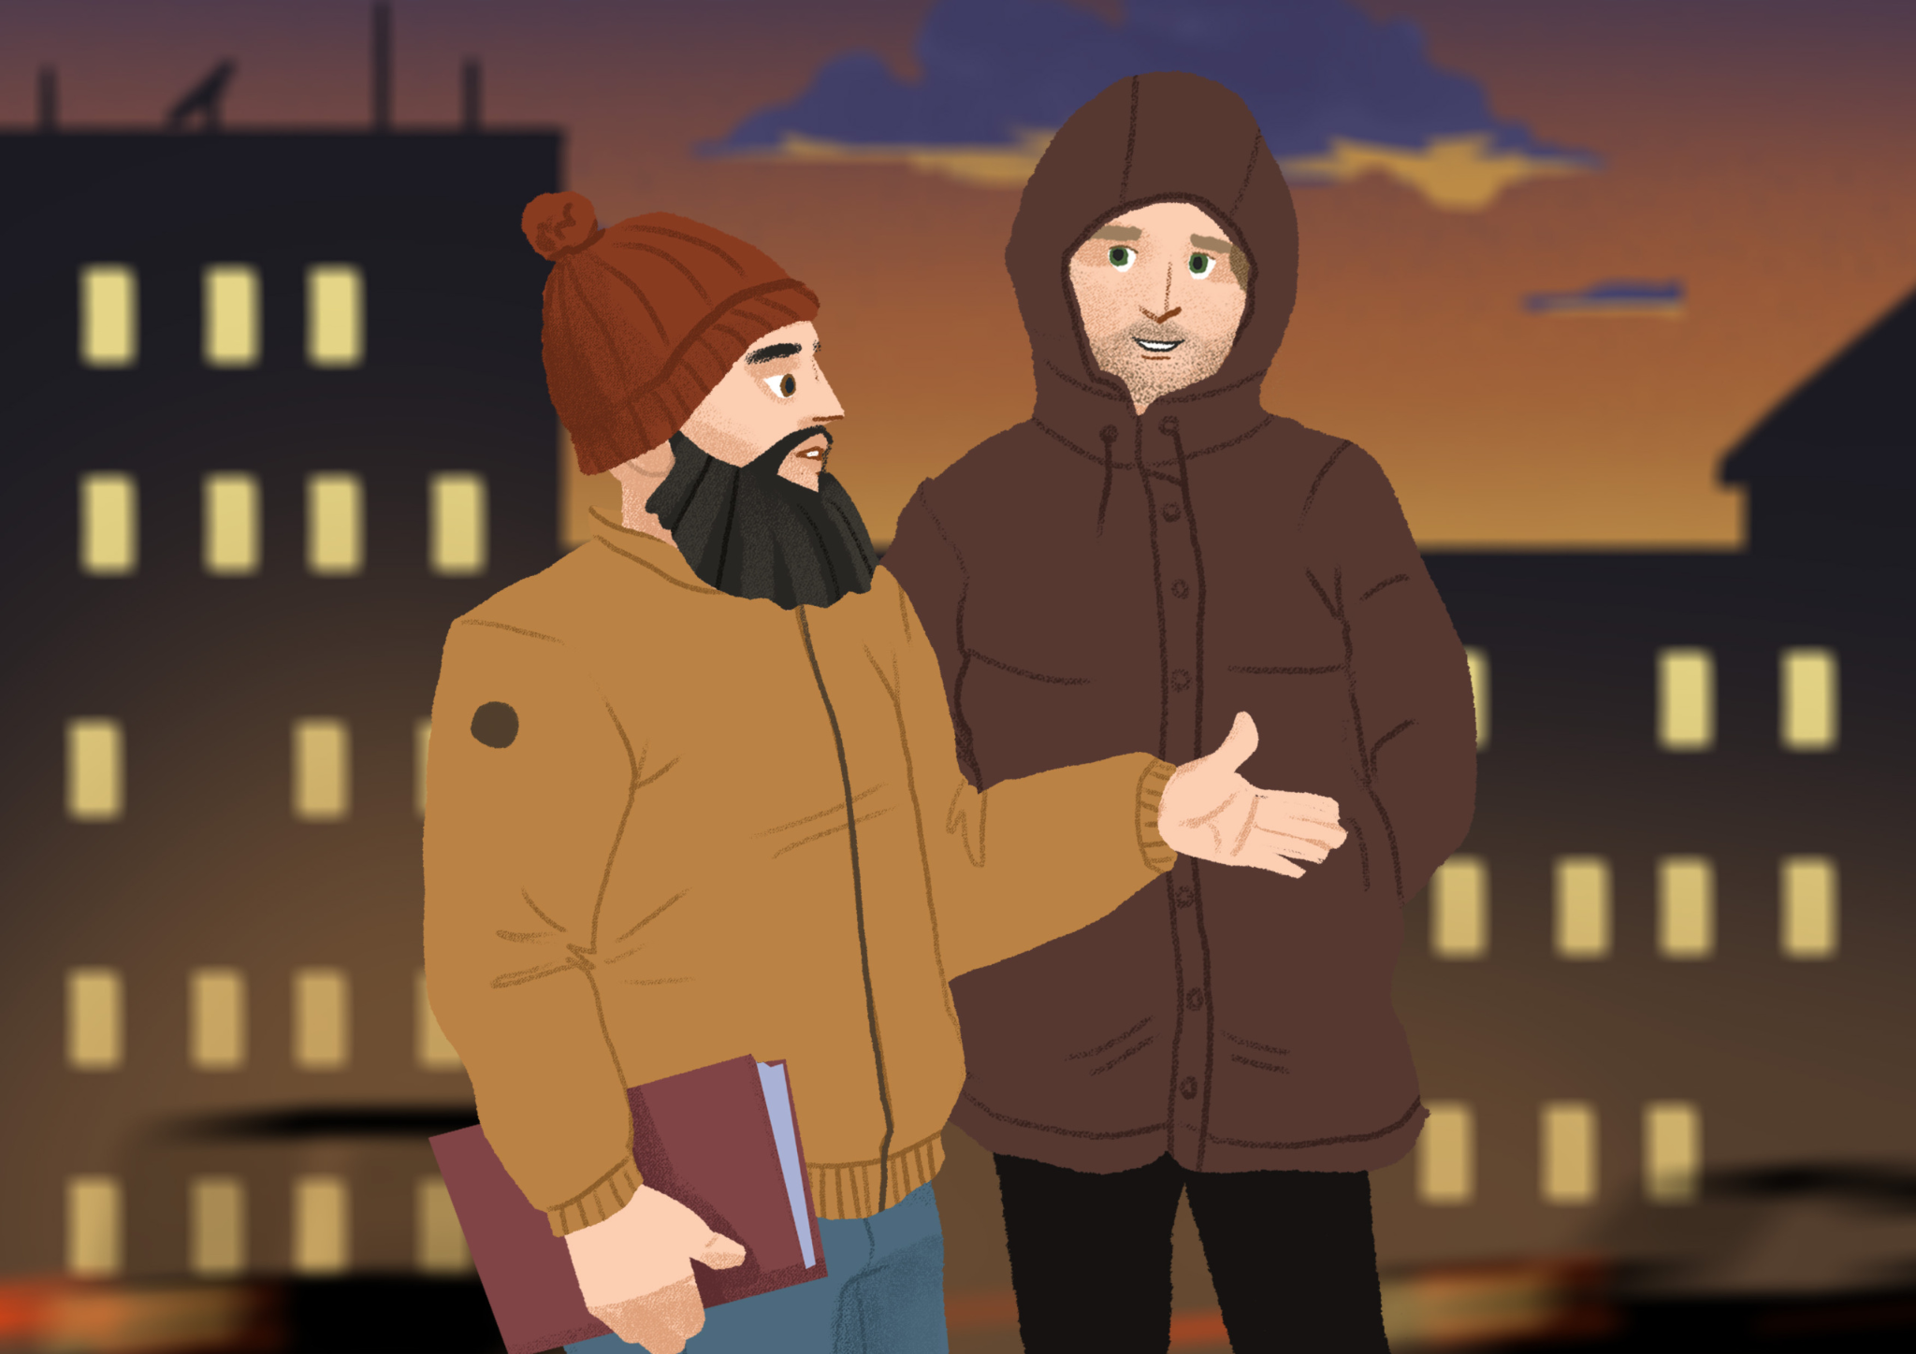 | In his conversation with Davor, Mario said: Želim ugodno i zabavno ljeto. Želim se odmarati, jesti dobru hranu i sunčati se. Jedva čekam probati lokalne specijalitete. Ti znaš da ne volim klubove, više volim opuštenu večer i dobru večeru u restoranu. Također, ne želim biti samo u jednom gradu. Želim vidjeti i gradove i mala mjesta.…

Part 2
Read about the following members of Mario’s family and friends. Decide who might be good company for him to travel with. You can pick more than one person. This is your opinion. Think of what you would suggest to Mario. After you mark da/ne for each person, answer the question below in which you will justify your choices. Be sure to say why you picked these certain people.

1 | S prijateljem Ivanom | da | ne
 | (audio)  On ne voli more, više voli snijeg i skijanje. On voli prirodu i voli planinariti. No, on uvijek planinari rano ujutro i treba društvo. On ide planinariti već oko 5:00 ujutro. Zanima ga lokalna, tradicionalna hrana. Uvijek zna kamo ići jesti dobru hranu. On je jako energičan i zanimljiv.
2 | Sa sestričnom Irenom | da | ne
 | (audio)  Sa sestričnom je ponekad zanimljivo, a ponekad dosadno. Uvijek nosi brošure, mobitel i laptop na plažu. Uvijek šalje poruke, radi selfije, šalje snapchat… To je ponekad dosadno. Ne priča puno i stalno je na mobitelu. No, ona uvijek nađe zanimljiva mjesta i na kraju putovanja uvijek ima odlične fotografije.
3 | S prijateljicama Jasnom i Katarinom | da | ne
 | (audio)  One su dobre, vrijedne i pristojne. Vole isplanirati svaku minutu. Sve mora biti po planu i programu. Vole plivati, sunčati se i odmarati. Također vole prirodu, ali vole izlaziti u barove i klubove cijelu noć.
4 | S bratićem Draganom | da | ne
 | (audio)  On je dobra i draga osoba. Dragan je tih i pristojan, ali uvijek je spreman za akciju. S Draganom je uvijek zanimljivo. Voli ići na more, plivati i sunčati se. Ne voli gradove, uvijek želi putovati u manja mjesta i sviđa mu se ekoturizam. Voli dobru hranu.
5 | S prijateljicom Lidijom | da | ne
 | (audio)  Želi plivati, kupati se, sunčati se, ići na izlet, a navečer ići u klubove. Ona planira aktivno ljetno putovanje. Ne želi biti u hotelskoj sobi i samo jesti i odmarati. Želi uživati u prirodi, veseliti se, izlaziti i upoznati nove ljude.

| Pitanje
S kim Mario može ljetovati? Zašto?
→

You encountered the following two phrases in the text above. What do those phrases mean? Is there any English equivalent?
 | Rečenice: | Engleski:
1 | Biti privjesak.
2 | Biti spreman za akciju.

Part 3
Now, imagine that you are sending an email to Mario, who is your good friend, and give him advice on who he should invite to go with him. This should be informal writing. Be sure to include the following:

- General introductory greeting.
- Reason why you send the email.
- Give advice on who he can invite to spend summer with him.
- Provide your reasons for each person.
- Finish your email in an appropriate way.
Moj email prijatelju Mariju:
→

7.1 Zadatak 6. Što vidjeti/posjetiti? Kamo ići?
Based on the dialogue between Mario and Davor, help Mario find good locations/activities for the summer, according to his interests. Find at least two places/activities for each of his interests listed below.

Što Mario želi? | Kamo može ići?
odmarati
jesti dobru hranu
sunčati se
vidjeti gradove
vidjeti mala mjesta

7.1 Zadatak 7. S kim putovati?
Write the assignment in a Google Doc and send it to your instructor prior to the next class session.

Part 1
Write a paragraph about where you would like to travel, and what would you like to do there. Mention your interests and things you would like to do.

Part 2
When you are done writing about your travel plans, write a paragraph for each of (at least) 4 different people (or group of people) that you think might be good company. You are not fully sure if any of them is the best choice. Together with a description of what they like on vacation, include at least 4 personality traits for each person. Look at the class document and the first task in this homework for inspiration. It will help you complete the assignment.

7.1 Zadatak 8. Događanja u Hrvatskoj
Look at the following website and find at least two different events that you would like to attend. Be sure to include the following:
 | the name of the event
 | when is it happening – give the exact date; if it is not available, then give at least the month and/or season
 | what do you want to do there, and (4) with whom you would like to go – who is good company

Prvo događanje: | Odgovor:
Na koje događanje želiš ići?
Kada je događanje?
Što tamo želiš raditi?
S kim želiš ići?
Drugo događanje: | Odgovor:
Na koje događanje želiš ići?
Kada je događanje?
Što tamo želiš raditi?
S kim želiš ići?

7.1 Zadatak 9. Hrvati i odmor
Look at the excerpt from the online article about Croatians and their summer vacation habits. Then, answer the questions below.
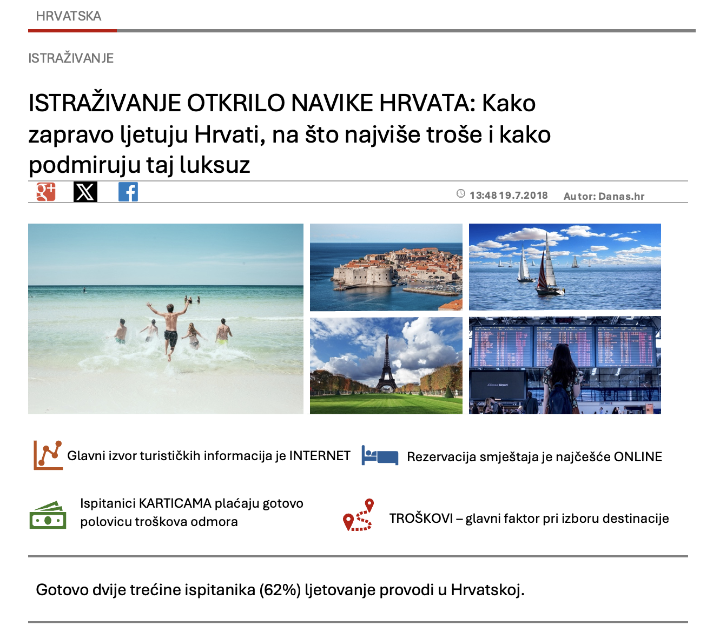
Gdje uglavnom ljetuju Hrvati?
u Europi | u SAD-u | u Hrvatskoj | na Jadranu
Kako hrvati plaćaju odmor?
gotovinom | karticom | čekom | bodovima
Kako Hrvati rezerviraju smještaj?
u agenciji | na internetu | na telefon | e-mailom
Gdje Hrvati traže informacije o destinacijama?
surfaju po  internetu | na turističkim sajmovima | u prospektima i/ili brošurama | razgovaraju s prijateljima

Moje mišljenje…
Answer the following question in English. Additionally, provide at least 2 or 3 sentences in Croatian. The Croatian sentences should express your main idea/thought.
| Question
Can you compare the US and Croatia in terms of planning/spending summer vacations? How similar is the situation?
→

Images used in this document are from these sources.

