10 | 1 | Lekcija 4: Rezervacija smještaja

| Turizam i putovanje
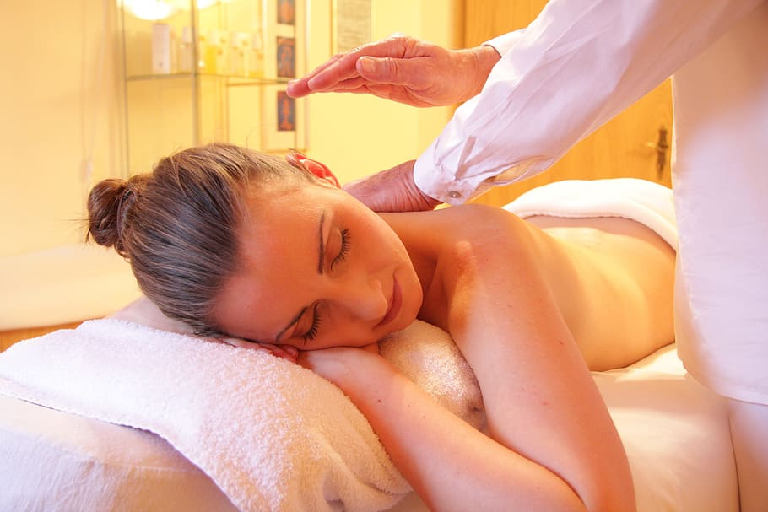 | 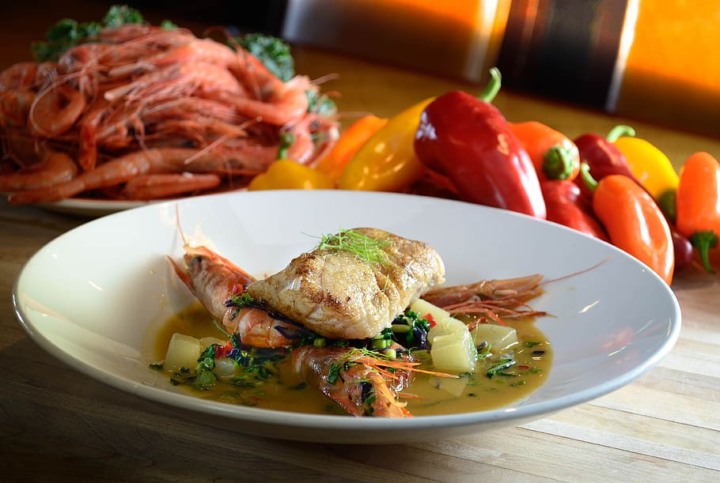 | 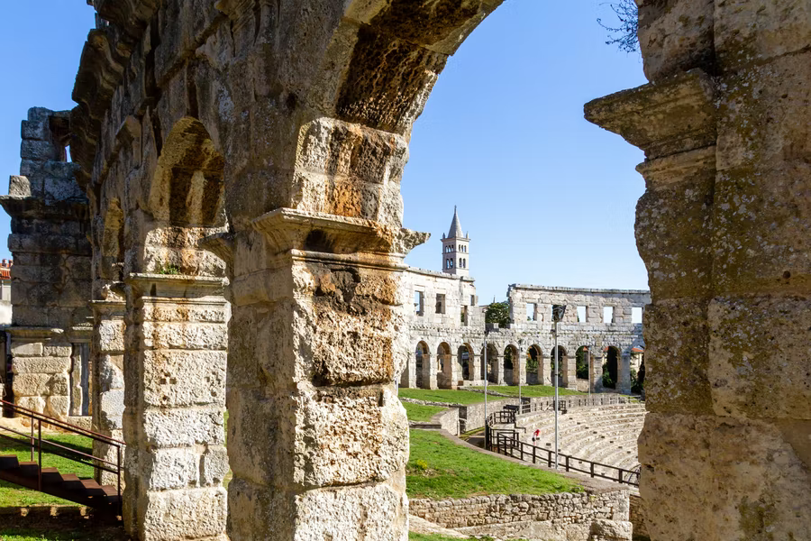 | 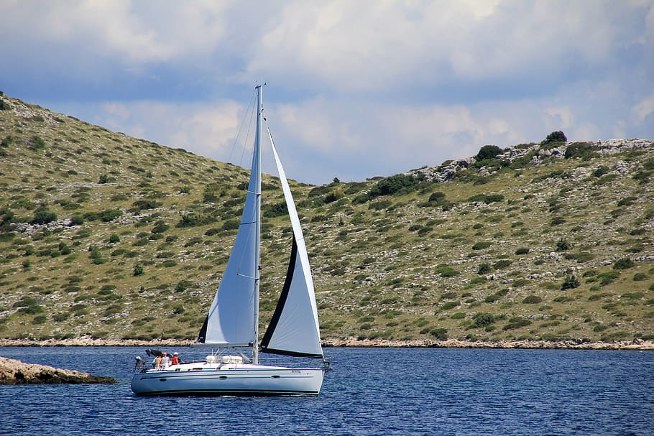
wellness turizam | gastronomski turizam | kulturni turizam | nautički turizam
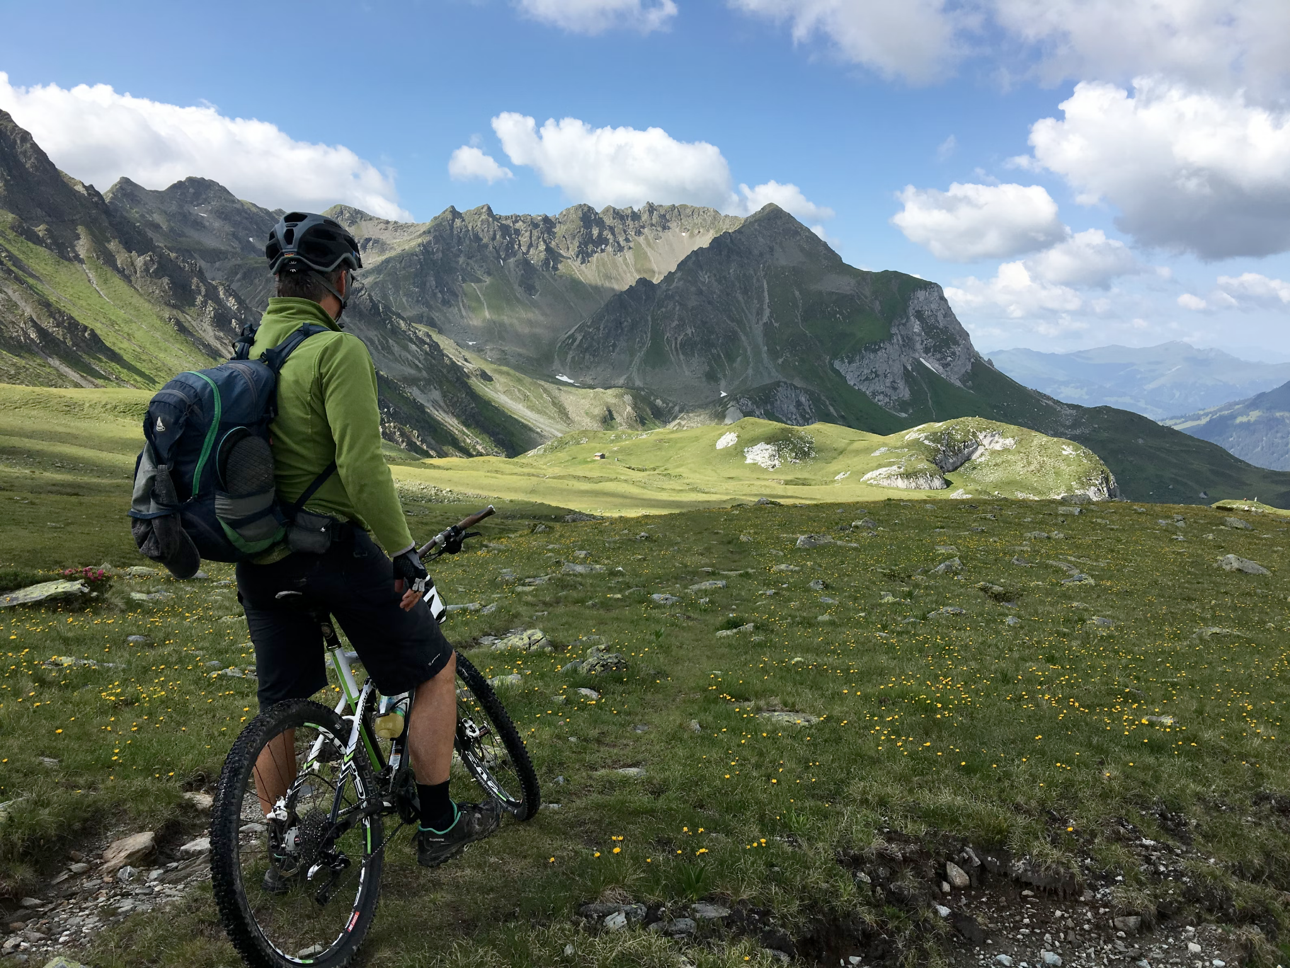 | 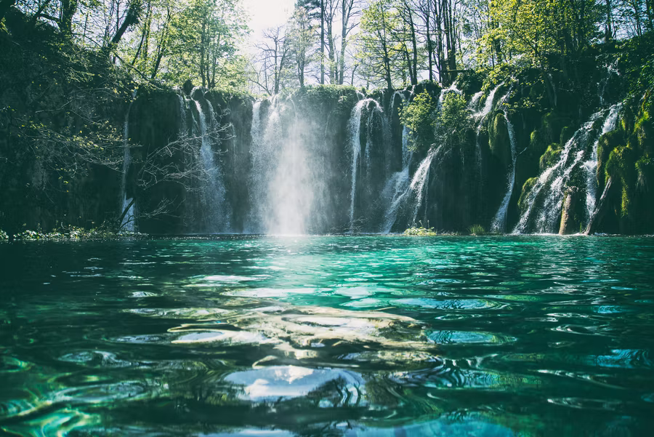 | 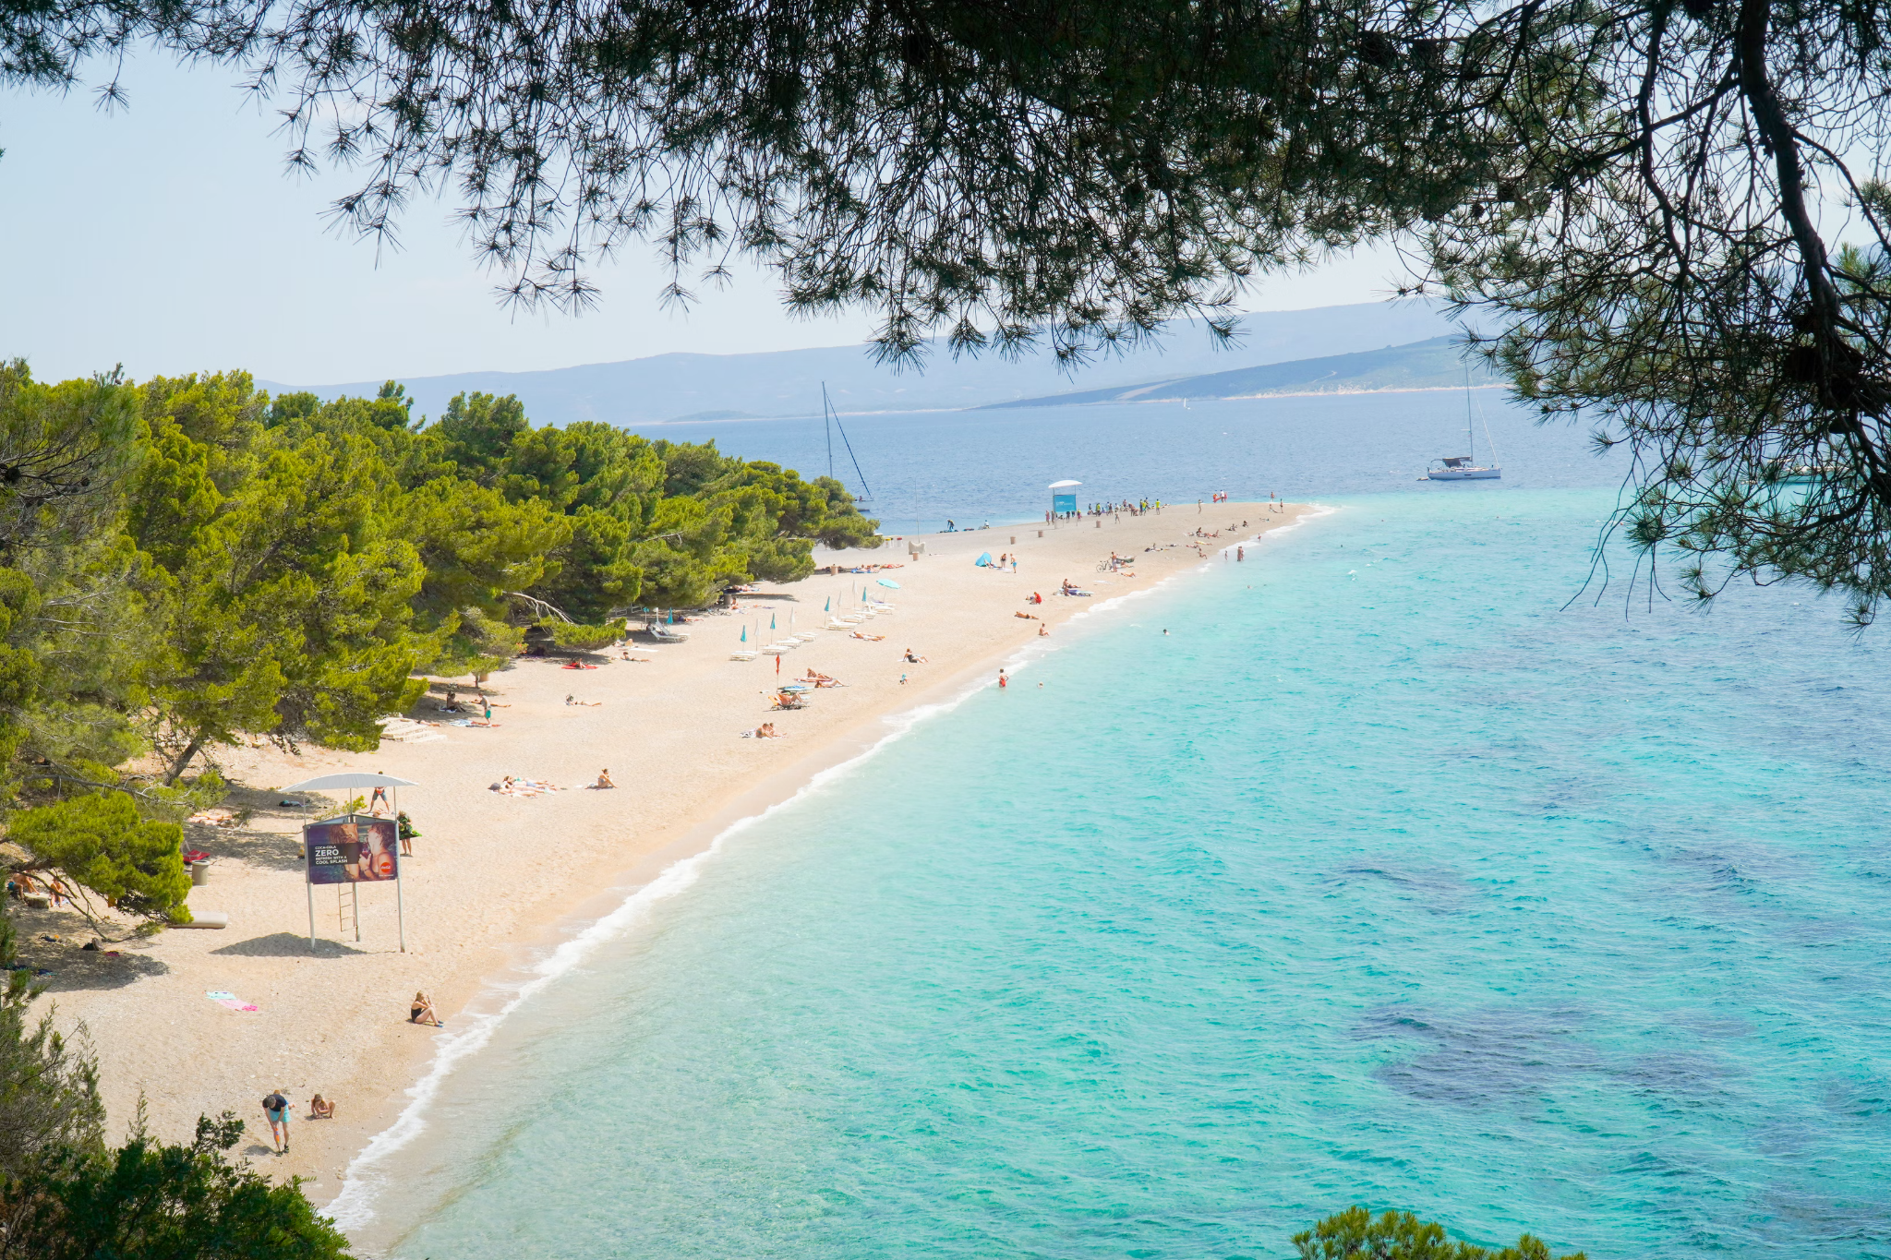 | 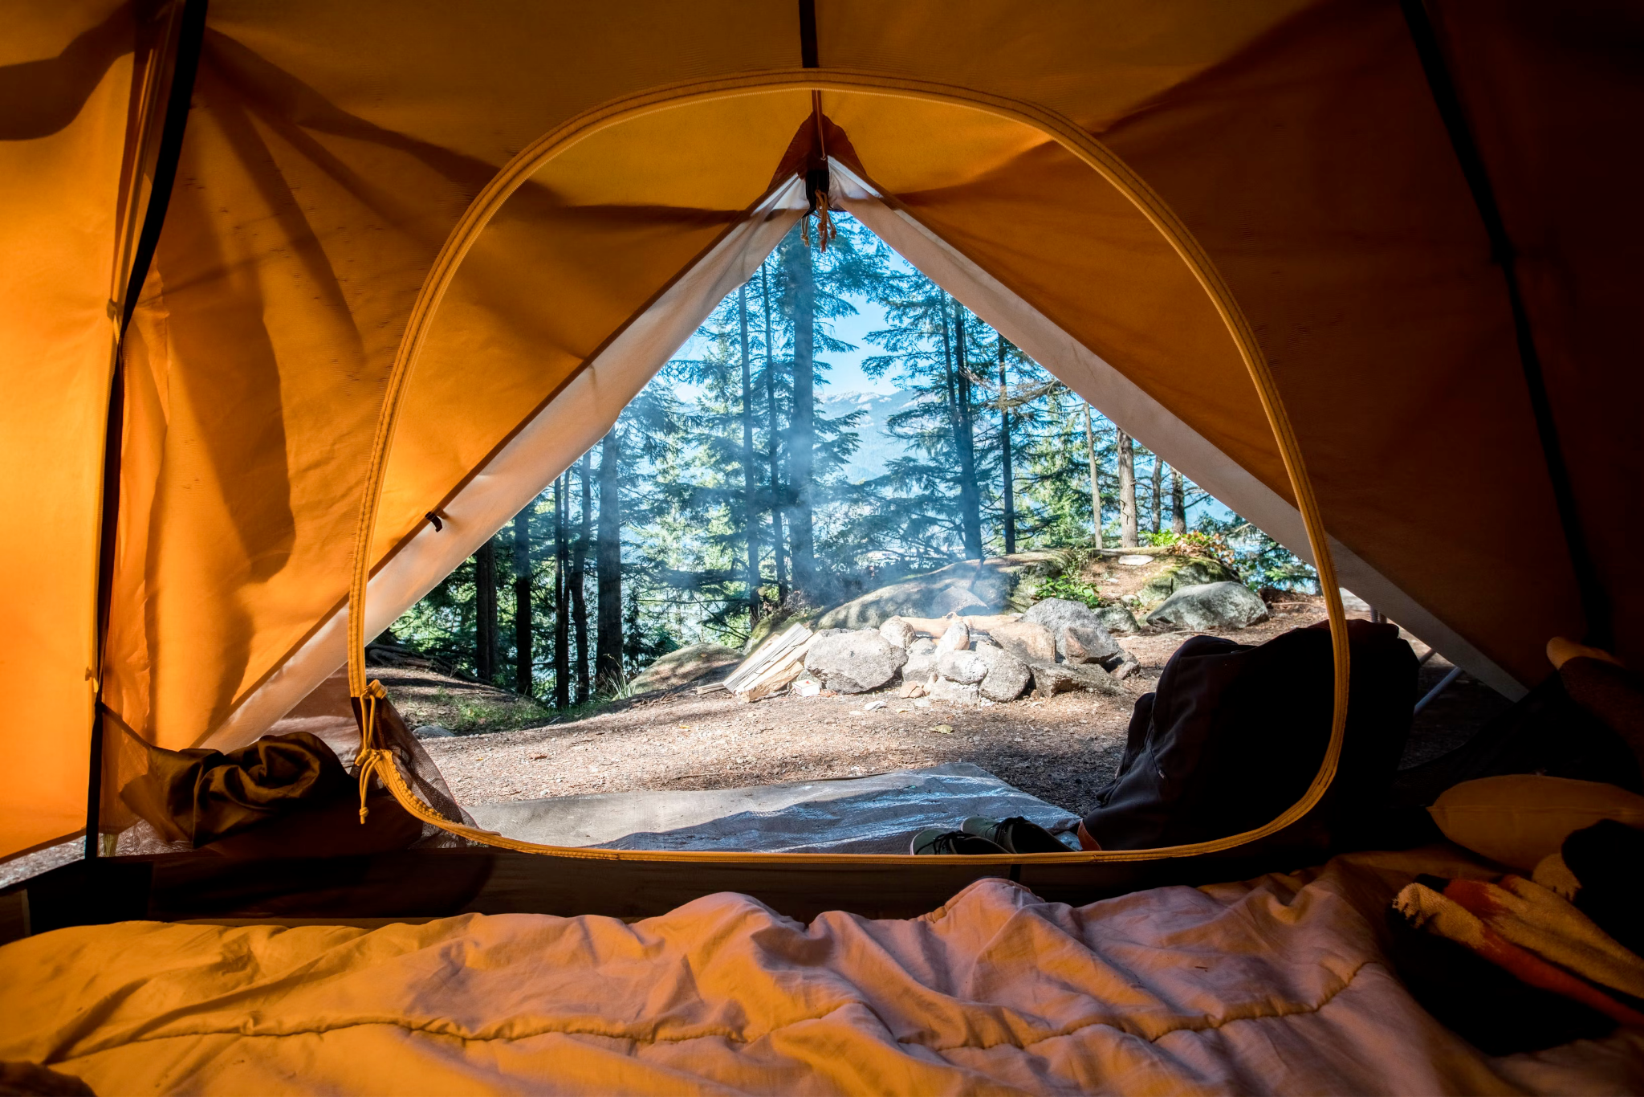
aktivni odmor | prirodni turizam | ljetni turizam | kampiranje

Here is some vocabulary that can be useful when talking about traveling and taking part in activities at your destination.
[h5p id="859"]

Now that you have practiced your vocabulary in the previous task, look at the pictures again and complete the sentences. This time, you will need to use the nouns in the appropriate case form. Verbs might be in their infinitive form or in a specific conjugated or past form. Read the sentences carefully.
[h5p id="860"]

10.1 Zadatak 3. Odmor
[h5p id="521"]

Images used in this document are from these sources.

