9 | 2 | Lekcija 2: Životopis

| Curriculum Vitae
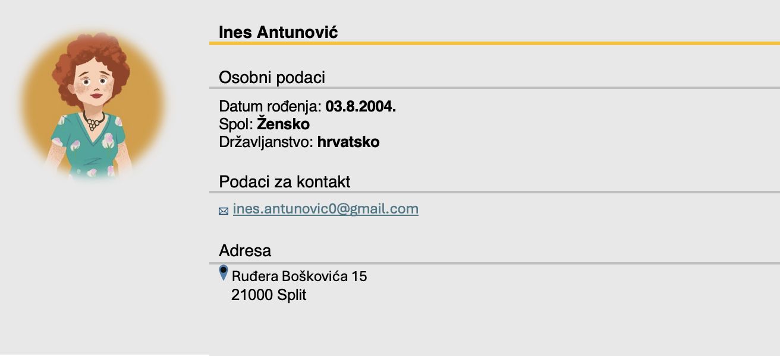
Osobni podaci
ime i prezime | datum rođenja | spol
državljanstvo | kućna adresa | e-mail adresa
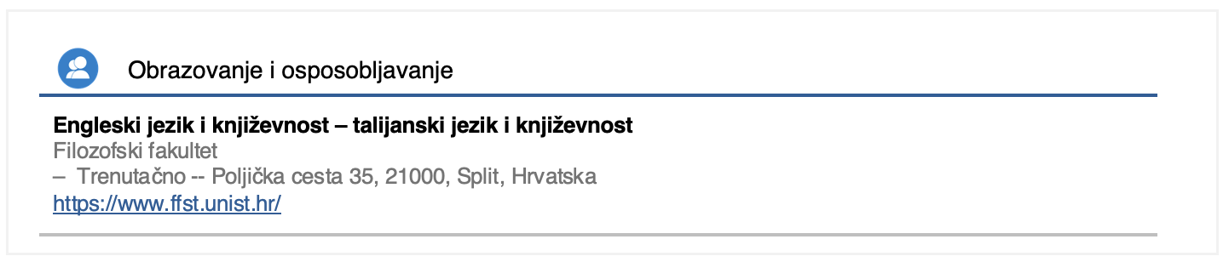
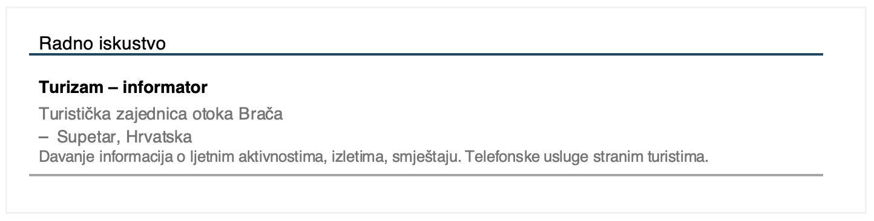
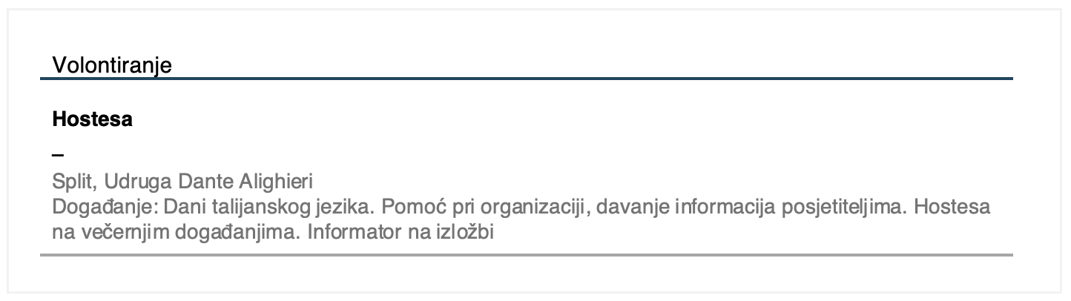

9.2 Zadatak 1. CV
Complete the sentences below paying careful attention to context and to what you have learned about writing your CV.
[h5p id="869"]

| (New) Verbs
Below are some useful verbs that we encountered in today’s lesson. All verbs are regular in their present and past tense forms, except the verb naći.
ponositi se  to be proud of | primiti  to receive | podnositi  to endure | ponašati se  to behave
prijaviti se  to apply | naći  to find | izgledati  to look like | motivirati  to motivate
[h5p id="503"]

| Vocabulary For the Interview
Here is some useful vocabulary when you want to talk about your work experience and personality traits so that you can prepare yourself for a job interview. Be careful, all words are in their dictionary form. When using adjectives, remember that they can be in all three genders and in singular and plural forms.
Adjectives (pridjevi)
strpljiv | slobodan | ponosan | odgovoran | koristan
Nouns (imenice)
stres | natječaj | poraz | kandidat | životopis
diploma | kritika | motivacija | organizacija | komunikacija
sposobnost | vještina | prijava | osobina | iskustvo

9.2 Zadatak 2. Intervju - reci o sebi
Practice your new vocabulary.
[h5p id="870"]

Images used in this document are from these sources.

