4.1 - Roční období - Seasons

V České republice jsou čtyři roční období.
In the Czech Republic there are four seasons.

This may seem like a somewhat trite statement, but Czechs will often talk about their weather in this way. It actually makes a lot of sense in comparison with other places (such as Texas! where it’s either hot or not hot)

Here are the four seasons in Czech. Listed with each season is how you say in the ________ (spring, summer, fall, winter). Note - these forms are somewhat irregular, so best just to memorize them.

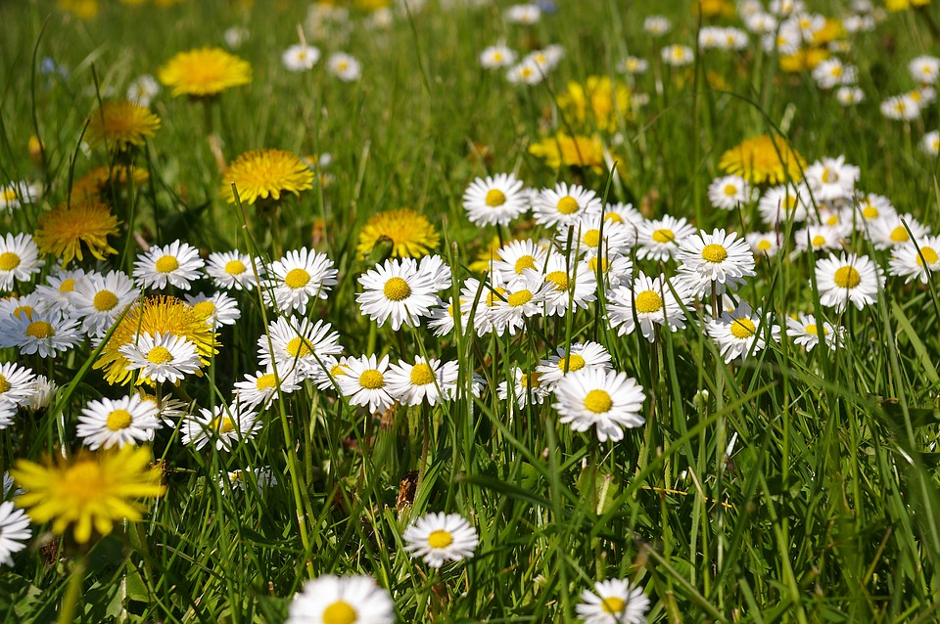 | jaro - spring  na jaře - in the spring
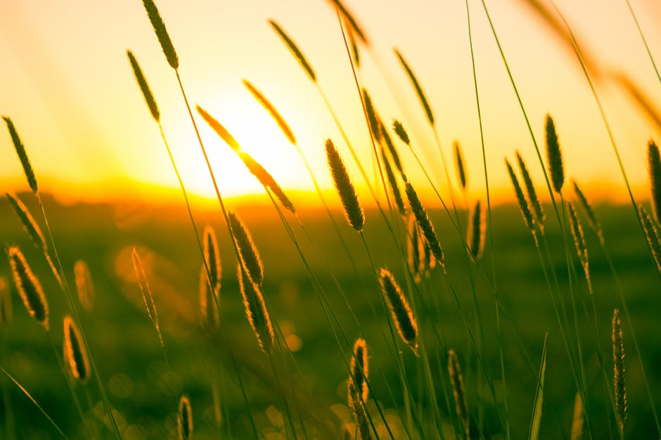 | léto - summer  v létě - in the summer
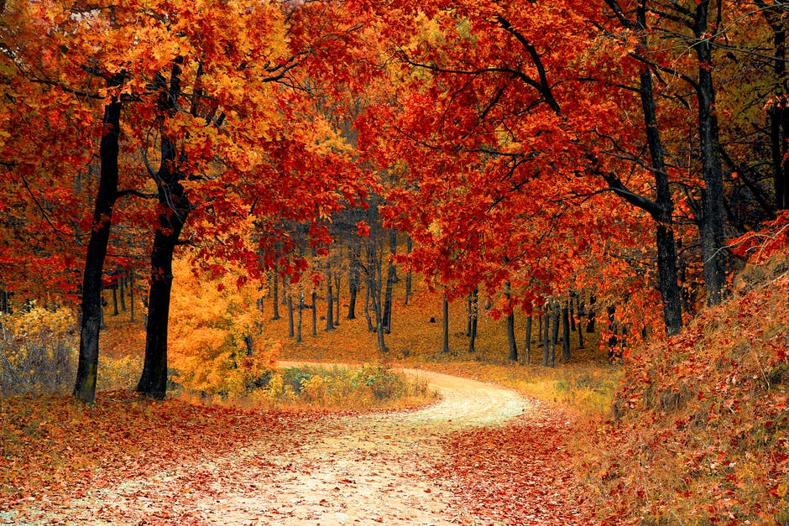 | podzim - fall/autumn  na podzim - in the fall/autumn
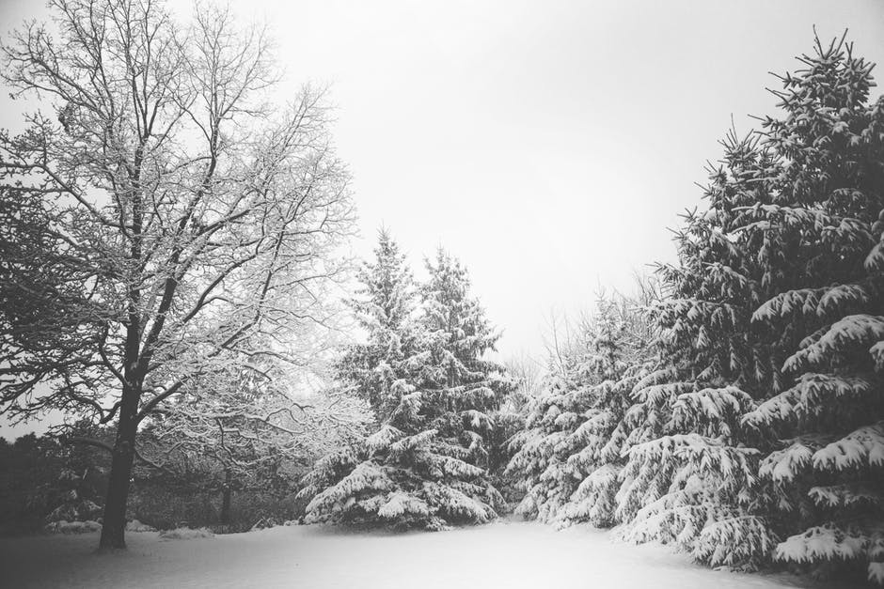 | zima - winter  v zimě - in the winter

Oh, and one final note…



Though interestingly enough, the name is related(!).

Images used in this document come from these sources.

