9.4 - Birth and Death

 | 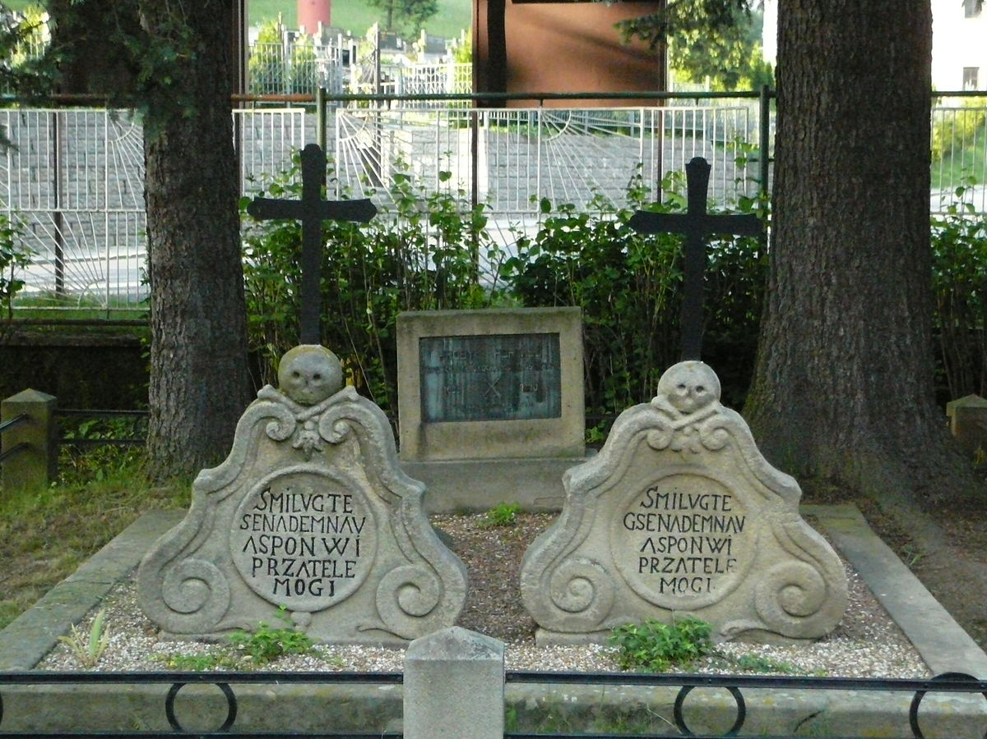

So we’re going to talk about when people were born and when applicable, when they died. We’re going to do this primarily in connection with dates.

First, we need the verbs for these actions:

imperfective | perfective
rodit se | narodit se | ‘to be born’
umírat | umřít | ‘to die’

To start, you can learn the imperfectives passively at this point. Why?

Well, if we recall, the imperfective is used typically for focusing on the activity. We rarely talk about birth as an activity itself, i.e. while he was being born, he is being born now, etc. It’s not impossible, as we can all probably imagine that situation. However, it won’t be of tantamount importance to us now.

With death, it may be a little more common to talk about when someone was dying, or to describe someone as being in the process of dying. All the same, we won’t be practicing that now.

Instead, we’re going to focus on the completed act so we can say when someone was born and when they died. The past tense of narodit se is regularly (i.e. narodil se). The past tense of umřít is umřel. Let’s see a some examples:

Václav Havel se narodil v roce 1936 a umřel v roce 2011. | 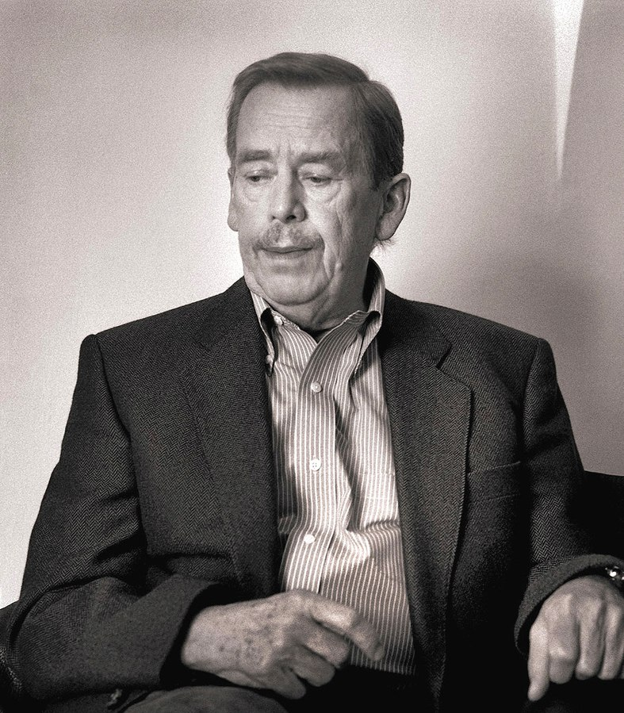
Eliška Junková se narodila v roce 1900 a umřela v roce 1994. | 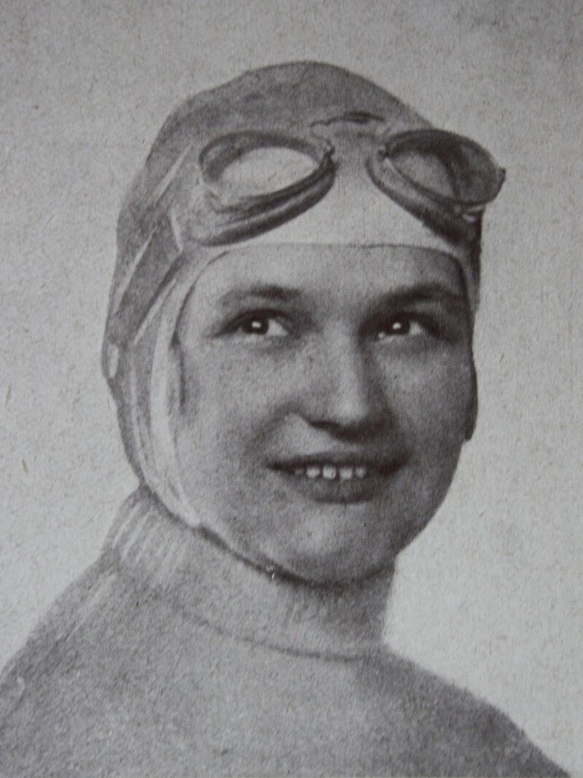

Images used in this document come from these sources.

