2.7 - Accusative Singular forms of Adjectives

It probably goes without saying that we’re going to want to describe things and people that we have in our lives (e.g. I have an old uncle, Jan has a younger sister, she has a big dog). For this we’re going to need accusative forms of adjectives in the singular and plural. Here are the endings:

Accusative Singular Endings

 | Masculine Animate | Masculine Inanimate | Feminine | Neuter
Hard stem Adjective | -ého  velkého | -ý  velký | -ou  velkou | -é  velké
Soft stem Adjective | -ího  mladšího | -í  mladší | -í  mladší | -í  mladší

Whenever you need to modify (combine) an adjective with a noun that is the direct object of a verb like mít ‘to have’, then you need to put the adjective in the accusative as well, e.g. -

  Iveta má velkého psa.  Iveta has a big dog. | 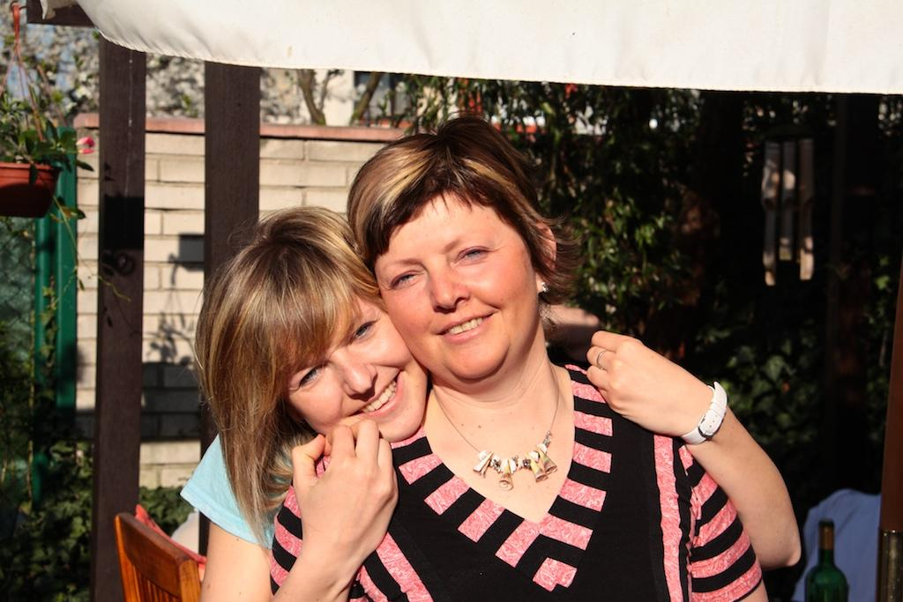  Ona má zajímavou tetu.  She has an interesting aunt.
  Mám mladšího bratra.  I have a younger brother. |   Pavel má mladší sestru.  Pavel has a younger sister.

Images used in this document come from these sources.

