4.7 - Describing Clothes - Colors

We’ve already gotten practice using our basic color adjectives in describing clothes –

červená | modrá | zelená | žlutá | bílá | béžová

černá | oranžová | fialová | šedá | hnědá | růžová

Now let’s dig a little deeper and learn some more ways of talking about colors.

Combining color adjectives
We might want to talk about something being light green or dark blue. To do this, combine them with the words světle ‘light’ and tmavě ‘dark’ (you remember these from beer, right?).

tmavě modrá | světle modrá | tmavě zelená | světle zelená | tmavě oranžová

You can also combine colors together:
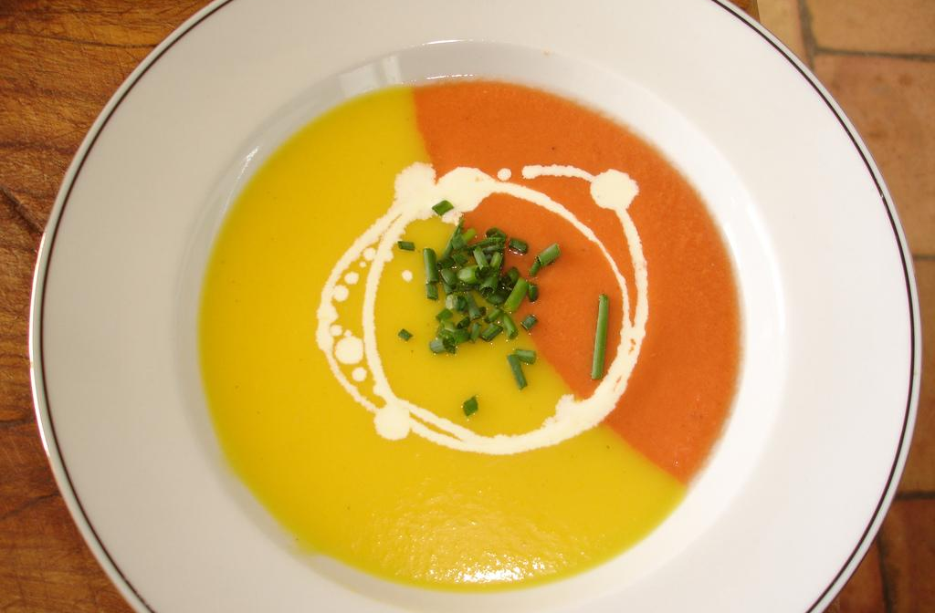  žluto-oranžová polévka  yellow and orange soup | 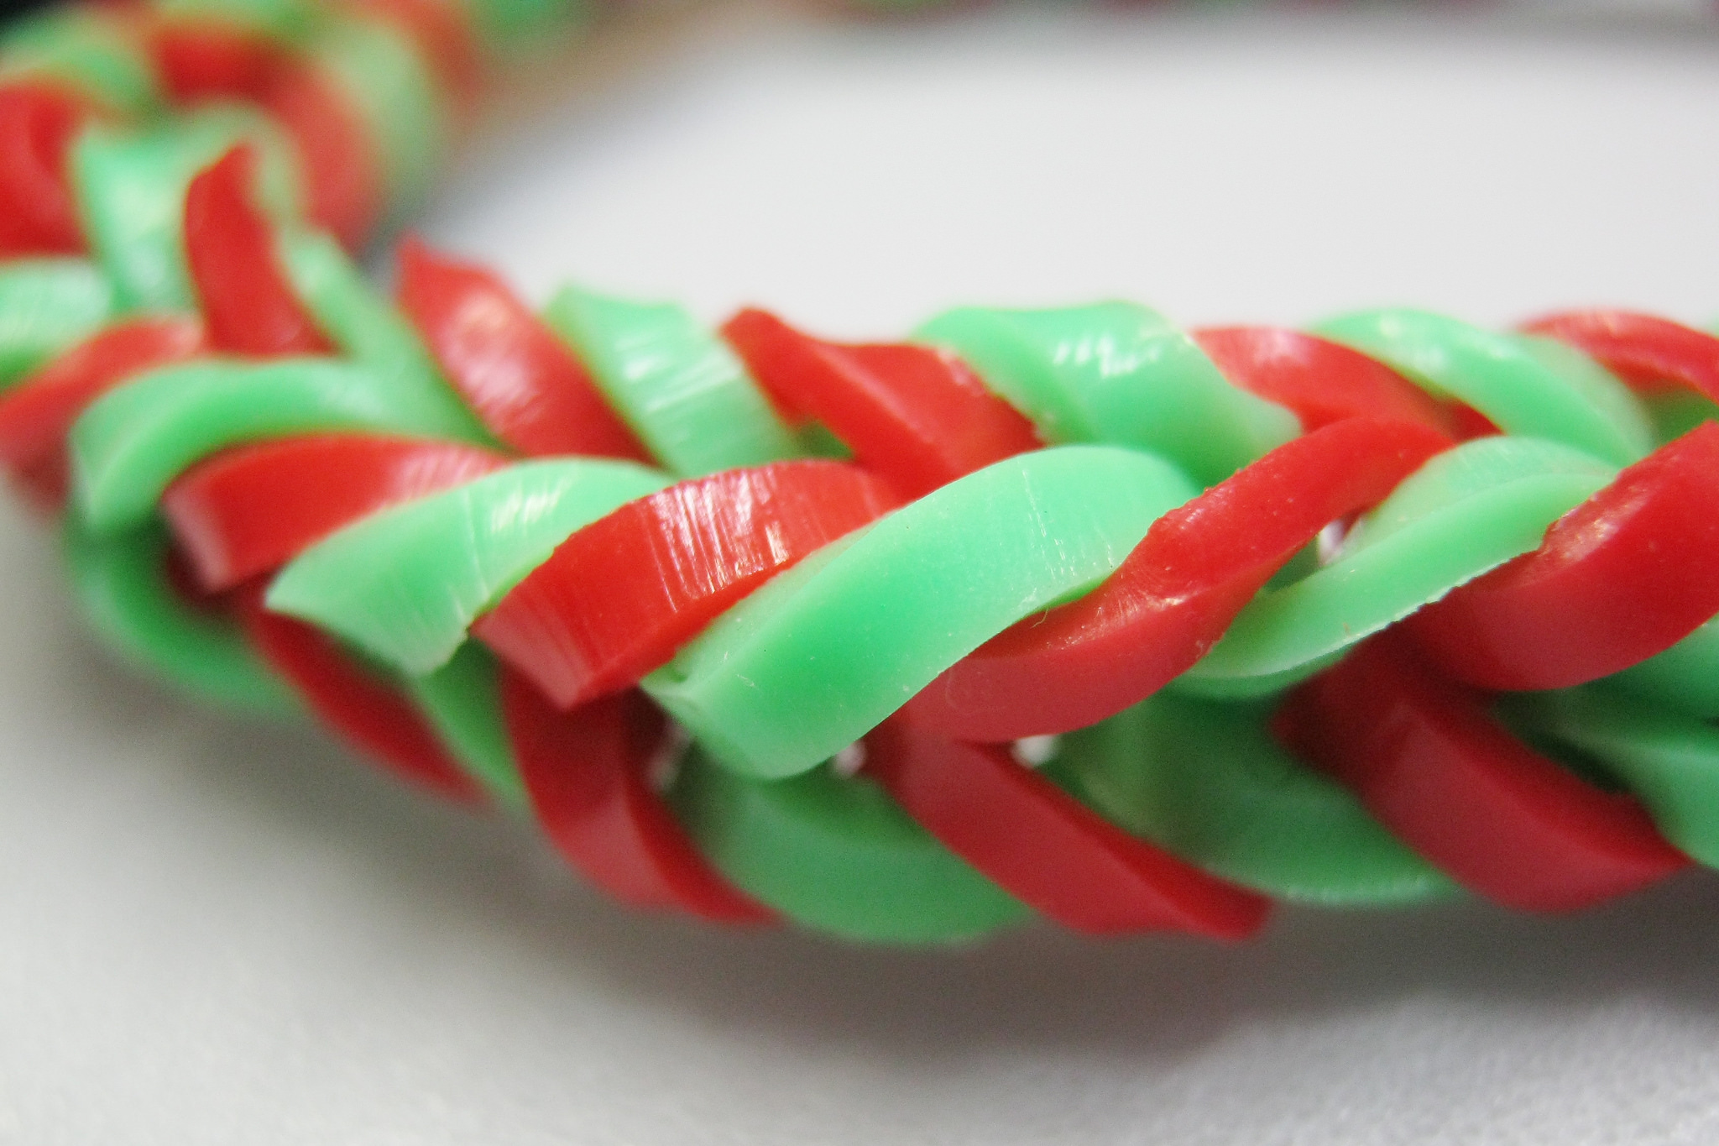  zeleno-červený náramek  green and red bracelet | 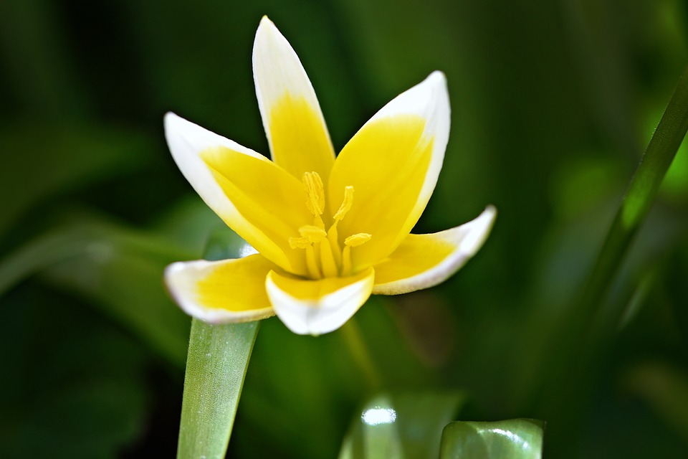  žluto-bílý květ  yellow and white flower

Now, these are really only if you want to get super specific with your colors. Most of the time you’ll be fine with the basic. But sometimes you just have that need…

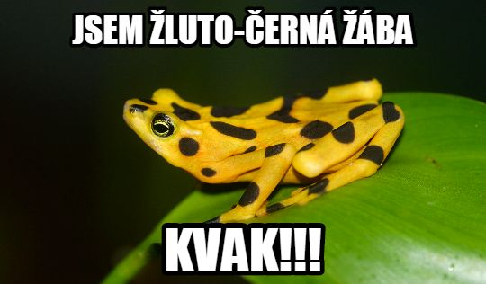

Images used in this document come from these sources.

Often these are hyphenated, though sometimes also written together, i.e. žlutooranžová, zelenočervená

