6.2 - O víkendu…během týdne...

Of great importance is knowing a very old Czech word víkend ‘weekend’...ok, so maybe not so old and clearly a borrowing from English. This of course is better for us, since it’s easier to memorize it this way. There’s still one thing we need to learn, which is how to say over the weekend – o víkendu (o + LOC). So now you can talk about things you do over the weekend.
Víkend in Czech is contrasted with všední/pracovní den - “week day’ (lit. ordinary day). Additionally, we need to learn the phrase během týdne ‘during the week’, so we can talk about things we do during the week.

  O víkendu Markéta často odpočívá. |   O víkendu skoro vždycky chodíme do hospody na pivo. | 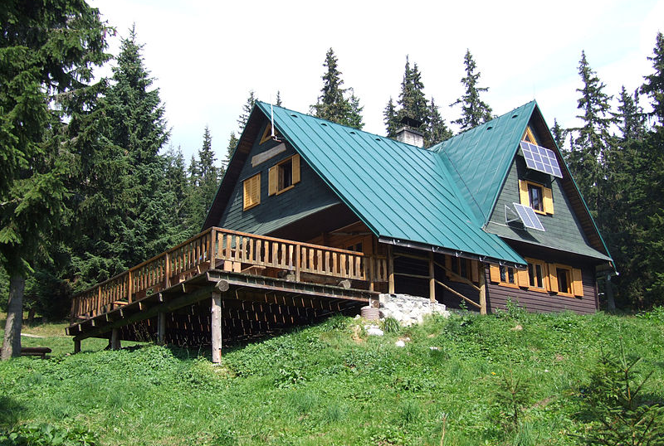  Během týdne v létě obvykle jezdíme na chatu.

Images used in this document come from these sources.

