1 | 2 | Lekcija 2: Osobine

1.2 Zadatak 4. Tko su oni?
Earlier you learned about some famous people who were present on Croatian banknotes before Euro. Let’s review and see if you remember who they are. Mark the correct answer.
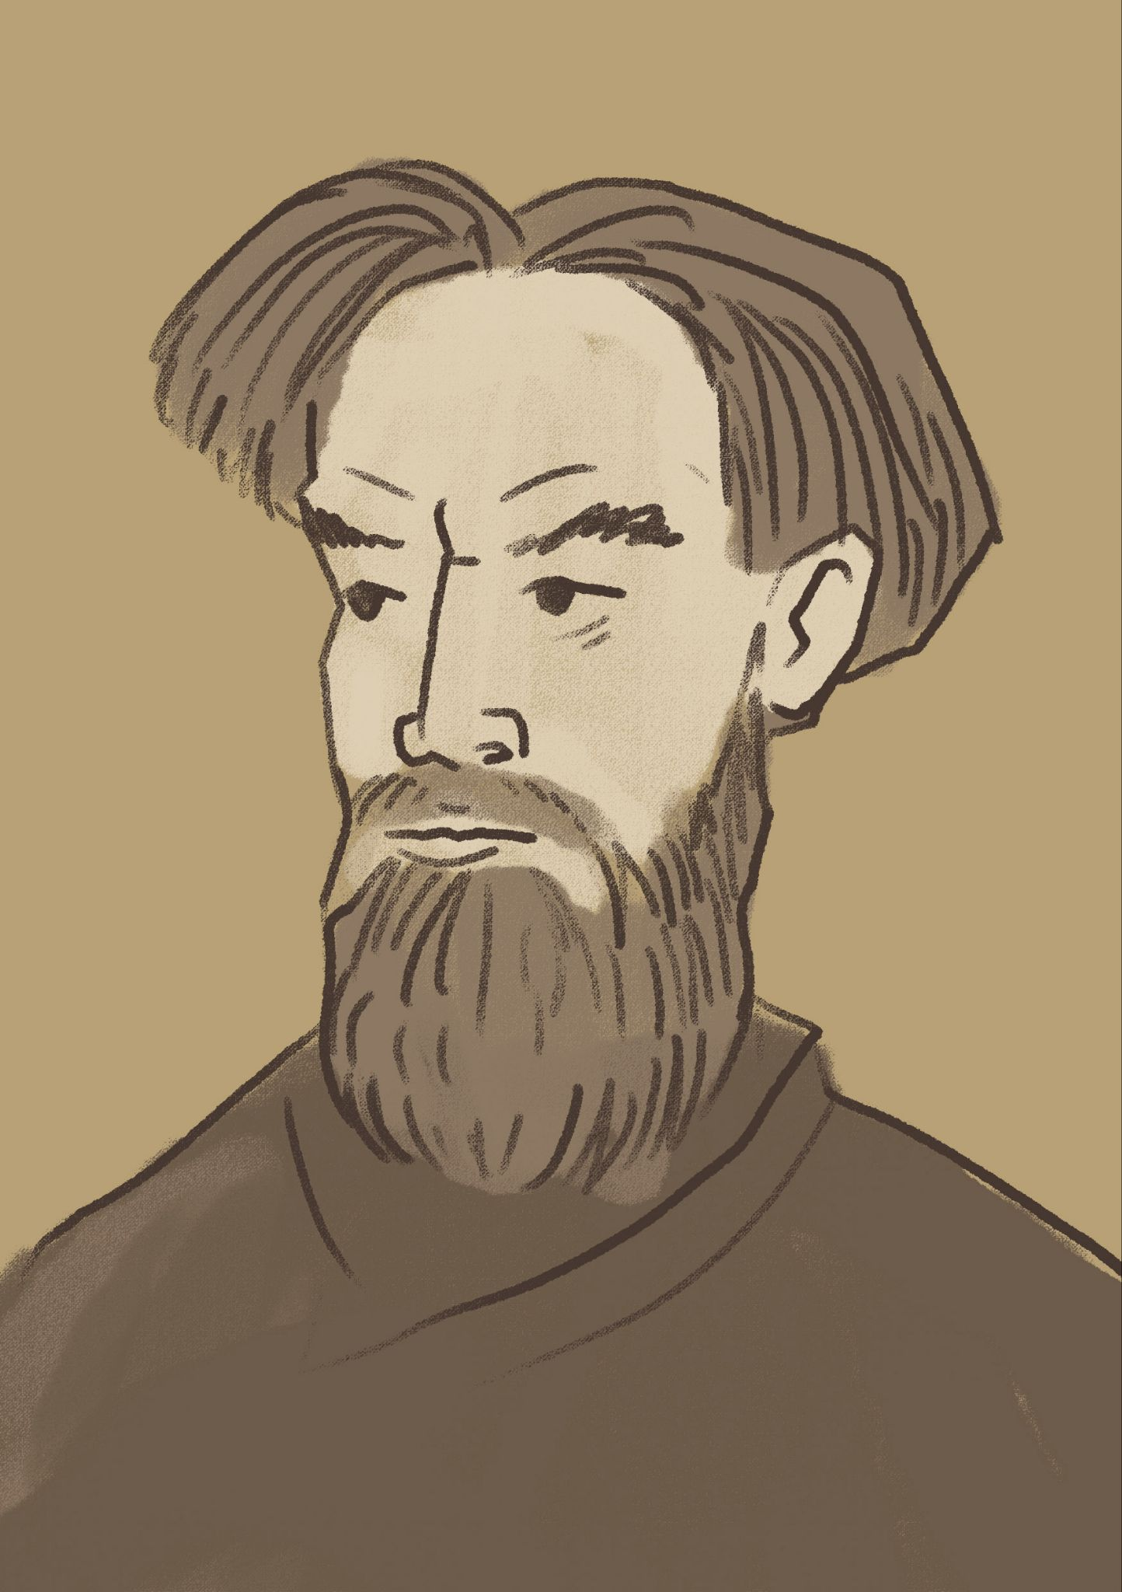 | Je li Marko Marulić političar?
 | a | Da, on je političar.
 | b | Ne, on nije političar.
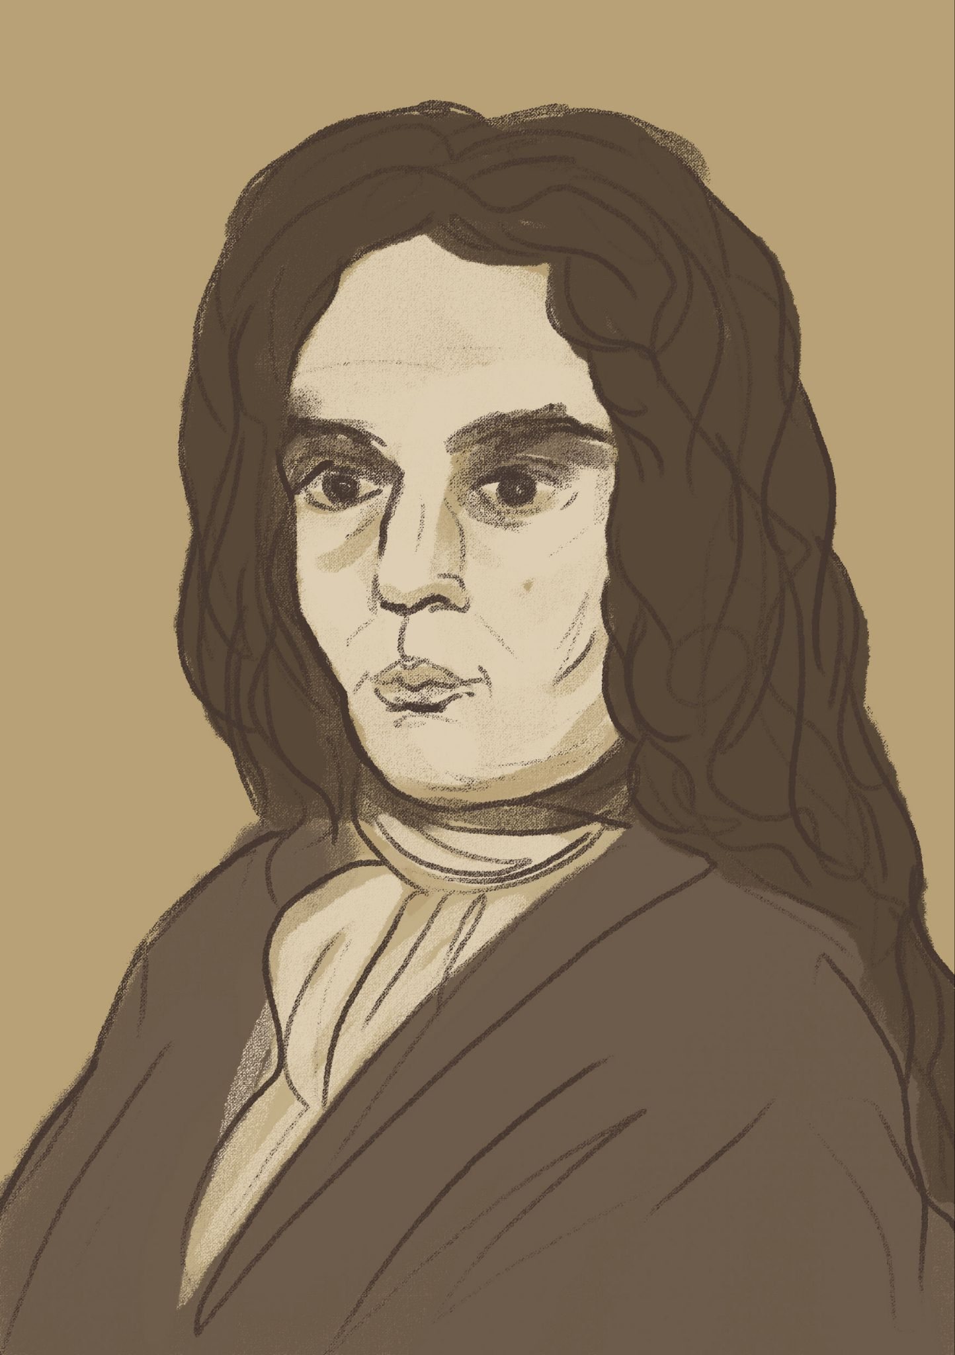 | Je li Ivan Gundulić pisac?
 | a | Da, on pisac.
 | b | Ne, on nije pisac.
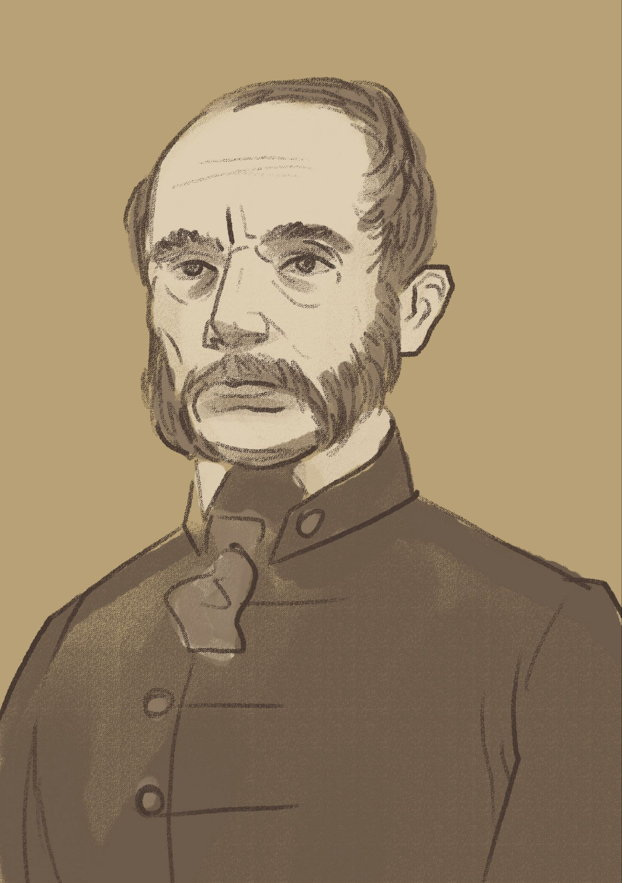 | Je li Ivan Mažuranić političar? ✅
 | a | Da, on je političar.
 | b | Ne, on nije političar.
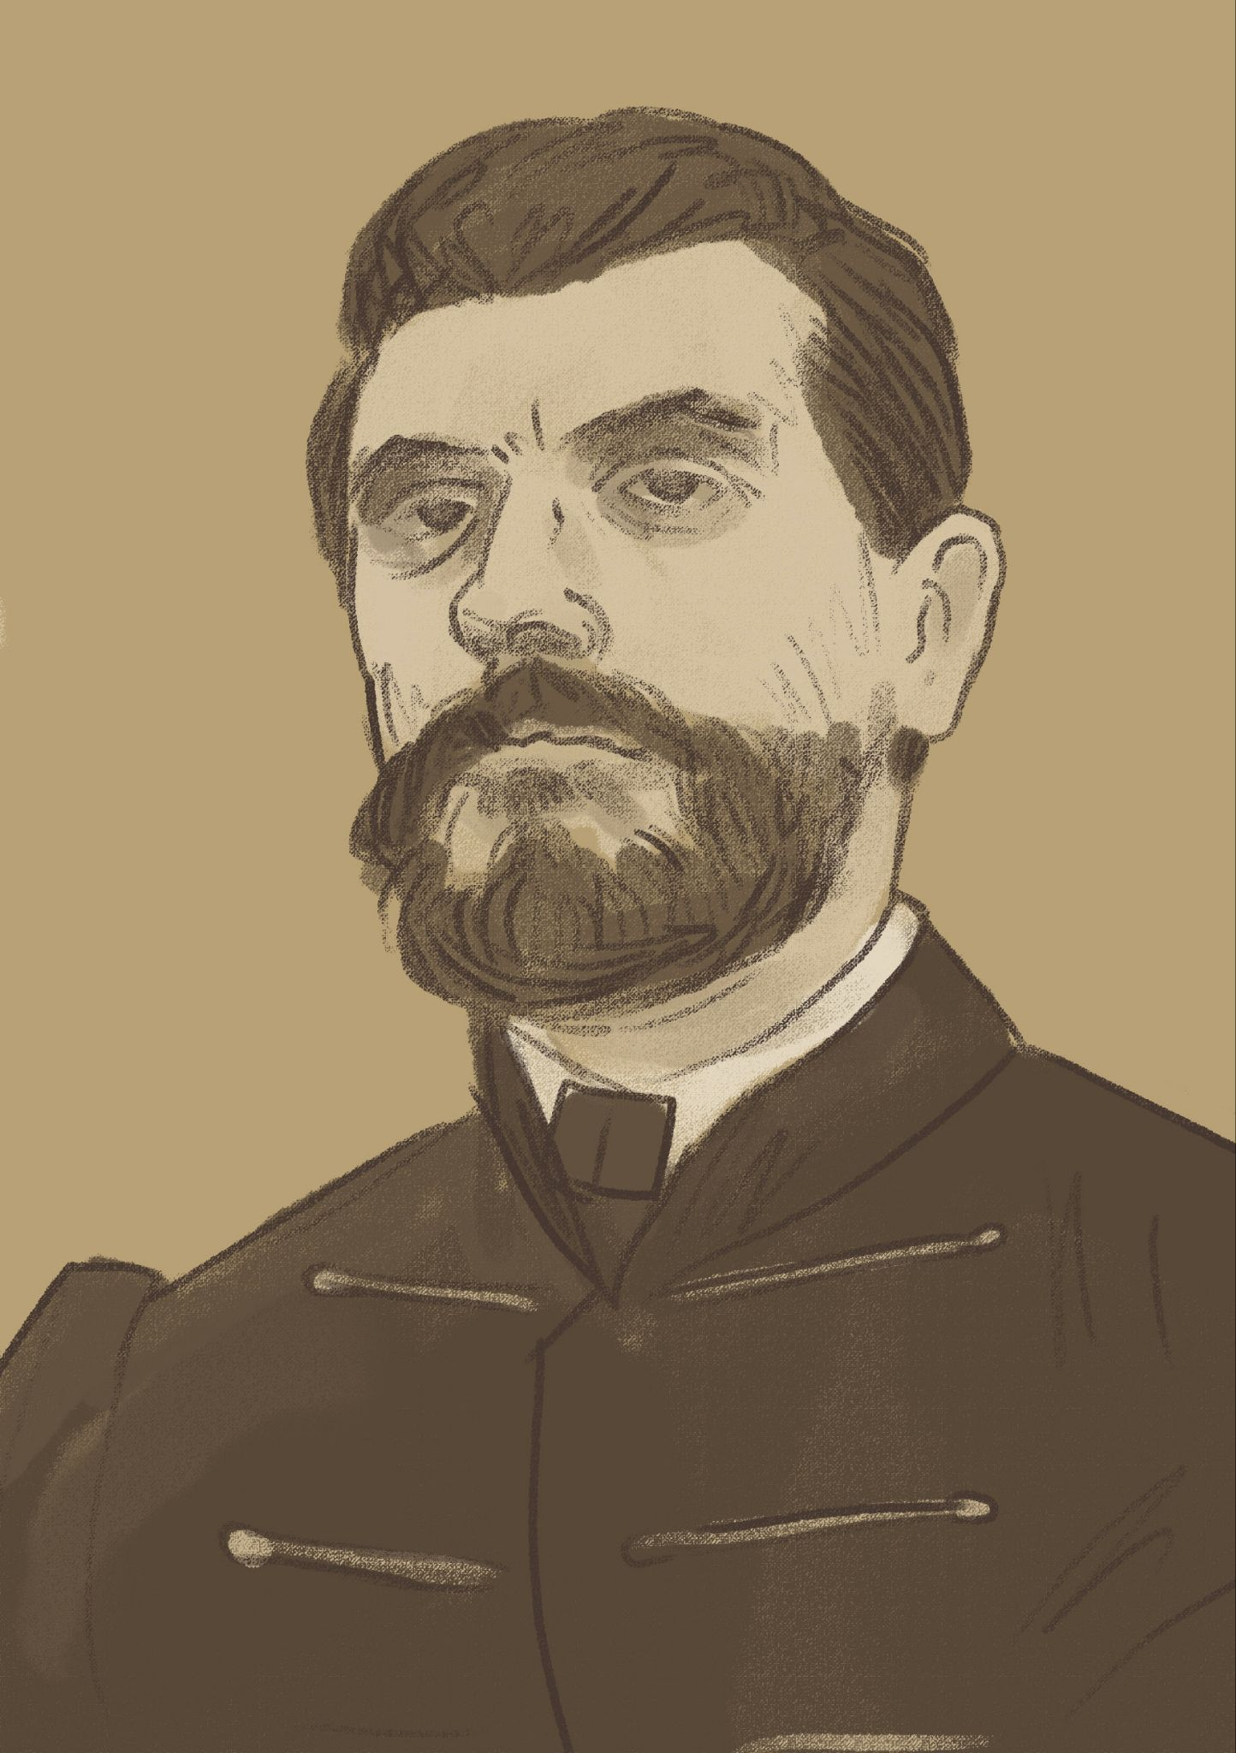 | Je li Ante Starčević pisac?
 | a | Da, on je pisac.
 | b | Ne, on nije pisac.

1.2 Zadatak 5. Kultura – razgovor

| Culture
In English (submit online). Now that you have a clear picture of people that appeared on Croatian banknotes before euro, answer the following questions:
1 | In terms of people who are represented on banknotes, how similar are those banknotes with the US currency (američki dolar)?
1 | -
2 | If we observe the hierarchy on the banknotes (i.e., the hierarchy of who is on higher denomination currency compared to small change) in both countries (US and Croatia), who are the people that are valued the most?
2 | -
3 | Is there gender equality? Explain the values that you see (interpret) behind the currency in your country and Croatia.
3 | -

1.2 Zadatak 6. Dijalog
💻 Video recording. Create a dialogue with other classmate(s). Continue to get to know your classmates better. Aim to use all the of the language elements we have covered so far, and be sure to include:
 | question forms (are you, is he/she, etc.)
 | negation (I am not, he/she is not, etc.)
 | statements (giving a brief statement, one-word-sentence)
 | more about physical and character traits

Images used in this document are from these sources.

How do James and Matija greet each other?
– Is it formal or informal?
– Would you greet someone like this in your country?
Matija asks: “Ti si Amerikanac?”
– What do you think about this question?
– Is it something people in your culture would ask right away?
Matija says: “Tvoja zemlja je baš zanimljiva.”
– Why do you think she says this?
– What might this tell us about how people in Croatia speak to new acquaintances?
What kind of first impression do you think James and Matija make on each other?
Imagine you meet someone new in your city.
– What do you usually say?
– Would this kind of conversation feel natural to you?

