3 | 1 | Lekcija 2: Krv nije voda

3.1 Zadatak 1. Odlazak na Brač
In the previous unit, you encountered a dialogue in which Ines invited James to join her over the weekend in visiting her family on one of the islands near Split. Now, James and Ines are on their way there.

Listen to the dialogue and complete the task.
🔊 In the dialogue, Ines said: Moji roditelji, brat, sestra i rodbina. Now, look at Ines’ family tree (only a part of it) and complete the task. You are seeing the family tree from Ines’ perspective.
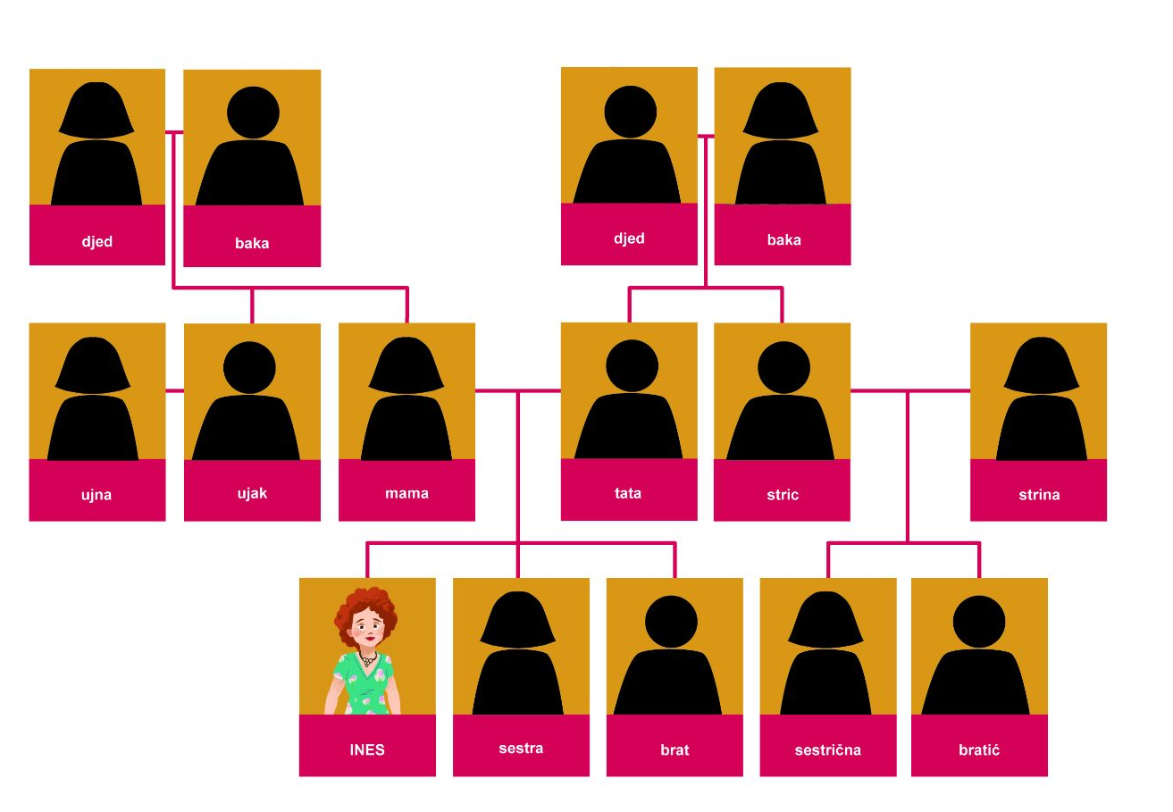
From Ines’ perspective, based on what you see above, separate people in the appropriate chart: family or relatives.
obitelj | rodbina

| Razumijevanje
1 | Kamo idu Ines i James?
1 | -
2 | Kada polazi trajekt?
2 | -
3 | Kada oni planiraju biti na otoku? (U koliko sati?)
3 | -
4 | Ima li Ines malu rodbinu?
4 | -
5 | Ima li James veliku rodbinu?
5 | -

3.1 Zadatak 2. Tko su oni?
🔊 Look at the image below and complete Ines’ family tree with family relation and a personal name. Complete the chart based on Ines’ perspective. Read the dialogues again if needed. You can also download a fillable PDF.
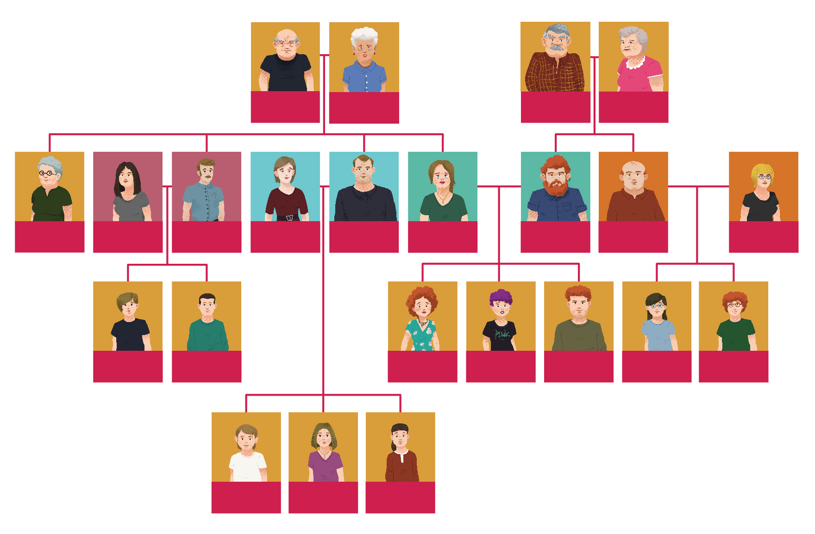
When you are done completing Ines’ family tree, talk with one of your classmates in order to check if you both correctly filled her family tree. Use possessive pronouns when asking the questions. Start your first question that relates to one person in Ines’ nuclear family and continue following people on her family tree.
Na primjer:
1 | Kako se zove njezina sestra?
1 | - Njezina sestra se zove Lana.

3.1 Zadatak 3. Moja uža i šira obitelj

​​Part 1: Moja obitelj
Provide basic information about your nuclear family. Fill in the information that is true for you.
Kako se zove tvoj […]? |  | Kako se zove tvoja […]?
brat | ↦ | sestra | ↦
tata | ↦ | mama | ↦
djed | ↦ | baka | ↦
stric | ↦ | strina | ↦
ujak | ↦ | ujna | ↦
tetak | ↦ | teta/tetka | ↦
rođak/bratić | ↦ | rodica/sestrična | ↦

After you answer all the questions above, make your own family tree. Then present it to one of your classmates, but don’t show them. Your classmate will need to draw what you tell them. Finally, compare the images. How accurate is what they drew? Switch roles when done.

Part 2: Njegova/Njezina obitelj
Having your classmate’s family tree, ask some additional questions that are listed below.
1 | Kakav je tvoj brat? and/or Kakva je tvoja sestra?
1 | -
2 | Kakav je tvoj tata? and/or Kakva je tvoja mama?
2 | -
3 | Što je po zanimanju tvoj tata/tvoja mama?
3 | -

In your answers, use appropriate adjective(s) when describing a person in your family. Be careful what gender you need to use.
zanimljiv | dinamičan | malen | dobar
arogantan | dosadan | nizak | visok
komunikativan | marljiv | vrijedan | drag

3.1 Zadatak 4. James i Laura

Part 1: Njihovo obiteljsko stablo
👥Rad u paru. Handout: Here are the empty family trees of our characters from the U.S. Each of you will have a completed family tree either of Laura or James. For example, if you receive a completed tree of Laura’s family, you need to ask questions of your classmate in order to complete James’ family tree. When done, switch roles. Start each question with appropriate structure:

Kako se zove njegov/njegova…?

Kako se zove njezin/njezina…?

Laura i njezino obiteljsko stablo
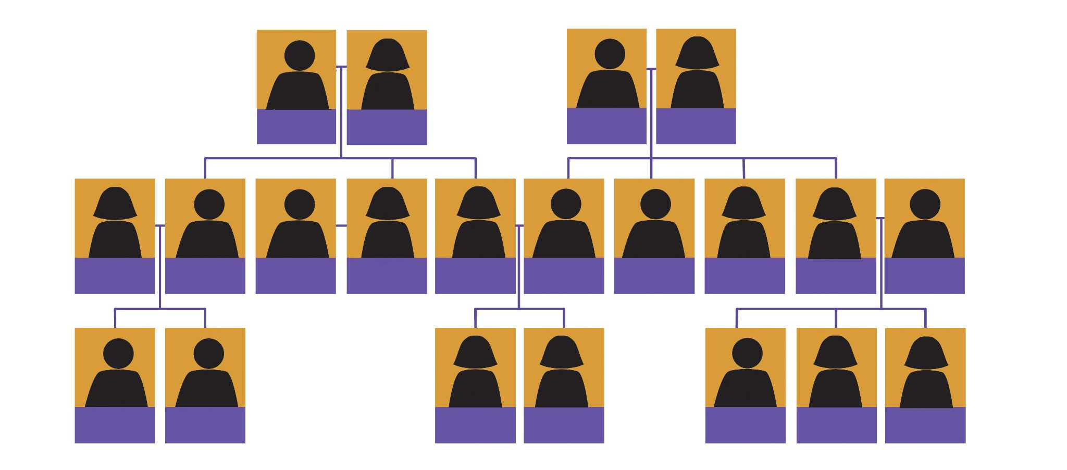
You can also download a fillable PDF and complete Laura’s family tree.

James i njegovo obiteljsko stablo
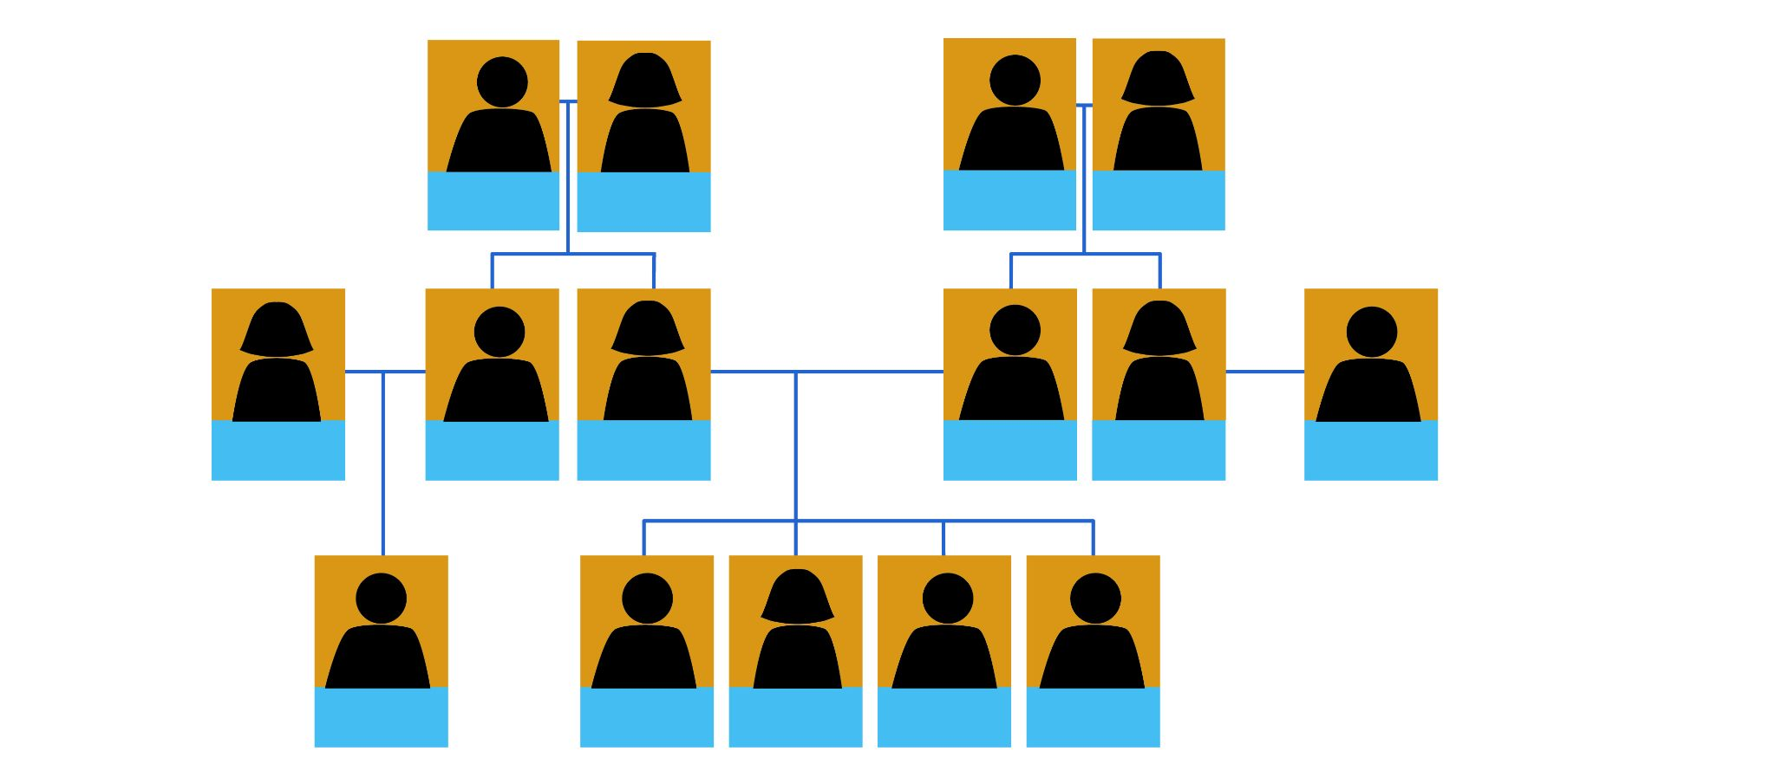
You can also download a fillable PDF and complete James’s family tree.

Part 2: Tradicionalno shvaćanje [traditional understanding]
When you have both family trees completed, discuss together the following questions. You will need to use your logic as not all information is present in the previous diagram.
James C. Williams
1 | Tko u obitelji ima isto prezime kao i James?
1 | -
2 | Tko u obitelji ima prezime Davis, a tko ima prezime Brown?
2 | -
Laura S. Lopez
3 | Tko u obitelji ima isto prezime kao i Laura?
3 | -
4 | Tko u obitelji ima prezime Reed, tko ima prezime Perez, a tko prezime Hughes?
4 | -
Images used in this document are from these sources.

🧑‍🏫

