1 | 1 | Lekcija 4: Kako ste?

1.1 Zadatak 10. Kultura - razgovor

| Culture
Look at the following picture. What type of greetings/questions can you associate with each picture? Use the phrases or questions that we covered so far. It might be possible to use the same phrase/question several times.
 |  |  | 
pozdrav:  → | pozdrav:  → | pozdrav:  → | pozdrav:  →

| In English
Look again at the pictures above and answer the following questions.
Pitanje | Do you greet your friends or family members in the same way? Can you give at least one example in which situations you would behave as shown in the pictures?
Pitanje | -

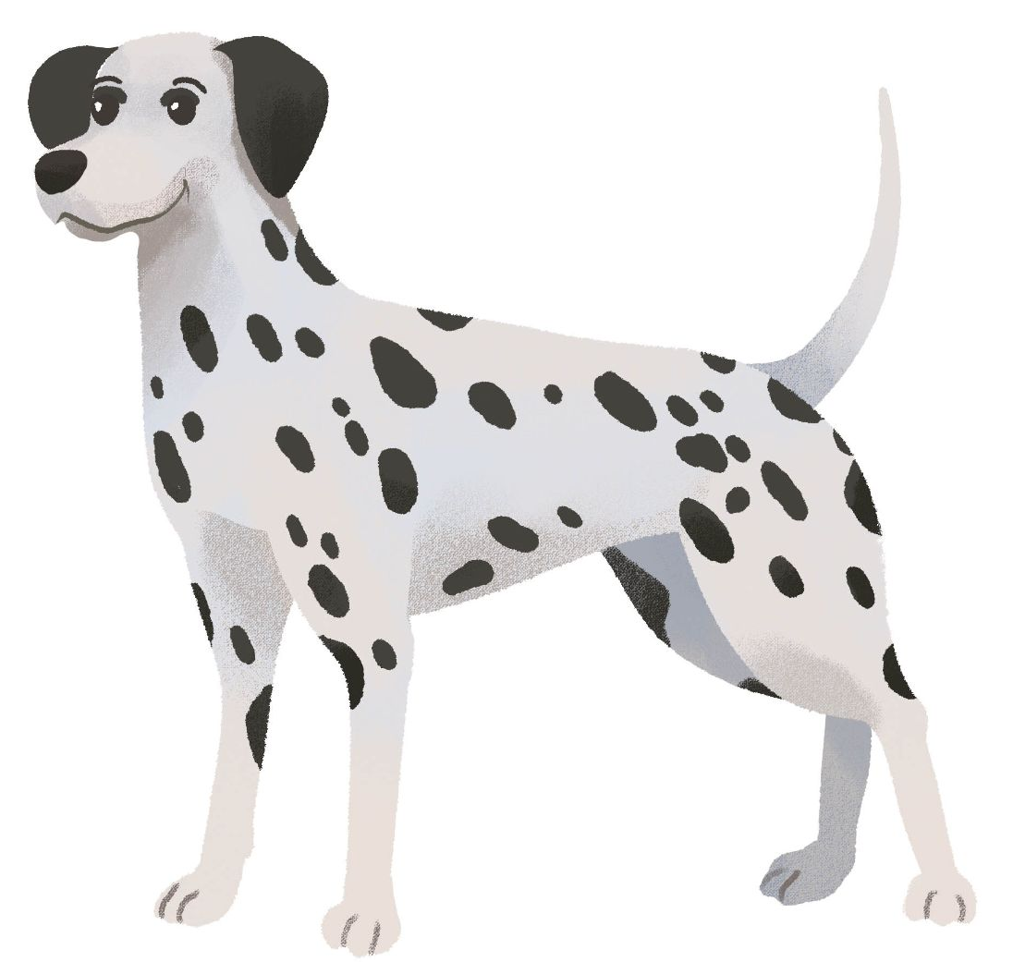 1.1 Zadatak 11. Kako si?
Read all three dialogues below and complete the task. Mark the correct answers about how each character feels.
Dijalog 1
Toni: | Hej, James! Kako si?
James: | Bog, Toni! Umoran sam. Hvala na pitanju. A ti?
Toni: | Izvrsno sam. Hvala na pitanju.

Dijalog 2
Laura: | Bok, David! Kako si?
David: | Bok, Laura. Umoran sam. A ti, kako si?
Laura: | Dobro sam, hvala na pitanju.

Dijalog 3
Diego: | Bok, Laura! Kako si?
Laura: | Hej, Diego! Dobro sam. Hvala na pitanju. A ti?
Diego: | Također, dobro sam. Hvala na pitanju.

Kako je…? |  |  | 
James says that he is:
Toni says that he is:
David says that he is:
Laura says that she is:
Diego says that he is:

1.1 Zadatak 12. Dijalog
Work with some of your classmates to create two dialogues.This assignment has two parts:

Part 1.
Create a Google Document. Working together, make a dialogue for the following scenario.

Scenario:
You meet your close friend in the city. Create a dialogue greeting your friend, asking how he/she is doing, and saying you’ll see each other later. Include any other information that you can ask about using language we have covered so far.

Part 2.
Make a video recording of you and your classmate conducting the dialogue based on your Google doc. Try not to read from your script. Upload your video recording and your Google doc link. Be sure that your Google doc setting will allow your instructor to edit (if needed).

1.1 Zadatak 13. Kako se kaže?
Answer the following questions in Croatian.
 | 

1 | How would you wish someone a good day?
1 | -
2 | How would you say to your friend that you will see each other later?
2 | -
3 | How would you express farewell / say goodbye?
3 | -

