1 | 2 | Lekcija 1: Ljudi i stvari

1.2 Zadatak 1. Ponavljanje
👥 Talk with one of your classmates and create a dialogue. You are both new students and you want to get to know each other more. Be sure to include the following information from Module One.
 | Kako se zoveš? | Kako se zove tvoj tata?
 | Kako si? | Kako se zove tvoja mama?
 | Odakle si? | Kako se zove tvoj prijatelj?
 | Koji je tvoj broj telefona? | Kako se zove tvoja prijateljica?
 | Koja je tvoja adresa? | Kako se zove tvoj brat/sestra?

1.2 Zadatak 2. Tko je ovo?

Part 1
Read/Listen to the short dialogues on the website in which our new student is asking for information about certain people. Below are all historical figures that appeared on Croatian currency (kuna) before the euro was introduced in 2023. James encountered pictures of some of them. While listening, write the appropriate name under the correct image.
Ivan Gundulić | Josip Jelačić | Marko Marulić
Ivan Mažuranić | Ante Starčević | Ivan Meštrović

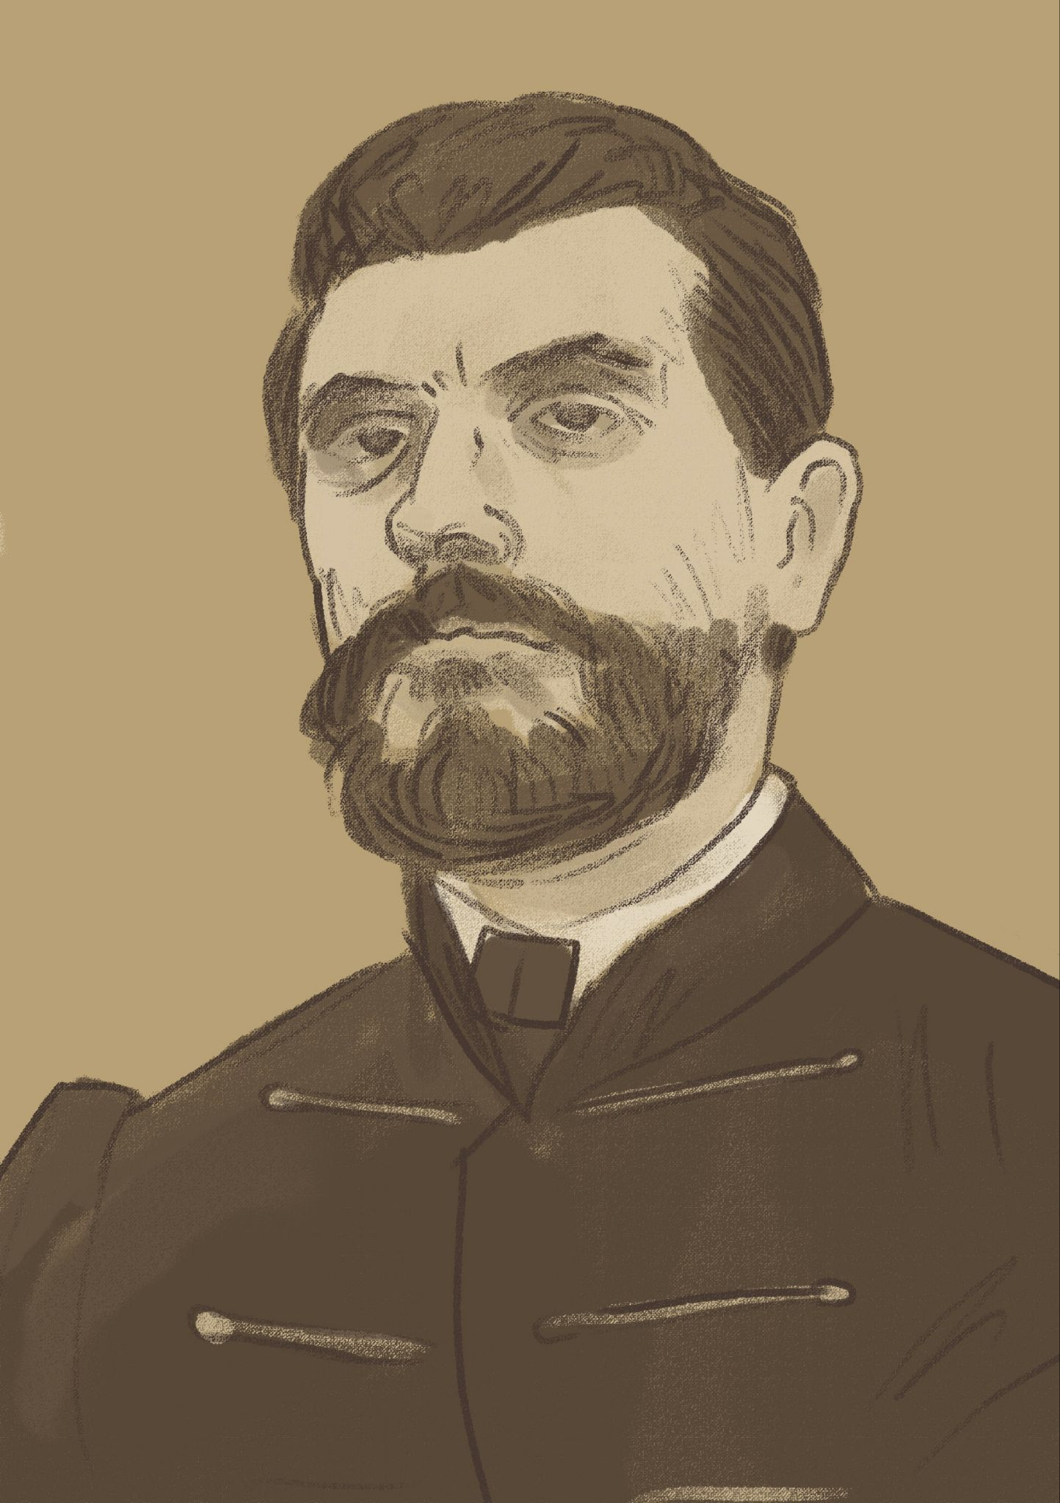 | 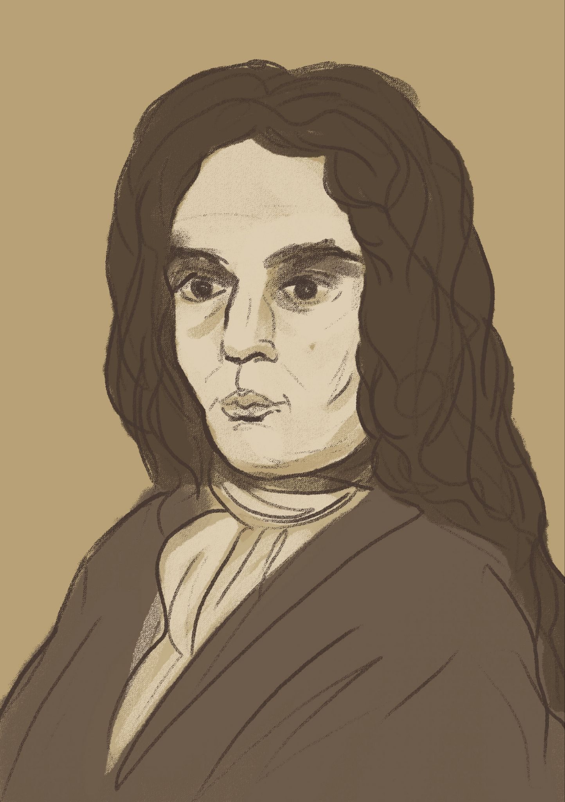 | 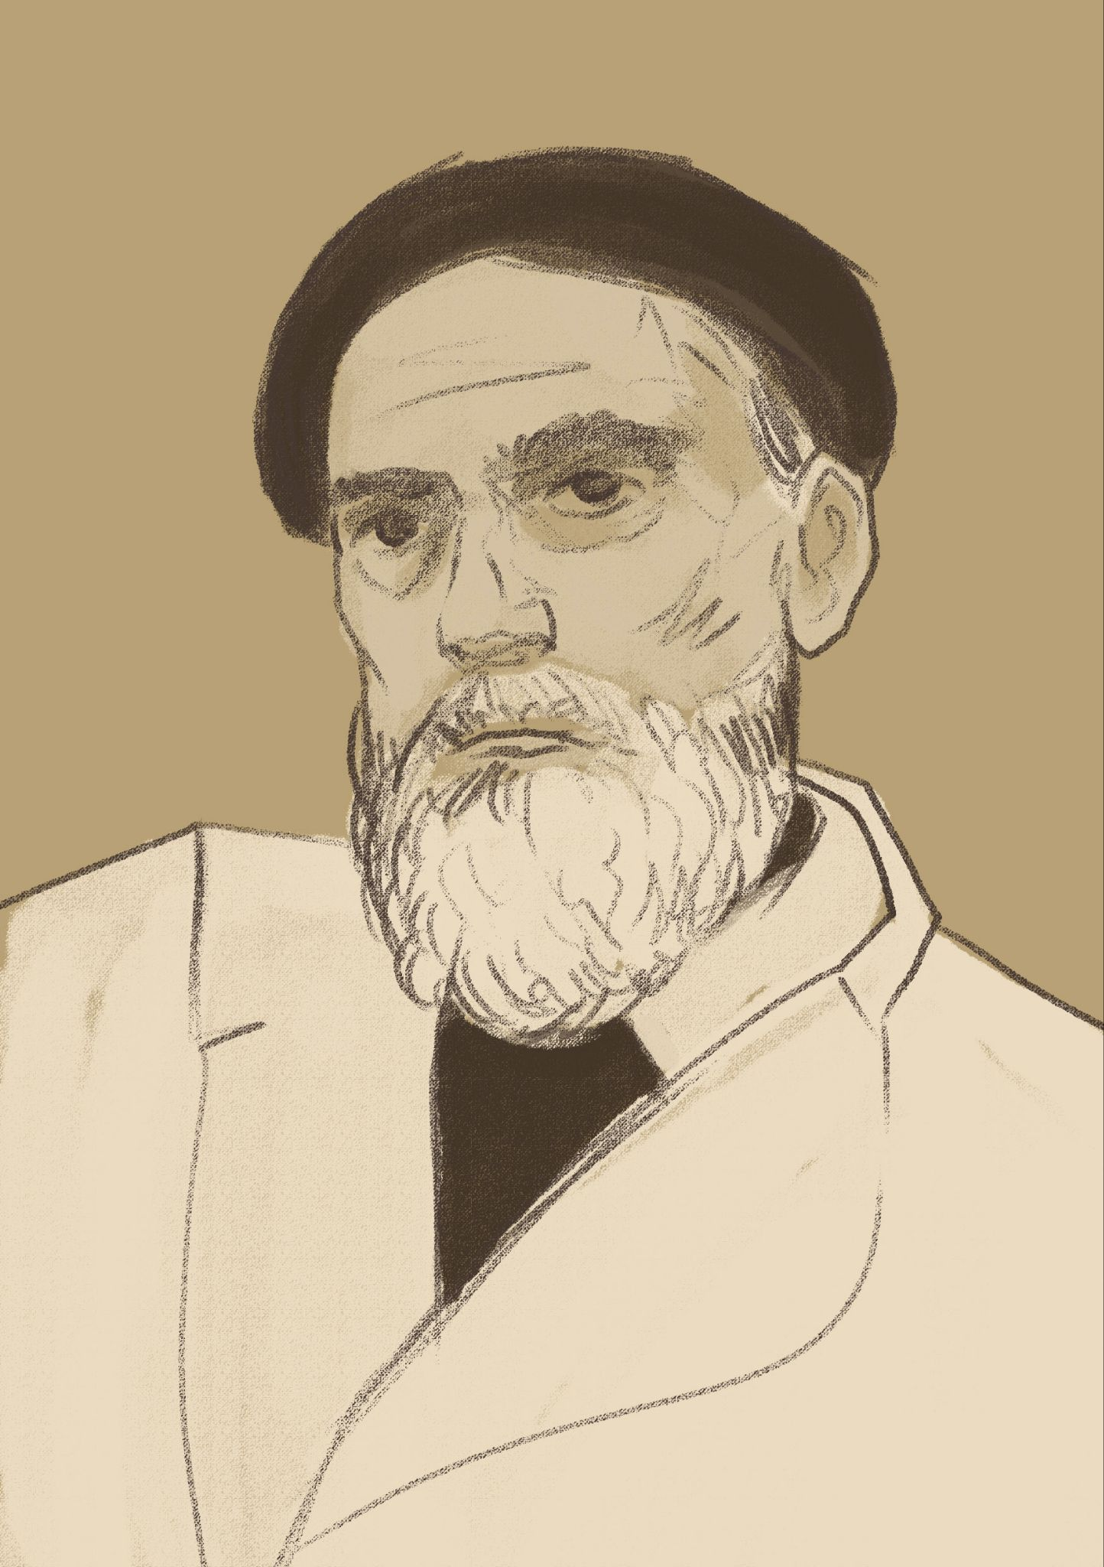
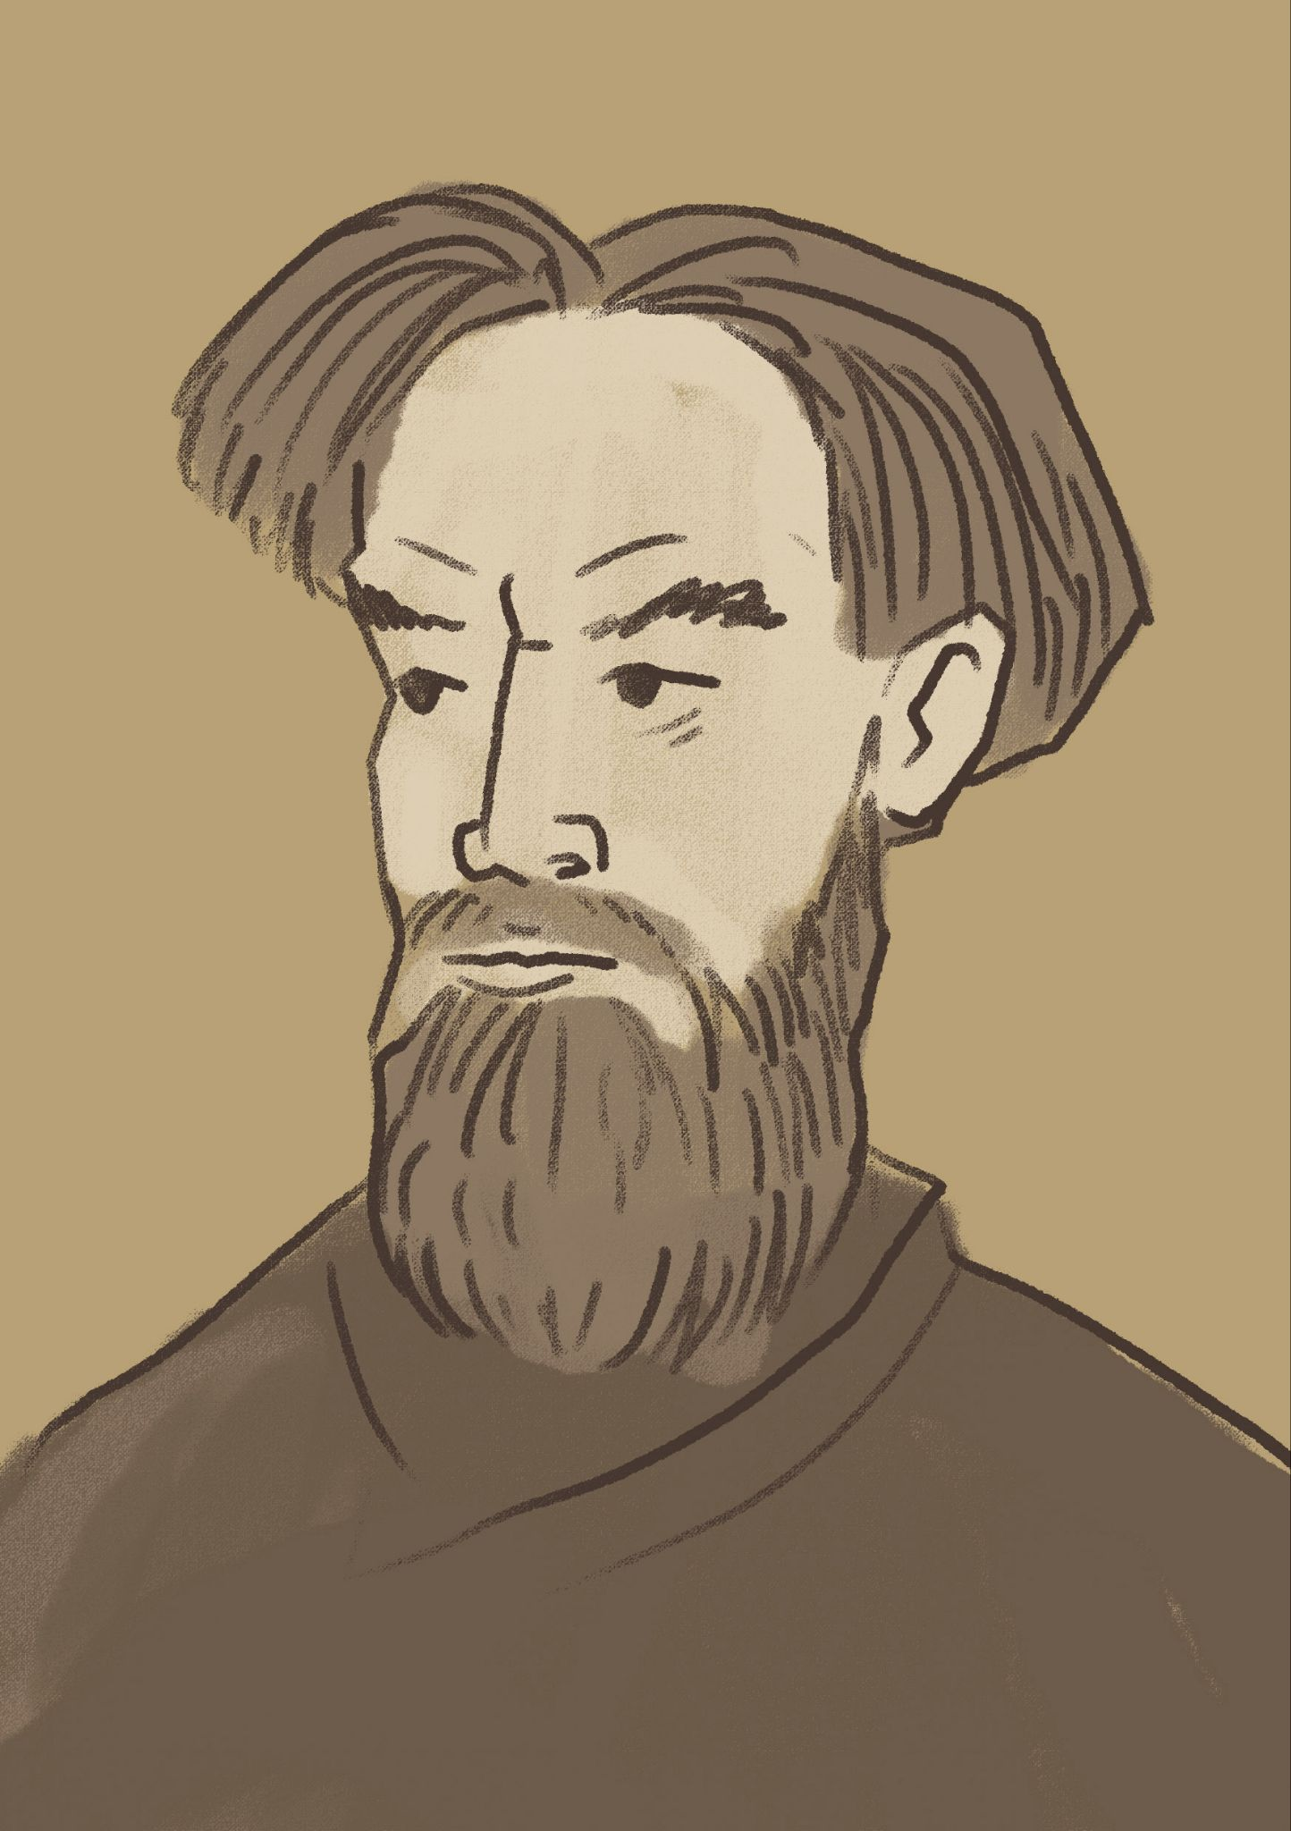 | 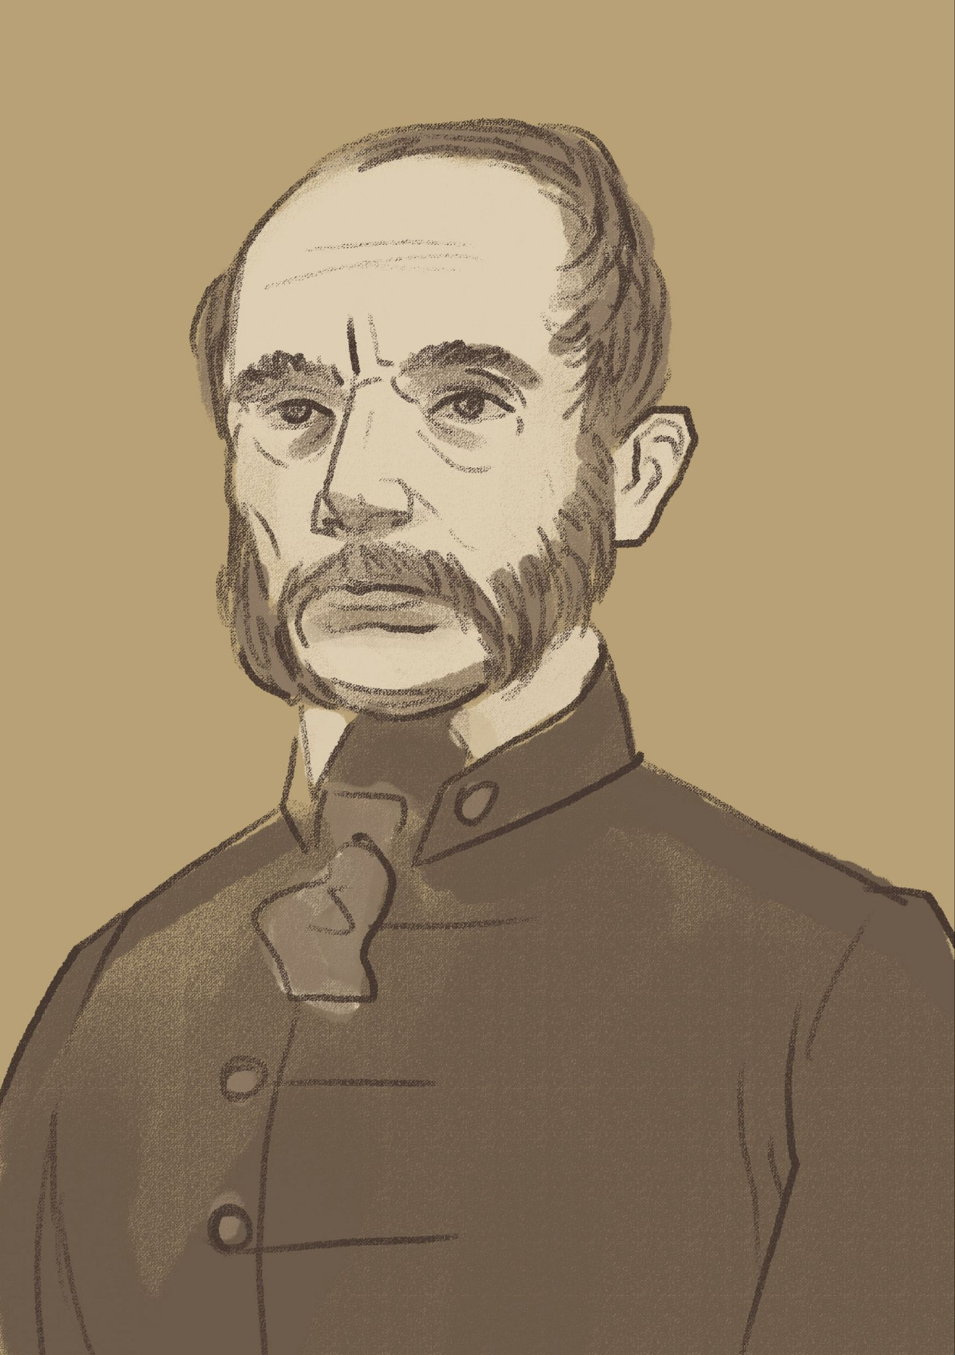 | 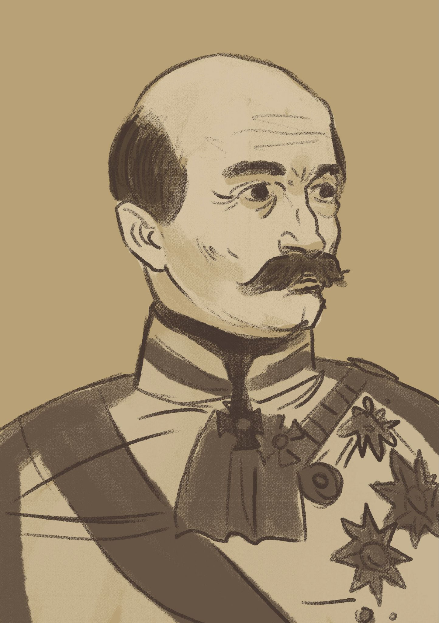
James learned the names of the people whose pictures are framed. However, he still doesn’t know why they are so important. Help him learn more about Croatian historical figures. Below are the professions of some historical figures. Do a quick online search in order to match the name with their specific profession. One example is done for you.
 |  |  | 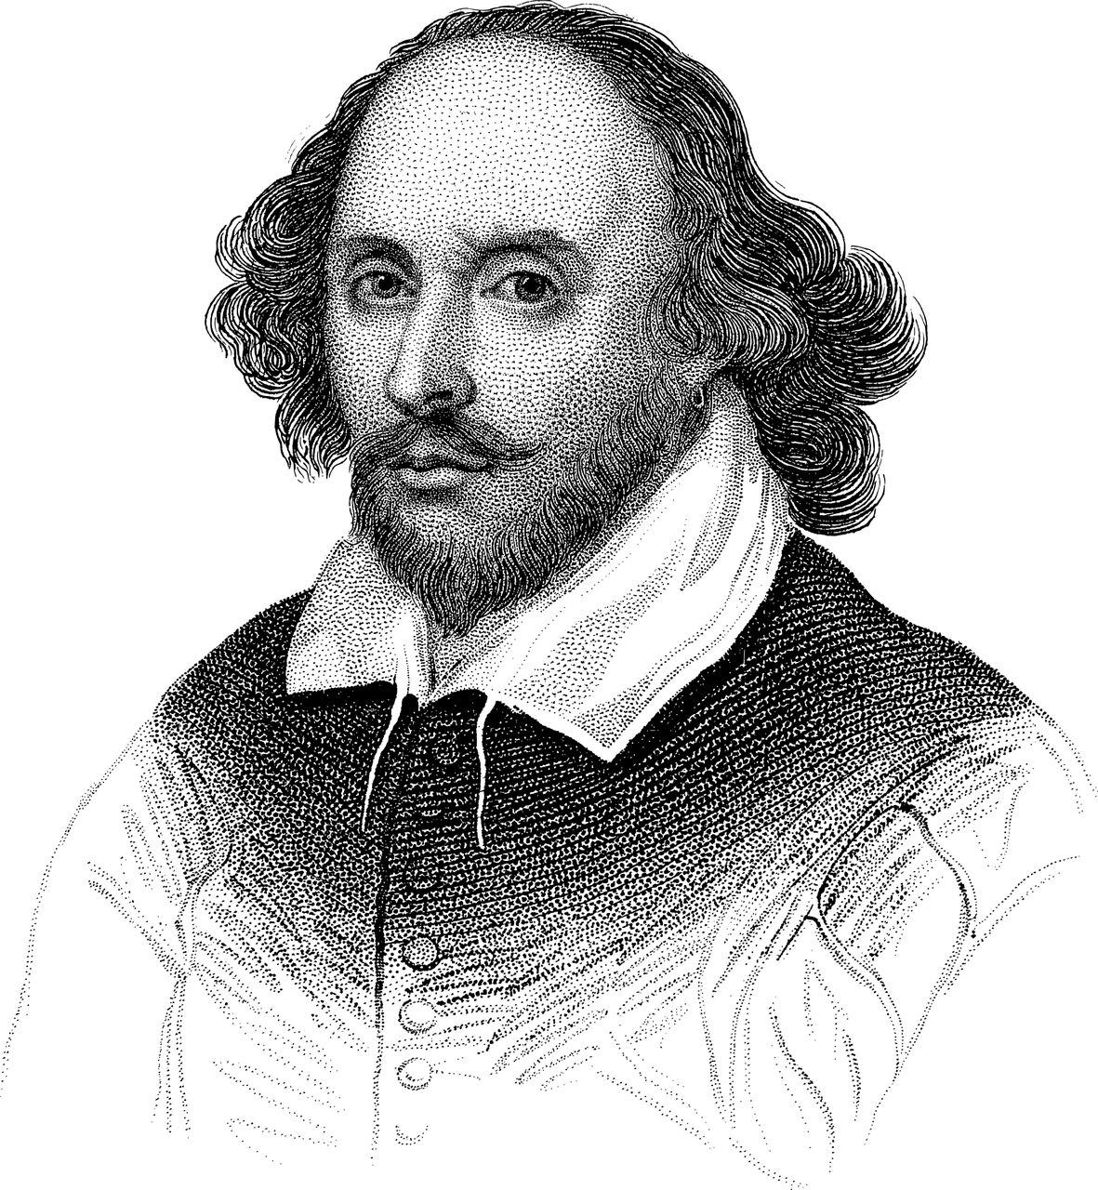
biskup | general | političar | pisac

Josip Jelačić | [odgovor] → | Josip Jelačić je ban.
Juraj Dobrila | [odgovor] →
Ivan Gudulić | [odgovor] →
Ivan Mažuranić | [odgovor] →
Stjepan Radić | [odgovor] →
Marko Marulić | [odgovor] →
Ante Starčević | [odgovor] →

When you have all the information, you will check your answers with your instructor.
Example:
Tko je ovo?
To je [...]. On je [...]

Part 2
Next, talk with your classmates in order to collect information about the following people. Take turns asking for information about each person. Follow the patterns from the dialogue between James and Luka.
sportaš – sportašica
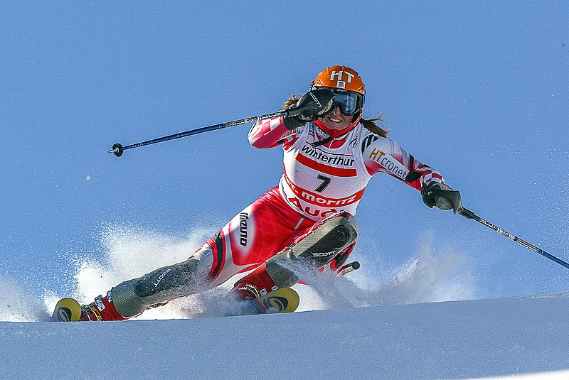 | 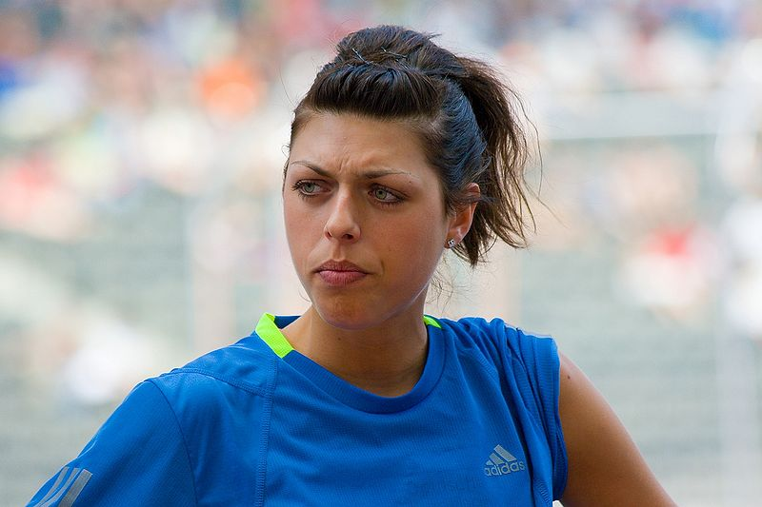 | 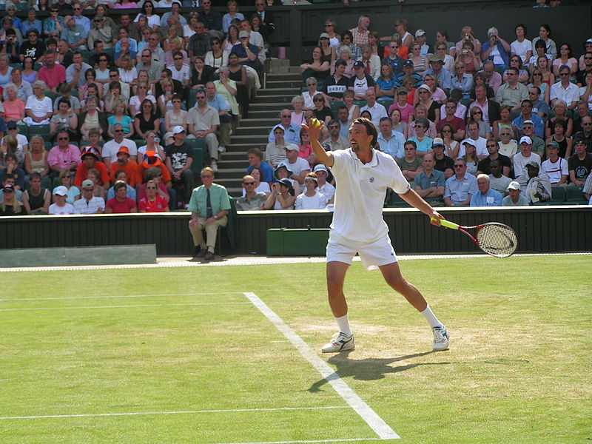
glumac – glumica
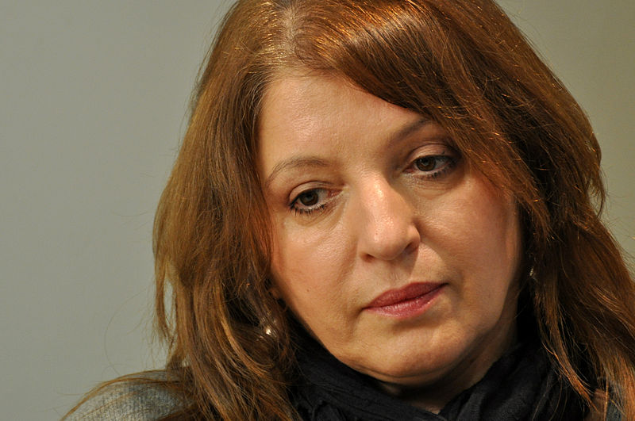 | 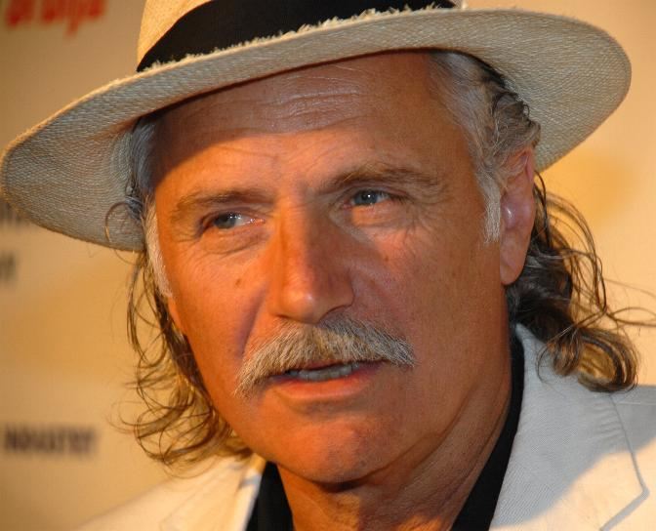 | 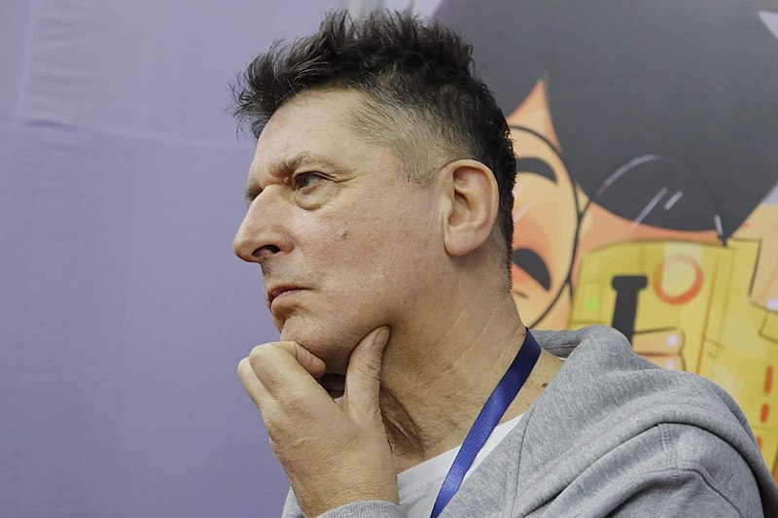
Boris Bakal – Rade Šerbedžija – Goran Ivanišević – Mirjana Karanović – Blanka Vlašić – Janica Kostelić

1.2 Zadatak 3. Tko su oni?
👥 Look at the following set of pictures. Take turns asking each other who these people are. In your answer you should include their names and professions.
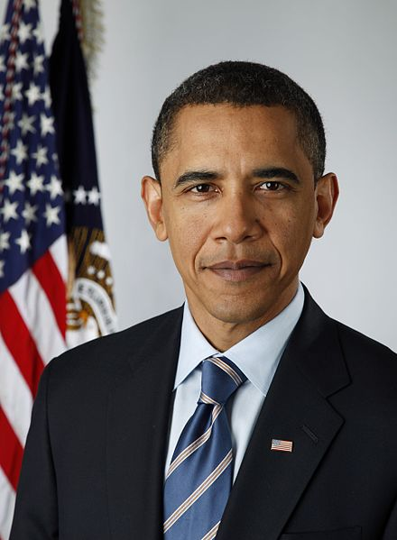 | 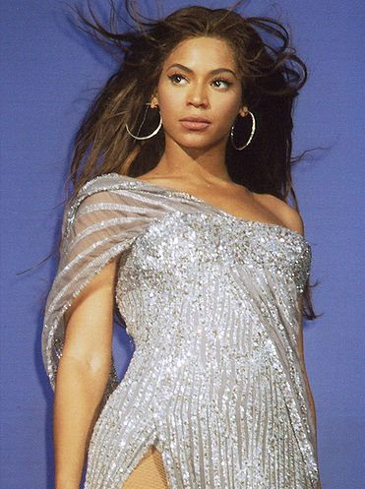 | 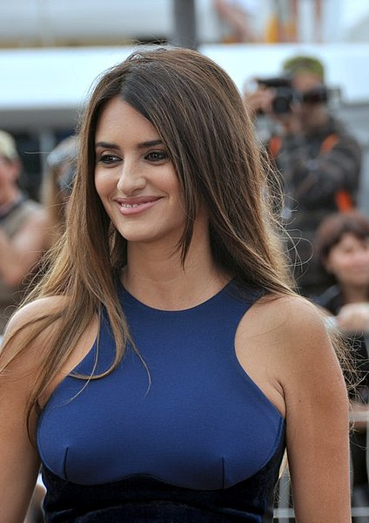
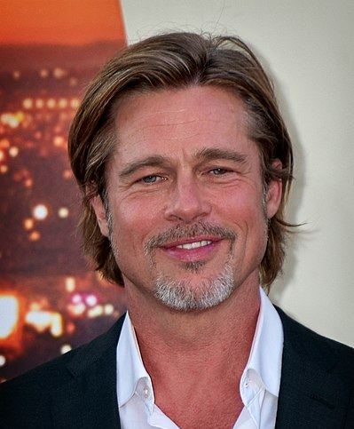 | 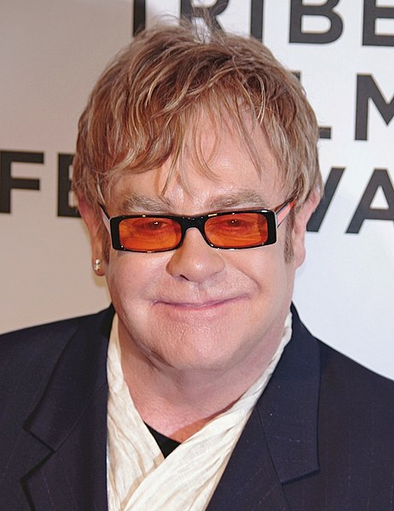 | 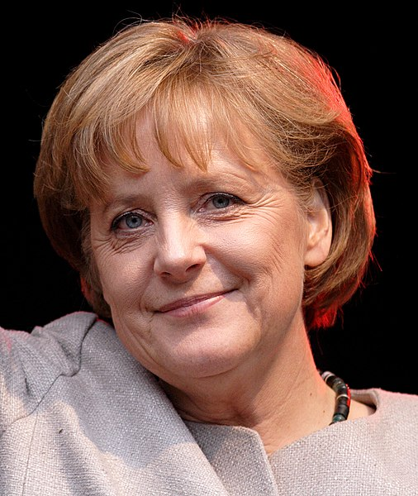

1.2 Zadatak 4. Što je ovo?

Part 1
Your instructor will show you the personal items that they have in their possession right now. After your instructor shows you all their items, you will be asked to provide the Croatian term for some of the items that your instructor has. Try to remember as many items as you can. 1️⃣

Part 2
Look at the following items and mark all the ones you have in your possession right now (i.e. you have them in the room near you). 2️⃣
 |  |  | 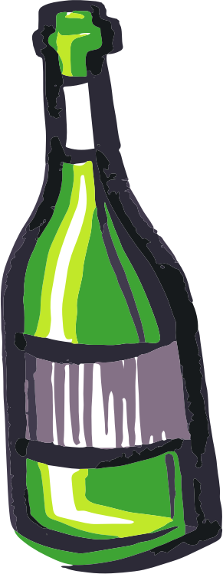
ključ | olovka | knjiga | boca
 |  | 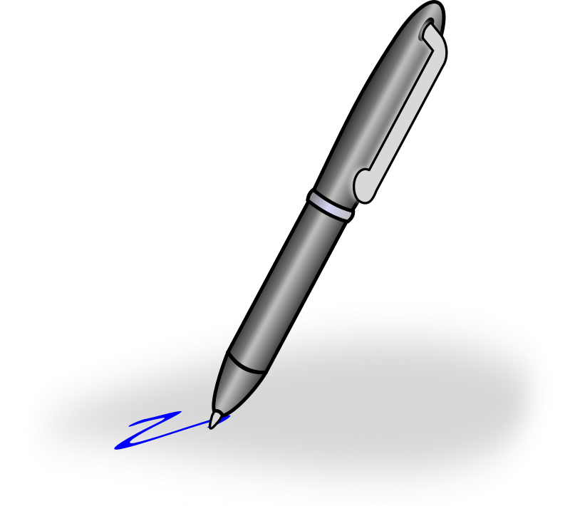 | 
laptop | mobitel | kemijska | kava
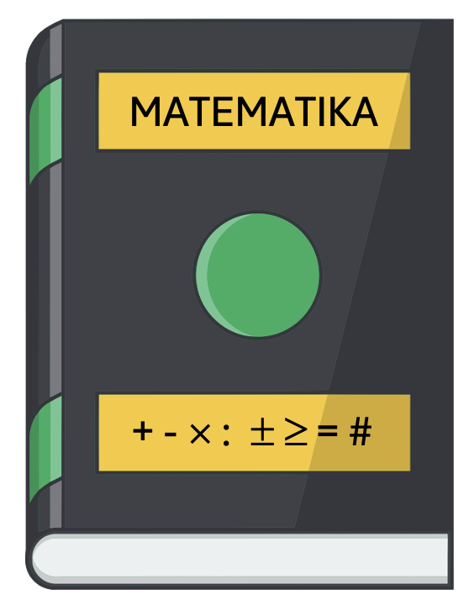 |  |  | 
udžbenik | bilježnica | iPad | čaj
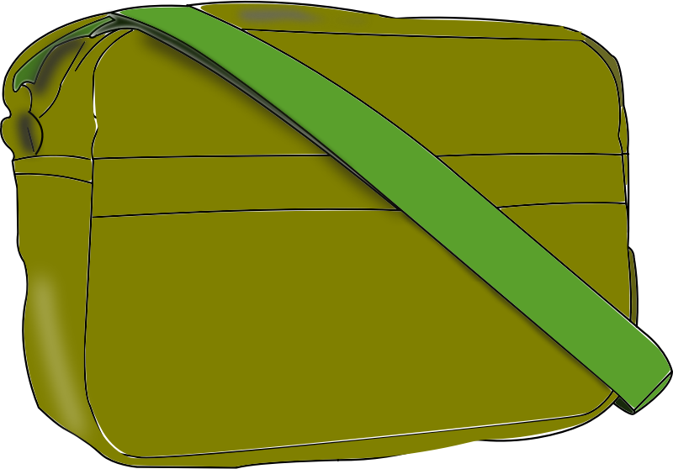 |  |  | 
torba | notes | kalendar | printer

Now, show the items to your classmates one by one. Lift them up and say what each thing is just like your instructor did at the very beginning of this task.

1.2 Zadatak 5. Stvari
Work with your classmates. Take turns while working through the Google slides, saying what it is you see. Na primjer:
 | Ovo je novčanik.
If you do not know the word, you need to ask one of your classmates for help. If you still need help, ask your instructor.

1.2 Zadatak 6. Što je to? Čije je to?
📄 Handout. Each of you will “adopt” a picture, as if it represents your family and home. Pretend like these things are yours. Tell each other what these things/people are, and what belongs to whom. Be creative and invent your answers! Na primjer [for example]
 |  |  | 
Ovo je njezina  kava. | Ovo je njezin  mobitel. | Ovo je njegova knjiga. | Ovo je njegov  šešir.

Images used in this document are from these sources.

