9 | 4 | Lekcija 2: Razgovor
Performance-Based Task

| Pre-class assignment preparation
Prepare yourself to make a dialogue (role-play) including the following elements.
One of you will be an international student and your instructor will play the role of a local friend. Use all previous tasks in this Unit to make a meaningful dialogue.
 | 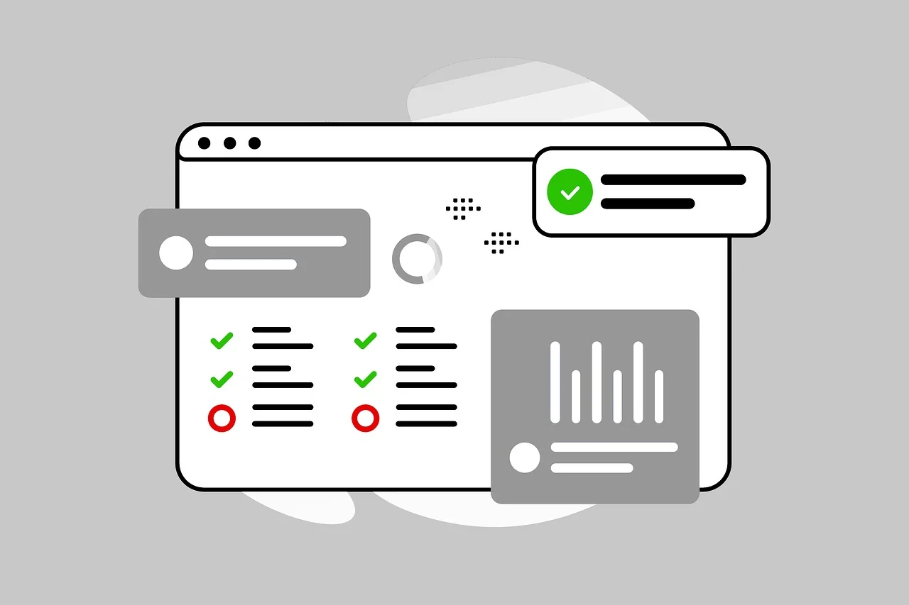

Scenario:
You need to talk with a friend about your family members, close friends, or yourself. Prepare to have a picture of your family for the conversation. In your conversation, you might need to talk about
 | physical description
 | how old they are
 | personality traits
 | your opinion about them
 | free time and activities
 | sport activities and interests
 | their profession
 | fears
 | eating habits
In a conversation you will both need to ask additional clarification questions on the given topics and provide necessary comments. A friend might also ask more specific questions on any of the people you are talking about. This will be developed based on what you mention in your conversation.

| In-class assignment
Listen to each of your classmates performing their dialogues. Take notes about their cultural performance in the table below. Your homework assignment will be to write a reflection on the cultural components that you noticed in each of your peers’ dialogues. When your classmate writes a response to your own performance, you will need to provide them with a follow-up and comment on their reflection.
 | 

As a person who is evaluating your peers’ performance, reflect on the following components:
1 | Evaluate how successful they were in navigating the conversation in a culturally appropriate way.
1 | -
2 | Did they recognize and-or use expressions that present a figurative meaning?
2 | -
3 | Were they able to recognize, understand, and react to non-verbal cues in dialogues with the instructor?
3 | -
4 | What else could they have done in performing real-life situational discourse?
4 | -

| Post-class assignment
 | 

Submit your notes from the class session on your peers’ performance. As a person who is reading responses from your peers, be sure to include in your comment:
1 | Do you agree with them? If yes/no – why?
2 | What will you do to improve (if needed) your future dialogues?
3 | Any other comments?

Submit this assignment also online.

Images used in this document are from these sources.

