7.3 - Osobní hygiena

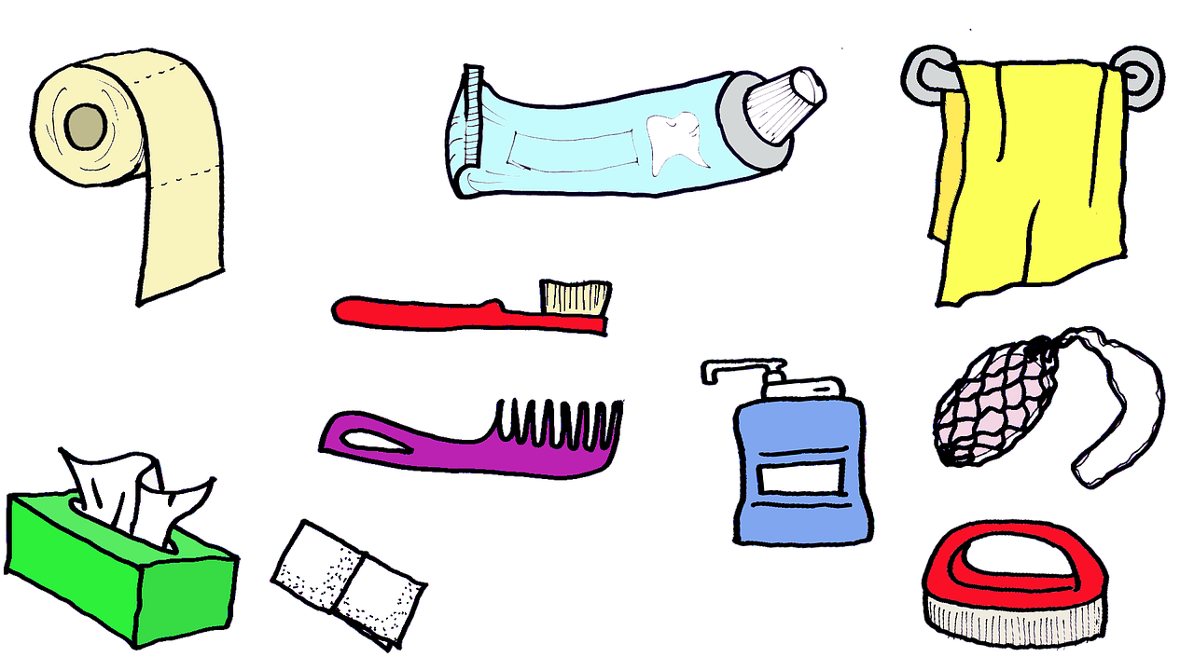
The following activities are all types of (osobní) hygiena - personal hygiene in Czech:

-á- verbs (see 2.2 - Conjugation of -á- verbs)
oblékat se | to get dressed | 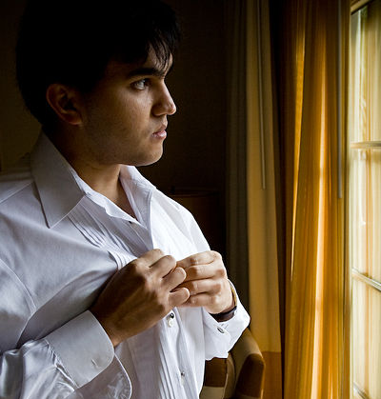  Karel se obléká.
vyndat si čočky | to take out your contact lenses | 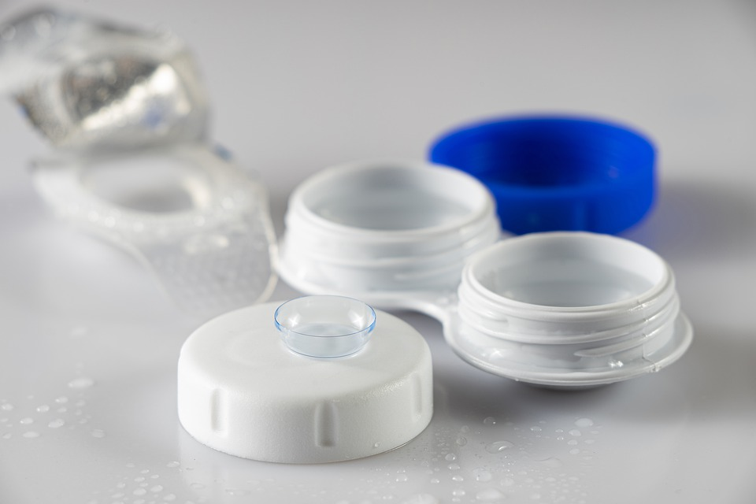
nasadit si čočky | to put in your contact lenses | 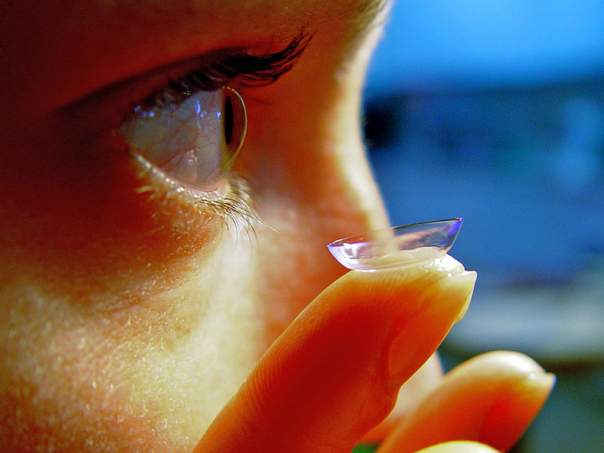

-í- verbs (see 2.2 - Conjugation of -í- verbs)
holit se | to shave | 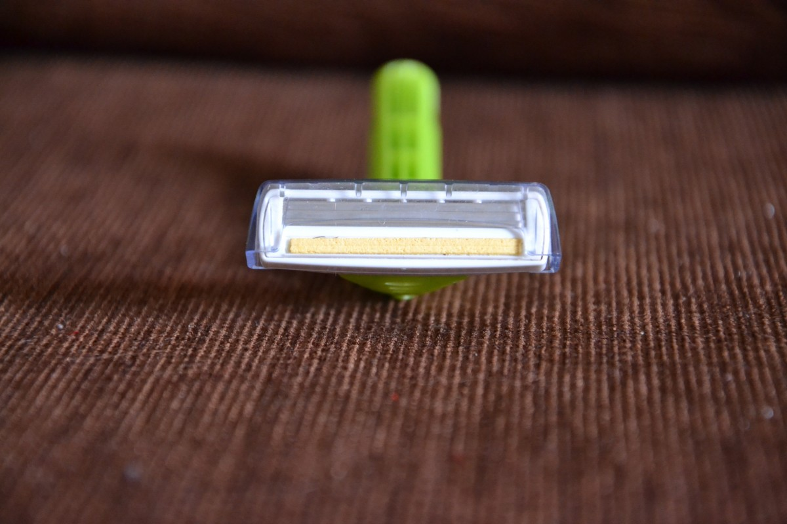  Pavel se holí každý den.
čistit si zuby | to brush ones teeth | 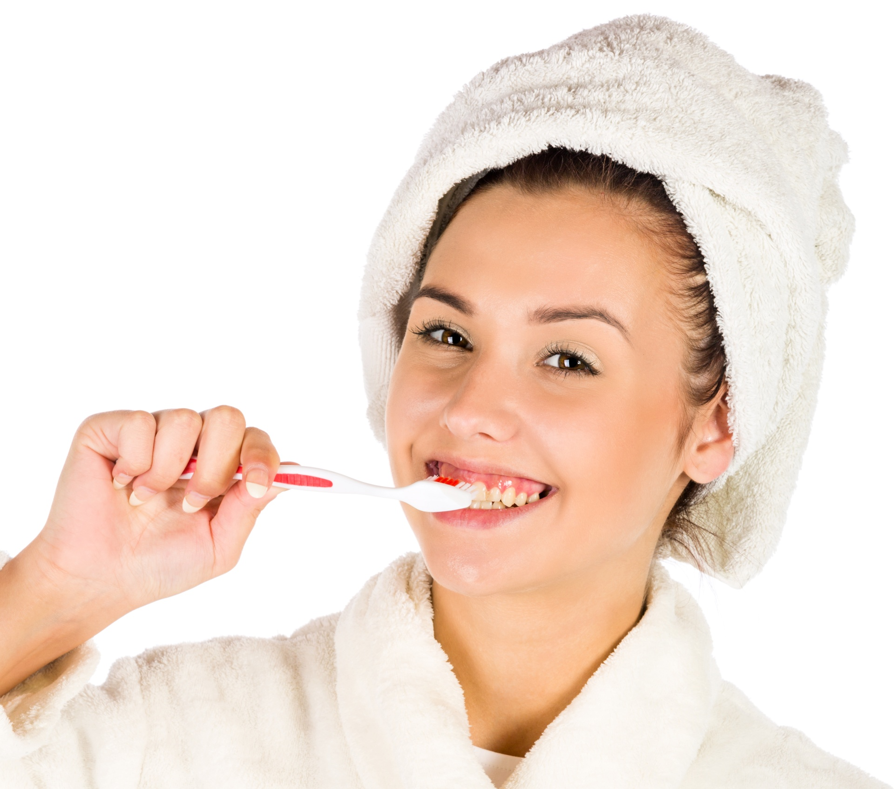

-e- verbs (see 2.4 - Conjugation of -e- verbs)
česat si vlasy  (češ-) | to brush your/ones hair | 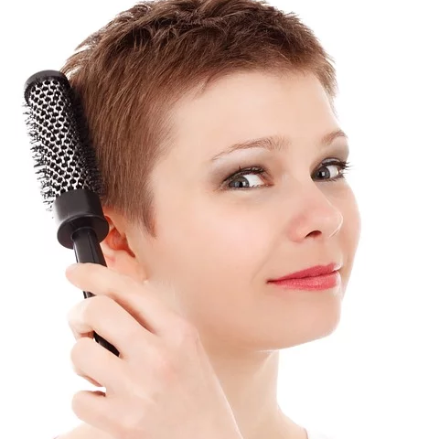  Marie si češe vlasy.
mýt si ruce  (myj-) | to wash ones hands  (lit. to wash hands for oneself) | 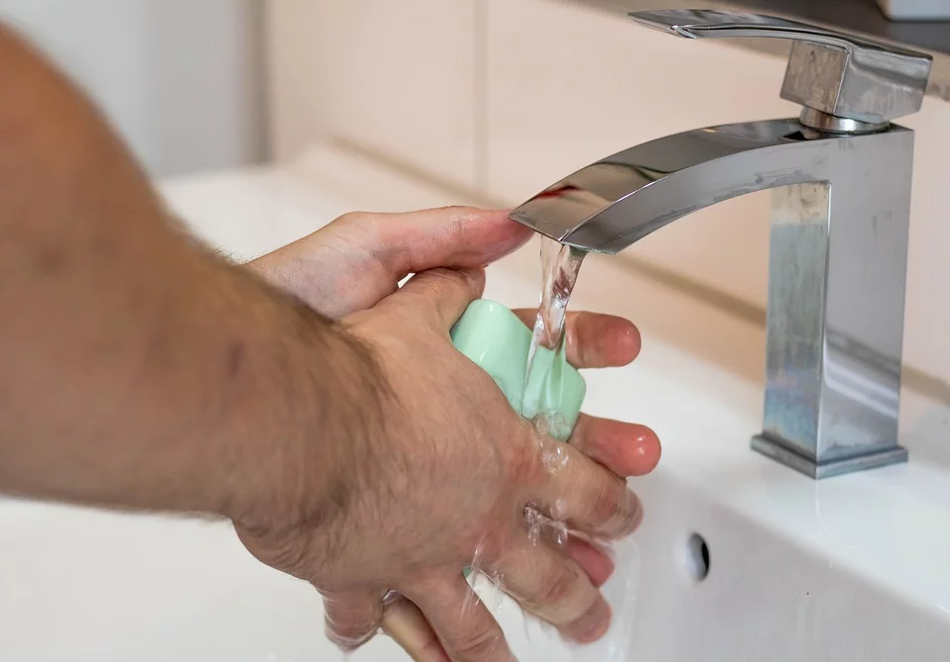  Myju si ruce, protože si chci dát něco k jídlu.
mýt se  (myj-) | to wash off, get washed off (lit. to wash oneself) | 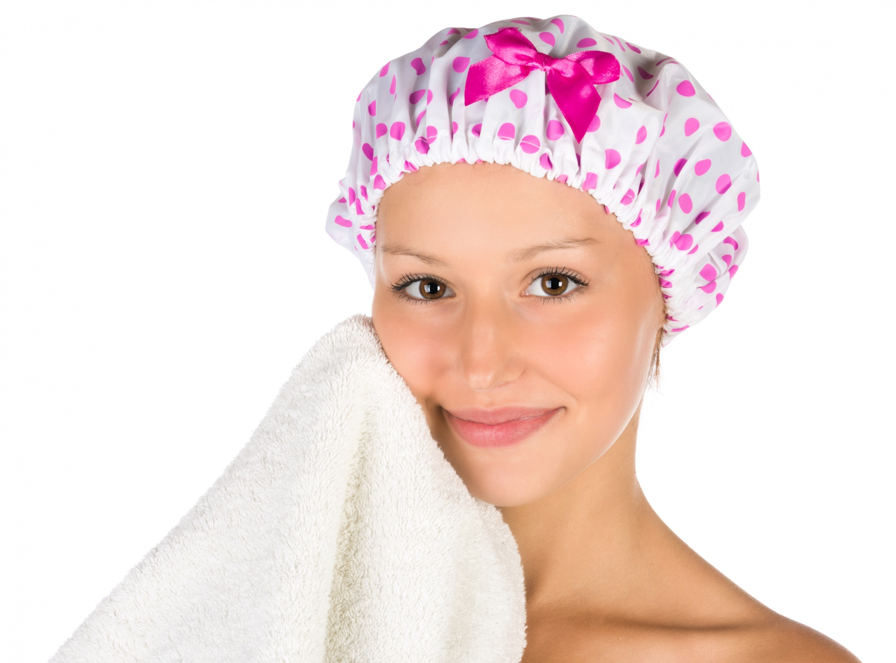  Lucka se myje v koupelně.
sprchovat se  (sprchuj-) | to shower | 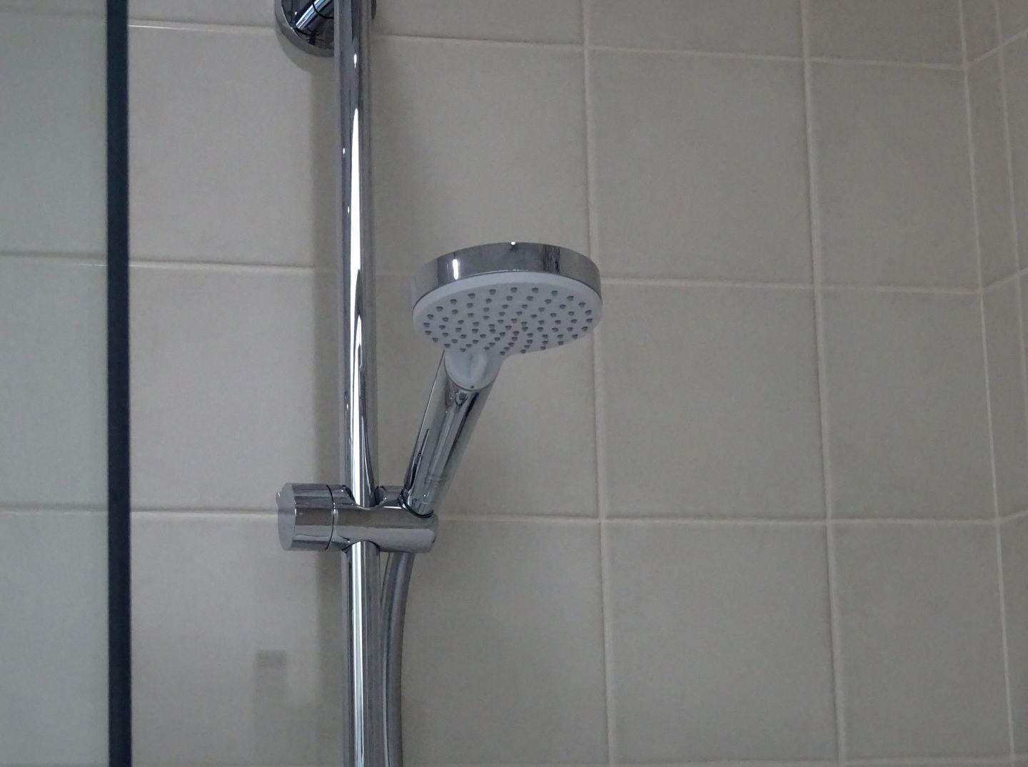  Sprchuju se každé ráno.

Recall that you need to learn a stem to go along with -e- verbs. The stems are given below the verbs above, but you can also find the full conjugation of these verbs below:

mýt to wash; l-form myl, myla...
(já) | myju / myji | (my) | myjeme
(ty) | myješ | (vy) | myjete
(on/ona/ono) | myje | (oni/ony/ona) | myjou / myjí

česat to comb; l-form česal, česala...
(já) | češu | (my) | češeme
(ty) | češeš | (vy) | češete
(on/ona/ono) | češe | (oni/ony/ona) | češou

Images used in this document come from these sources.

