8.3 - Locative singular

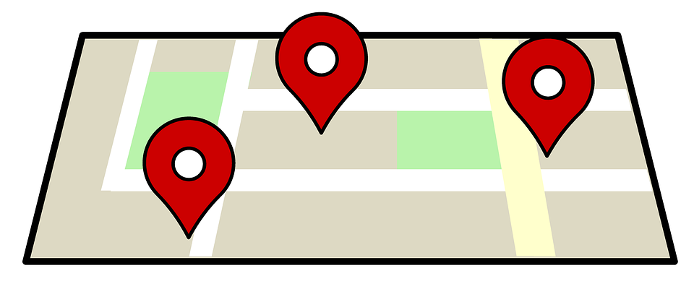
The locative singular is the case that is used after the following prepositions in Czech:

v/ve ‘in, at’
na ‘on, at’

o ‘about’
po ‘after’

The following endings are used when forming the locative plural. As you can see, there are a few instances where more than one ending is used. This lesson will focus on these endings.

 | Masculine Animate | Masculine Inanimate | Feminine | Neuter
Hard | -ovi | -e /-ě or -u | -e /-ě | -e /-ě or -u
Soft | -ovi or -i | -i | -i | -i | -í

Masculine animate:

 | Masculine animate
hard stem | -ovi  all animate nouns  Jakub → o Jakubovi ‘about Jakub’  doktor → o doktorovi ‘about a doctor’  soused → o sousedovi ‘about a neighbor’
soft stem | -ovi for proper nouns:  Aleš → o Alešovi ‘about Aleš’  Tomáš → o Tomášovi ‘about Tomáš’  -i for all other masculine animate soft stem nouns  učitel → o učiteli ‘about a teacher’  (though o učitelovi is also possible)

Note: strings of animate/proper nouns behave slightly differently than animate words on their own. Even though all words of a proper name are animate, only the last word of the phrase uses the -ovi ending. The preceding nouns take -u if hard and -i if soft. This is a somewhat esoteric rule and is often not followed in colloquial speech, but is worth knowing, at least passively.

o Janu Svěrákovi ‘about Jan Svěrák’
o Miloši Formanovi ‘about Miloš Forman’

 | Masculine inanimate
hard stem | -e /-ě for most nouns ending in t,d,s,z,l:  (see summary of softenings/mutations)  t, d  byt → v bytě ‘in the apartment’  hrad → na hradě ‘at the castle’  s, l, z  -e without háček (i.e. written se, ze, le)  les → v lese ‘in the forest’  kostel → v kostele ‘in the church’  -u for most other nouns  park → v parku ‘in the park’  sever → na severu ‘in the north’  exception: there are some exceptions:  dům → v domě ‘in the house’  strom → na stromě ‘in the tree’  chléb → v chlebě/chlebu ‘in bread’
soft stem | -i for all soft stem masculine inanimate nouns:  počítač → o počítači ‘about a computer’  pokoj → v pokoji ‘in the room’

 | Feminine
hard stem | -e /-ě  (see summary of softenings/mutations)  banka → v bance ‘in a bank’  Praha → v Praze ‘in Prague’  střecha → na střeše ‘on the roof’  sestra → o sestře ‘about a sister’  mapa → na mapě ‘on the map’  kráva → o krávě ‘about a cow’  chata → na chatě ‘at the cottage’  třída → ve třídě ‘in the classroom’  kavárna → v kavárně ‘in the café’  Again, the sounds s, z, l are never ‘softened’ and thus stems ending in s, z, l will be written without a háček ˇ.  z menza → v menze ‘at the cafeteria’  s kasa → v kase ‘in the safe’  l škola → ve škole ‘at school’
soft stem | -i  consonant final  kolej → na koleji ‘at the dorm’  vowel final  učebnice → v učebnici ‘in the textbook’

 | Neuter
hard stem | velars (k, h, g, ch)  -u is used for all neuter nouns whose stems end in velars (k, h, g, ch):  k oko ‘eye’ v oku ‘in the eye’  after other consonants the ending is generally -e/ě plus applicable softening (see summary of softenings/mutations):  kino → v kině ‘in the theater’  jídlo → v jídle/jídlu ‘in food’
soft stem | -i (for nouns that normally end in -e)  moře → na/v moři ‘at the sea’  letiště → na letišti ‘at the airport’  -í (for nouns ending in -í)  náměstí → na náměstí ‘on the square’  nádraží → na nádraží ‘at the train station’

Images used in this document come from these sources.

