9 | 3 | Lekcija 1: Strah i bolest

9.3 Zadatak 1. Kako se kaže?
🔊 Listen to the dialogue from today’s lesson one more time and complete the task.
 | 

1 | How would you say that everything hurts you? (There is a phrase for this.)
1 | -
2 | How would you say to your friend that they can’t be their own doctor?
2 | -
3 | What would you bring to your friend if they have a sore throat?
3 | -
4 | What would you bring to your friend if they have an upset stomach?
4 | -
5 | How would you say that you have no energy at all?
5 | -

9.3 Zadatak 2. Strahovi
Interview two of your classmates and find out more about their fears. Come up with at least 8 different types of fears before interviewing them. You cannot use the ones from our class session.
 |  |  | 

Bojiš li se [...]? | ime | ime
mraka | da ✔ ne ❌ | da ✔ ne ❌

When you interview your classmates, make a statement about your own fears and what fears you and your classmates have in common
1 | Čega se ti bojiš?
1 | -
2 | Čega se vi bojite?
2 | -

Look back at the part when you interviewed your classmates. Based on their answers (things they have a fear of), ask them what they fear more.

Look at the example:
James: | Ines, čega se ti bojiš?
Ines: | Bojim se mraka, smrti i zmija.
James: | A bojiš li se više smrti ili zmija?
Ines: | Više se bojim zmija.
Now it’s your turn to ask about your classmates. An example from the above dialogue is included as a guiding point. You can ask this question as well. Submit both parts of your interview online.
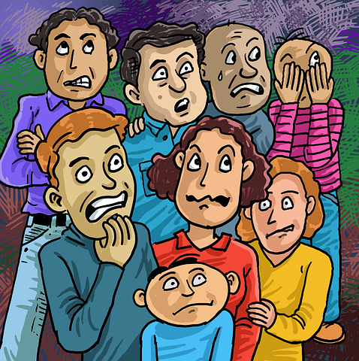 | 

Čega se više bojiš? | ime | ime
smrti ili zmija

9.3 Zadatak 3. Koronavirus
In class we already covered the symptoms for a general cold and flu. Now it’s your turn to find out what the symptoms are for Covid-19. You can check your answers on the website (Section “Medicinski podaci” #1) as well – you are not required to understand everything, but you will be able to recognize terms we mentioned in the class.
 | 

1 | Koji su simptomi koronavirusa?
1 | -

9.3 Zadatak 4. Biti bolestan
Answer all the following questions, except the last one. These are related to your personal actions and opinions. When you have your answers, interview one of your classmates. Only then will you be able to answer the last question. Submit your video recording of interviewing a classmate online.
 | 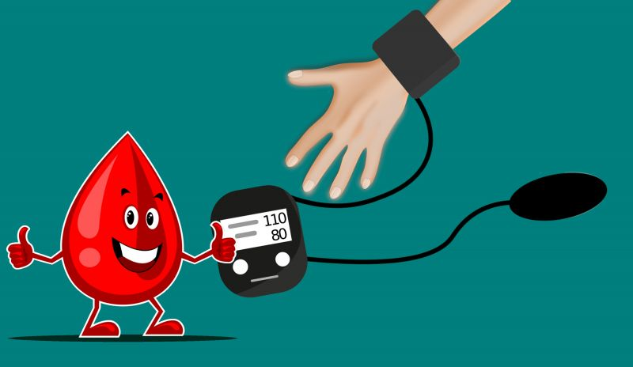

| Osobni stav
1 | Što te često boli?
1 | -
2 | Ideš li liječniku kad si bolestan/bolesna?
2 | -
3 | Što obično jedeš i piješ kad si bolestan/bolesna? Zašto?
3 | -
4 | Što radiš kad si bolestan/bolesna?
4 | -
5 | Piješ/uzimaš li tablete kad si bolestan/bolesna (npr. aspirin, ibuprofen)?
5 | -
6 | Koliko ste vi slični?
6 | -

9.3 Zadatak 5. Dijalog
👥 Rad u paru: Dijalog. You are talking on the phone with your friend. Start the conversation by calling your friend. One of you is playing the role of being sick, the other one wants to check up/help a friend.
Ask/answer about their symptoms and current eating habits, and if they’re taking any medications. Offer to take your friend to see a doctor. Offer to bring whatever your friend needs. Be specific on the items you suggest. Say why will you bring the specific things you mention.
Submit your video dialogue online.

9.3 Zadatak 6. Razgovor – kultura
This assignment is in English and it reflects your understanding and further research on cultural components related to Croatia. Look back at the class session Google document – task Kako biti zdrav. Then, read the following articles as well before answering the questions.
About propuh (Cody McClain Brown)
Writing from Cody McClain Brown (4 very short texts)
Rakija, Croatia’s legendary liqueur (focus on the section: Situations when Croats use rakija)
8 ways Croatia has not changed me (focus on parts about health)

1 | Are any Croatian attitudes and/or beliefs similar to ones in your country?
1 | -
2 | Why do you think rakija is so important in Croatian society/culture? What values lie behind it?
2 | -
3 | Are any of the actions/behaviors from today’s class task Kako biti zdrav applicable in your country? Why do you think so?
3 | -
4 | Related to the last article from the external reading list: Could you see yourself behaving the same way as Sara after living in Croatia? Why? Explain.
4 | -
5 | What does propuh mean to you? How do you interpret Croatian behavior in terms of propuh?
5 | -

Images used in this document are from these sources.

