10.4 - Going by transport - Instrumental ‘by means of’

 | 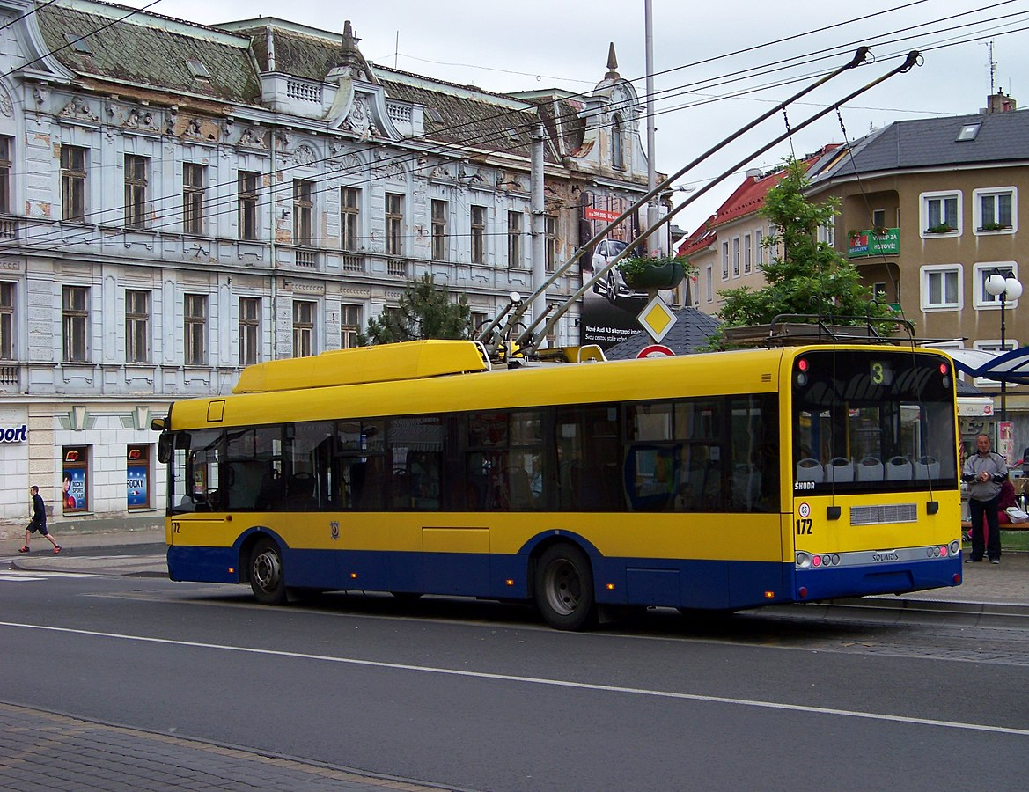
Lidi v Praze často jezdí metrem. | Bára dnes jede do práce trolejbusem.
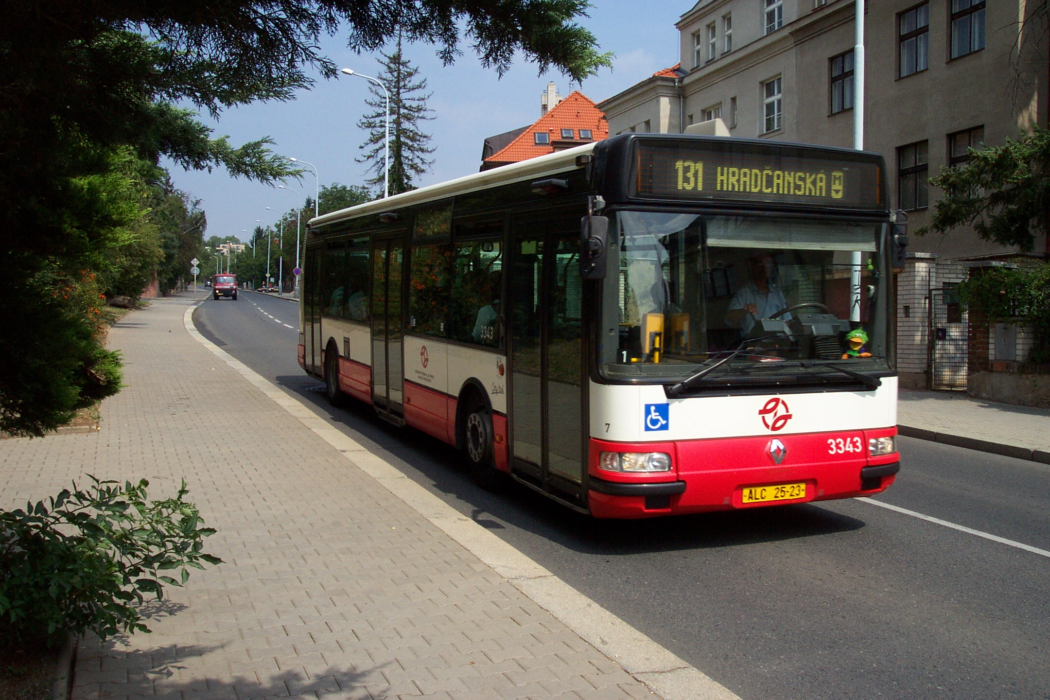 | 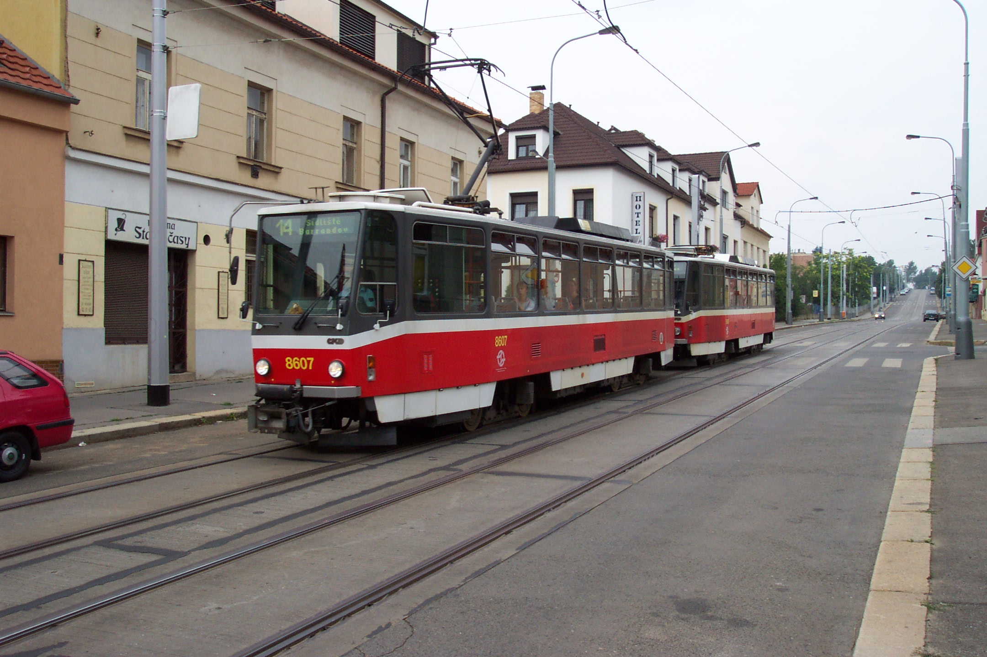
Málokdy jezdím autobusem, protože mám auto. | Jezdíme tramvají skoro každý den.

Take a look at these sentences above. All of them talk about How a person is getting somewhere. For this we use the instrumental in the meaning by means of. They are being combined with our verbs jezdit and jet ‘to go by vehicle’.

Means of Transport | Meaning | Instrumental Form (i.e. by means of…)
auto | car | autem
autobus (colloquially bus) | bus | autobusem (colloquially busem)
letadlo | plane | letadlem
loď (f.) | boat | lodí
metro | metro | metrem
tramvaj (f.) | tram | tramvají
trolejbus | trolley | trolejbusem
vlak | train | vlakem

Images used in this document come from these sources.

