4 | 1 | Lekcija 3: Kupnja u IKEA-i

4.1 Zadatak 15. Laurina soba
Video presentation. Based on the class assignment on Laura’s bedroom, upload your video presentation of your work. You will need to show us your košarica (shopping bag) list. Tell us what you want to buy and where you would place all the things in the bedroom. Preferably, copy-past images of things you want to buy into Laura’s bedroom so other students can get the visual representation of your idea. Submit your video presentation online.

4.1 Zadatak 16. U studentskom domu
Online dialogue with another classmate. You and your future roommate are both international students who are spending a semester in Zagreb. You have a room in studentski dom Stjepan Radić that you will share for the entire semester.
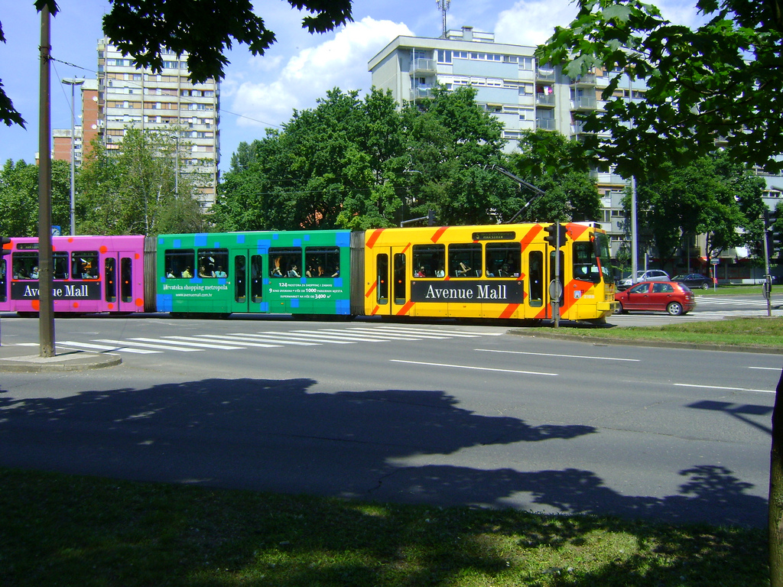 | 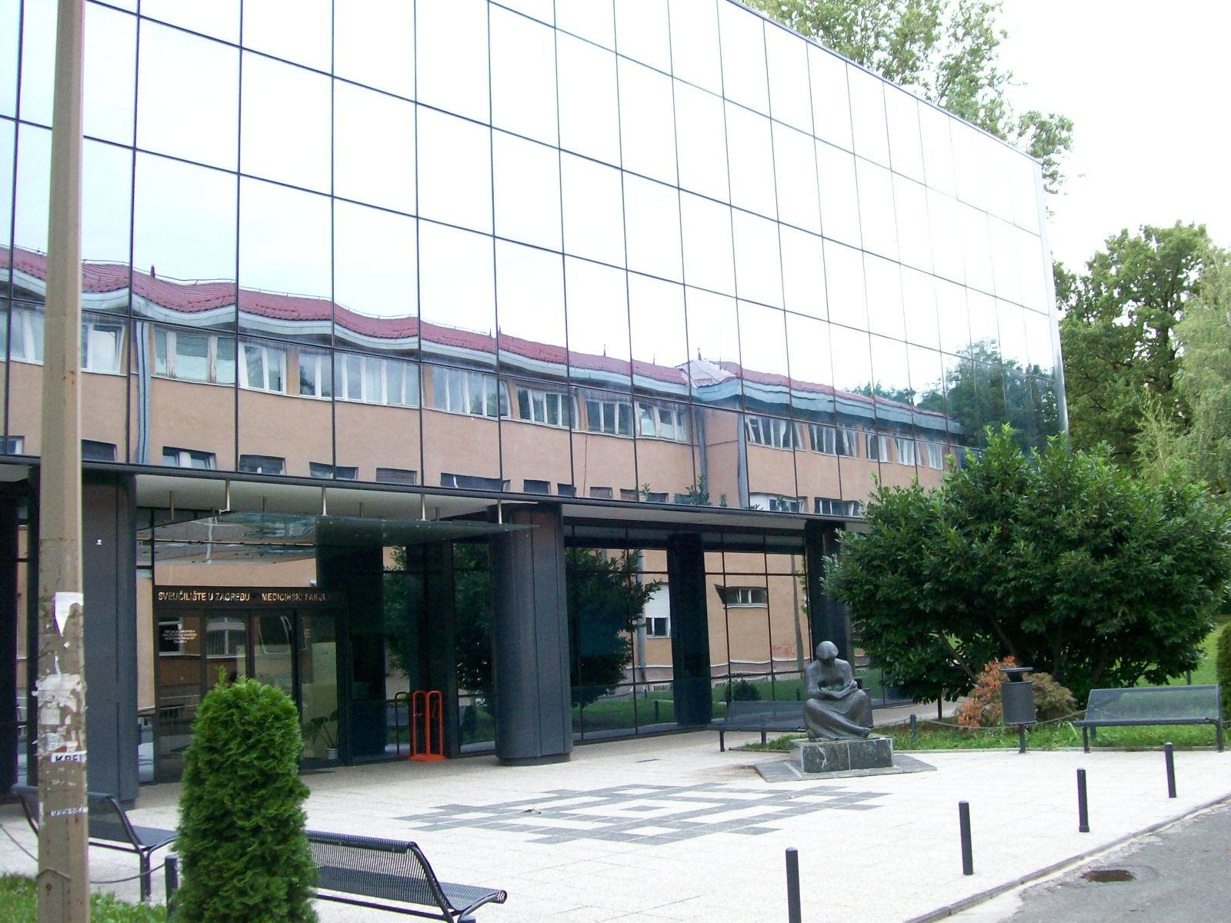
Before completing the task, do some online research to find out more about studentski dom Stjepan Radić. You can start by looking at the following link.

Part 1
Pick one of the pictures from the link. Based on that picture, you will need to buy furniture (things that you would like to have in your room) in IKEA:
Have your shopping bag ready for the dialogue, you will need to show your new roommate what you bought.

Part 2
Make a cohesive dialogue in which you will meet for the first time, learn some information about each other, and then switch to talking about your shared room. Ask each other why you are in Zagreb. Exchange opinions about the dorm and your (empty) room. Negotiate where you will place all the items that you both bought individually. Since this is a shared space, you both need to feel comfortable in the room.

| Questions to include in your dialogue/discussion
Odakle si?
Zašto studiraš u Zagrebu?
Kakav je studentski dom?
Gdje se nalazi dom u Zagrebu? (mapa)
Je li to moderan, staromodan, renoviran studentski dom?
Što ima u sobi?
Kako urediti sobu?
Gdje staviti stvari/namještaj?

4.1 Zadatak 17. Šoping u Zagrebu
Since Laura is in Zagreb for a year, she decided to buy some furniture for her bedroom. She will probably sell her stuff at the end of the academic year on Facebook market, website Njuškalo, or her friends will help her. To buy furniture, Laura decided to rely on what she knows and went to IKEA. However, people in Croatia also use the website njuškalo.hr to buy things. People in Zagreb also go to Hrelić to find things.

| In English

NJUŠKALO
Browse through njuškalo.hr and tell us what the website is for. What sections can we find there?
Would you consider using the website if you find yourself living in Croatia for an entire academic year as our characters Laura and James? Is there any similar website/concept in your country/city?

HRELIĆ
Browse the internet and find what Hrelić is. Provide your opinion about the place – be detailed in your answer. Would you consider going there and/or buying something there? Is there a place like this in your city?

| In Croatian
Answer the questions.
1 | Što je Hrelić?
1 | -
2 | Gdje se nalazi Hrelić?
2 | -
3 | Što možemo kupiti na Hreliću?
3 | -
4 | Jesu li stvari skupe ili jeftine na Hreliću?
4 | -
5 | Što želiš kupiti na Hreliću?
5 | -

Images used in this document are from these sources.

