9 | 3 | Lekcija 2: Doktore, pomozite!

9.3 Zadatak 7. Kako se kaže?
What are the three main legal documents/cards that every citizen in Croatia has/can have?
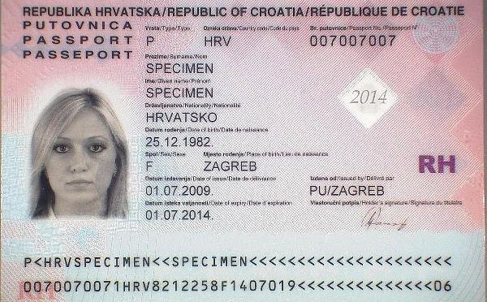 | 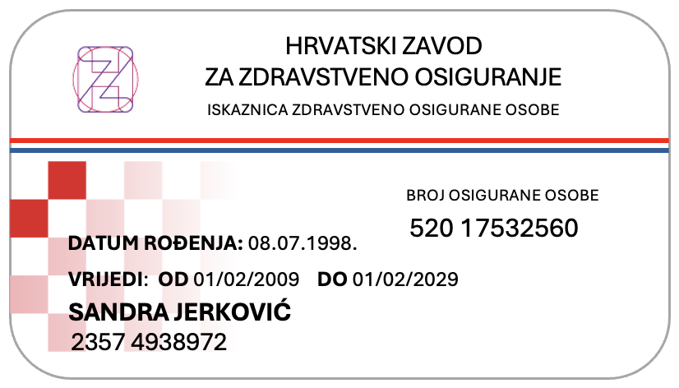 | 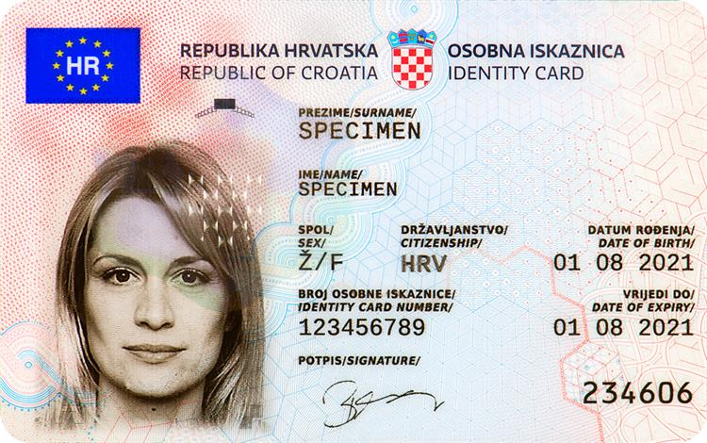
→ | → | →

1 | How would you say to someone that they need to wait?
1 | -
2 | How would you say that someone can anticipate certain questions?
2 | -
3 | How would you say that you are afraid of something?
3 | -
4 | How would you say that it’s dangerous to take medicine on your own?
4 | -
5 | How would you say that it’s nothing serious?
5 | -
6 | How would you express gratitude to someone? There’s a phrase for this.
6 | -
7 | How would you remind someone to do something?
7 | -
8 | How would you say that you are weak with no strength?
8 | -
9 | How would you say that you need to take an antibiotic twice a day? (There are two ways of saying this.)
9 | -

9.3 Zadatak 8. Kako se brinuti o sebi?
Look at the following suggestions on what someone should do when sick. Use the appropriate verb in the imperative form based on the rest of the sentence.
jesti | koristiti | odmarati
kupiti | izmjeriti | drijemati
piti | gledati | pogledati

_____________ puno povrća i voća u trgovini. _____________ puno vode i čaja. Organizmu treba puno vode. _____________ laganu hranu, nemoj jesti slatkiše. Ako možeš, _____________ temperaturu i tlak. Normalni tlak je 120/80mmHg, a normalna tjelesna temperatura je oko 36,1°C. Jednom dnevno _____________ je li tvoje grlo crveno. Ako je grlo crveno i kašlješ, _____________ sirup za kašalj. _____________ i _____________! Tijelo se treba odmoriti. Trebaš više energije nego inače. Ponekad, ako imaš dovoljno snage, _____________ malo TV. Ne previše jer te može glava boljeti.

9.3 Zadatak 9. Bolest i simptomi
Look at the following information and pick only one set of symptoms. In column (a), write what a doctor should do, what tests should the doctor perform? In column (b), write what you would suggest to your friend in the event they have those symptoms. In column (b) use the imperative and write complete sentences.
Simptomi | Koronavirus | Prehlada | Gripa
temperatura | uobičajeno | rijetko | uobičajeno
umor | ponekad | ponekad | uobičajeno
kašalj | uobičajeno | ponekad | uobičajeno
kihanje | ne | uobičajeno | ne
bolovi | ponekad | uobičajeno | uobičajeno
curenje nosa | rijetko | uobičajeno | ponekad
grlobolja | ponekad | uobičajeno | ponekad
proljev | rijetko | ne | ponekad
glavobolja | ponekad | rijetko | uobičajeno
teško disanje | ponekad | ne | ne
Koja je bolest?
Stupac (A)  Što liječnik treba napraviti? |  | Stupac (B)  Tvoj savjet prijatelju:
→ |  | →

9.3 Zadatak 10. Slušaj me!
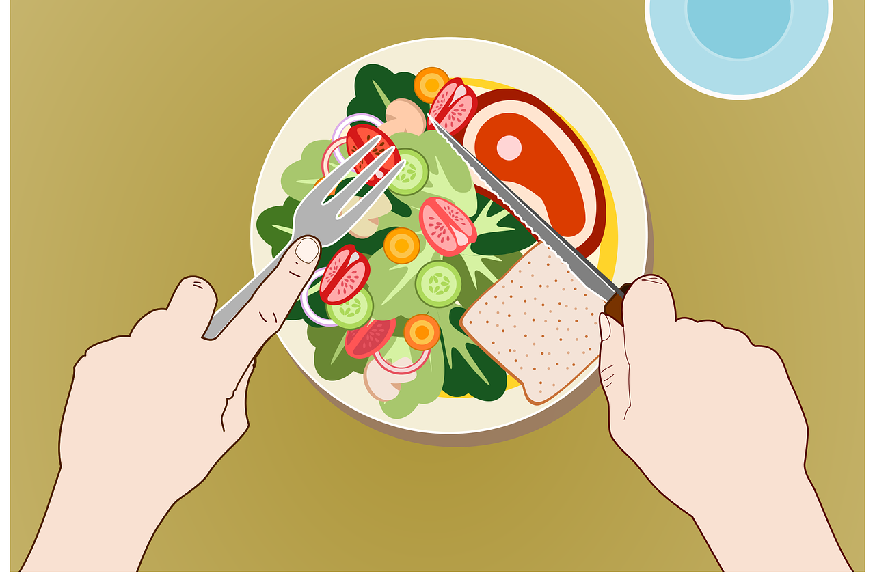 | 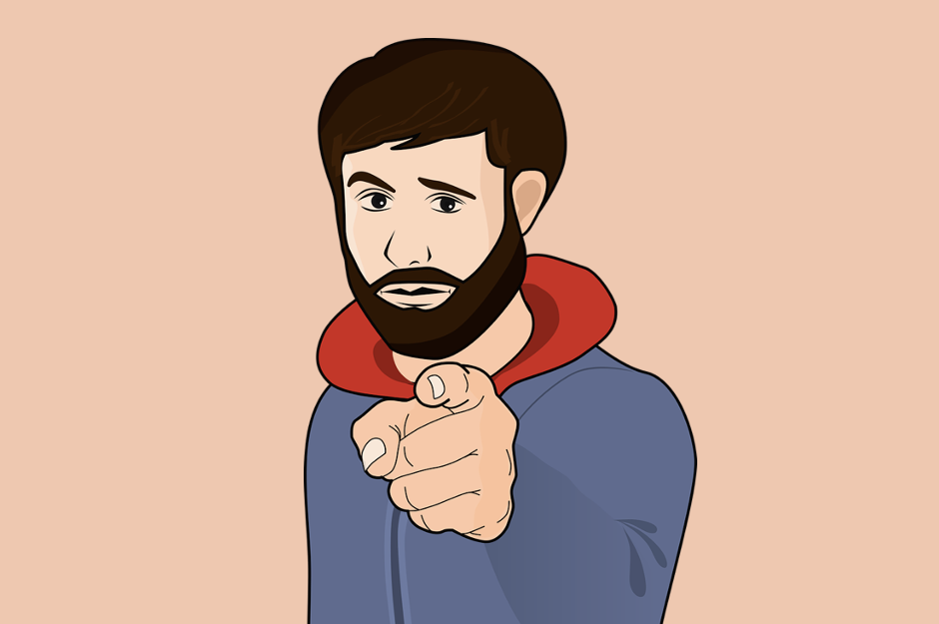

👥 Meet with one of your classmates. Ask them about their regular day. What does it look like – daily habits, work, activities, eating/drinking habits, sleep, etc. (and anything else you think is important to include). When you collect the information, give suggestions to your classmate about what they should do to live healthier – both what to do and what not to do). Submit your video recording online. Use the imperative to express your suggestions (do this, do that).

Images used in this document are from these sources.

