9 | 1 | Lekcija 1: Sport i rekreacija

9.1 Zadatak 1. Kako se kaže?
Based on today’s dialogues, how would you express the following situations in Croatian?
1 | How do you say that you have no energy?
1 | -
2 | How do you say that you envy someone?
2 | -
3 | How do you express that you are not opposed to something?
3 | -
4 | How do you express that you have not been physically active lately?
4 | -

9.1 Zadatak 2. Olimpijske igre
Ljetne i zimske Olimpijske Igre
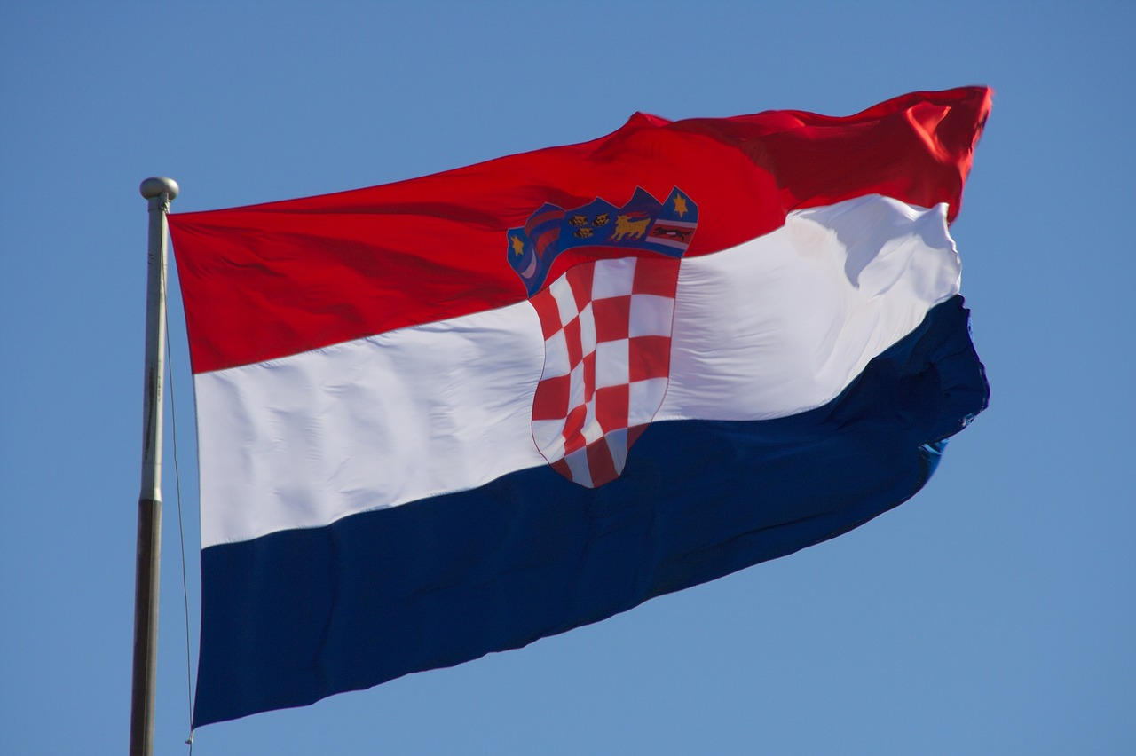 | 
Look at the following types of sports. Write answers to the questions.

 |  |  | 
 |  |  | 
 |  |  | 
 |  |  | 

1 | Koje sportove voliš gledati?
1 | -
2 | Kojim sportom/sportovima se baviš u slobodno vrijeme?
2 | -
3 | Jesi li ikada igrao/igrala neki sport profesionalno? (ikada = ever)
3 | -
4 | Koje sportove ne voliš? Zašto?
4 | -

9.1 Zadatak 3. Moja obitelj
Tell us more about two members of your family. Be sure to include the following elements. Submit your video recording online.
| Pitanja
Koji sport ga/je zanima?
Čime se bavi u slobodno vrijeme?
Gdje trenira?
Živi li zdrav ili nezdrav život?

9.1 Zadatak 4. Popularni sportaši
Look at the following pictures and write where they are from and which sport are they playing?
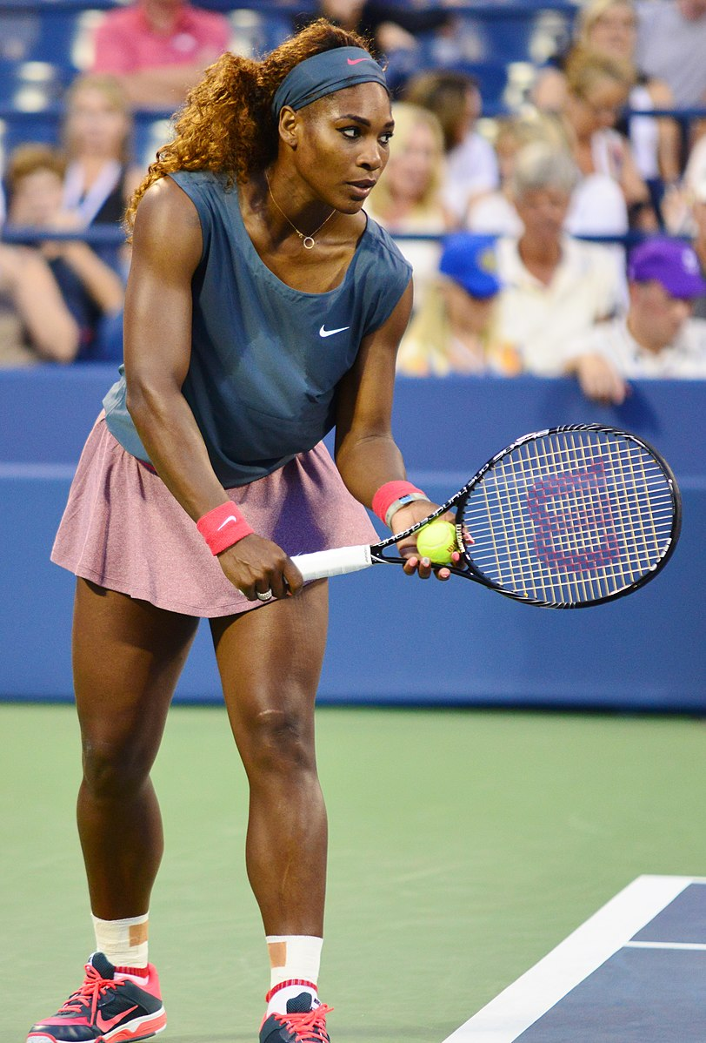 | 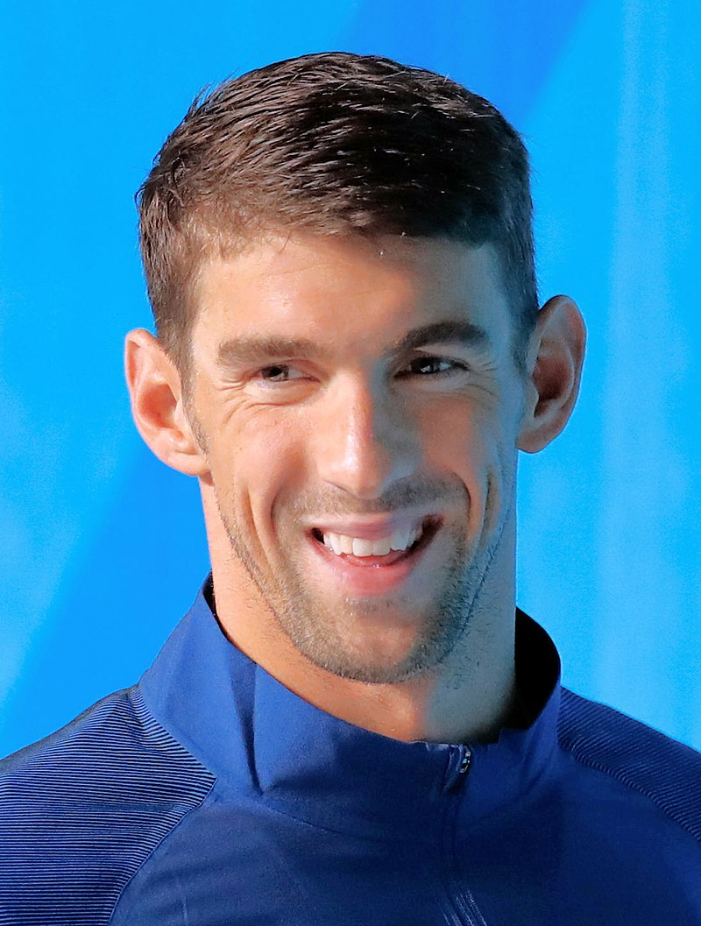 |  | 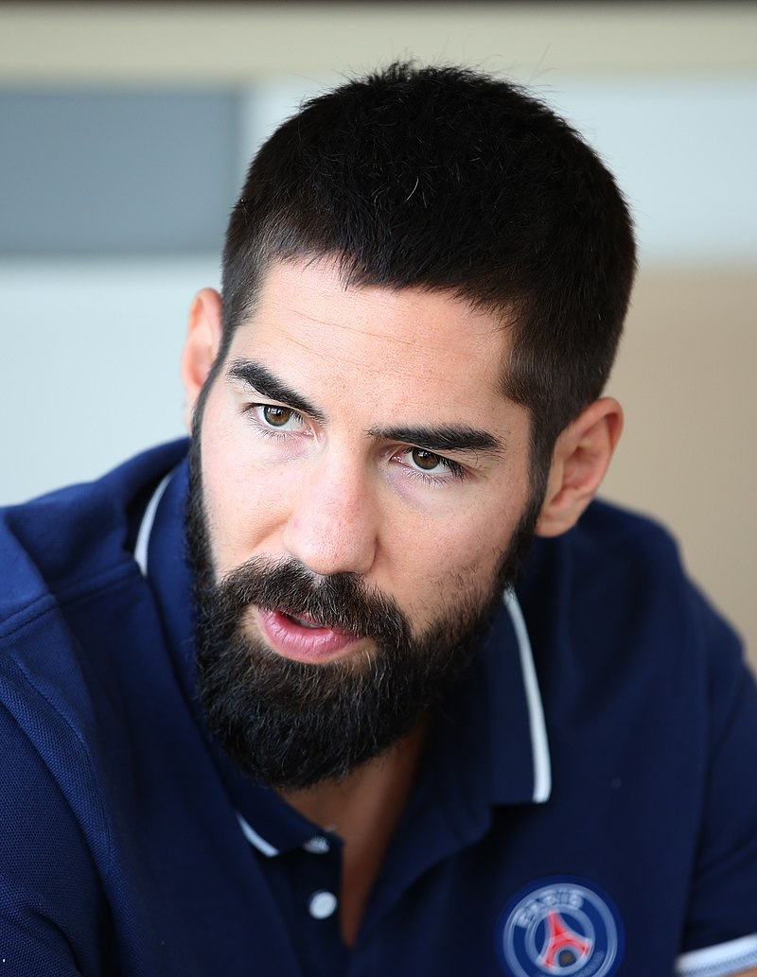
Serena Williams | Michael Phelps | Dale Steyn | Nikola Karabatic
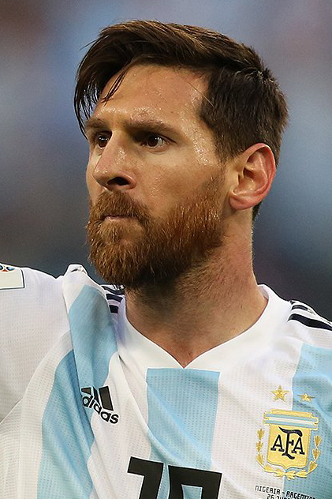 | 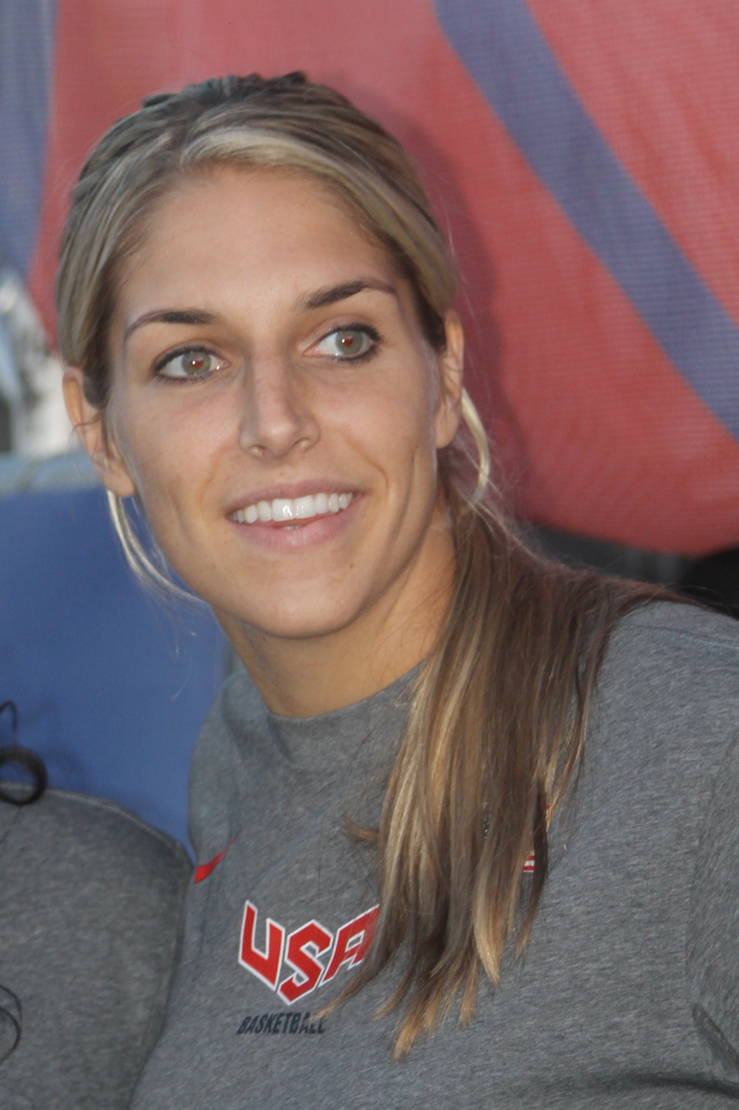 | 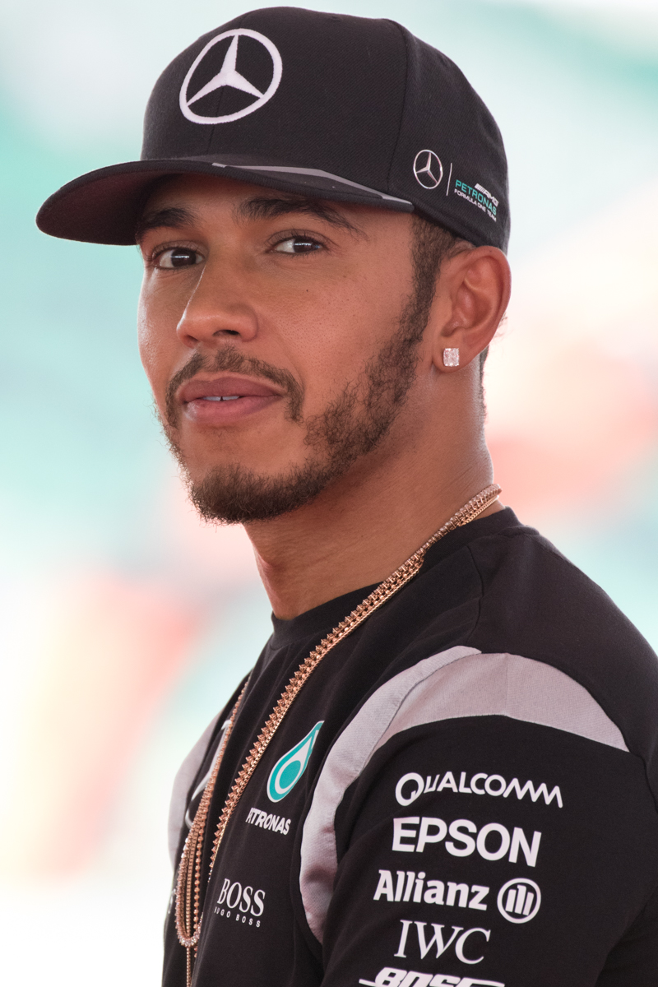 | 
Lionel Messi | Elena Delle Donne | Lewis Hamilton | Mike Trout
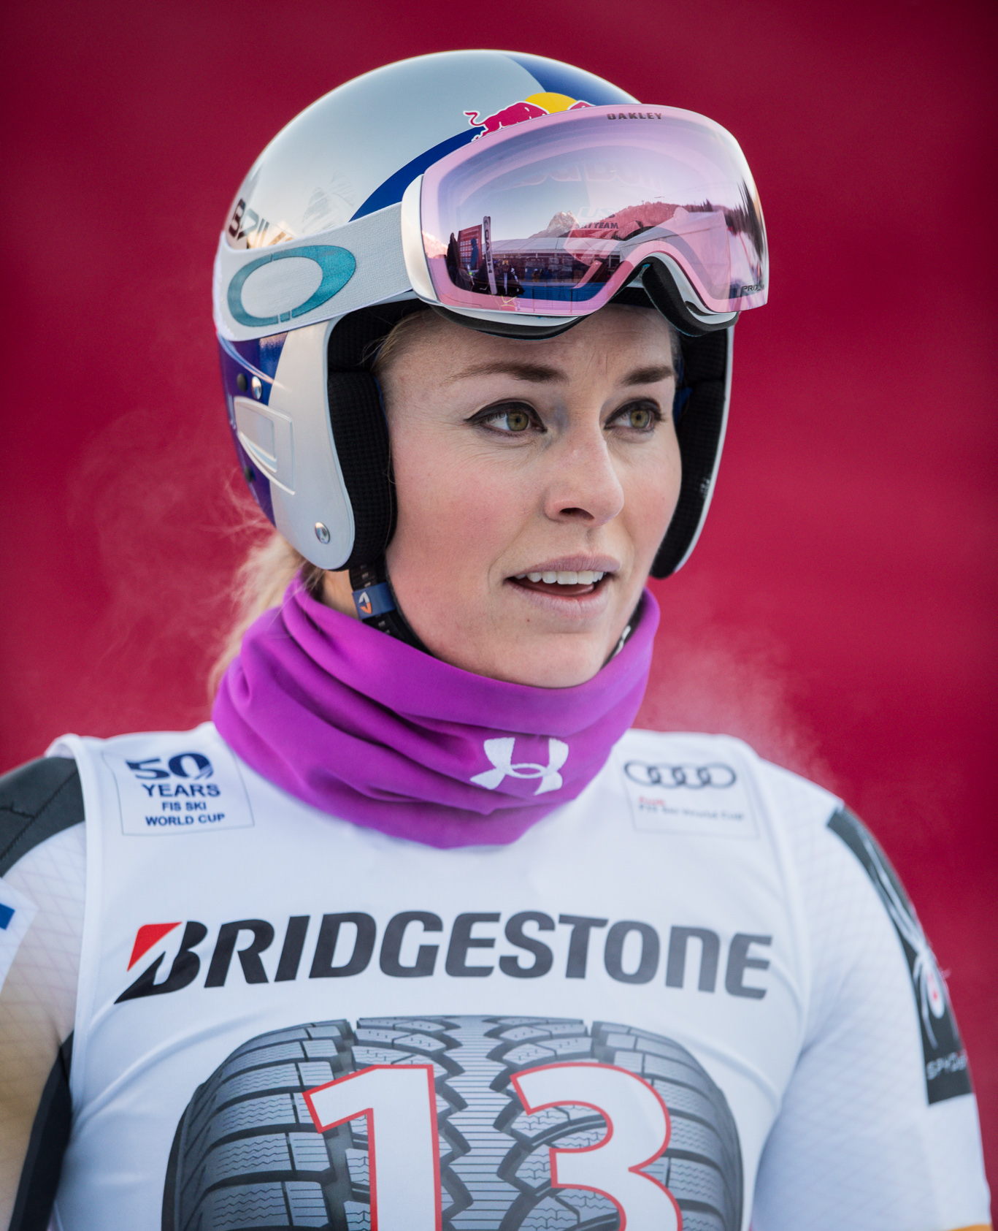 | 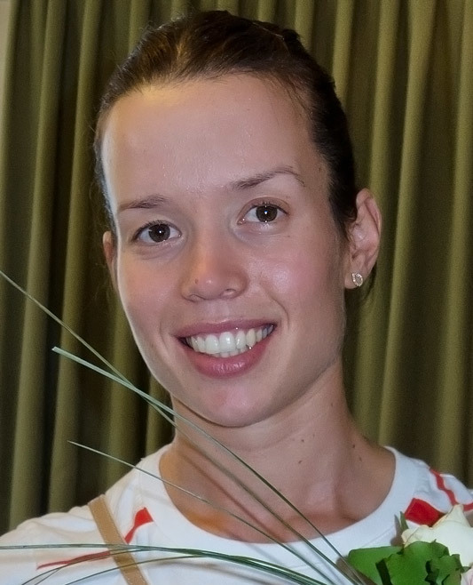 | 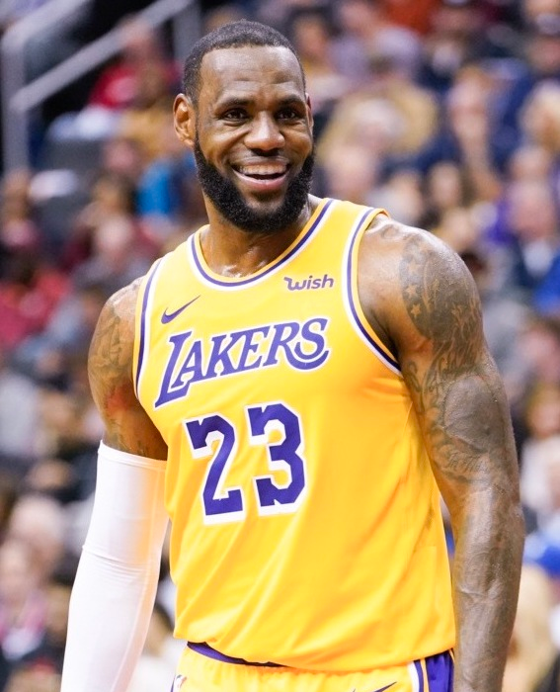 | 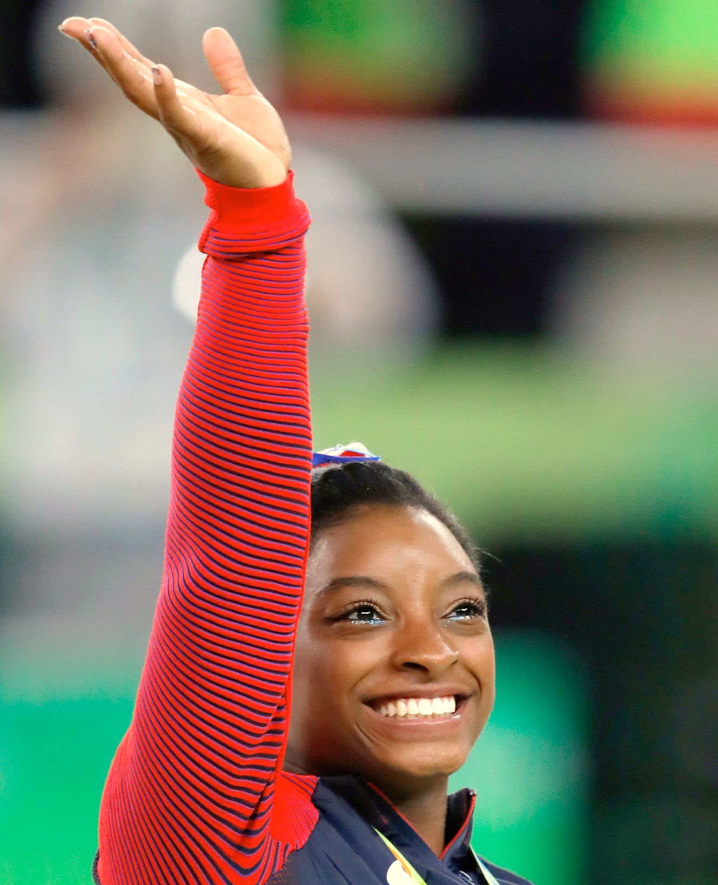
Lindsey Vonn | Lucija Zaninović | LeBron James | Simone Biles

| Odgovor
1.
2.
3.
4.
5.
6.
7.
8.

9.1 Zadatak 5. Intervju
👥 Video recording. Talk with one of your classmates and find more about his/her habits and free time. When you collect the information you will need to provide some comments. Based on the information you collect, write a paragraph about your classmate.
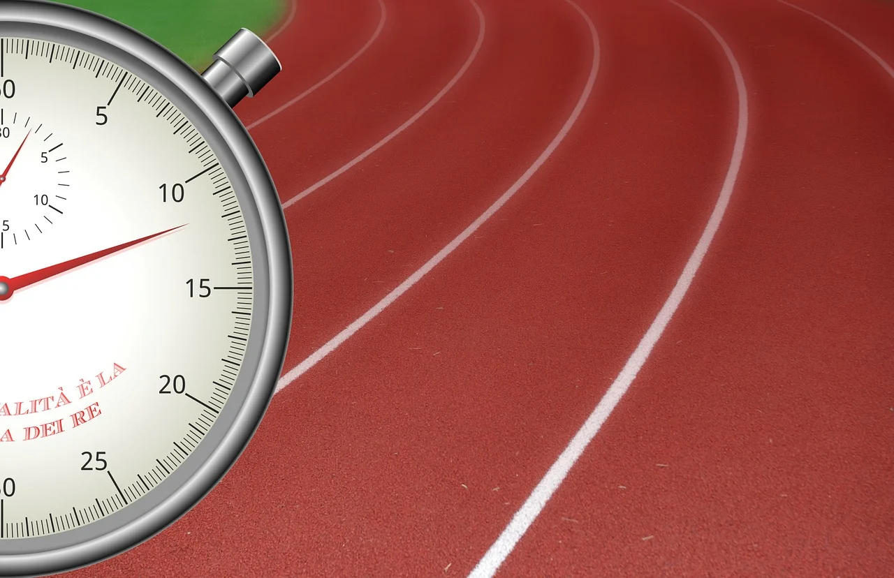 | 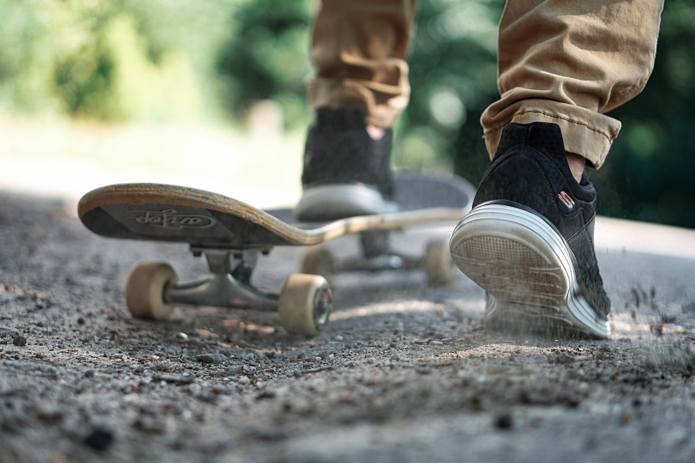
Below are some example questions. However, do not limit yourself to those questions only.
Submit your recorded interview online.

| Possible questions to ask:
Koji su njegovi/njezini interesi?
Bavi li se nekim sportom i koliko dugo?
Tko se u obitelji bavi sportom? Koliko dugo?

| Possible comments:
How similar are you both?
Would you like to play/learn a certain sport that your classmate plays?
Should your classmate be more active?

Images used in this document are from these sources.

