1 | 1 | Lekcija 2: Kako se zoveš?

1.1 Zadatak 4. Kako si?
 |  |  | 
Izvrsno sam. | Dobro sam. | Loše sam. | Umoran sam. | Umorna sam.

Ask one few of your classmates how they feel today.
Student 1 | Kako si?
Student 2 | - (choose from the list above)

Your instructor will check your findings.
Instructor | Kako je on/ona?
Student 2 | - On je… / - Ona je…

Look at the following set of pictures and indicate how they feel:

 |  | 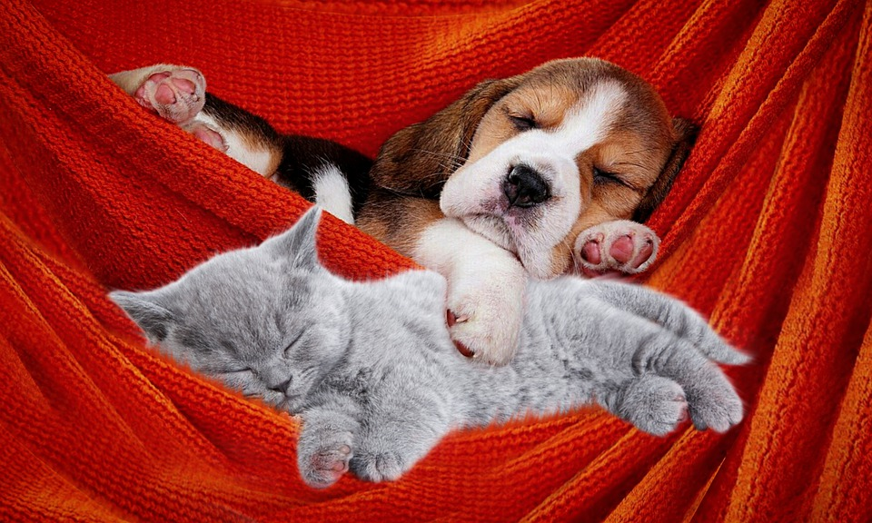

1.1 Zadatak 5. Kako se zoveš?

Part 1
Before proceeding with the task, your instructor will role-play a small dialogue with one of you. Listen carefully to how your instructor phrases the dialogue. Try to guess what it is about.

Example dialogue to perform:
 | 
 | Dobar dan! Ja sam Davor. Kako se ti zoveš?  Dobar dan! Zovem se Laura. Kako si?  Dobro sam, hvala. A ti?  Dobro sam.
Talk with your classmates in order to ask them about their names.
1 | Kako se ti zoveš?
1 | - Zovem se…

Part 2
🔊 Now, listen to the following short dialogues (1 and 2) between students as they ask each other what their names are.
 | 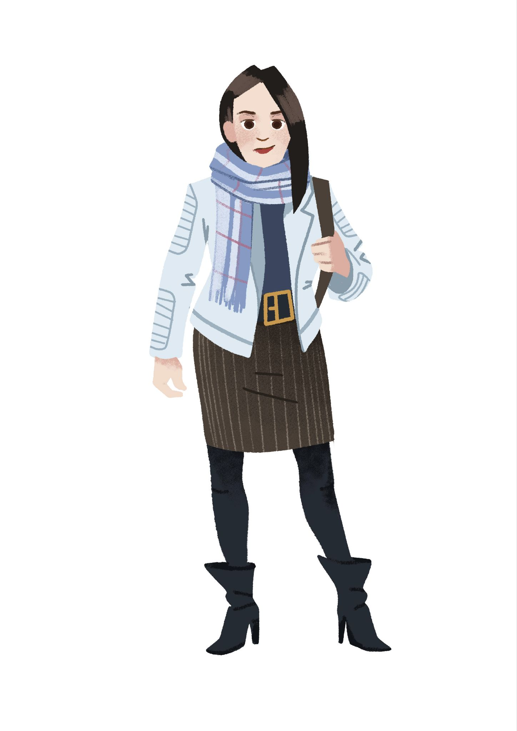 |  | 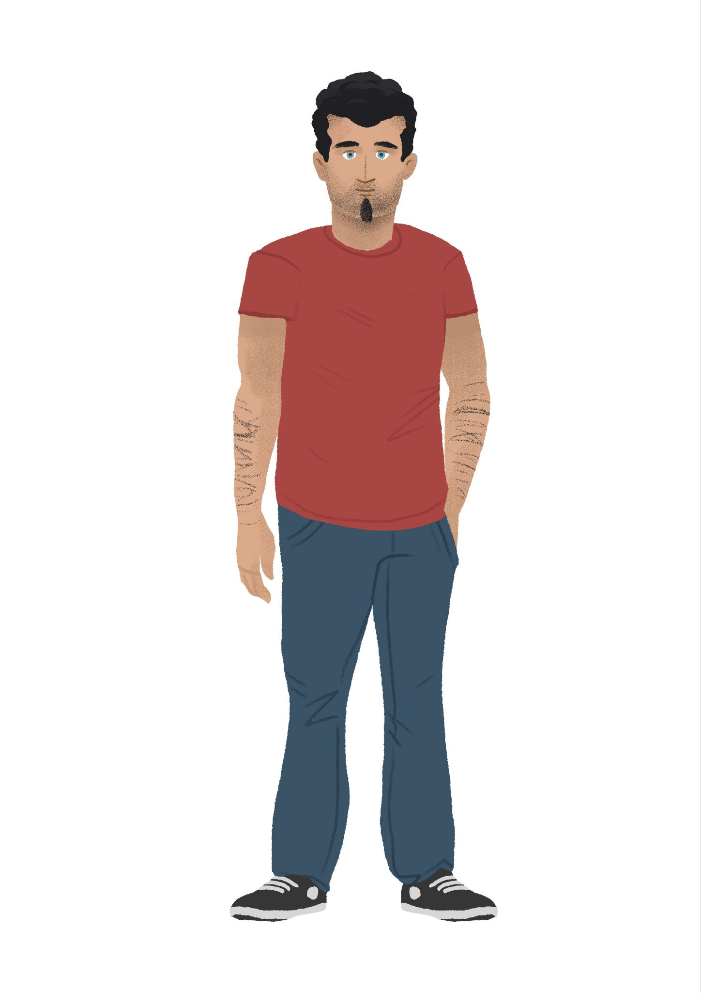
1 | Kako se ona zove? | 2 | Kako se on zove?
1 | - | 2 | -
 | 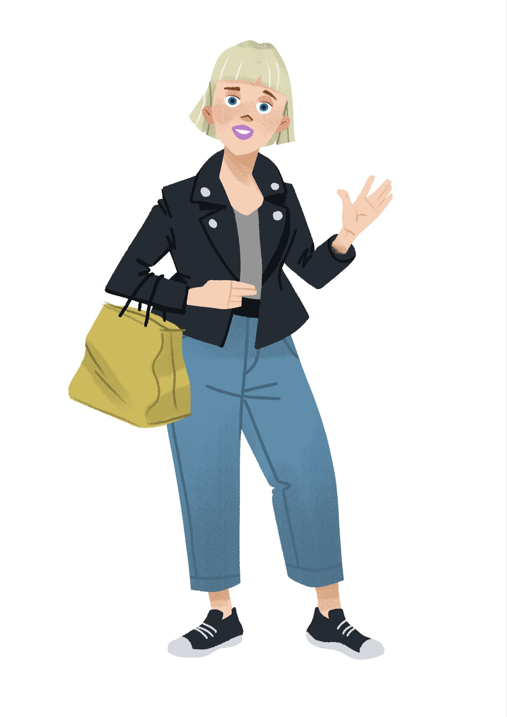 |  | 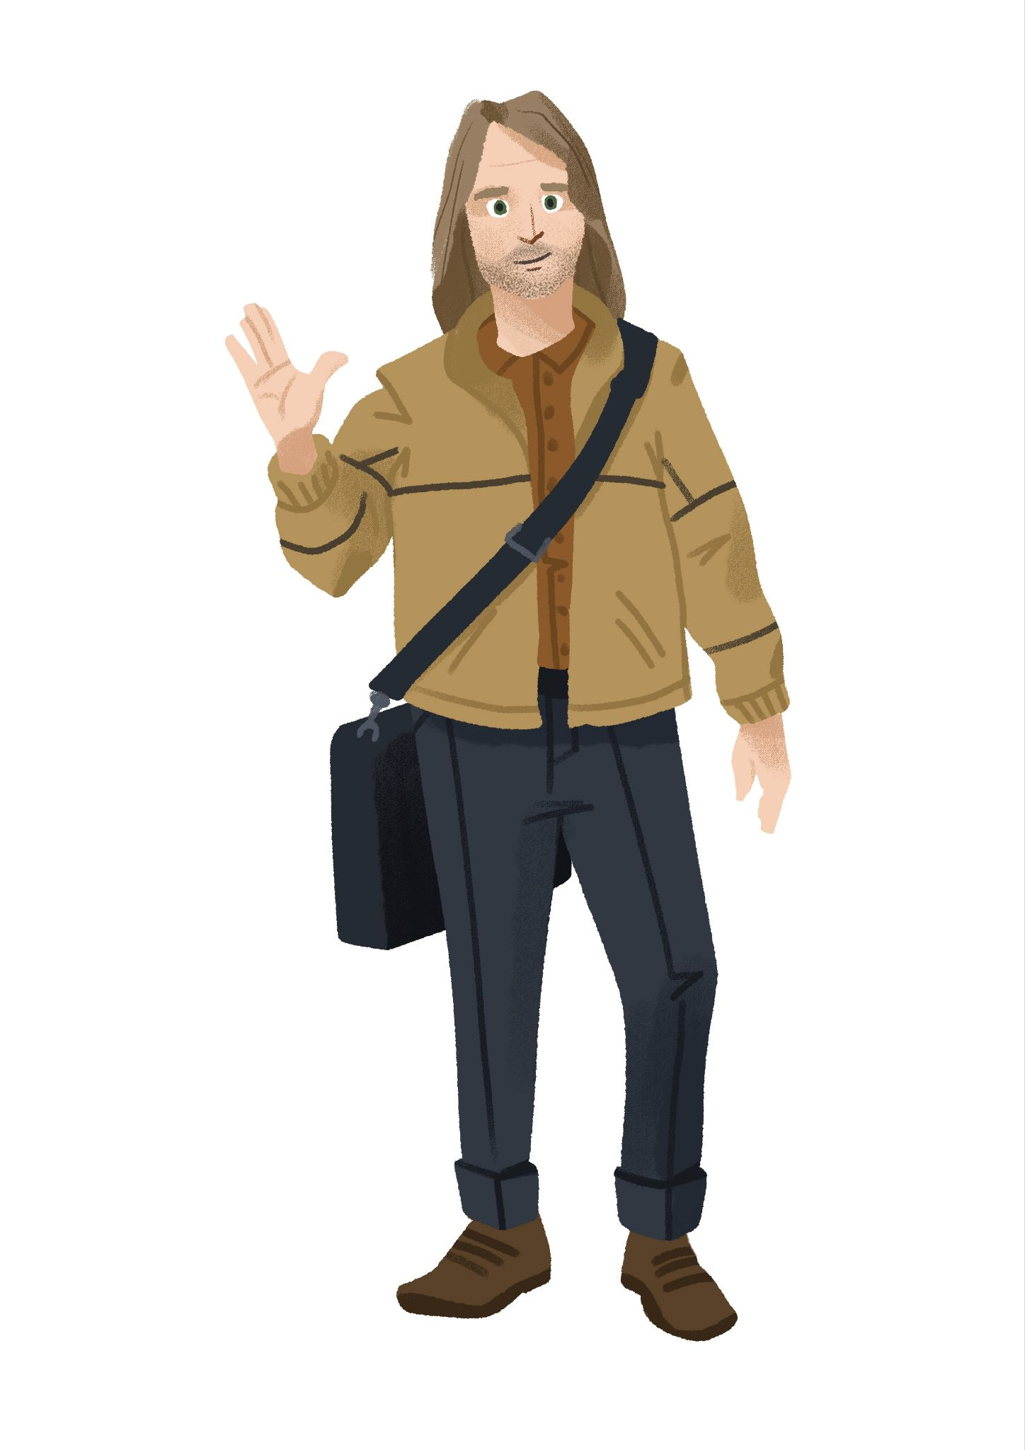
3 | Kako se ona zove? | 4 | Kako se on zove? ♂️
3 | - | 4 | -

1.1 Zadatak 6. Kako se zove?
Based on the information provided next to each name, complete the task.
(1) Janica Kostelić ⛷️ | (2) Ivica Kostelić ⛷️ | (3) Luka Modrić ⚽
(4) Duje Draganja 🏊 | (5) Goran Ivanišević 🎾 | (6) Bojan Bogdanović 🏀

Kako se on zove? |  | Kako se ona zove?
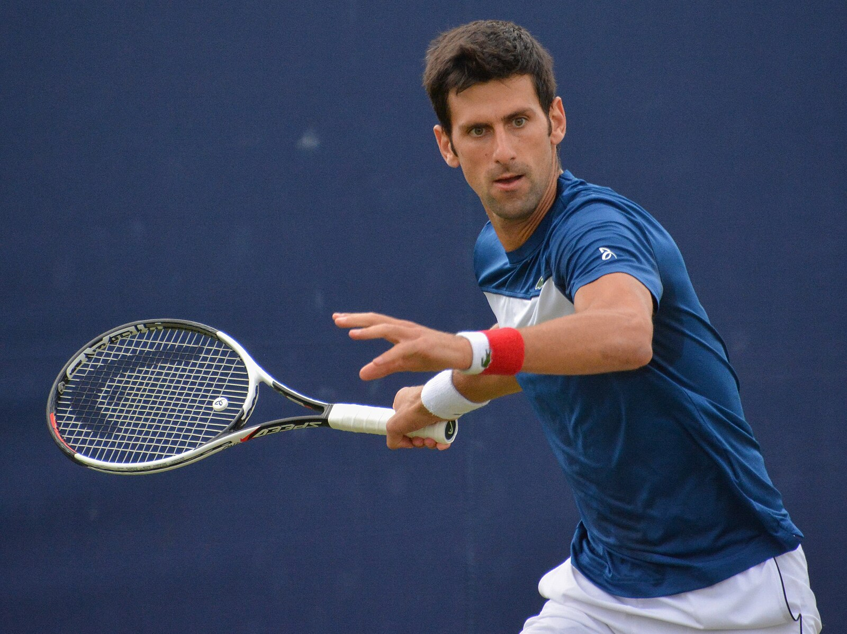 | On se zove …  On je sportaš. | 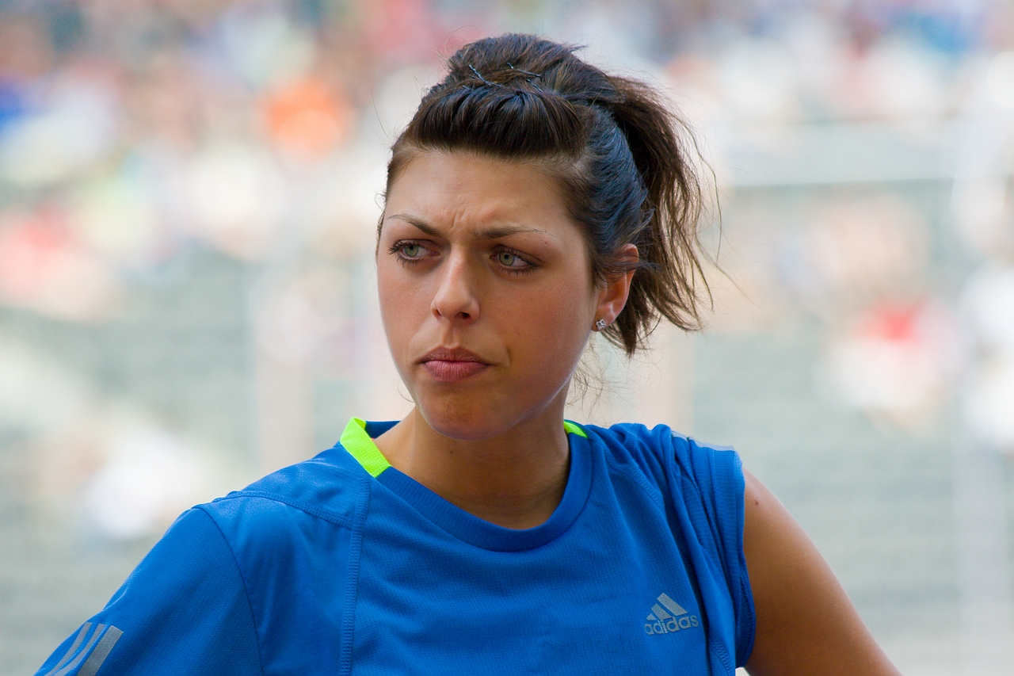 | Ona se zove …  Ona je atletičarka.
Kako se oni zovu?
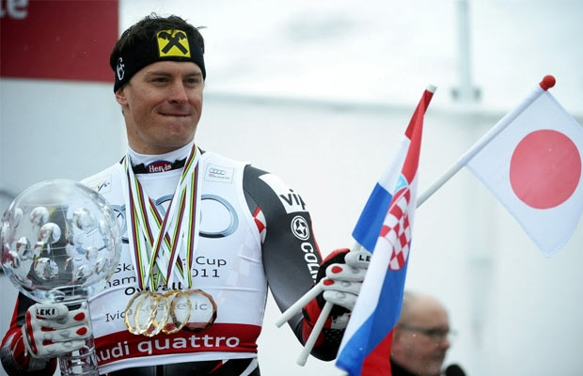 | 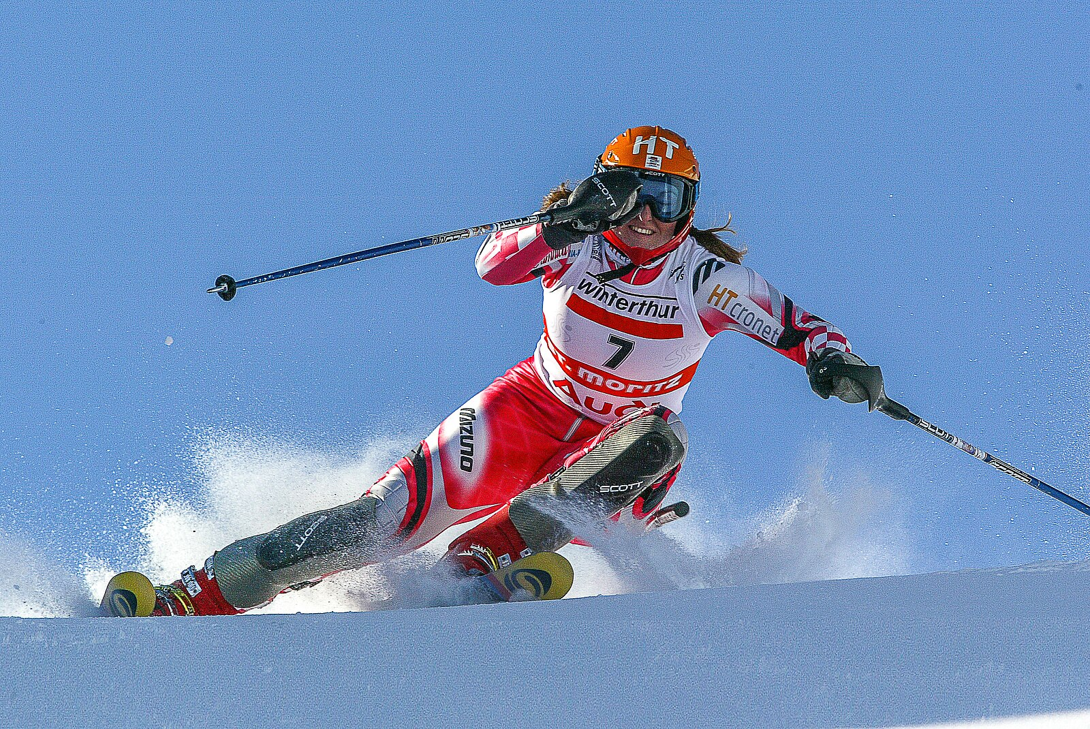 | Oni se zovu … i …  Oni su skijaši.

1.1 Zadatak 7. Kako se oni zovu?
👥 Rad u paru [Pair-work]
Handouts to distribute. Work with a classmate in order to complete the task. When you are done, switch roles (you will have a different set of pictures).

Students A will receive a set of pictures of people, but with their names missing | ➜ | Student A will ask for the name of each person. | ➜ | Student A will write down the person’s name for each picture.
Student B will receive the same set of pictures, but this list will names | ➜ | Student B will provide the names of the people. | ➜ | Student A and Student B will then switch roles.
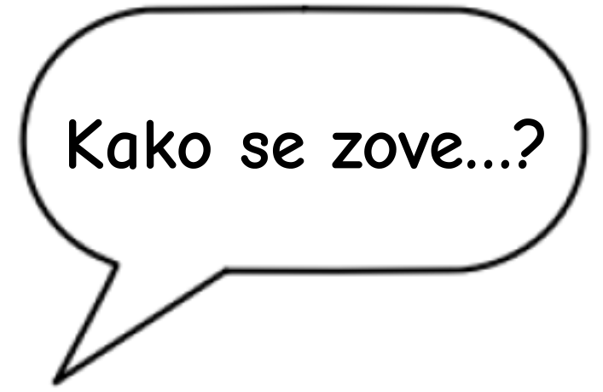 |  |  | 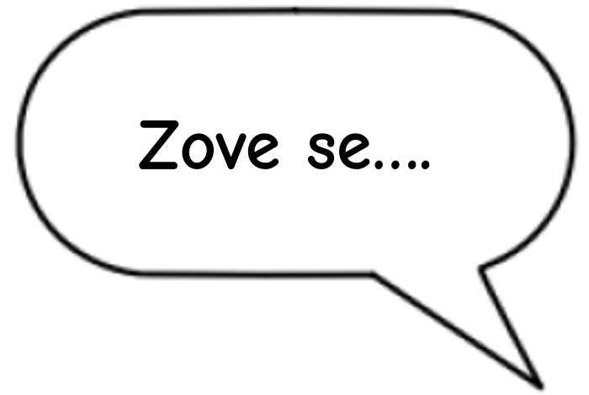

1.1 Zadatak 8. Odakle je?
Tko? |  |  | nacionalnost
(on) | 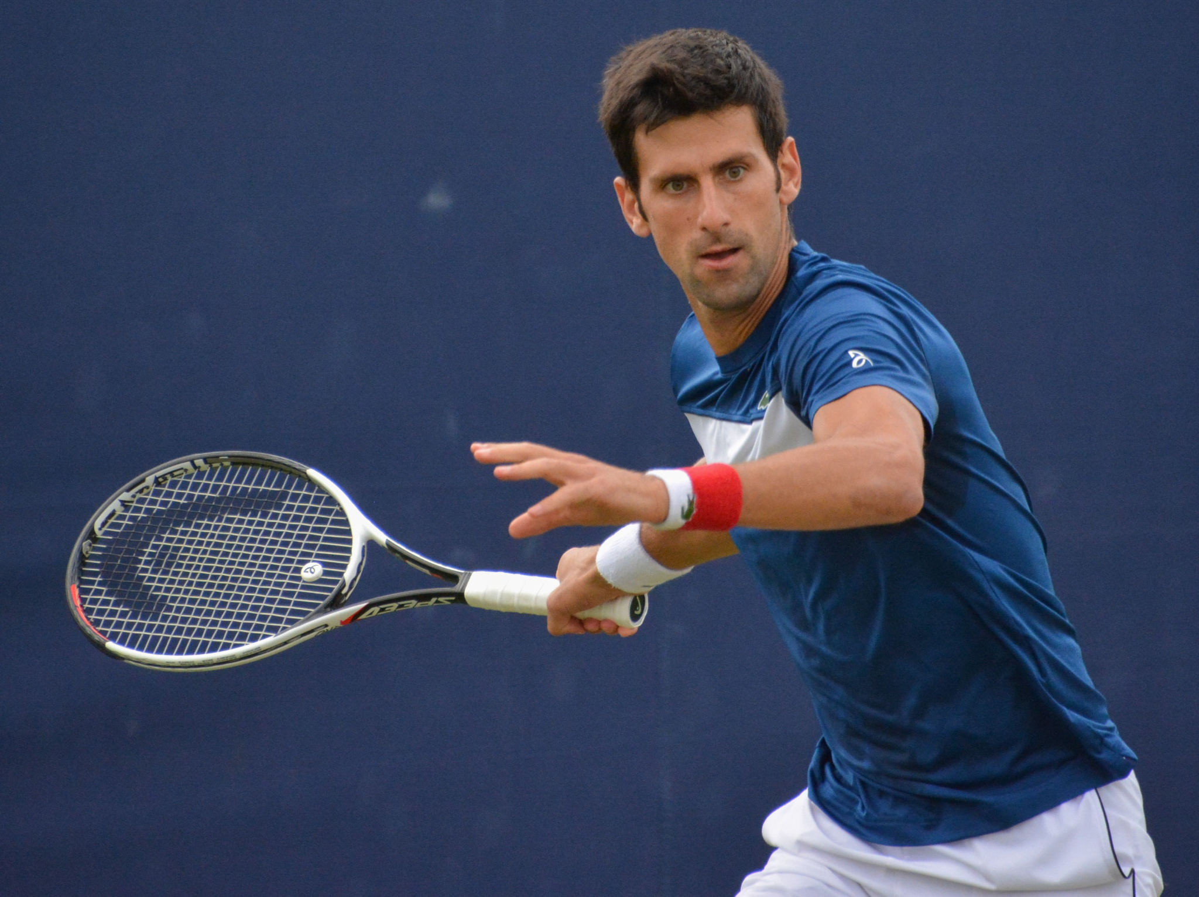 | Novak Đoković je... | →
(ona) | 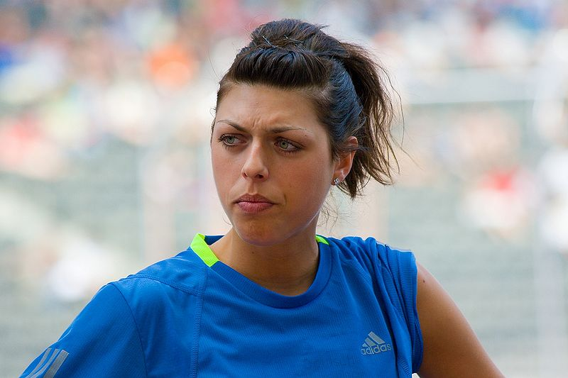 | Blanka Vlašić je... | →

Bosna i Hercegovina | Crna Gora | Hrvatska | Srbija
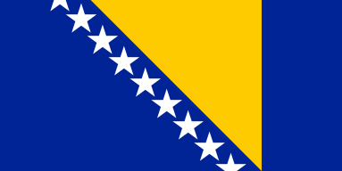 | 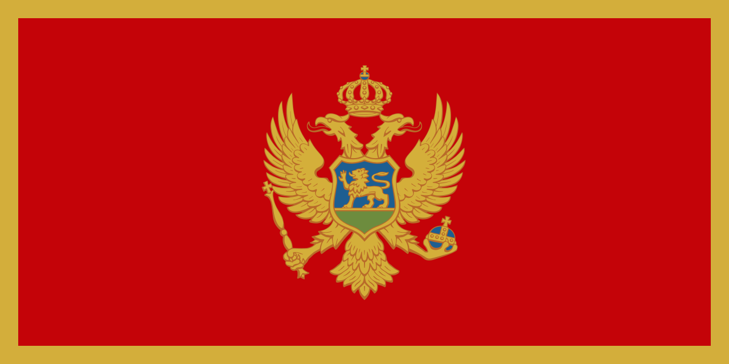 | 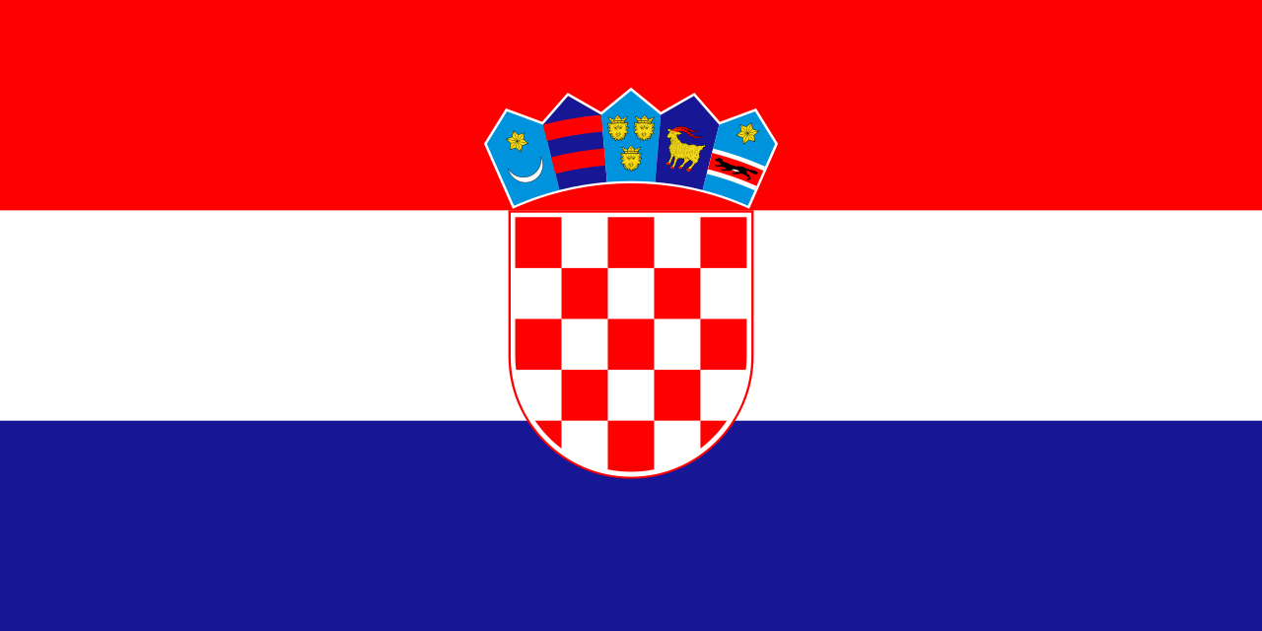 | 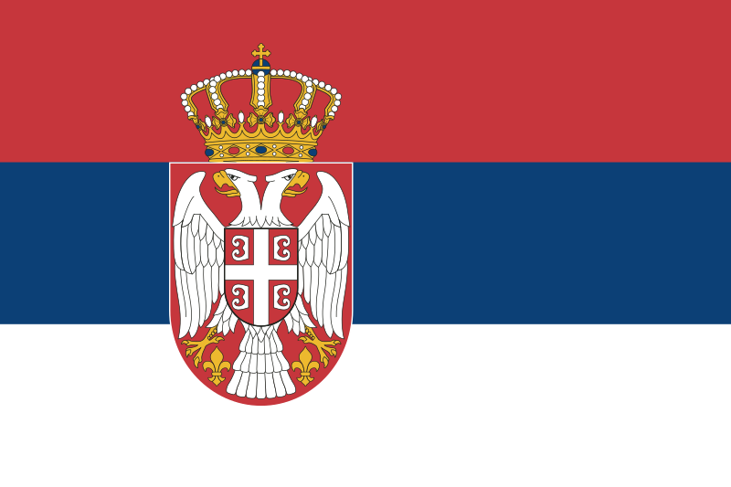
Bosanac  Bosanka | Crnogorac  Crnogorka | Hrvat  Hrvatica | Srbin  Srpkinja
SAD | Meksiko | Kanada | Slovenija
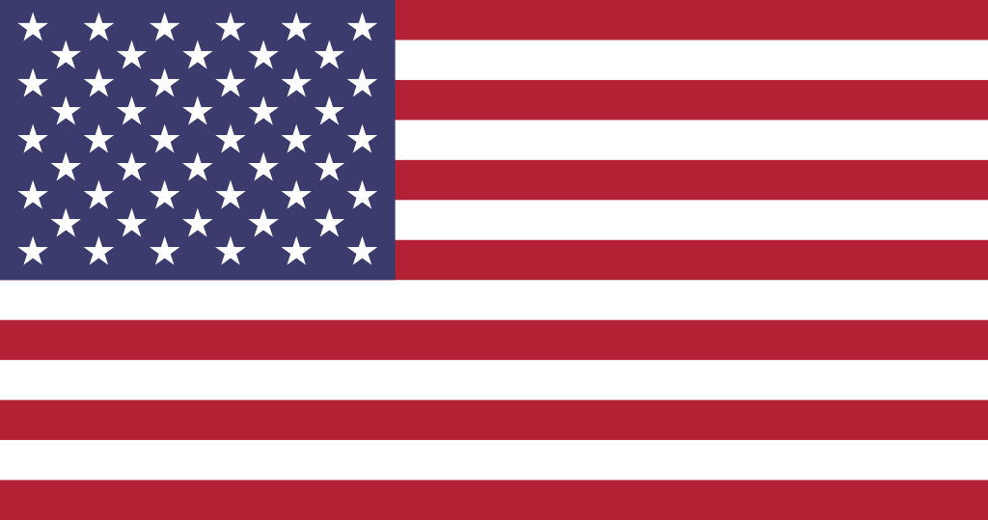 | 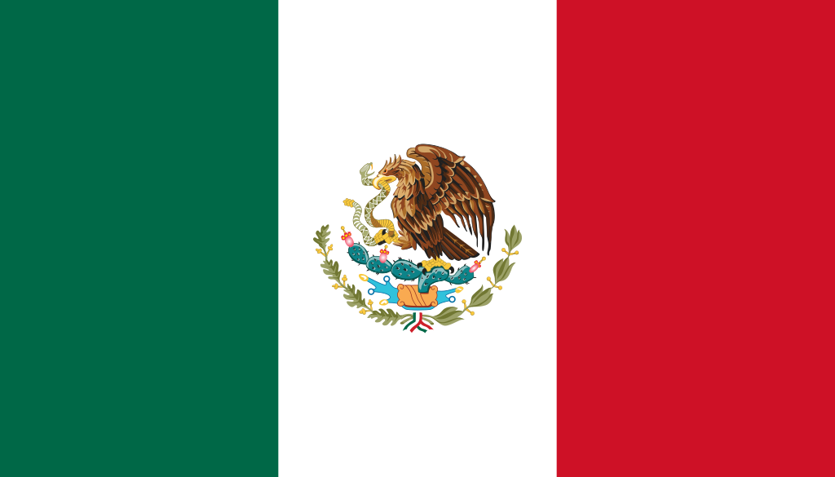 | 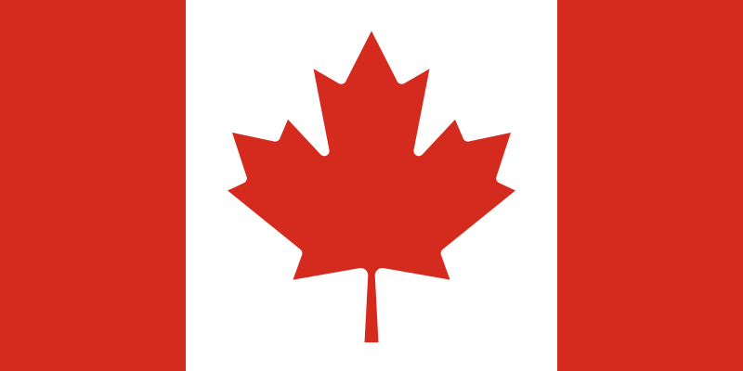 | 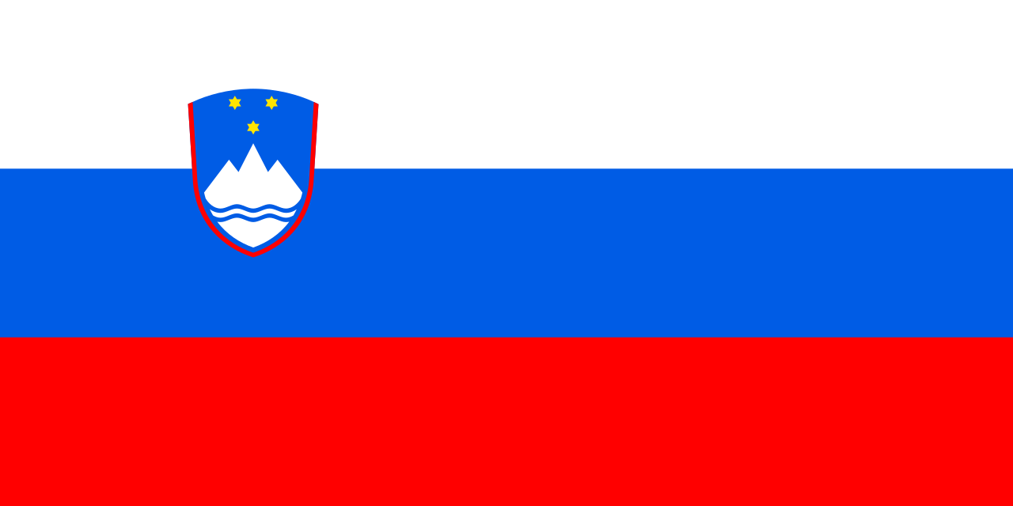
Amerikanac Amerikanka | Meksikanac Meksikanka | Kanađanin Kanađanka | Slovenac  Slovenka

A odakle si ti?- Ja sam …

| Odakle je (on/ona)? Where is he/she from?
Look at the following list of people and connect them with their nationality. If you need any help, try asking one of your classmates for help. Maybe they know the answer. If after asking around you still do not know where someone is from, use Google search to find the answer. Your instructor will check your answers after you complete the task.
1 | 🇷🇸 Mirjana Karanović je | A | Rus – Ruskinja
2 | 🇪🇸Penelope Cruz je | B | Hrvat – Hrvatica
3 | 🇫🇷 Nikola Karabatić je | C | Argentinac – Argentinka
4 | 🇷🇺 Fjodor M. Dostojevski | D | Bosanac – Bosanka
5 | 🇭🇷Marko Marulić je | E | Kinez – Kineskinja
6 | Ivan Meštrović je | F | Španjolac – Španjolka
7 | 🇧🇦Edin Džeko je | G | Srbin – Srpkinja
8 | 🇦🇷Lionel Messi je | H | Francuz – Francuskinja
Images used above are from these sources.

1.1 Zadatak 9. Zastave
Look at the following flags and check off their colors from the list below each image.
Kakva je zastava?
Hrvatska | Bosna i Hercegovina | Italija
 |  | 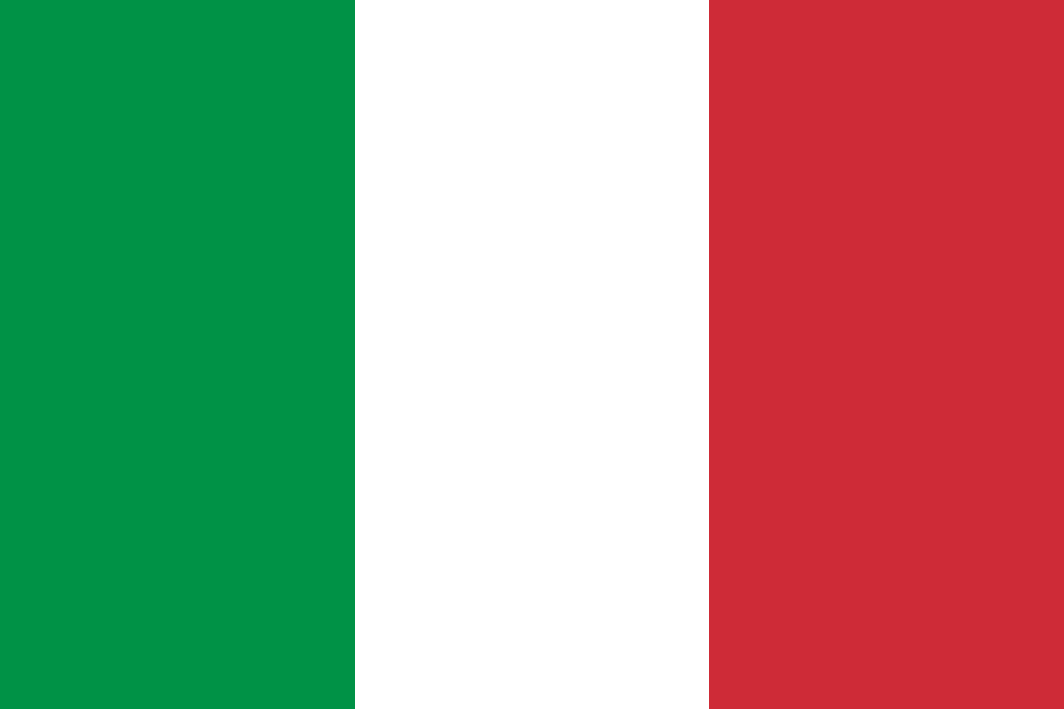
crvena | plava | zelena
bijela | žuta | bijela
zelena | zelena | crna
plava | bijela | crvena
Let's take a moment to look at the colors and make sure you remember them well.
 |  | 
crvena | plava | bijela
 |  | 
žuta | crna | smeđa
 |  | 
zelena | ljubičasta | narančasta

👥 Rad u paru [Pair-work]. Handouts to distribute. You need to describe a flag to your classmate in order for him/her to guess which country you are referring to. When describing a flag, start from left to right, or from top to bottom (depending on the flag). For now, ignore any additional symbols that might appear on the flag. Concentrate only on the main colors.

Na primjer [For example]:
Student (A): Zastava je crvena, bijela i plava.
Student (B): To je Hrvatska.

When you are done, switch the roles. Write your answers below.
STUDENT (A) |  |  | STUDENT (B)
Zastava 1 | → |  | Zastava 1 | →
Zastava 2 | → |  | Zastava 2 | →
Zastava 3 | → |  | Zastava 3 | →
Zastava 4 | → |  | Zastava 4 | →
Zastava 5 | → |  | Zastava 5 | →
Zastava 6 | → |  | Zastava 6 | →

🔺 All flag images are from Wikimedia and are in the public domain.
All other images used in this document are from these sources.

