1 | 1 | Lekcija 1: Dobar dan!

| Personal Pronouns
Just like in English, Croatian has personal pronouns indicating a specific person or a group of people. By now you have already seen several personal pronouns in Croatian:
SINGULAR |  |  | PLURAL
(audio) | ja | I | (audio) | mi | we
(audio) | ti | you | (audio) | vi | you [all]
(audio) | on | he | (audio) | oni | they / masculine
(audio) | ona | she | (audio) | one | they / feminine
(audio) | ono | it | (audio) | ona | they / neuter

At the very beginning, you will mostly work only with pronouns ja, ti, on, ona that you encountered in this lesson. We will work with the rest of the personal pronouns later in the unit.

1.1 Zadatak 1. Osobne zamjenice
[h5p id="568"]

1.1 Zadatak 2. Ja, ti, on, ona…
Look at the following set of pictures. Place the beginning of the sentences next to the appropriate picture. Which pronoun corresponds to the given image?
[h5p id="1"]

| The verb BITI (“to be”)
The verb ‘biti’ is the most used verb in Croatian. In the Present Tense it has two forms, a stressed and unstressed form. However, for now we will look only at its unstressed form.

| Unstressed form
SINGULAR |  |  | PLURAL
(audio) | ja sam | (I am) | (audio) | mi smo | (we are)
(audio) | ti si | (you are) | (audio) | vi ste | (you [all] are)
(audio) | on je | (he is) | (audio) | oni su | (they are) / m
(audio) | ona je | (she is) | (audio) | one su | (they are) / f
(audio) | ono je | (it is) | (audio) | ona su | (they are) / n

For short sentences, like saying that you are a student or an instructor, you MUST ALWAYS use a pronoun in front of the verb. You can only say: Ja sam student (studentica)… Ti si student (studentica). You cannot say: Sam student*.

1.1 Zadatak 3. Tko je ovo?
Look at the following pictures and complete the sentences with logical and grammatical construction.
 | 
[h5p id="27"]
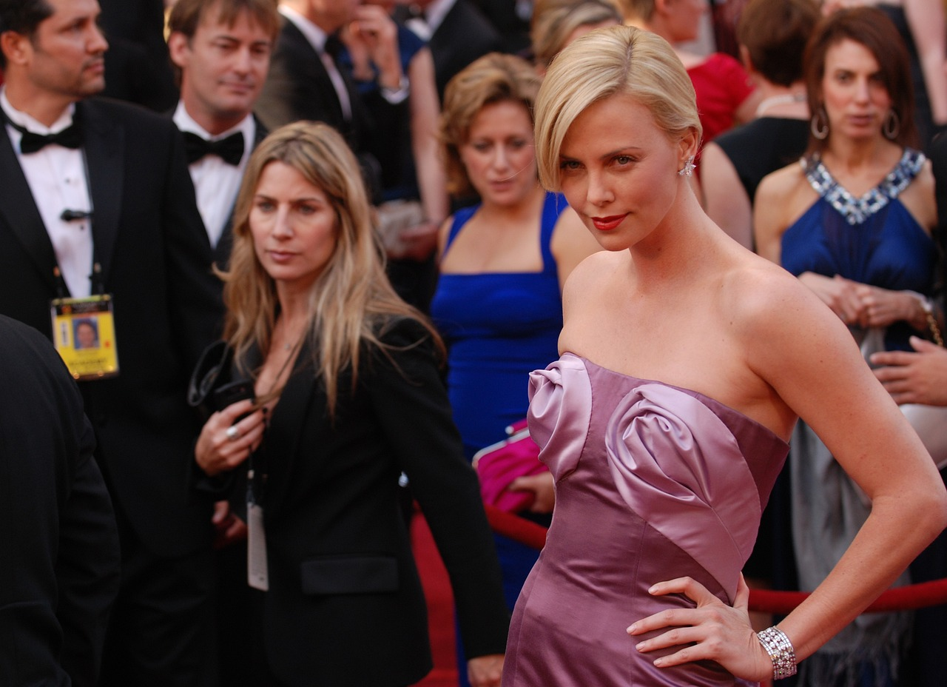 | 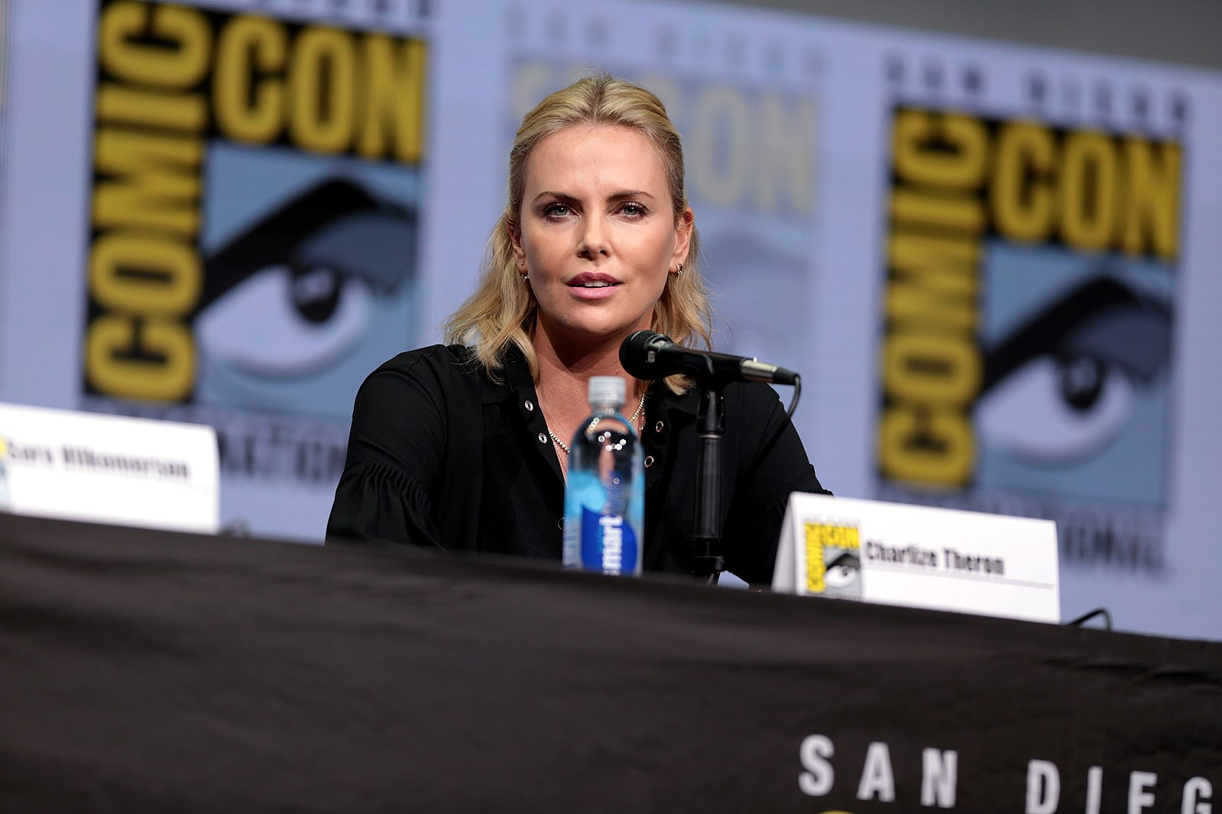
[h5p id="30"]
 | 
[h5p id="31"]
 | 
[h5p id="28"]
 | 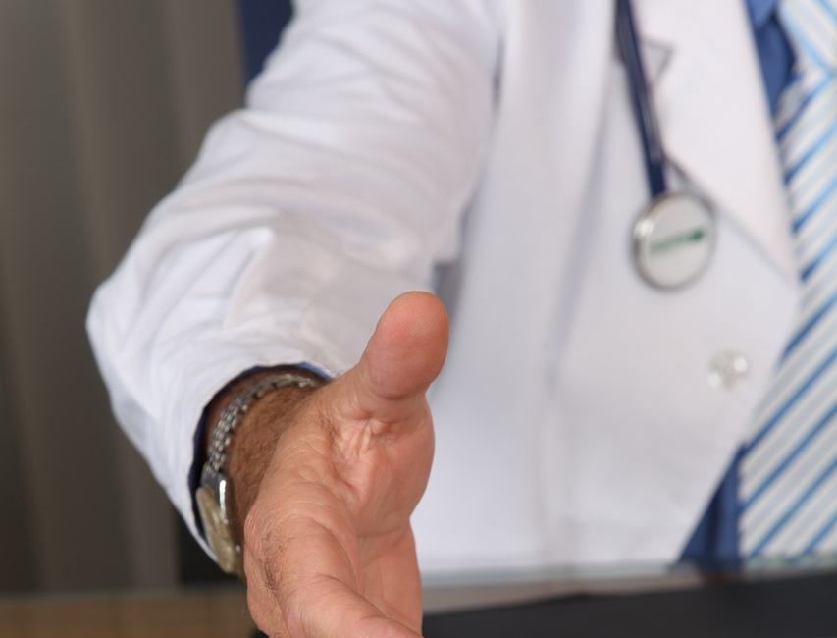
[h5p id="29"]

| Vowel Pronunciation: Practice
We’ll explore the Croatian alphabet through three short videos. In this first video, we’ll focus on vowels in the Croatian language.
🎧 Before each word is played, you’ll have a brief moment of silence to guess what the word might be. After you hear the word, there’s another pause so you can repeat it out loud. Feel free to pause the video at any time if you want to repeat a word again or write it down.
👉 Don't worry about memorizing everything. This is just for practice and exposure—the goal is to get comfortable with the sounds and to have plenty of chances to practice your pronunciation.
Make sure to turn on the closed captions so you can see how each word is spelled.

O | 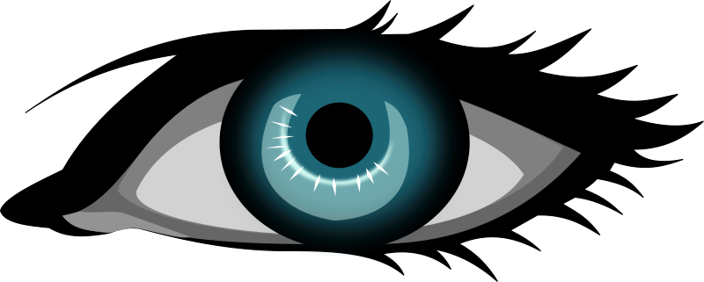 |  | 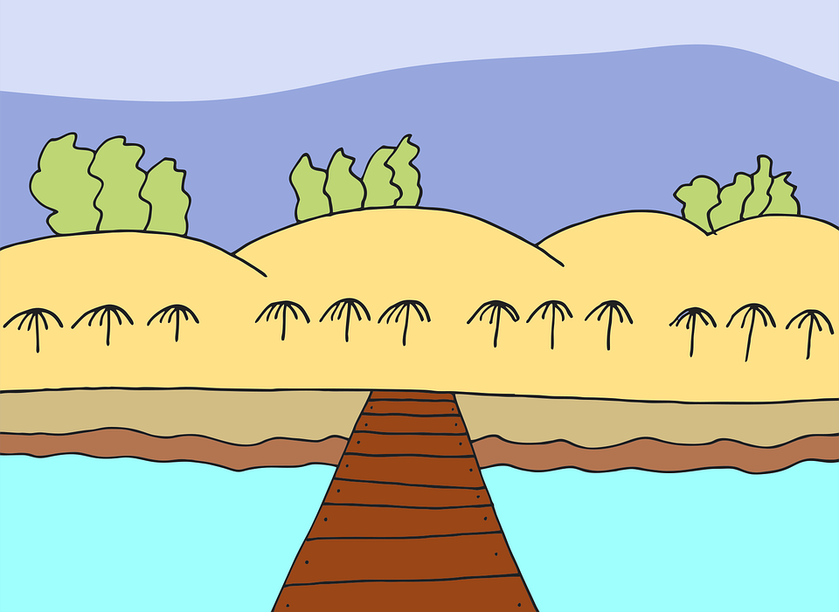
O | oko  (audio) | otok  (audio) | obala  (audio)

U | 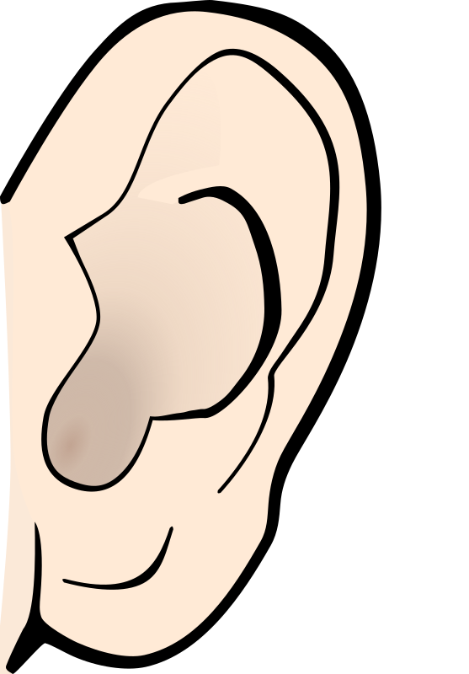 |  | 
U | uho  (audio) | upitnik  (audio) | ured  (audio)

E | 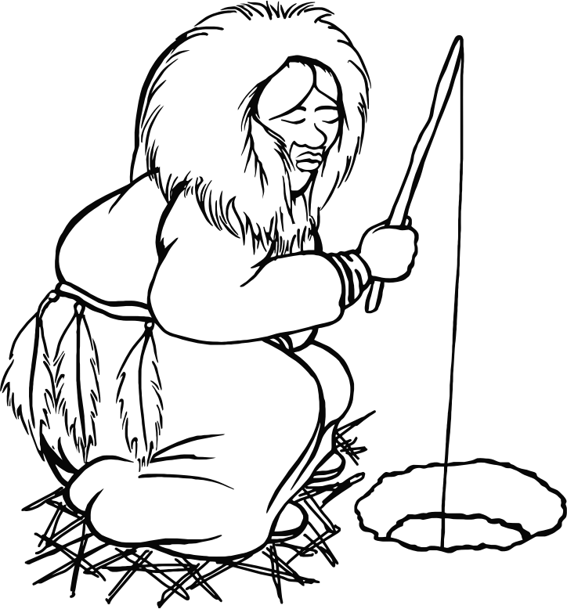 |  | 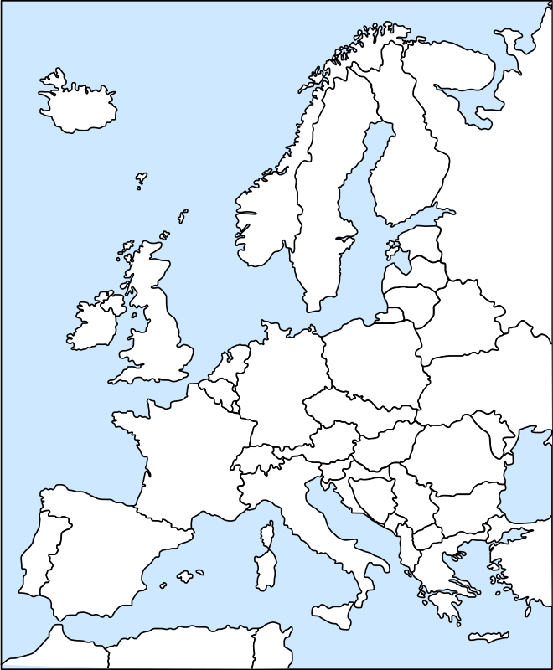
E | Eskim  (audio) | Euro  (audio) | Europa  (audio)

I | 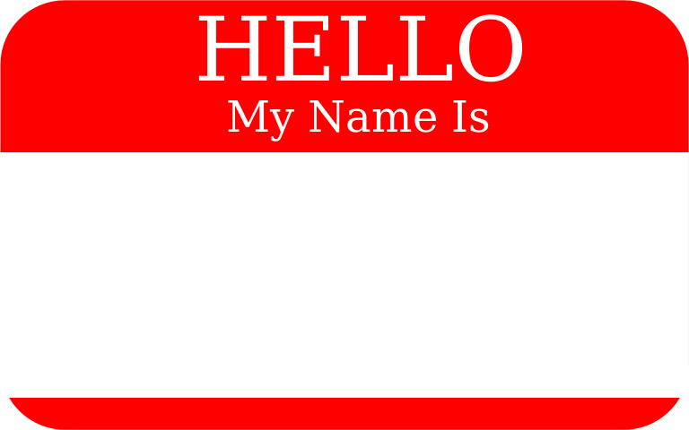 | 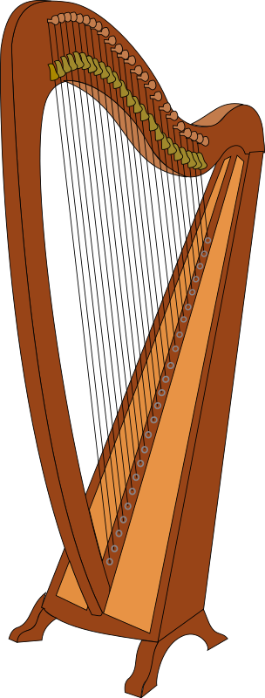 | 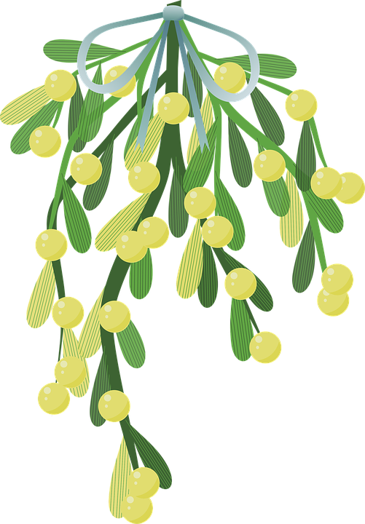
I | ime  (audio) | instrument  (audio) | imela  (audio)

A | 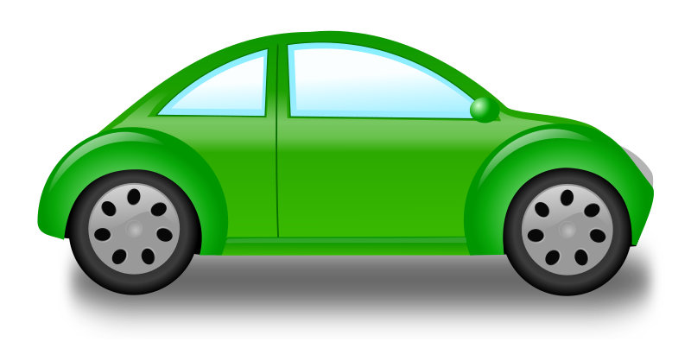 |  | 
A | automobil  (audio) | avion  (audio) | astronaut  (audio)

| Practice your new vocabulary.
[h5p id="570"]
Laura is learning some new vocabulary. It’s hard to keep track of everything. Click on the image for each picture to check your new vocabulary.
[h5p id="571"]

| Consonant Pronunciation: English Equivalent
In this video, we’ll focus on Croatian letters that sound similar to English. This should feel a bit easier, but it’s still important to listen closely and practice saying each word out loud. Just like in the first video, there’s a short pause before and after each word—use the time before to guess the word, and the time after to repeat it. Don’t forget to turn on closed captions so you can see how each word is spelled. And of course, feel free to pause the video anytime if you want to repeat a word or write it down.
👉 You’re not expected to memorize everything. This is all about getting comfortable with the sounds and practicing as much as you can.

B |  | 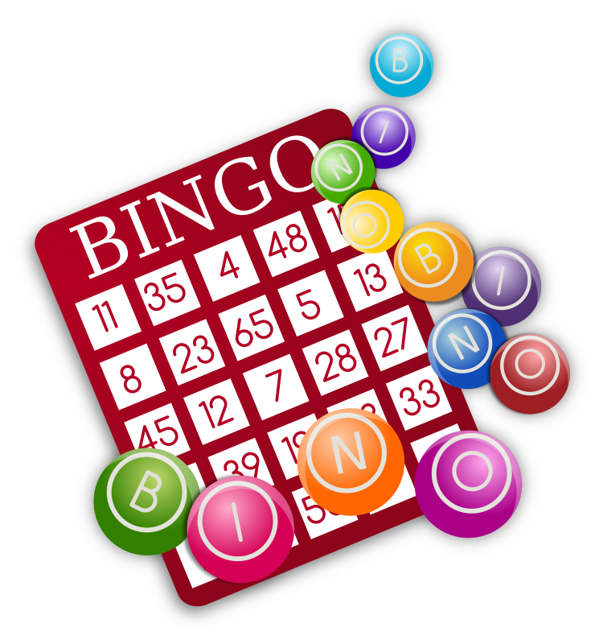 | 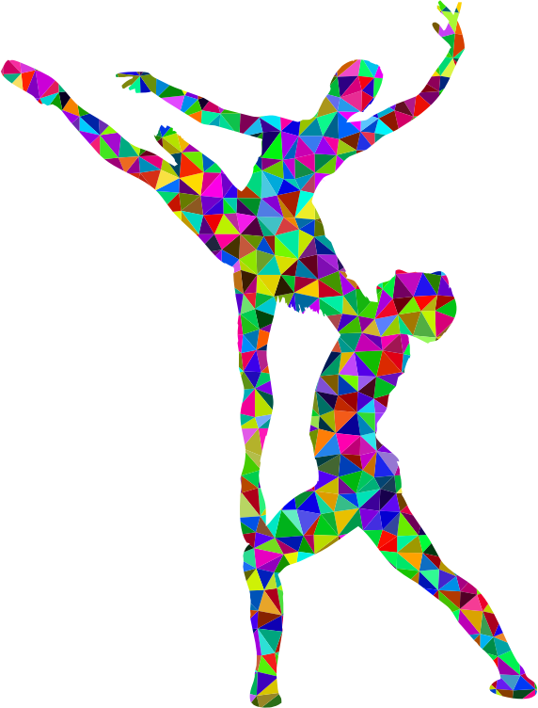
B | blog  (audio) | bingo  (audio) | balet  (audio)

P | 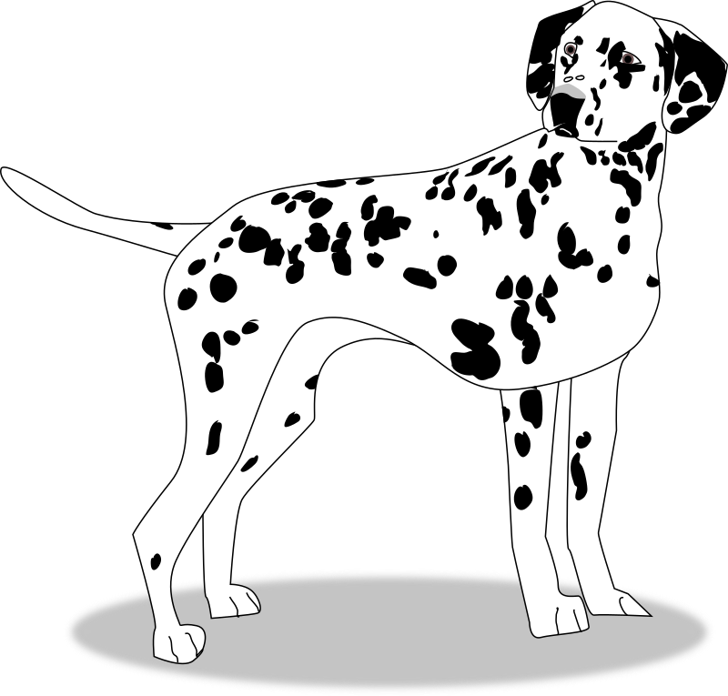 | 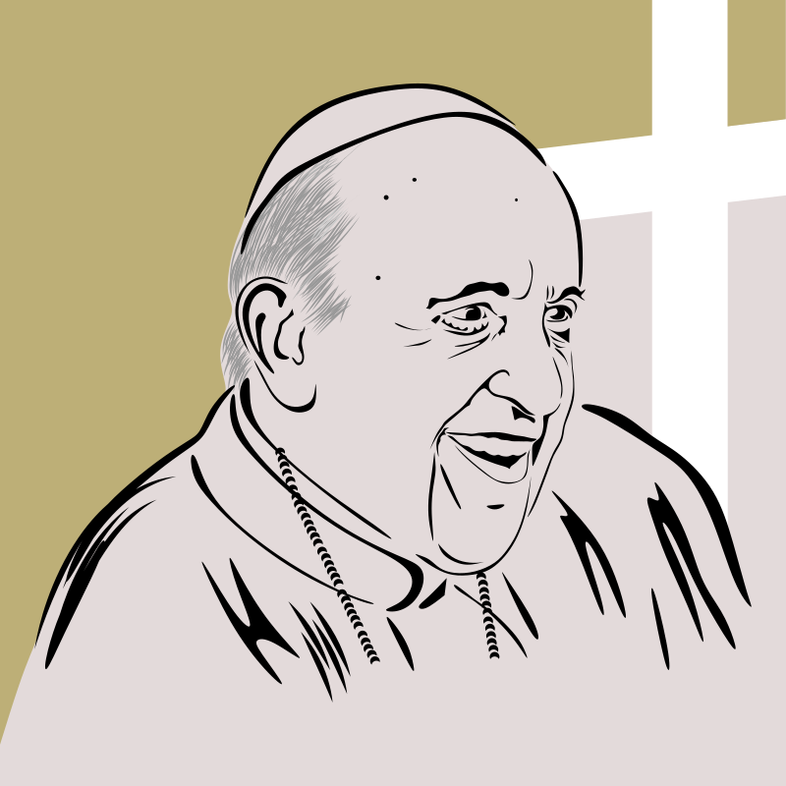 | 
P | pas  (audio) | papa  (audio) | papir  (audio)

M |  |  | 
M | mapa  (audio) | metro  (audio) | med  (audio)

L |  |  | 
L | lampa  (audio) | lopta  (audio) | lav  (audio)

R |  | 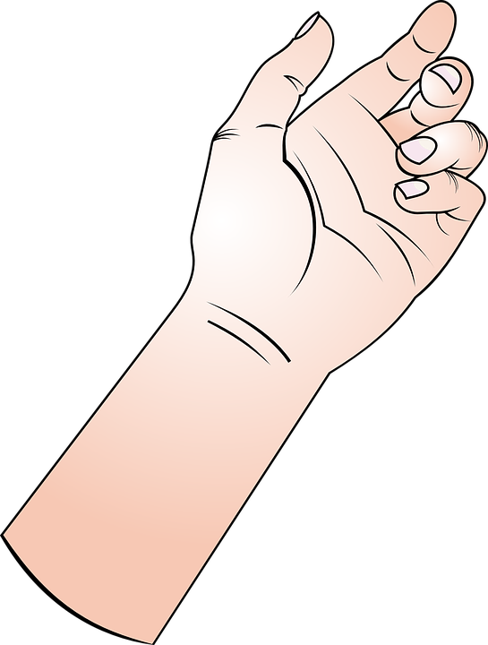 | 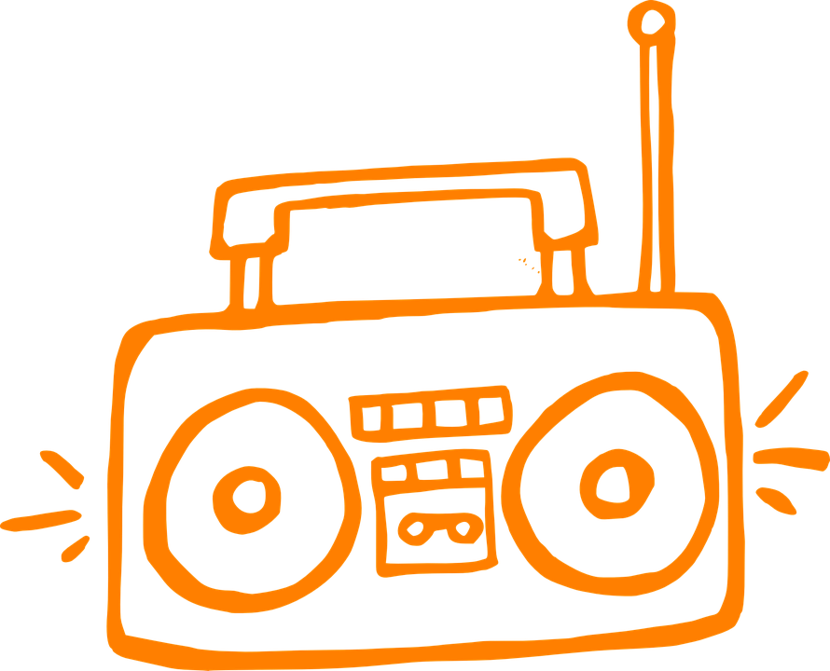
R | robot  (audio) | ruka  (audio) | radio  (audio)

F | 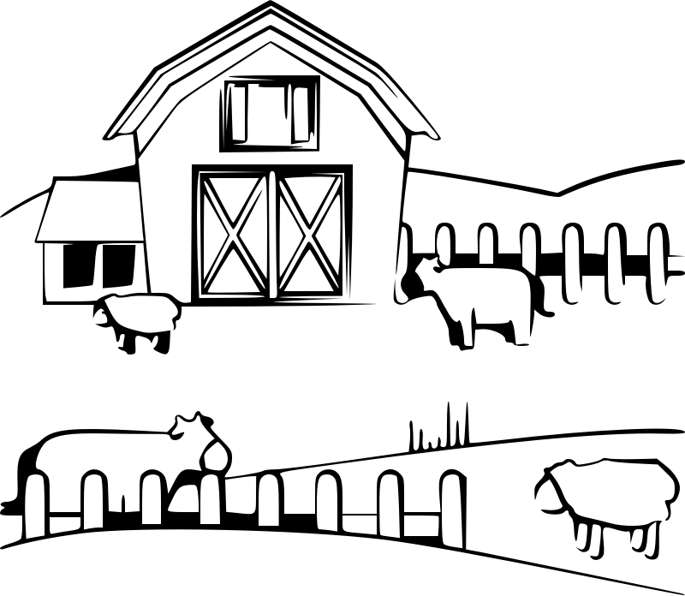 | 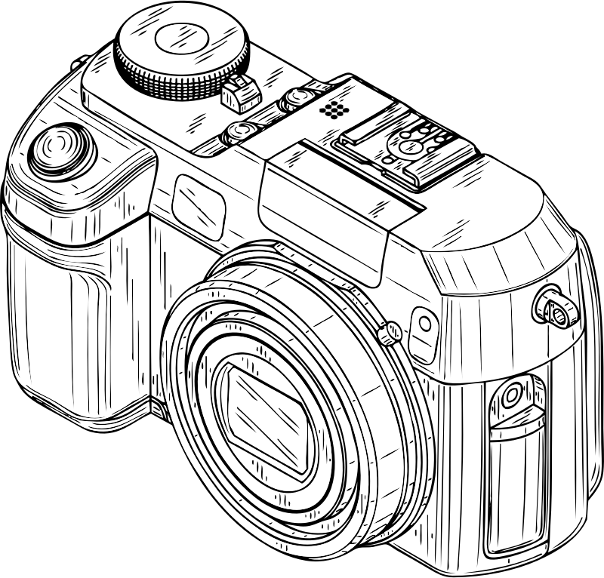 | 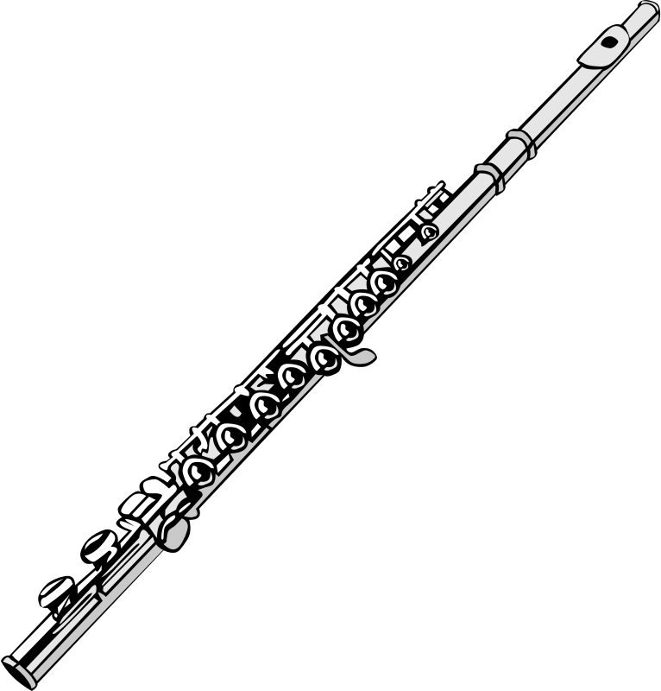
F | farma  (audio) | fotoaparat  (audio) | flauta  (audio)

V |  |  | 
V | vaza  (audio) | veterinar  (audio) | vino  (audio)

D |  |  | 
D | doktor  (audio) | dupin  (audio) | desert  (audio)

T | 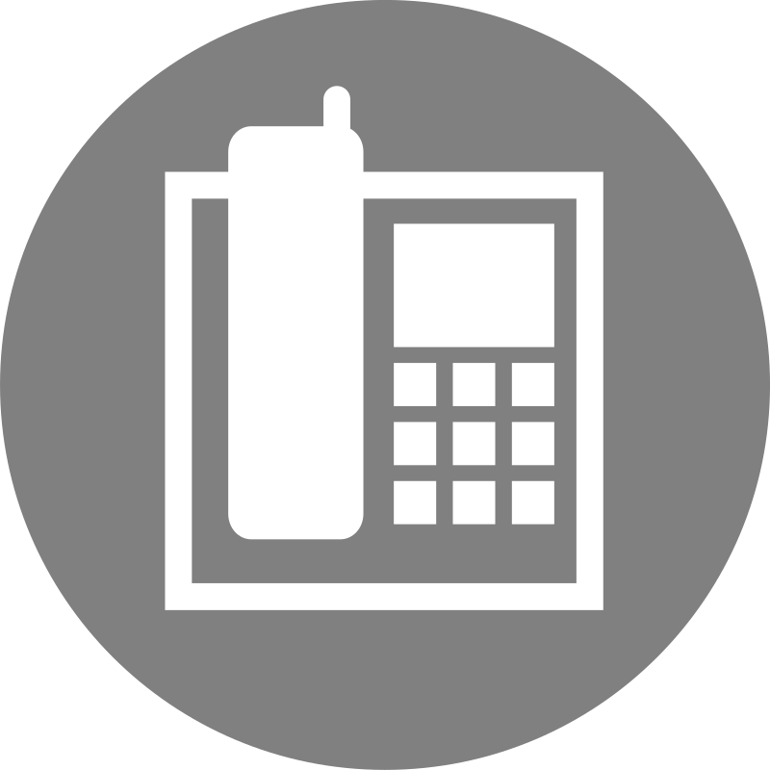 | 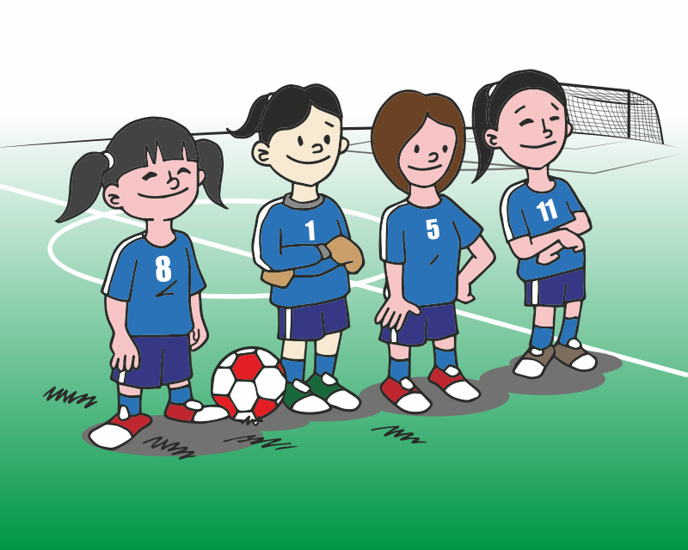 | 
T | telefon  (audio) | tim  (audio) | tulipan  (audio)

N | 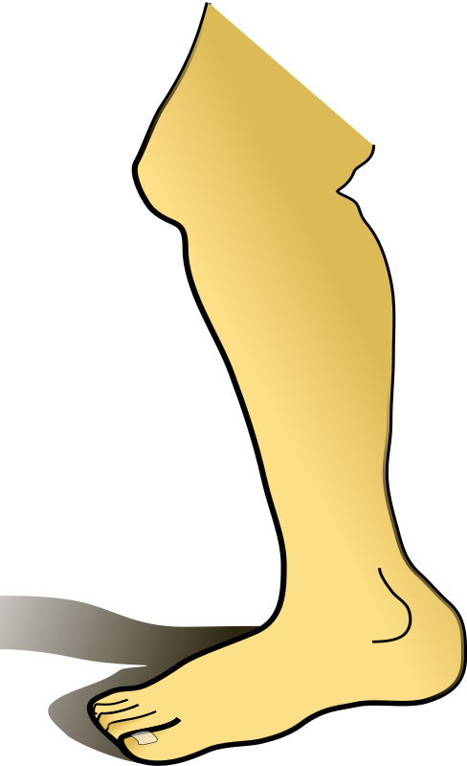 |  | 
N | noga  (audio) | nogomet  (audio) | nebo  (audio)

Z |  | 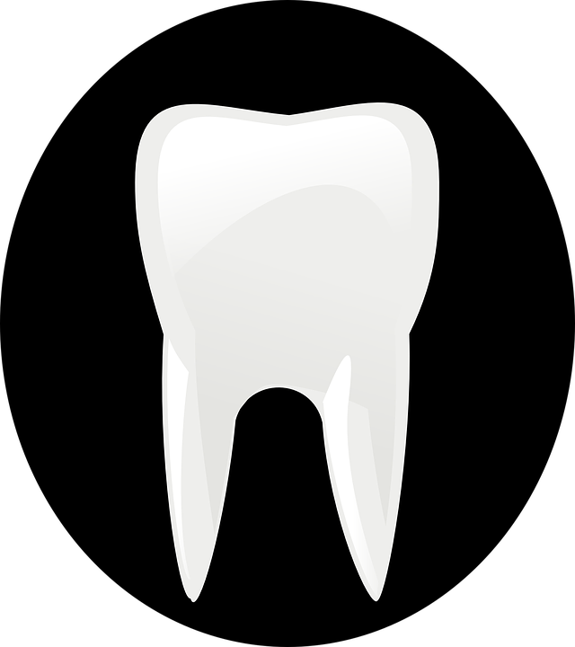 | 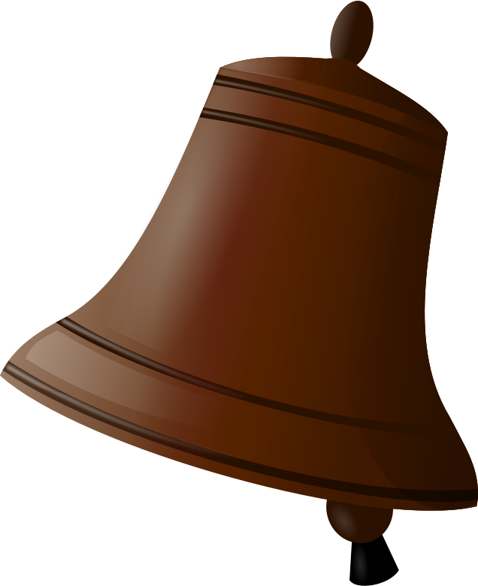
Z | zebra  (audio) | zub  (audio) | zvono  (audio)

S | 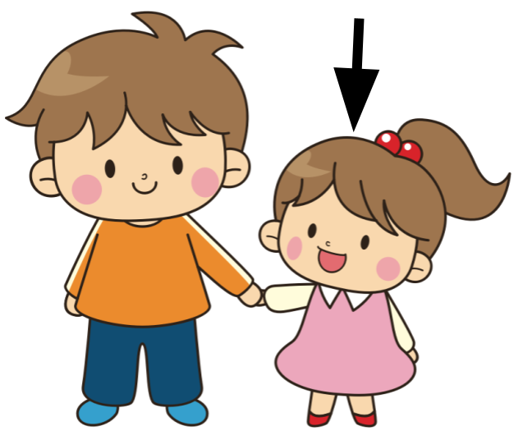 |  | 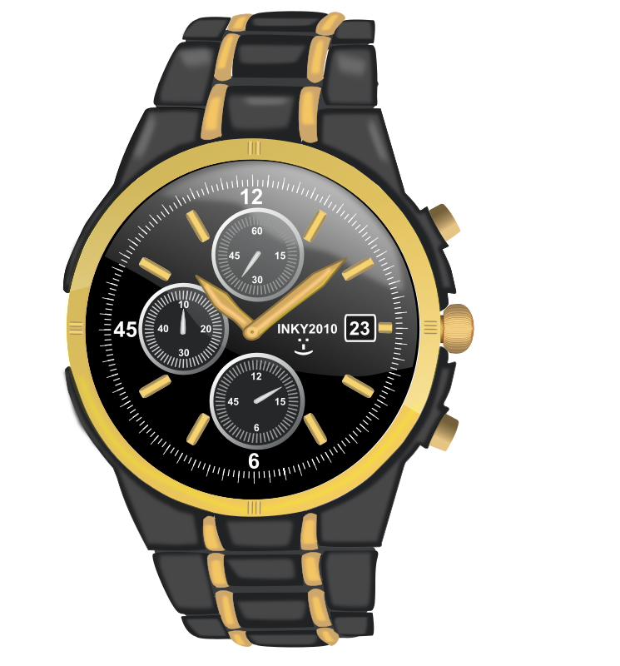
S | sestra  (audio) | sir  (audio) | sat  (audio)

K | 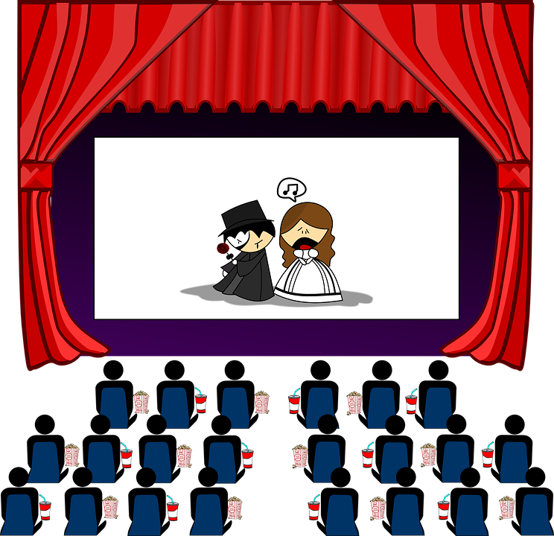 |  | 
K | kino  (audio) | krokodil  (audio) | kava  (audio)

H | 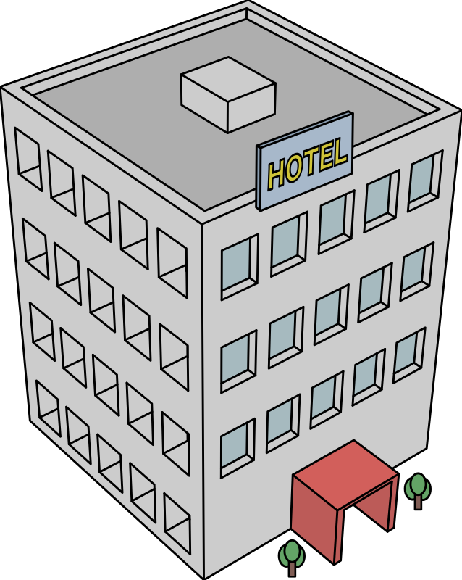 | 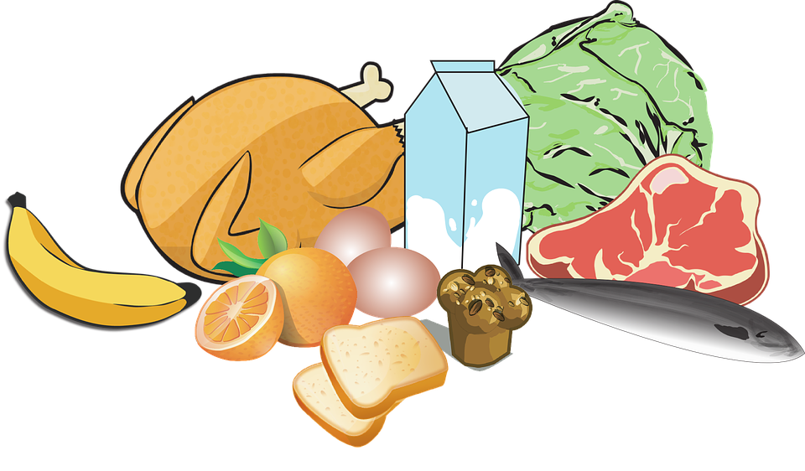 | 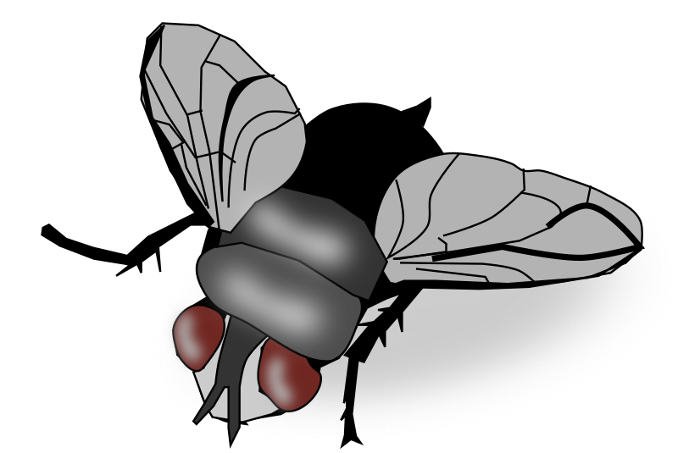
H | hotel  (audio) | hrana  (audio) | muha  (audio)

| Practice your new vocabulary
[h5p id="573"]
Look at the following slides. On each slide choose an image for which the word is spelled completely the same in English and in Croatian.
[h5p id="574"]

| Consonant Pronunciation: Croatian Letters
In this final video, we’ll focus on Croatian letters that don’t exist in English or that sound different from what you might expect if English is your first language. Some of these sounds may feel new or unusual at first, but don’t worry! Make sure to turn on the closed captions so you can see how each word is spelled, and feel free to pause the video whenever you want to repeat a word or write it down.
Č | 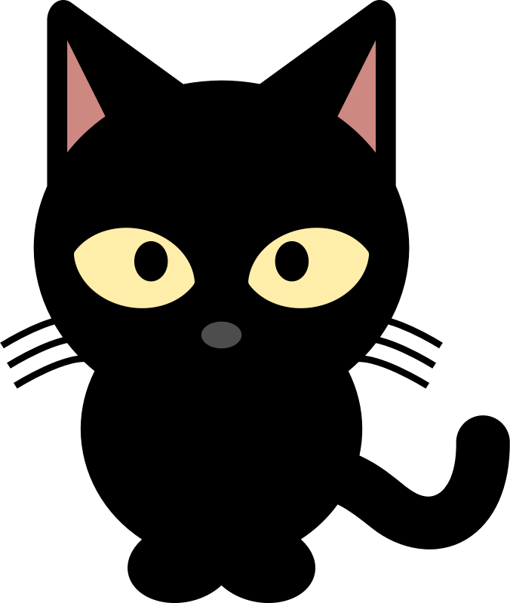 | 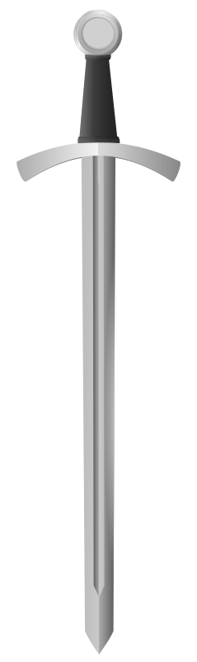 | 
Č | mačka  (audio) | mač  (audio) | čokolada  (audio)

DŽ |  |  | 
DŽ | džip  (audio) | džungla  (audio) | džemper  (audio)

Š |  | 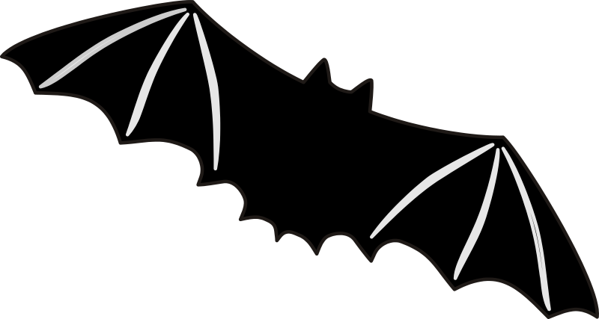 | 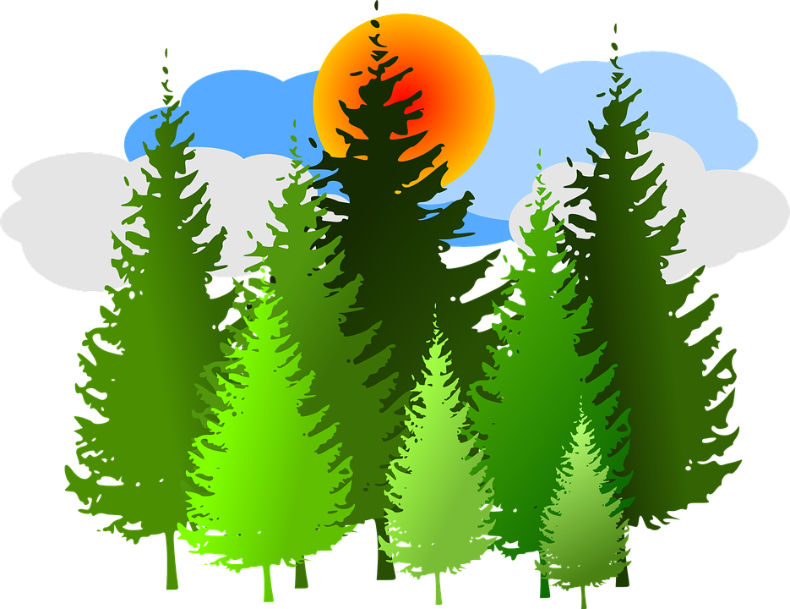
Š | šešir  (audio) | šišmiš  (audio) | šuma  (audio)

Ž | 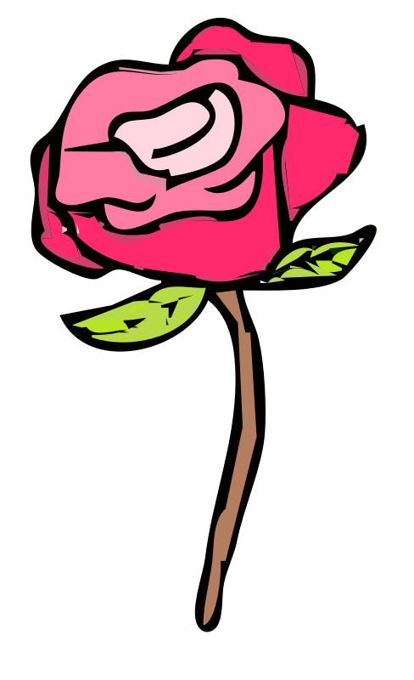 | 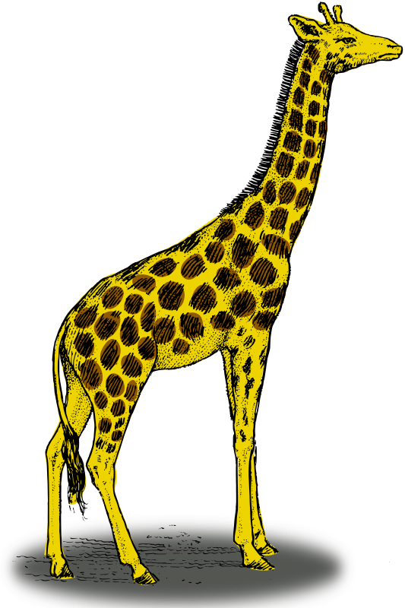 | 
Ž | ruža  (audio) | žirafa  (audio) | plaža  (audio)

Ć | 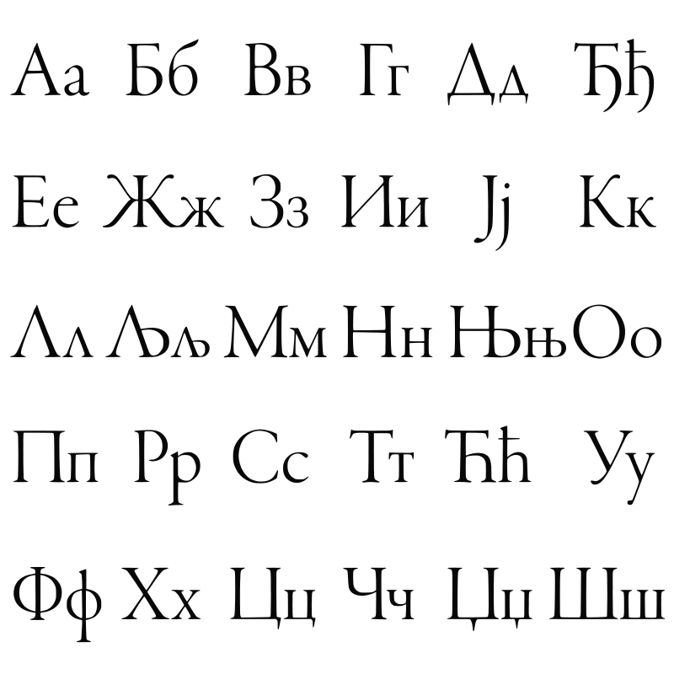 | 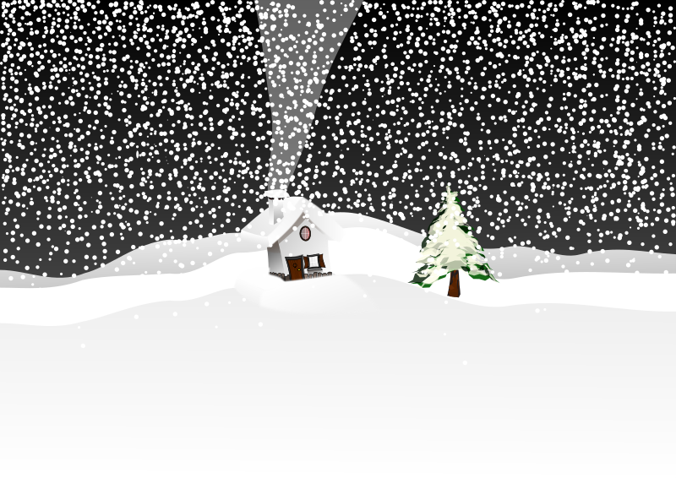 | 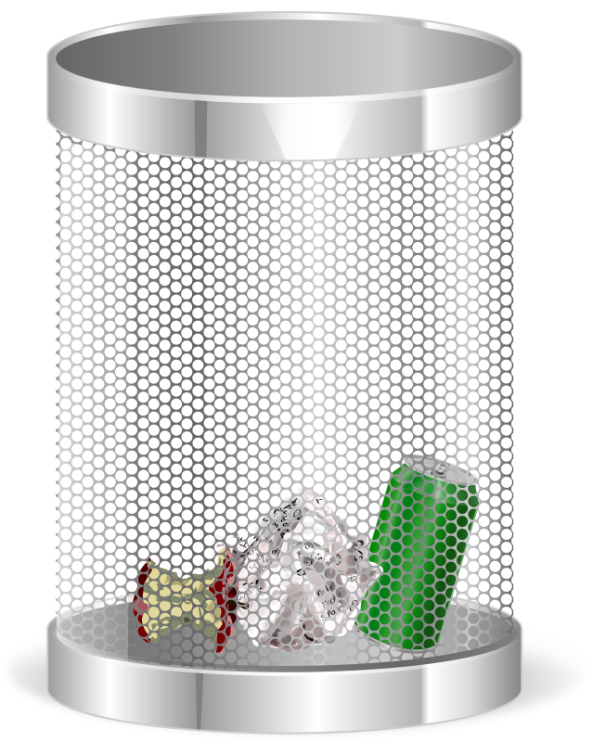
Ć | ćirilica  (audio) | mećava  (audio) | smeće  (audio)

Đ |  | 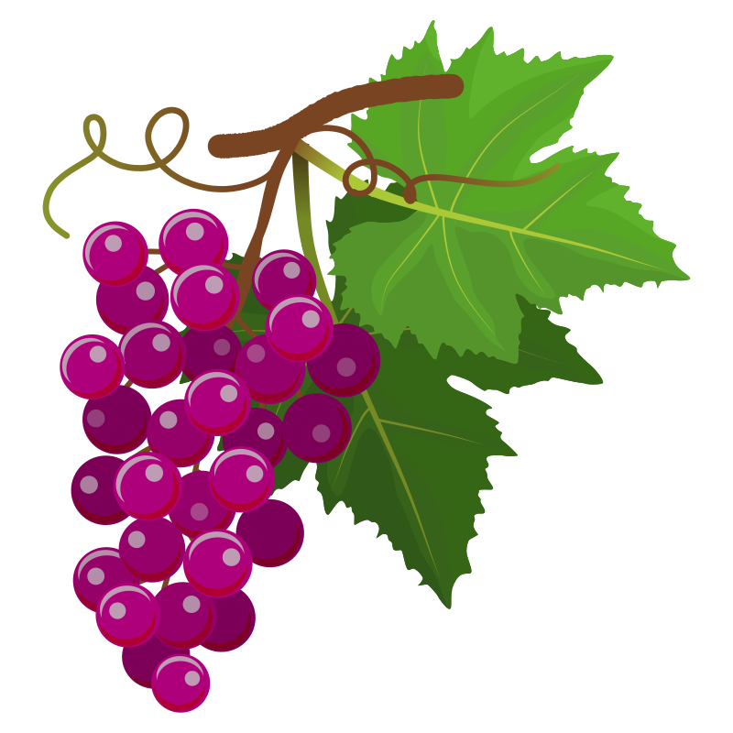 | 
Đ | anđeo  (audio) | grožđe  (audio) | rođendan  (audio)

LJ |  | 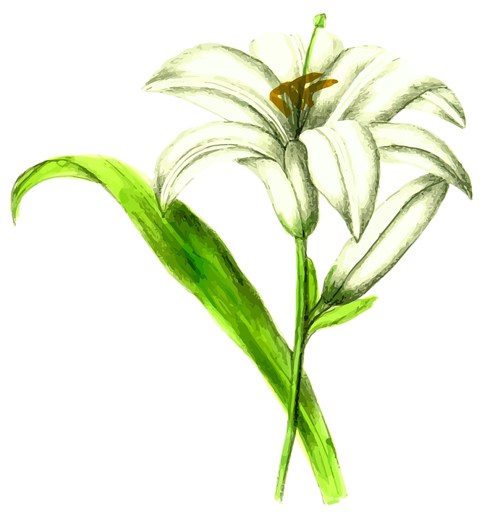 | 
LJ | ljekarna  (audio) | ljiljan  (audio) | ljubav  (audio)

NJ |  |  | 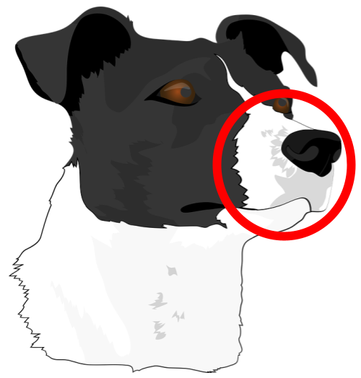
NJ | tanjur  (audio) | kornjača  (audio) | njuška  (audio)

C |  |  | 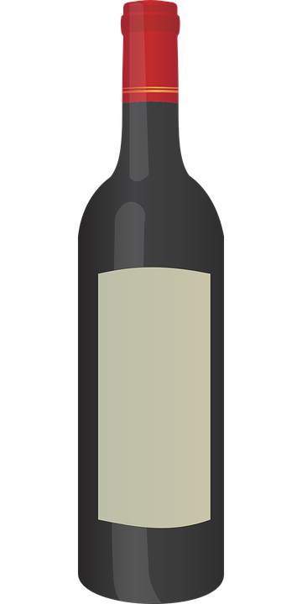
C | cesta  (audio) | čamac  (audio) | boca  (audio)

G | 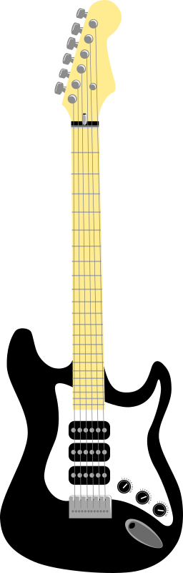 |  | 
G | gitara  (audio) | gljiva  (audio) | glava  (audio)

J |  | 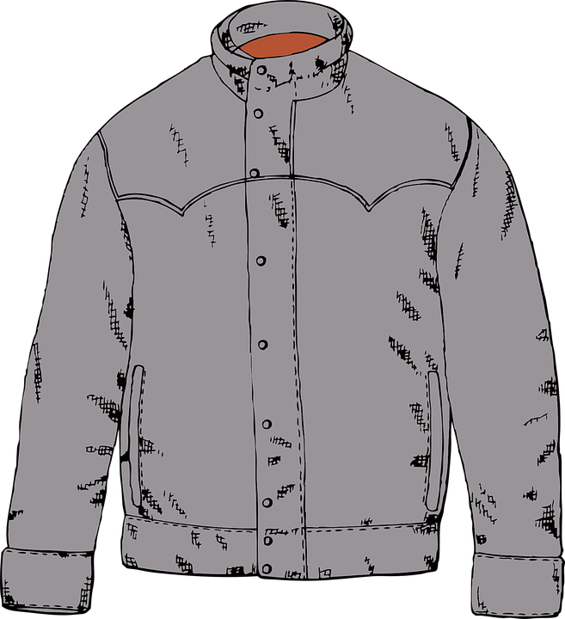 | 
J | jezero  (audio) | jakna  (audio) | jelo  (audio)

| Practice your new vocabulary.
[h5p id="576"]

1.1 Zadatak 4. Nove riječi

| Words That Are Similar to English
[h5p id="577"]

| Words Related to Nature and Animals
[h5p id="581"]
Decide whether the statement is true (Točno) or false (Netočno).
[h5p id="580"]

Images used in this document are from these sources.

