1.6 - Božena Němcová and Babička / Grandmother
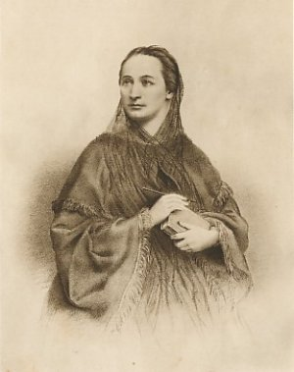 | 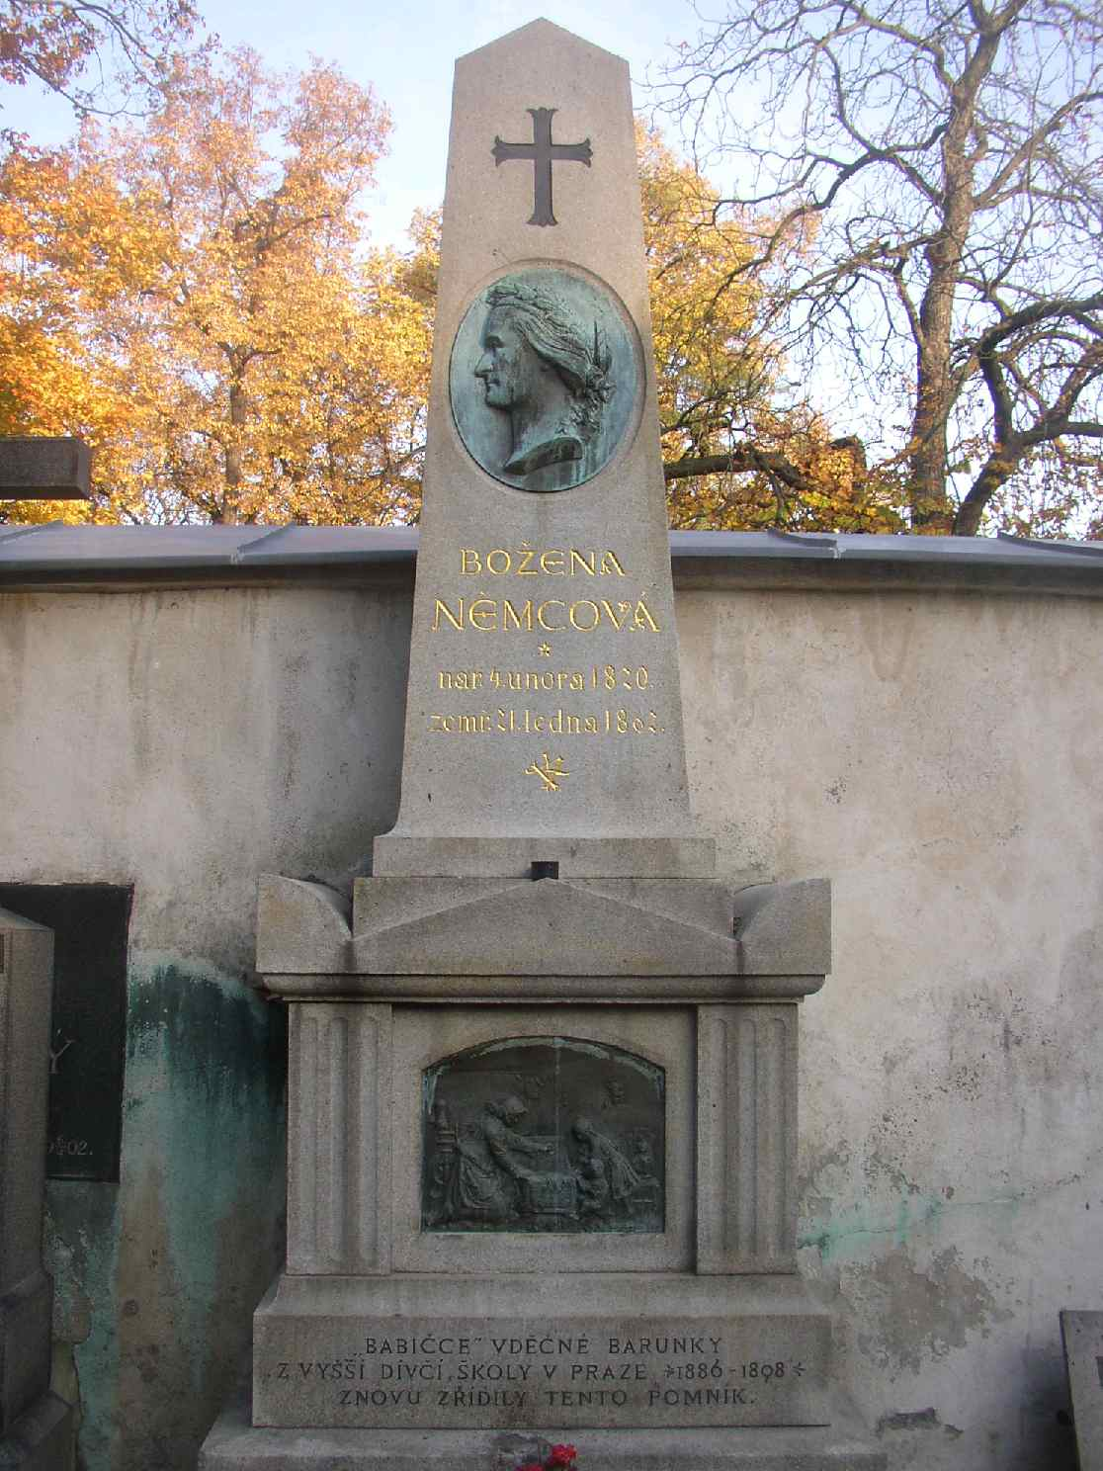

Božena Němcová (4 February 1820 in Vienna – 21 January 1862 in Prague) was a Czech writer of the final phase of the so-called Czech National Revival movement, in which the Czech legends and folklore played an integral part.

In her childhood, Němcová lived near the small town of Ratibořice, in northeast Bohemia, where her grandmother Magdalena Novotná played an important part in her life. Němcová would later write her most famous novel, Grandmother (Babička) with the main character inspired by her grandmother, and the castle in Ratibořice is also featured in the novel.

When she was 17 years old, she married Josef Němec, a state employee, with whom Němcová is said to have had strained relations. Eventually, Němcová relocated to Prague, where she connected with other authors and poets of the time. Němcová lived there for the remainder of her life, and when she died, was already something of a national hero.

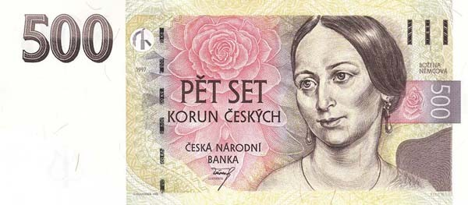

Her image can be found on the 500 Czech crown note (about $20), distinguishing the Czech Republic from the United States by featuring a woman—and an author!—on its currency.

(adapted from Wikipedia: https://en.wikipedia.org/wiki/Bo%C5%BEena_N%C4%9Bmcov%C3%A1)

Images used in this document come from these sources.

