6.2 - Every day, week, month... Time Expressions with každý
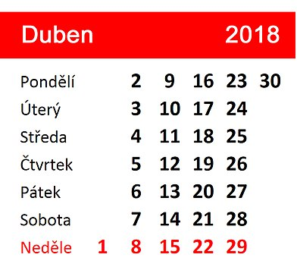

If you want to say how often you do something using expressions such as every week, every year, every day, etc., use the word každý. The whole každý expression must be in the accusative case.

Díváme se na televizi každý den.
We watch tv every day.

Pavel cvičí každé ráno.
Pavel exercises every morning.

Lucie pracuje doma každou sobotu.
Lucie works at home every Saturday.

Běhám každou středu a každý pátek.
I run every Wednesday and every Friday.

Days and Gender
For a lot of the days it’s easy to guess their gender, all the same, this brief chart might come in handy:

Masculine | Feminine | Neuter
čtvrtek  pátek | středa  sobota  neděle | pondělí  úterý

Image used in this document comes from this source.

