3.8 - České peníze - Czech Money

If you’re going to buy food, or anything else for that matter, then you’re going to need to know a little about Czech money.

As of 24.10.2017 the exchange rate is 1 dollar = 21.78 crowns (koruna - crown)

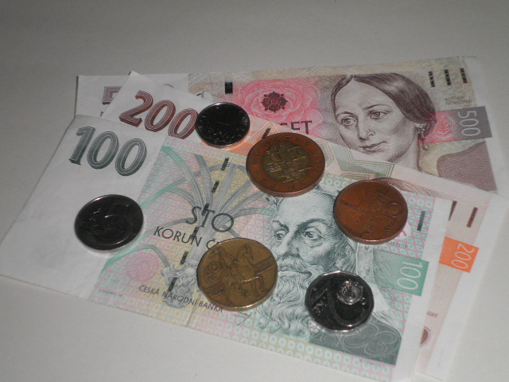

Mince
Czech coins (mince) are divided up into the following denominations:
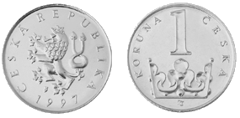 | jedna koruna
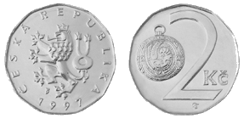 | dvě koruny
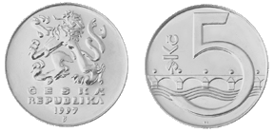 | pět korun
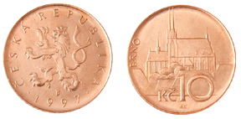 | deset korun
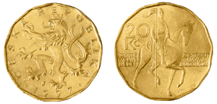 | dvacet korun
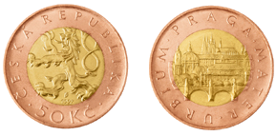 | padesát korun

drobné (colloquial drobný) - This is how you say change, as in máte drobné? - Do you have any change?

Bankovky
Bankovky is the word for paper money (it translates to something like banknote). Here are the bankovky currently in circulation:
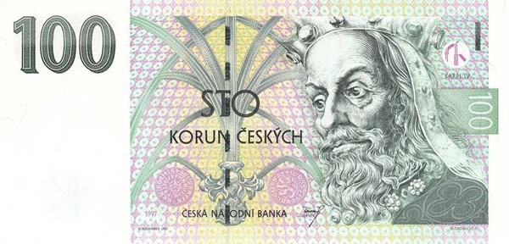 | 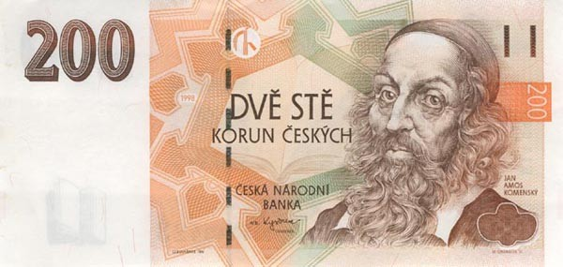
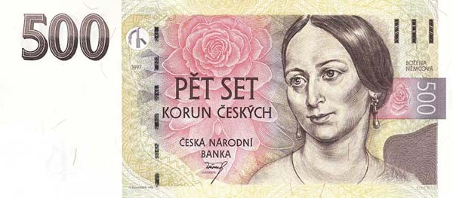 | 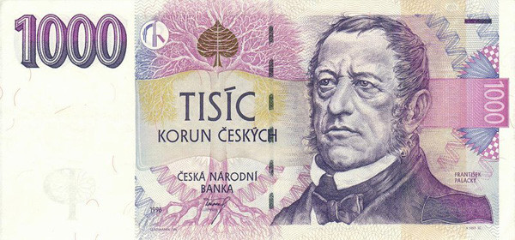
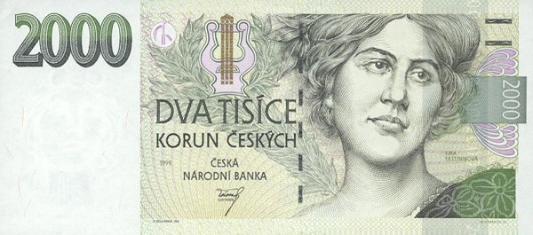 | 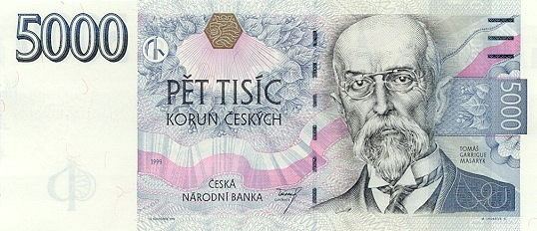

The abbreviation for koruna is Kč and stands for koruna česká. If you notice the descriptions of the coins and the words on the bank notes themselves, you’ll see that the word for crown changes depending on the number with it. It follows the Czech rule on counting, which is as follows:

1 | singular | koruna
2, 3, 4 | regular plural form | koruny
5+ | genitive plural | korun

Now, we haven’t learned the genitive plural yet (and we really don’t even know what it is for that matter). But we can at least learn the form in the context of money. The third column above gives the correct forms you will need after each.

Images used in this document come from these sources.

