2.7 - Accusative Plural of Adjectives
You’ll need these endings when you modify plural nouns in the accusative with adjectives:

 | Masculine Animate | Masculine Inanimate | Feminine | Neuter
Hard stem Adjective | -é  velké | -é  velké | -é  velké | -á  velká
Soft stem Adjective | -í  mladší | -í  mladší | -í  mladší | -í  mladší

Whenever you need to modify (combine) an adjective with a noun that is the direct object of a verb like mít ‘to have’, then you need to put the adjective in the accusative as well, e.g. -
  Bára má dva malé psy.  Bára has two small dogs. | 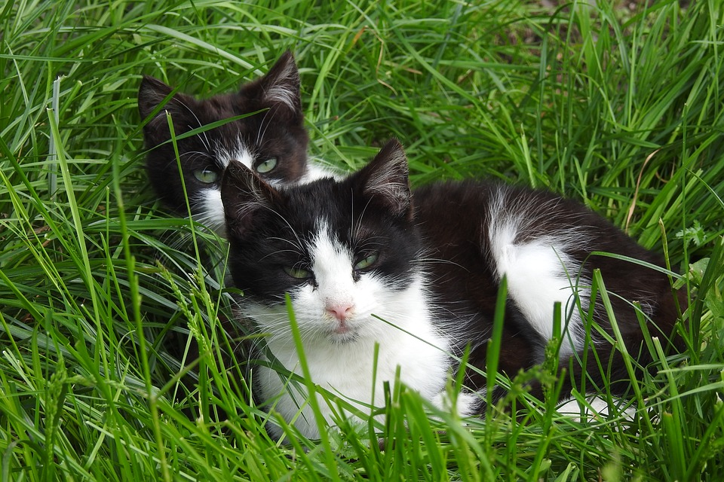  Zdeněk má malé kočky.  Zdeněk has small cats.
  On má dva starší bratry.  He has two older brothers. |   Pavel má dvě mladší sestry.  Pavel has two younger sisters.

Images used in this document come from these sources.

