7 | 4 | Lekcija 1: Ponavljanje

7.4 Zadatak 1. Lukino putovanje
🔊 Listen to Luka talking about the trip that he took in the past. Give information for the following components.
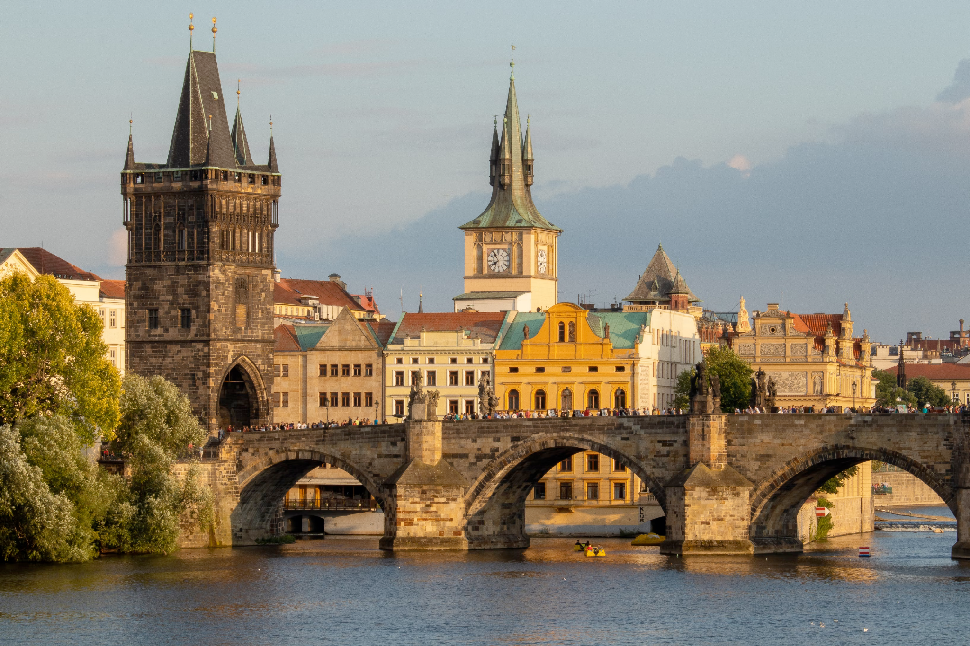 | 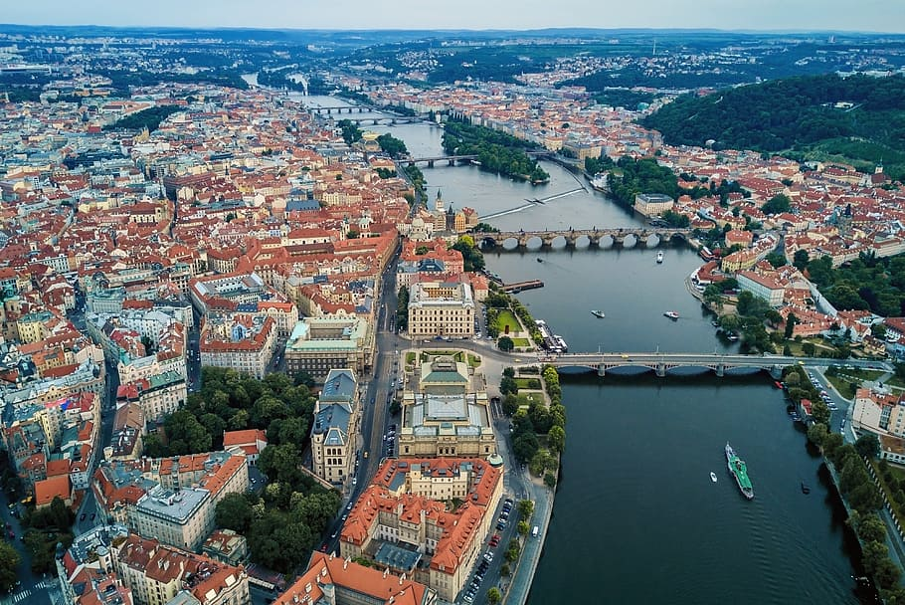

Pitanja: | Odgovor:
Destinacija:
Godišnje doba:
Datum (polazak i povratak):
Koliko je dana bio u gradu br. 1?
Koliko je dana bio u gradu br. 2?
Vremenska prognoza:
S kim je Davor putovao?
Čime su putovali?
Koliko je trajalo putovanje do destinacije?
Što su svi zajedno radili?
Koliko je trajao put, grad br. 1 - grad br. 2?
Što su posjetili u gradu br. 1?
Jesu li se vozili brodom?

7.4 Zadatak 2. Čime putuješ?
Look at the types of transportation below and possible destinations. What type of transportation would you use to get there and why? There is more than one possible answer. List as many as you think are possible.
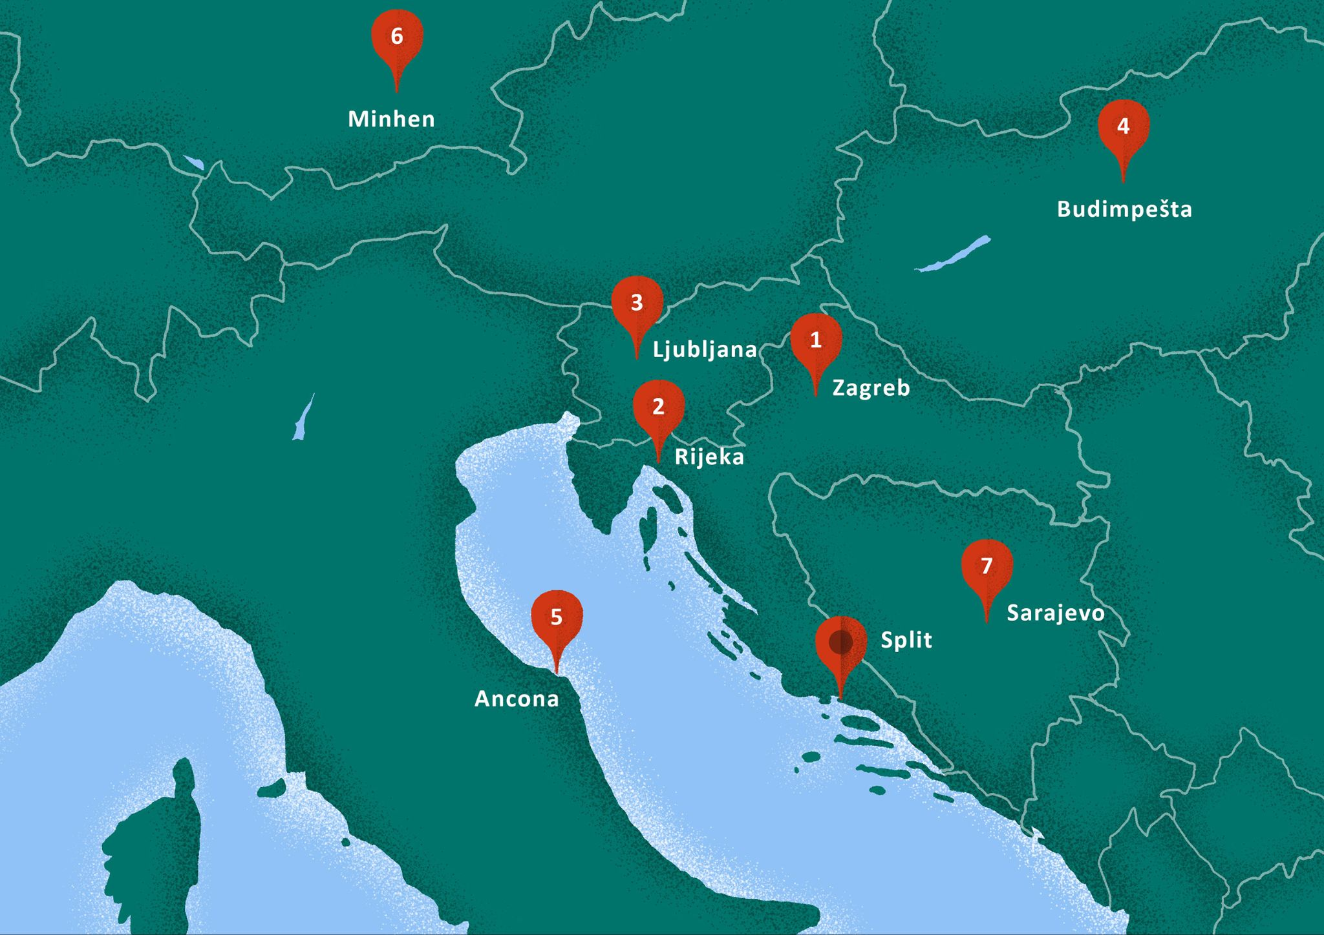
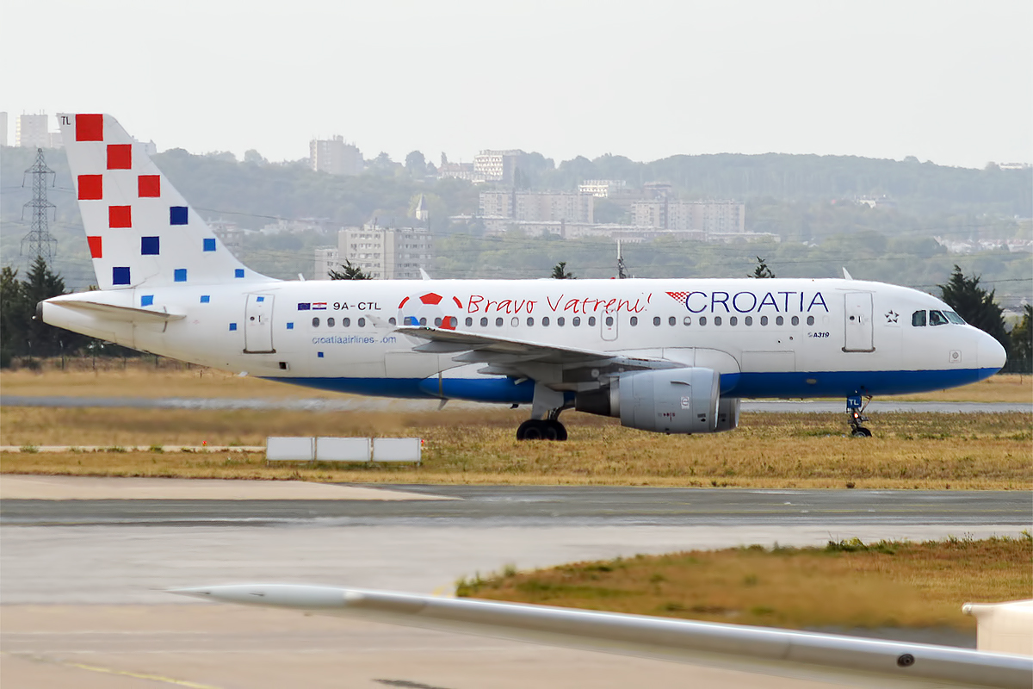 | 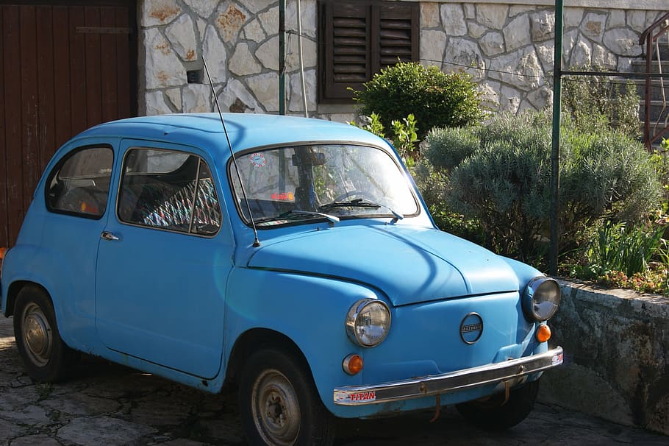 | 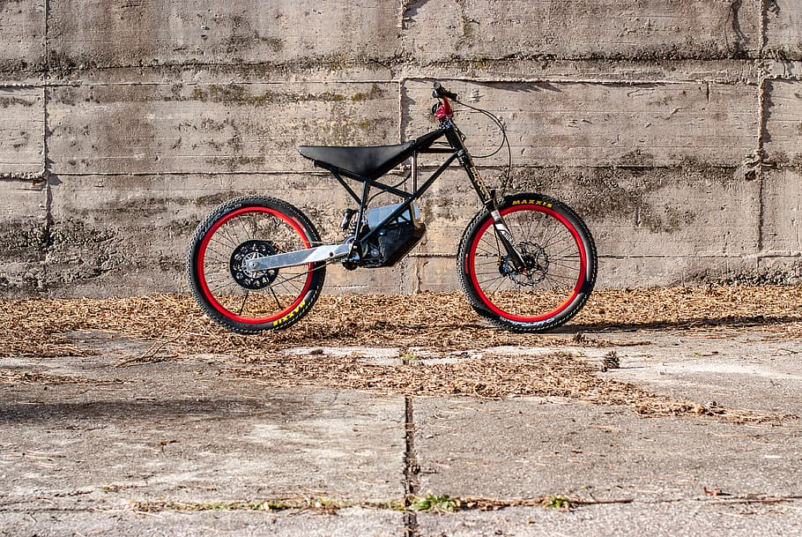 | 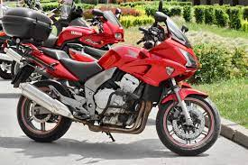
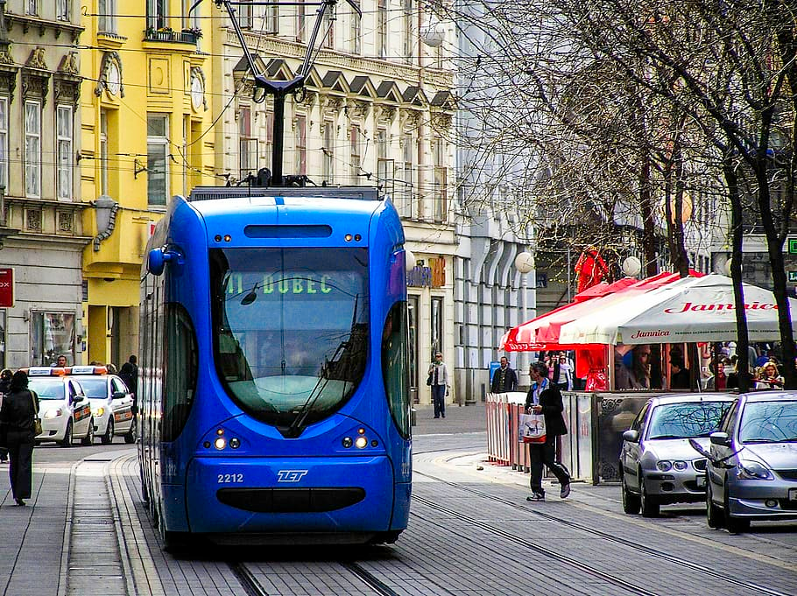 | 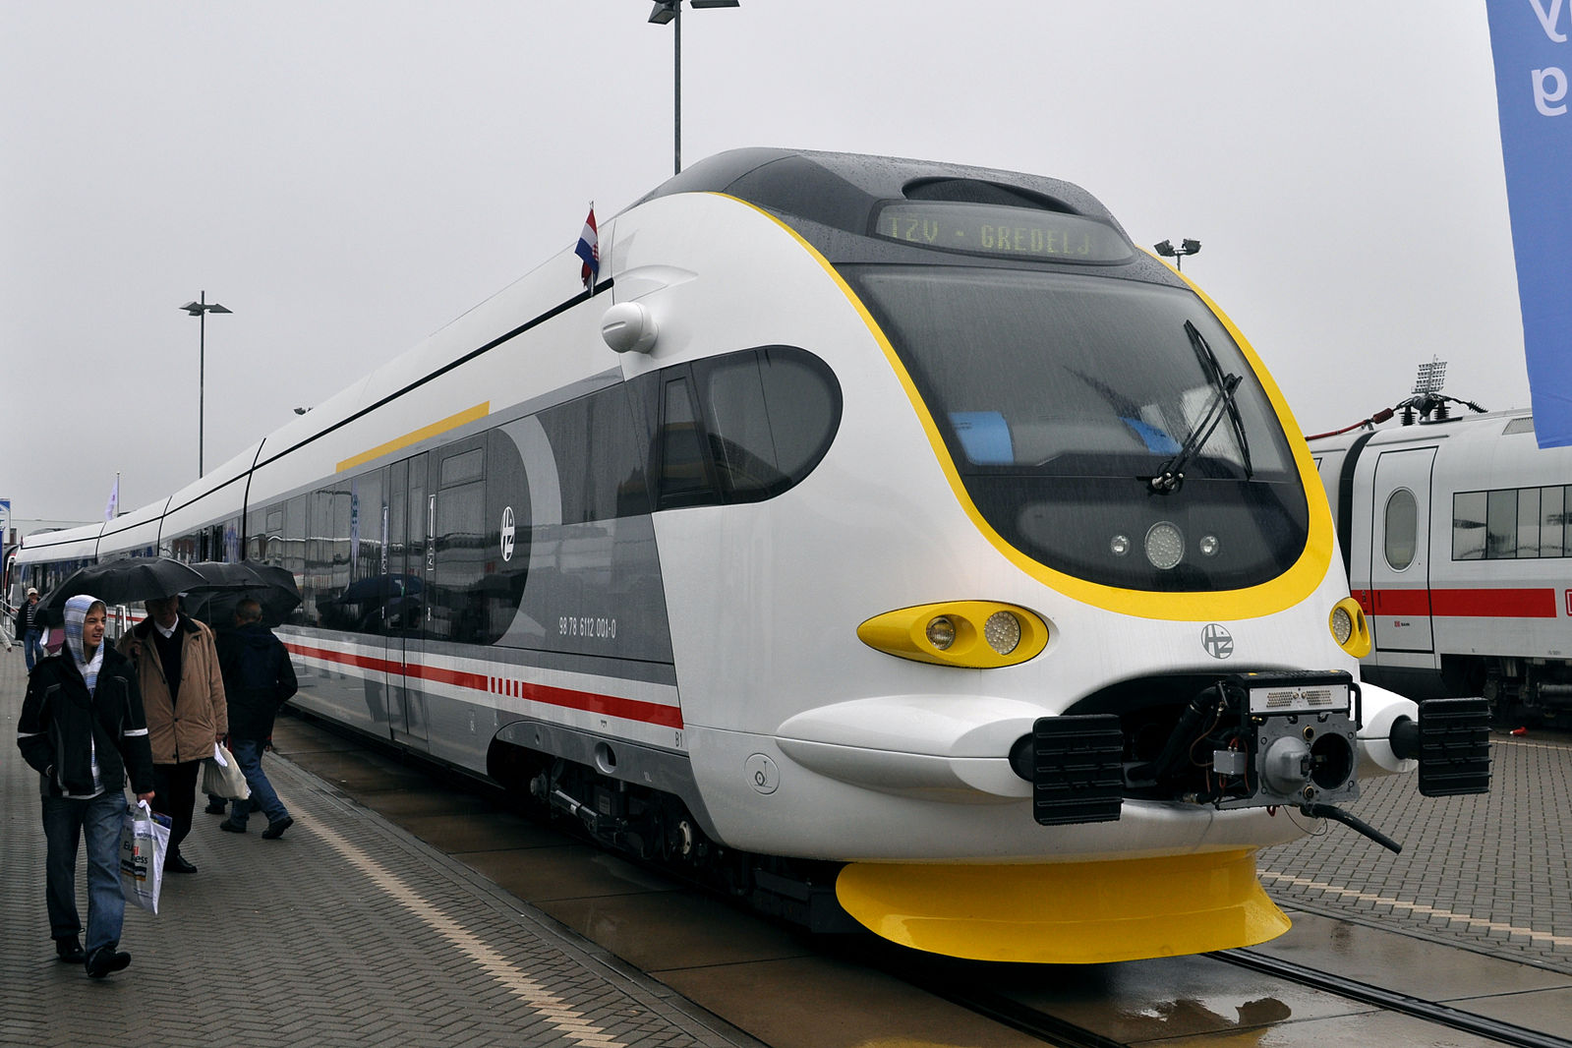 | 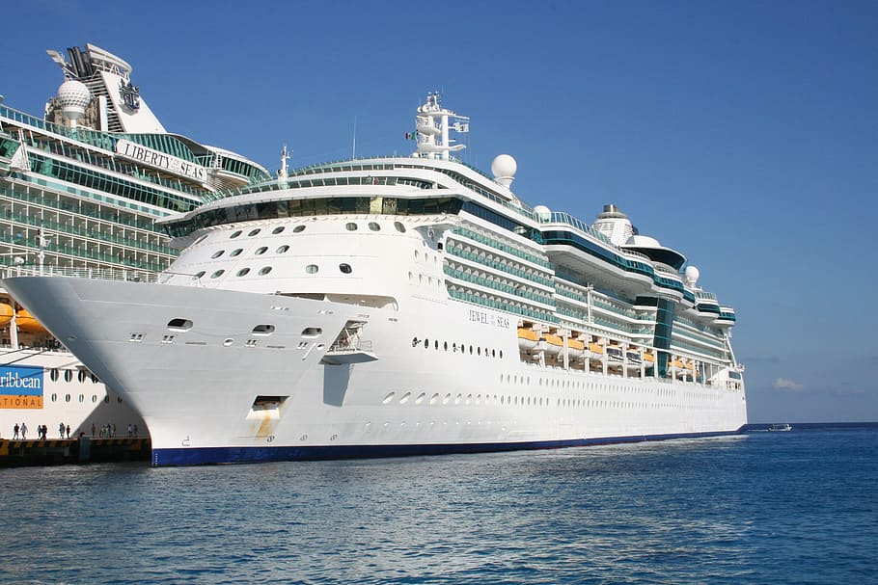 | 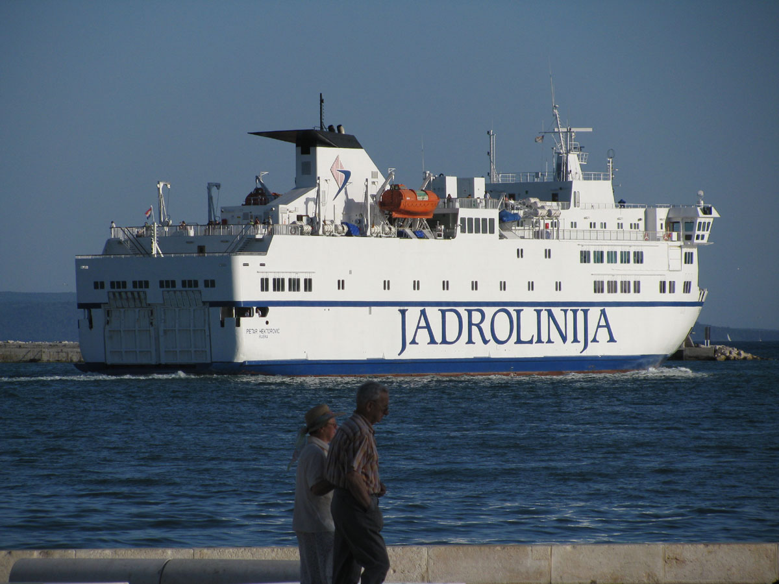

| Čime putuješ?
Destinacija Split - Zagreb:
Destinacija Split - Rijeka:
Destinacija Split - Ljubljana:
Destinacija Split - Budimpešta:
Destinacija Split - Ancona:
Destinacija Split - Minhen:
Destinacija Split - Sarajevo:

7.4 Zadatak 3. Kamo i s kim?
Look at the pictures and list of people below. Choose four people (or group of people) that you believe would be a good travel companion. Say where would you go with that person and why (you cannot repeat the city/destination). Why do you believe that person is a good match for you? Use the Instrumental case when talking about who you want to travel with.
Kamo putovati?
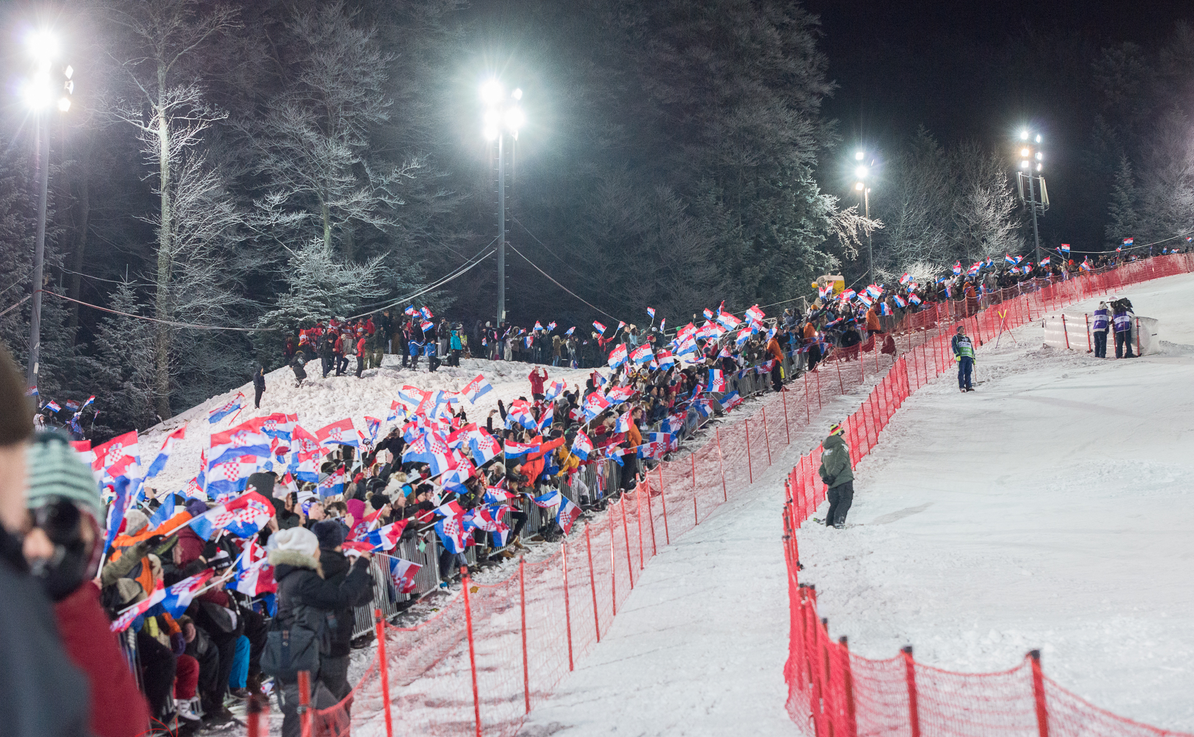 | 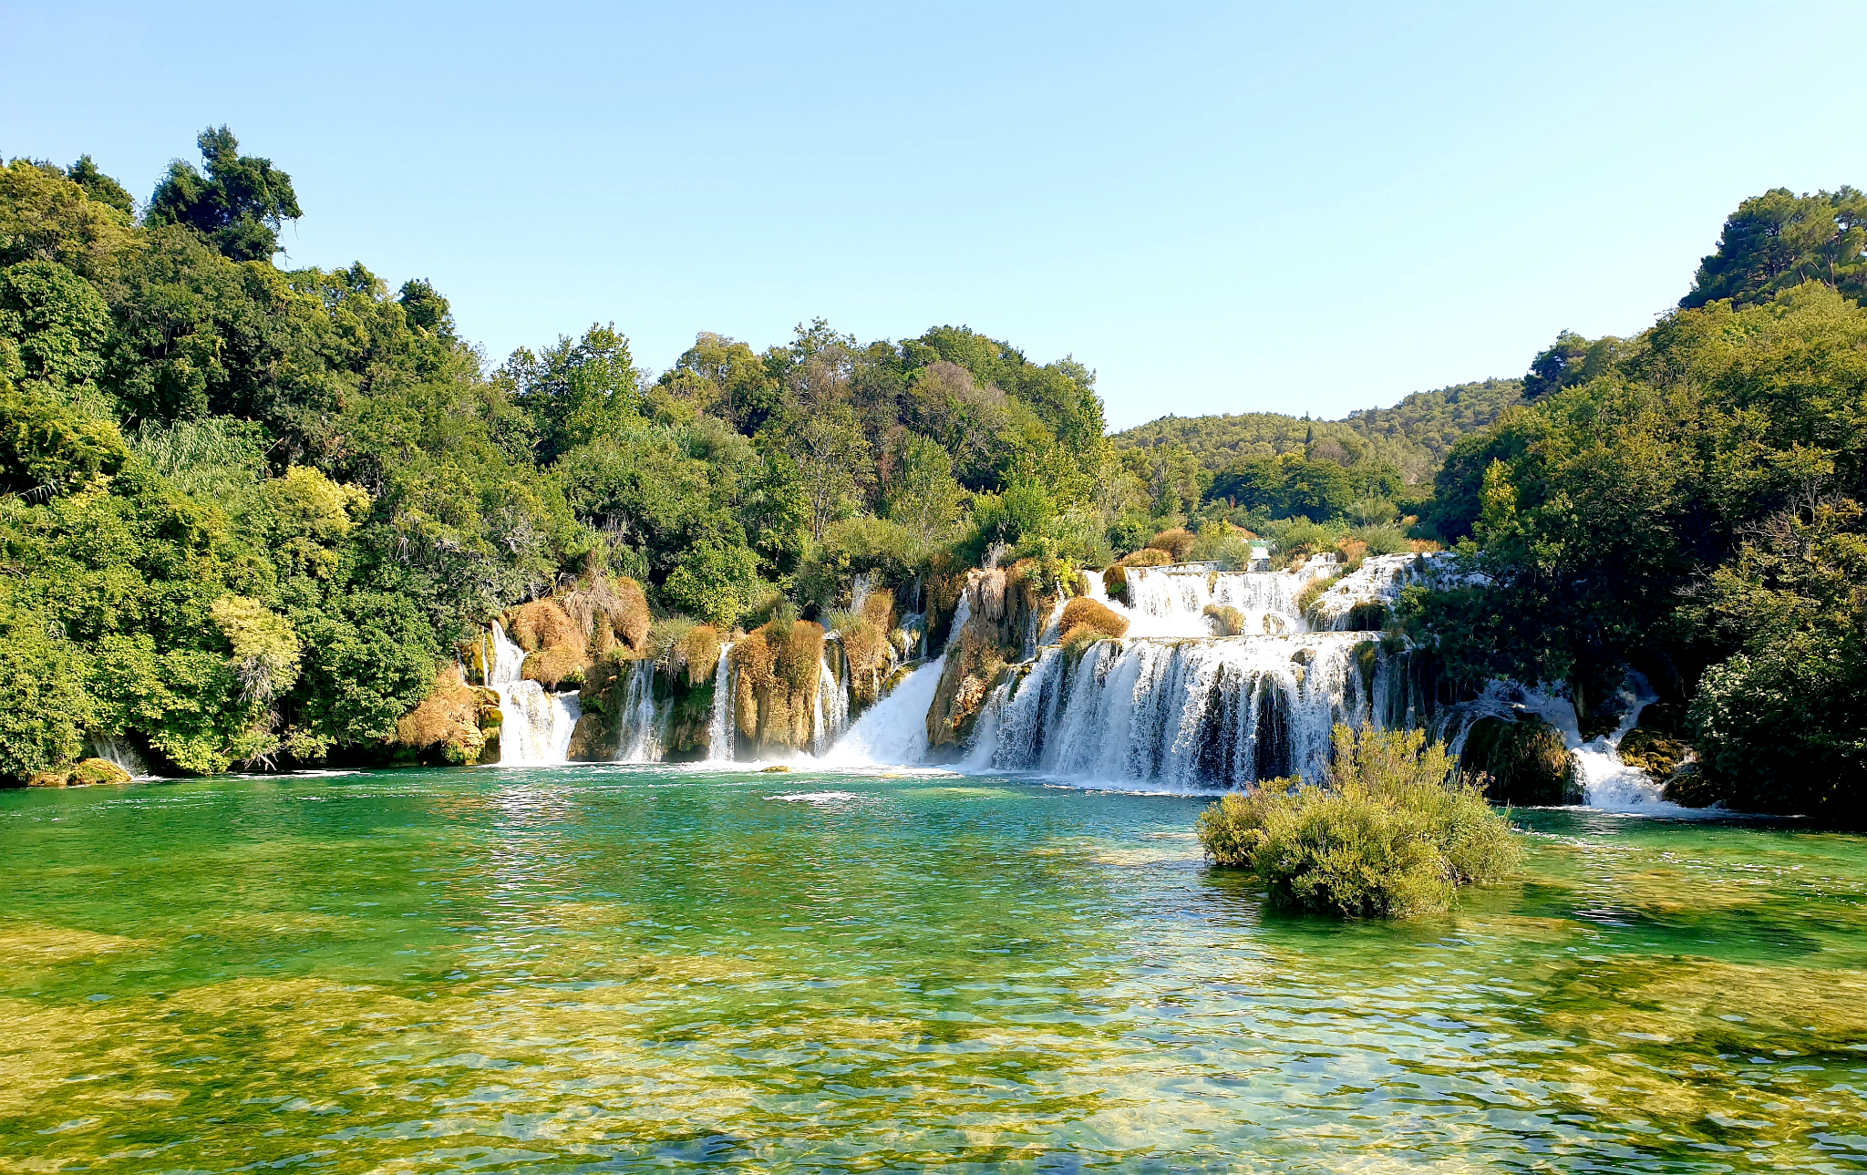 | 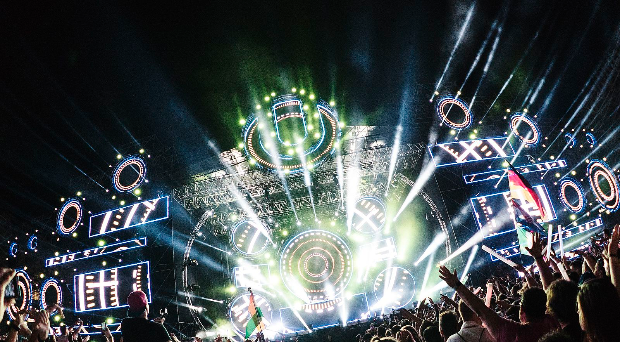
Sljeme - skijanje | Nacionalni park Krka | Ultra Music Festival, Split
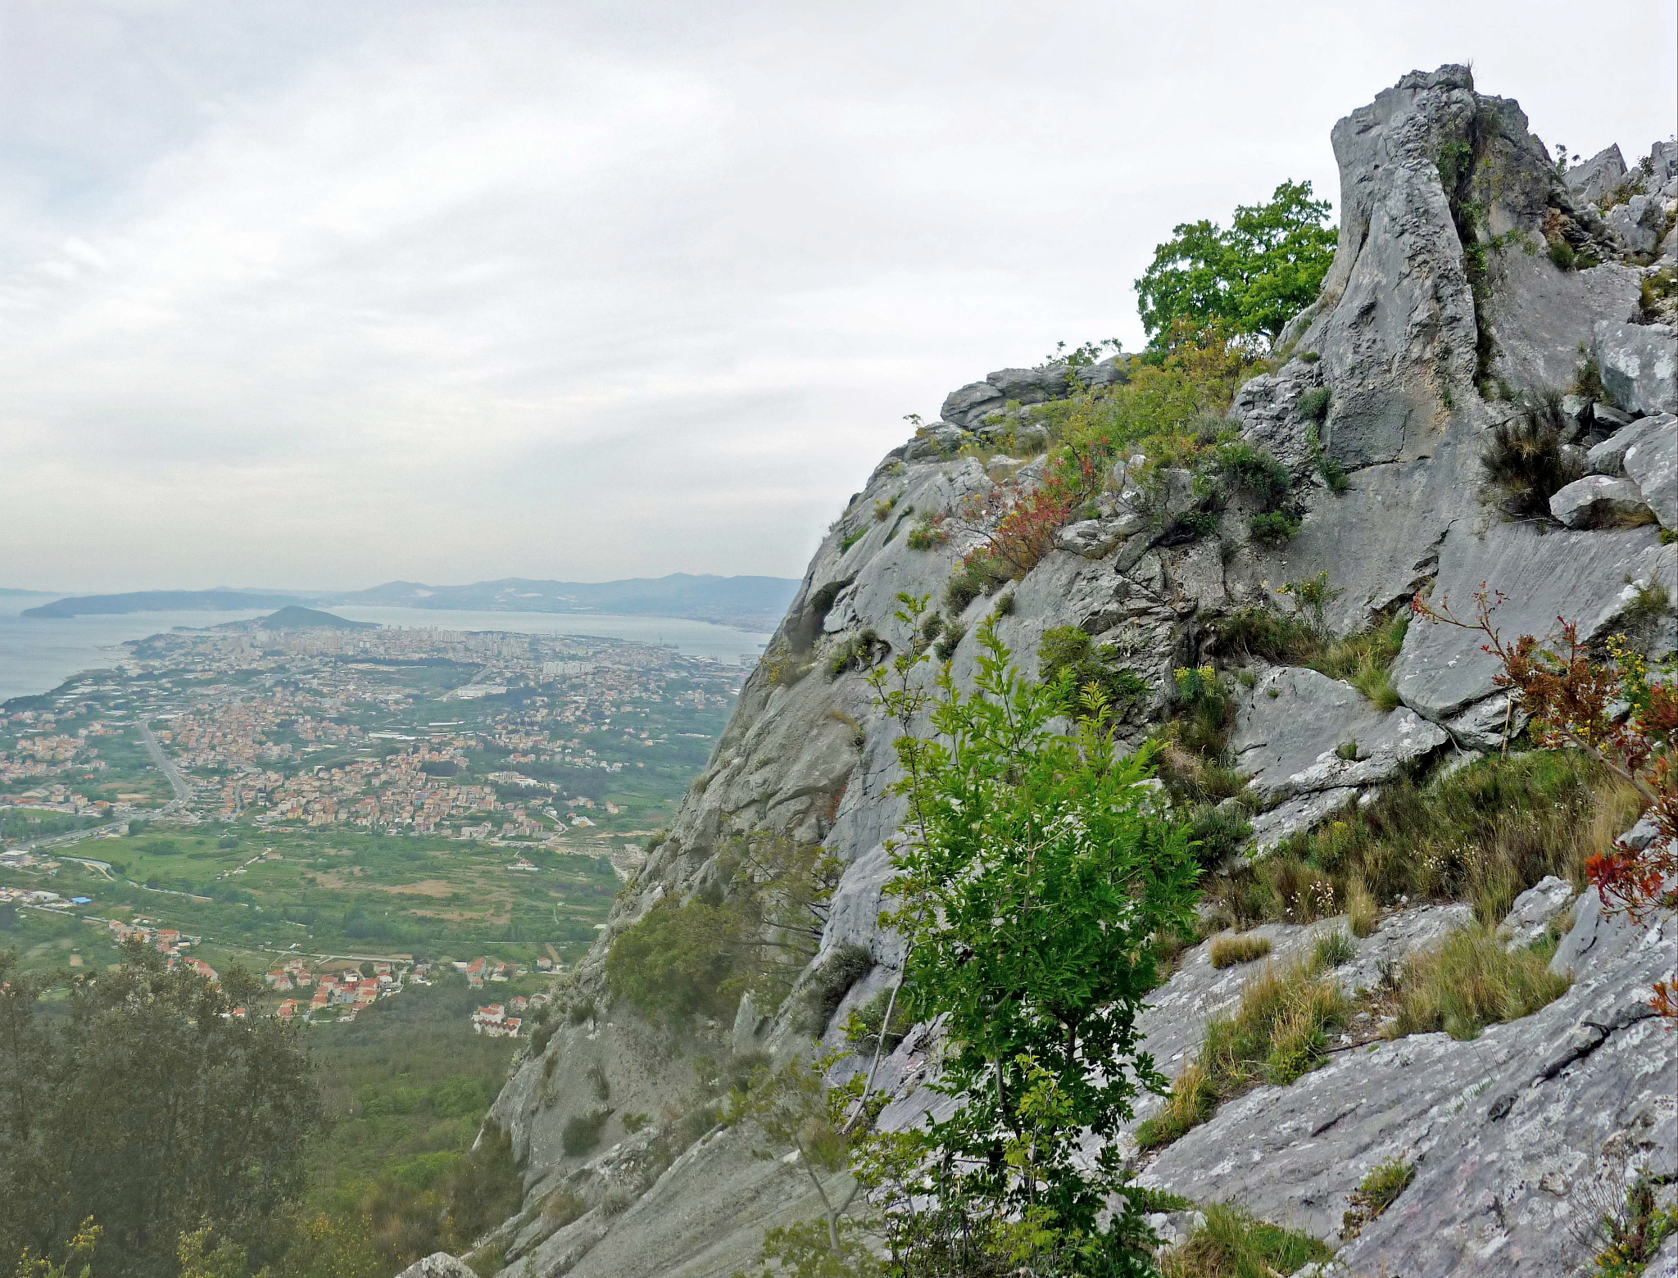 | 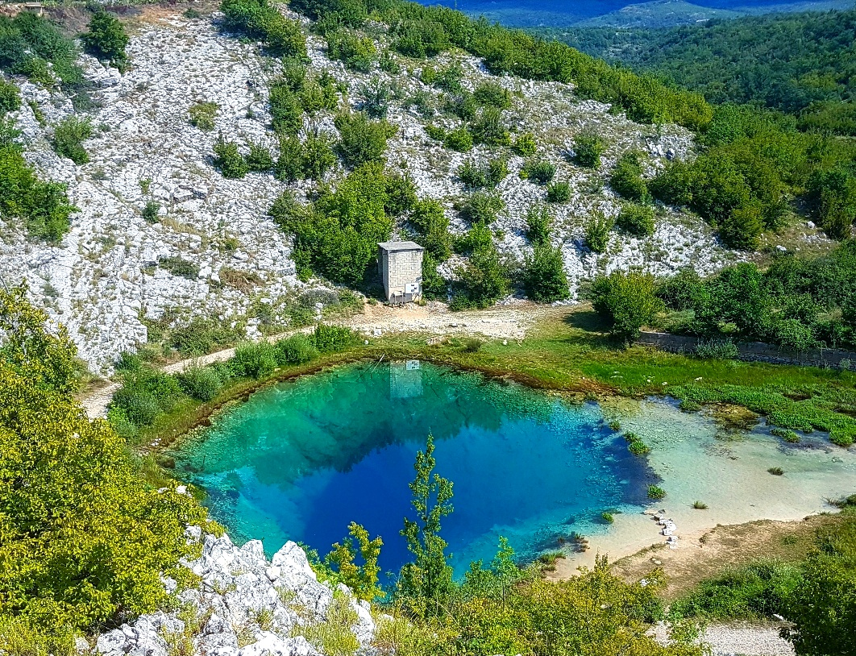 | 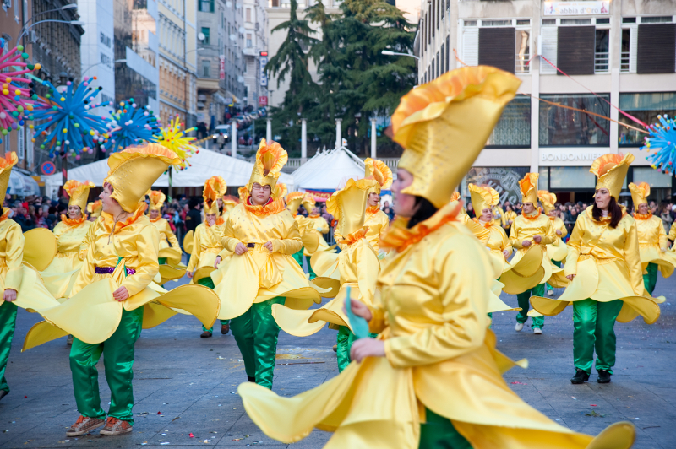
Perun - planinarenje | Izvor Cetine | Riječki karneval

S kim putovati?
mama | starija/mlađa sestra | stariji/mlađi brat
teta | starija/mlađa sestrična | stariji/mlađi bratić
tata | muž ili žena | prijatelj
stric | prijateljice | braća

| Kamo i skim putovati?
→
→
→
→

7.4 Zadatak 4. Na autobusnom kolodvoru
Read the dialogue and answer the questions.
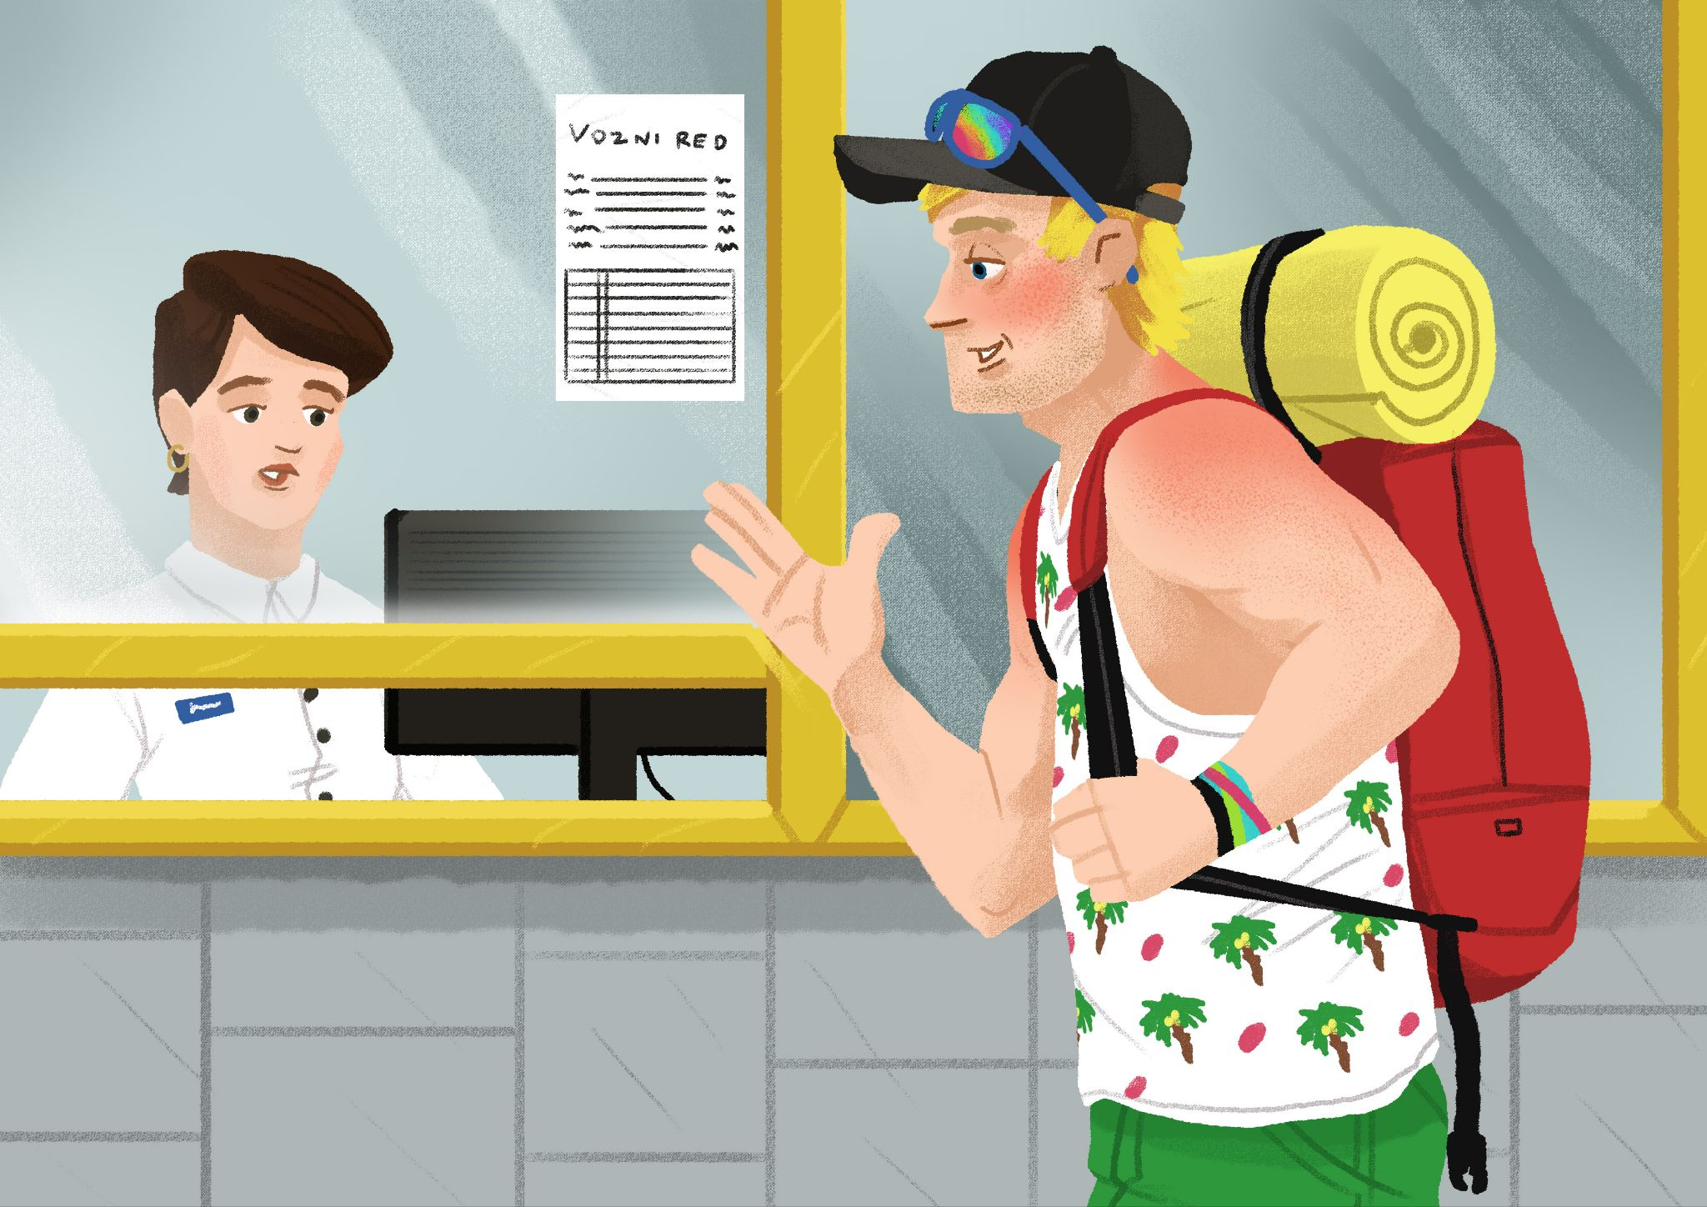

Turist | Dobar dan. Imate li polazak za Šibenik u četvrtak ujutro u 10:30?
Operater | Nažalost, nemamo autobus koji polazi u 10:30, ali imamo u 10:00 ili u 11:00.
Turist | A koliko dugo traje vožnja?
Operater | Autobus koji polazi u 10 dolazi u Šibenik u 11:10.
Turist | A autobus koji polazi u 11:00, kad on dolazi u Šibenik?
Operater | Autobus koji polazi u 11:00, dolazi u Šibenik u 12:30. Također imamo i autobus u 9:00. Dolazi u Šibenik u 10:15.
Turist | Ne, hvala. Ima li mjesta u autobusu koji polazi u 11:00?
Operater | Da.
Turist | Odlično. A kada je povratak u nedjelju?
Operater | Polazak je u četvrtak u 11:00, a povratak u nedjelju u 13:30. Prijevoznik je Autotrans, peron broj 3.
Turist | Koliko košta karta?
Operater | Jednosmjerna karta bez popusta košta 48,00kn. Povratna karta Zadar-Šibenik košta 72,00 kn.
Turist | Imate li popust za studente?
Operater | Da. Za studente jednosmjerna karta košta 36,00kn. Povratna karta košta 58,00kn.
Turist | Odlično, hvala. Mogu li rezervirati povratnu kartu?
Operater | Naravno. Kartu morate preuzeti 1 sat prije polaska.
Turist | Hvala.

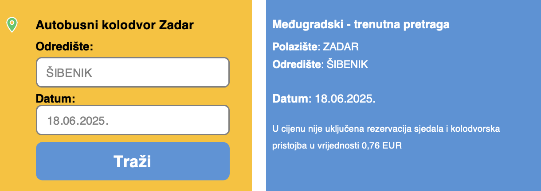
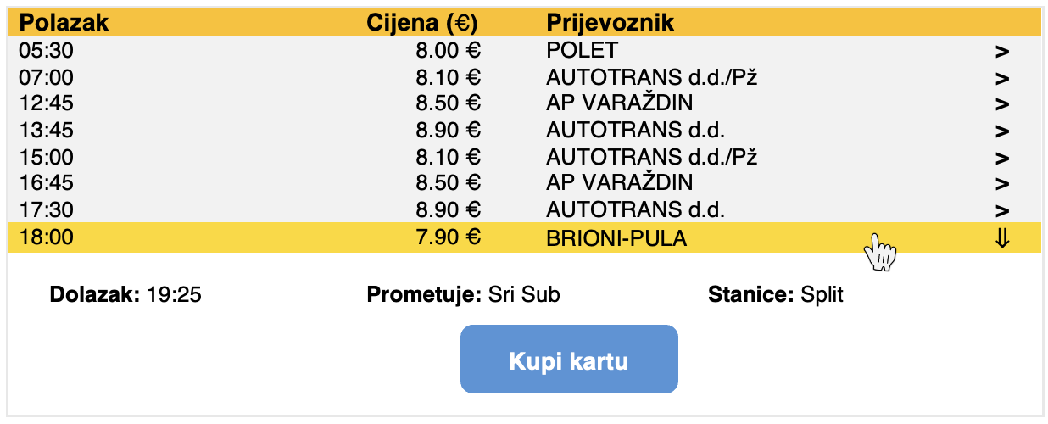

| Razumijevanje
1 | Kamo turist putuje?
1 | -
2 | U koliko sati turist želi putovati?
2 | -
3 | U koliko sati će turist krenuti u Šibenik?
3 | -
4 | Kada je dolazak u Šibenik?
4 | -
5 | Kada je povratak u nedjelju?
5 | -
6 | Koliko košta povratna karta?
6 | -
7 | Koliko je turist platio kartu? Zašto?
7 | -
8 | U koliko sati turist mora biti na autobusnom kolodvoru? Zašto?
8 | -

7.4 Zadatak 5. Moja destinacija
Choose a destination in Croatia that you want to visit. You are located in Split and you want to go somewhere for a long weekend (Friday-Monday). Based on your destination, what type of transportation do you want to use? Investigate how to get to your destination by using one of the websites based on your preference.
 |  | 
Željeznički kolodvor | Autobusni kolodvor | Zračna luka

| Pitanja
Gdje putuješ? Zašto?
Čime putuješ? Zašto?
U koliko sati je polazak?
U koliko sati je dolazak?
Kada je povratak (sat i datum)?
Gdje ćeš spavati?*
Je li smještaj skup ili jeftin?
Koliko moraš platiti sveukupno?
* For your accommodation, use online resources to find somewhere to stay and how much you will pay.

You will present your choices to the rest of the class. You can use your notes while presenting your plans/ideas.

7.4 Zadatak 6. E-mail
Write an email to your language school in Croatia where you are currently studying. They asked you to send them an email with a description of the recent trip that you took during the weekend. You are not sure who will receive your email as you are sending it to a general school email.
 | 

| Be sure to include the following:
Where and why did you travel (your main reason/event)?
How did you travel to your chosen destination?
How was your experience using the specific transportation?
Include details of your departure/return (day, date, hour)
Where did you stay at your destination?
What did you visit in the city of your choice?
Express your overall opinion about your trip.
Give advice to other international students.

Images used in this document are from these sources.

