6.6 - A few words to talk about the past...

A rather small lesson...here are some words that will come in handy.

včera - yesterday – listen to it being pronounced here
předevčírem - the day before yesterday – listen to it being pronounced here
tenkrát - then (lit. that time [in the past])
loni - last year
minulý (týden, měsíc, čtvrtek,...) - last (week, month Thursday,...)

Včera jsem byl doma.
Yesterday I was at home.

Loni jsem nepracovala.
I didn’t work last year.

That’s it!

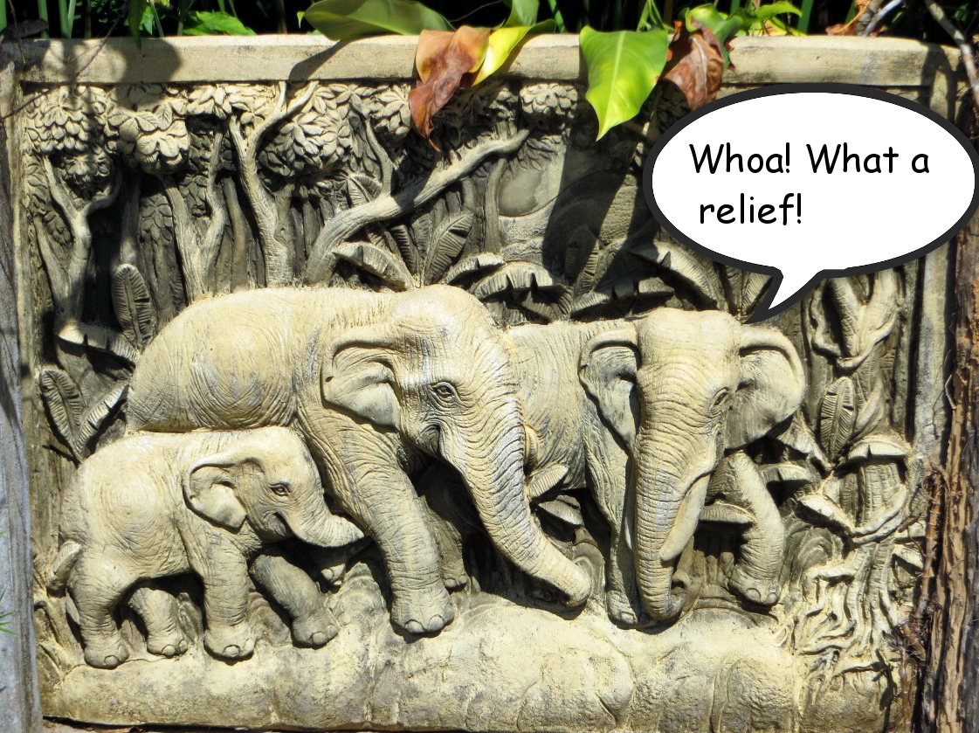

Image used in this document is from this source.

