5.1 - Barva očí - Eye color

Here are just a few examples with eye color. Read through them to give yourself a model regarding how eye color is described.
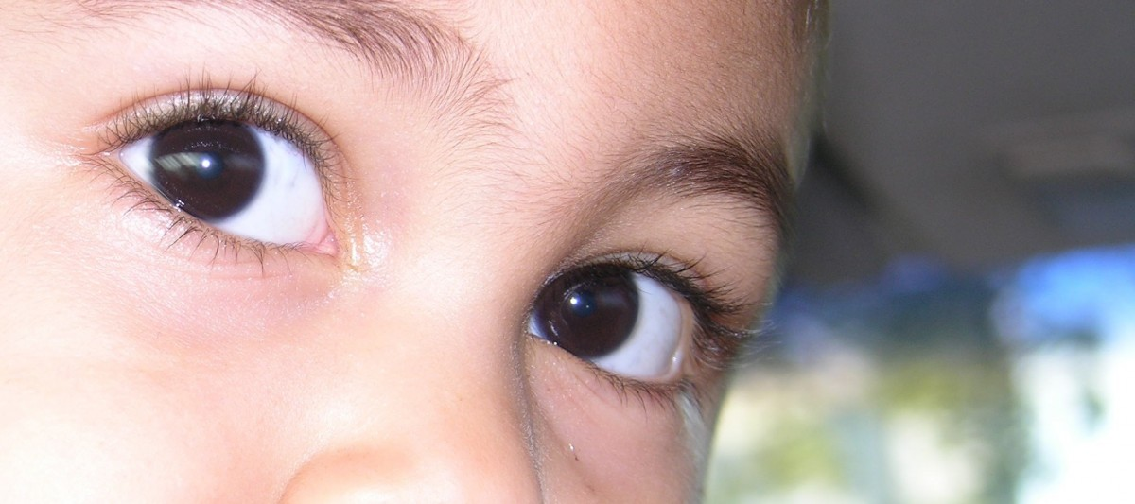
Hana má hnědé oči.
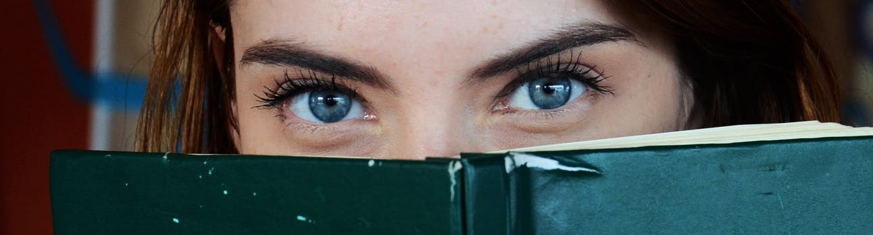
Jana má modré oči.
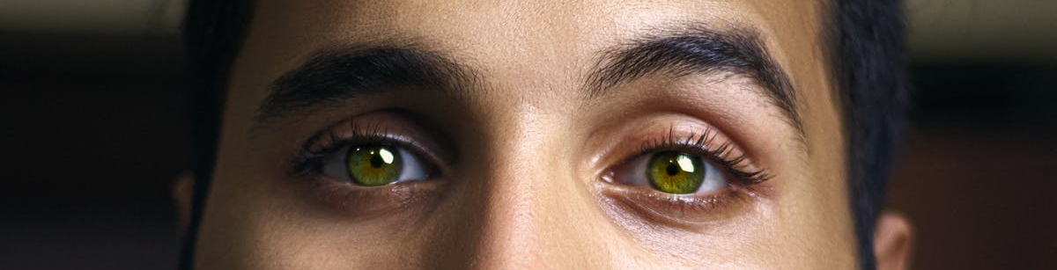
On má zelené oči.
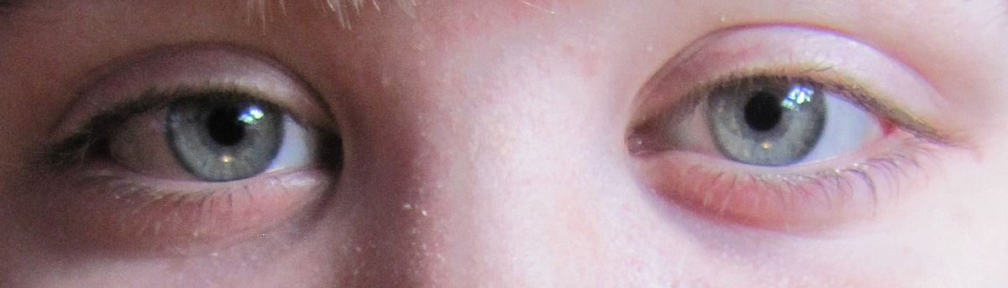
Petr má šedé oči.

Images used in this document come from these sources.

