3.9 - mít chuť na něco

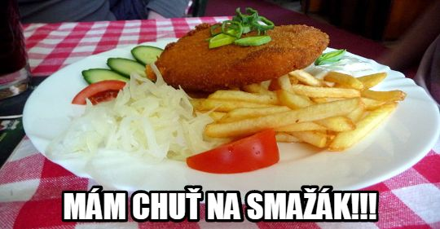
Note - smažák is a colloquial way of saying smažený sýr

I’ve got a craving for something. I’ve got a hankering for something.

These are things we say when we feel like having something – ok, we probably don’t say hankering so much (it sounds a bit old-fashioned, at least to my ear), but you get the point, right? We have ways of saying that we feel like having something. How do we say this in Czech???

Turns out, we use the same word we just learned for wishing someone a good appetite - dobrou chuť. We use the word chuť to literally say I have an appetite for something. Take a look at the following examples:

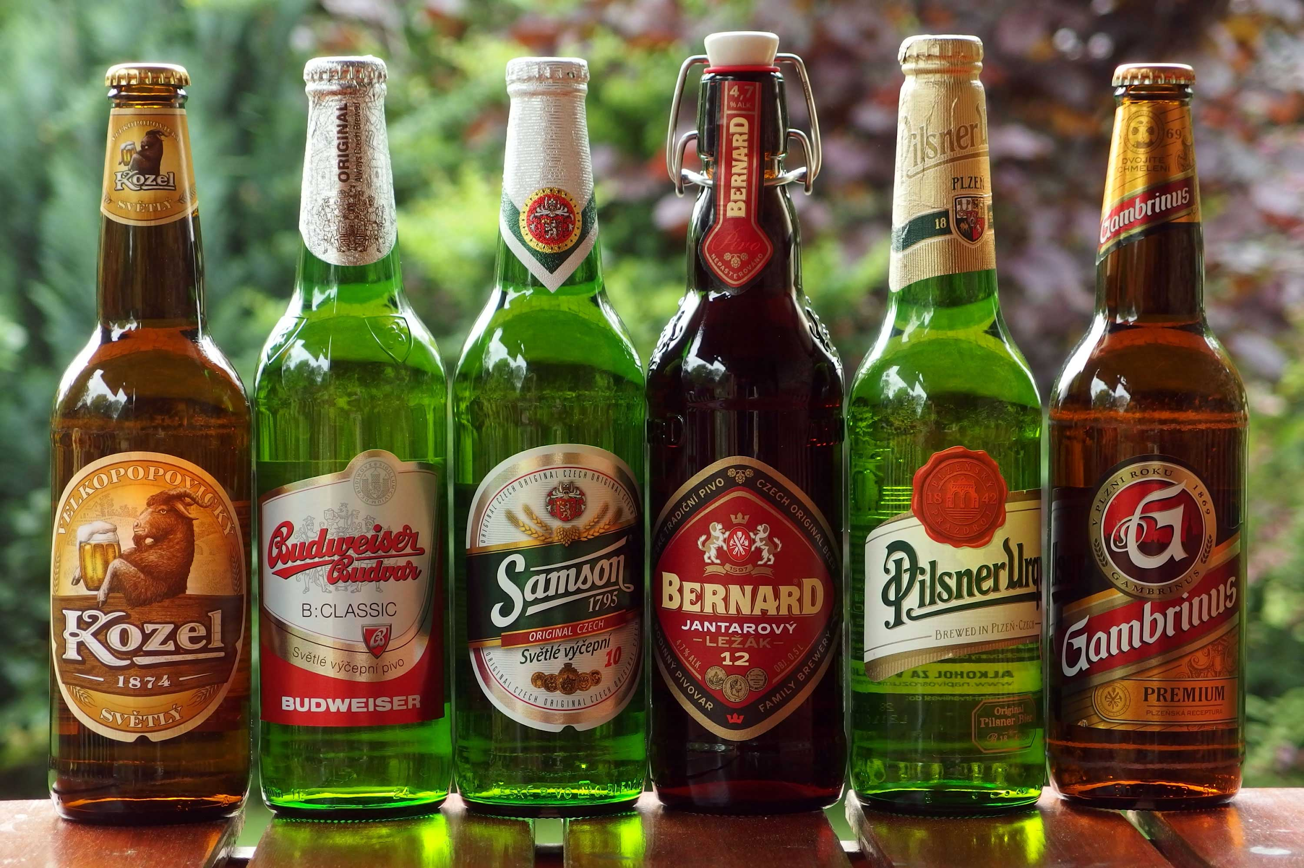  Mám chuť na pivo.  lit. I have a craving for beer (I feel like having beer). | 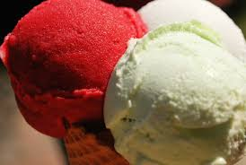  Máme chuť na zmrzlinu.  lit. We have a craving for ice cream (We feel like having ice cream).
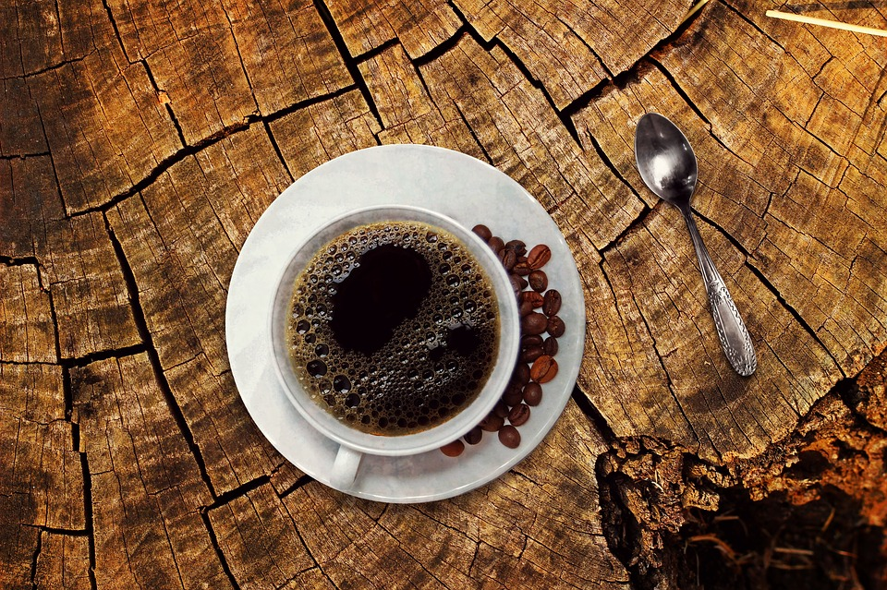  Máš chuť na dobrou kávu?  lit. Do you have a craving for good coffee? (Do you feel like having good coffee?) | 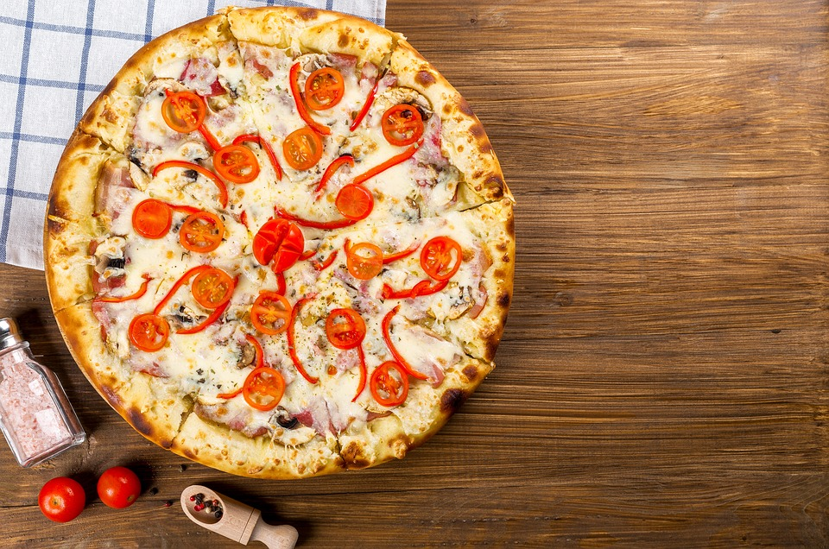  Pavla má chuť na pizzu.  lit. Pavla has a craving for pizza (Pavla feels like having wine and cheese).

So can you figure out the whole construction? It’s mít chuť na _________.

But there’s still one piece of information missing. Can you look back at the sentences above and figure out what case the word in the blanks needs to be? If you look carefully, you’ll notice that these words are in the accusative (the feminine -u ending gives it away).

Finally, the question – you can ask someone what they have a craving for:

Na co máš chuť?
What do you have a craving for? (what do you feel like having?)

Well, in English we can put a preposition right at the end of a sentence (despite what your English teacher might have taught you – here the preposition is for). In Czech, that’s totally impossible, instead you literally have to say for what do you have a craving? Sounds awful, right? Bring that sentence back to your English teacher! But that’s exactly the normal and natural way of asking the question in Czech.

So to sum up:

mít chuť na (+ Accusative Case)

Na co máš/máte chuť?
What do you feel like having? lit. what do you have a craving for?

Images used in this document come from these sources.

