6.6 - saying ‘last _______’ - minulý
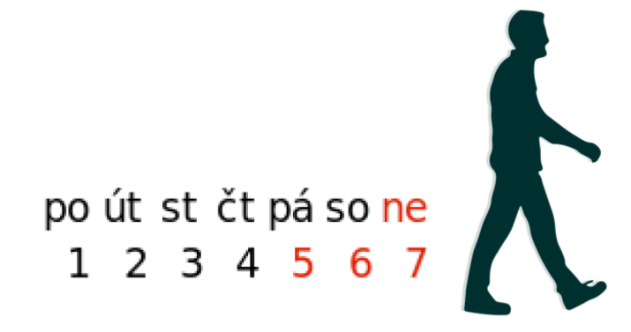

If you want to use the word minulý - ‘last’ to say things like last summer, last year, last Sunday, etc. just use the word minulý (making sure to pay attention to gender of the noun you put it in). The entire expression should in the accusative case.

Byl jsem tam minulou sobotu.
I was there last Saturday.

Minulý čtvrtek jsem byla v New Yorku.
Last week I was in New York.

Minulý rok jsem pracovala v restauraci.
Last year I worked in a restaurant.

Images used in this document come from these sources.

