2.2 - Conjugation of -á- verbs

We have already learned how to conjugation the verb být ‘to be’, so you should be familiar with the concept of verbs changing their form to indicate different subjects. This lesson covers conjugation of -á- type verbs

-á- verbs:

The endings for -á- verbs are as follows:

(já) | -ám | (my) | -áme
(ty) | -áš | (vy) | -áte
(on/ona/ono) | -á | (oni/ony/ona) | -ají

Most -á- verbs end in -at, such as dělat ‘to do’. Remove the -at before putting on the endings:

(já) | dělám ‘I do / am doing’ | (my) | děláme ‘we do / are doing’
(ty) | děláš ‘you do / are doing’ | (vy) | děláte ‘you all do / are doing’  ‘you (formal) do / are doing’
(on/ona/ono) | dělá ‘he/she/it does / is doing’ | (oni/ony/ona) | dělají ‘they do / are doing’

(já) | odpočívám ‘I relax, am relaxing’ | (my) | odpočíváme ‘we relax, are relaxing’
(ty) | odpočíváš ‘you relax, are relaxing’ | (vy) | odpočíváte ‘you all relax / are relaxing’  ‘you (formal) relax / are relaxing’
(on/ona/ono) | odpočívá ‘he/she/it relaxes’ | (oni/ony/ona) | odpočívají ‘they relax, are relaxing’

If you want to negate the verb (i.e. say that you don’t do something), simply add ne- to the front of the verb.

Nedělám

Here are some common -á- verbs that you will use in this chapter:

Infinitive | Meaning
dělat | ‘to do’
odpočívat | ‘to relax, rest’
poslouchat (hudbu) | ‘to listen (to music)’
běhat | ‘to run’
zpívat | ‘to sing’

  Lucie často běhá.  Lucie often runs. |   Karel zpívá.  Karel is singing
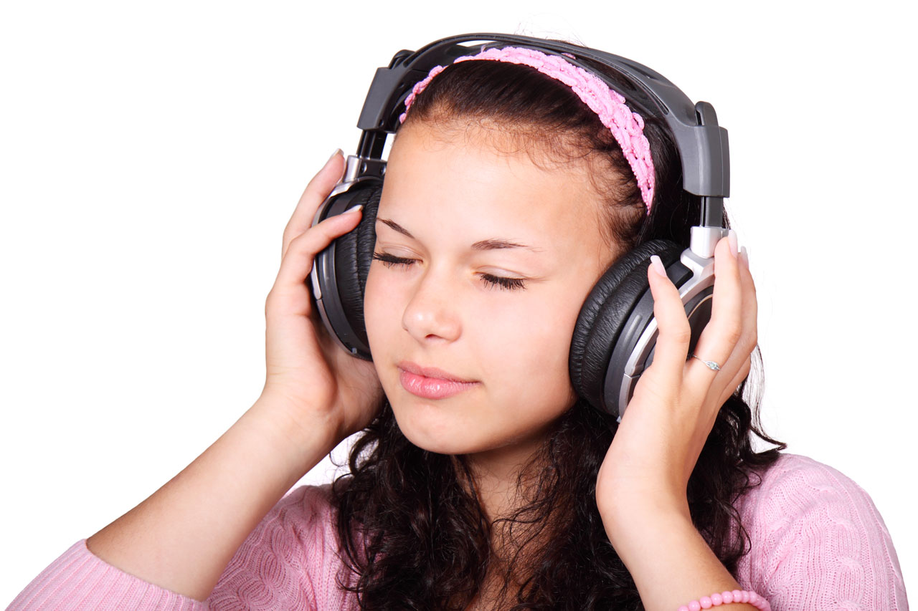  Eva poslouchá hudbu.  Eva is listening to music. | 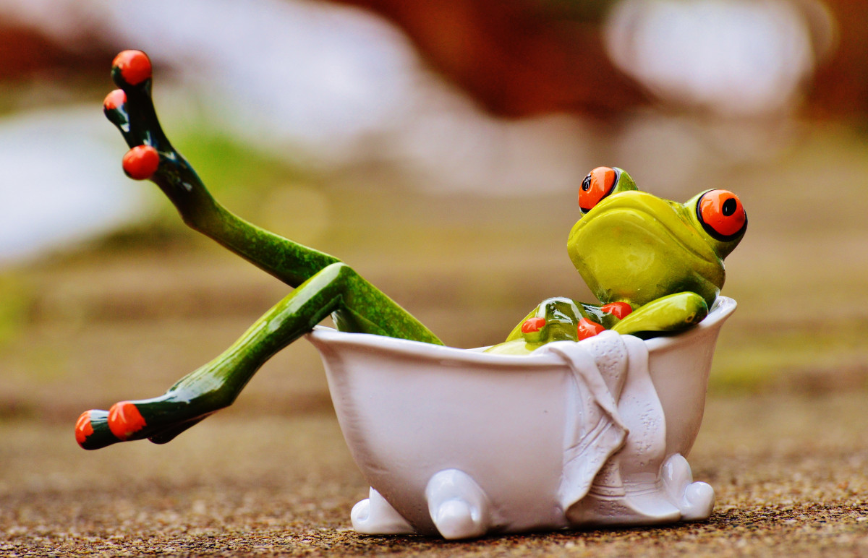  Žába odpočívá.  The frog is relaxing.

Images used in this document come from these sources.

