3.8 - Check please! - Zaplatíme, prosím!

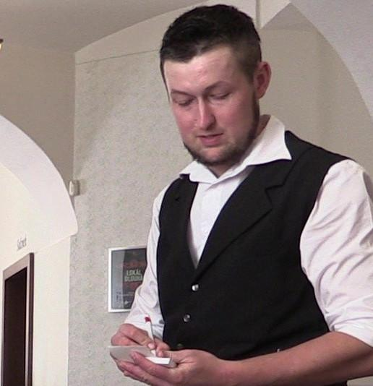

Your favorite part of going out – paying the bill.

Getting the Bill
To say you want to pay, once you’re talking to your server, say zaplatím prosím or if there are more of you zaplatíme prosím.

zaplatím - I’ll pay
zaplatíme - We’ll pay

Your server will typically ask you if you want to pay together or separately - dohromady nebo zvlášť?

dohromady - together
zvlášť - separately

How much do I owe?
Czechs typically pay for their bills separately zvlášť and the customs of payment make this really easy. Each person at the table will let the server know what they had.

Tak tři piva, česnečka, guláš, knedlíky.
So, three beers, garlic soup, goulash, dumplings.

The server will then add up the items (in what can only be described as a superhuman ability to do quick arithmetic) and say the amount owed, such as the followin total:

Dvě stě šedesát čtyři (korun), (prosím).
Two hundred and sixty four (crowns), (please).

Paying and Tipping
At this point you pay the amount and give a tip - spropitné (colloquially dýško). It’s somewhat unexpected for many foreigners, because you do this in full view of the server (basically tipping them right to their face) by announcing how much you will pay in total, i.e. you tell the server the total amount you are paying, meaning the bill total + the tip as a single sum . Tipping over there is closer to about 10% and you always round to the nearest tens place. So given a bill of 264 Kč, I might pay a total of 290 Kč. Rounding to a whole number (nearest tens) is very important. So, based on this, I would just say:

Dvě stě devadesát.
Two hundred ninety.

That’s it! There’s no leaving money on the table – after all, someone could steal it, right?

Images used in this document come from these sources.

I put a few items in parentheses, because they may or may not say the crowns or even please

