4.5 - Weather and its Effects on Us
 | 

Physical Effects
Let’s first start with some phrases. One thing that is interesting about these phrases is that they are structured a bit differently than English (see literal translations below).
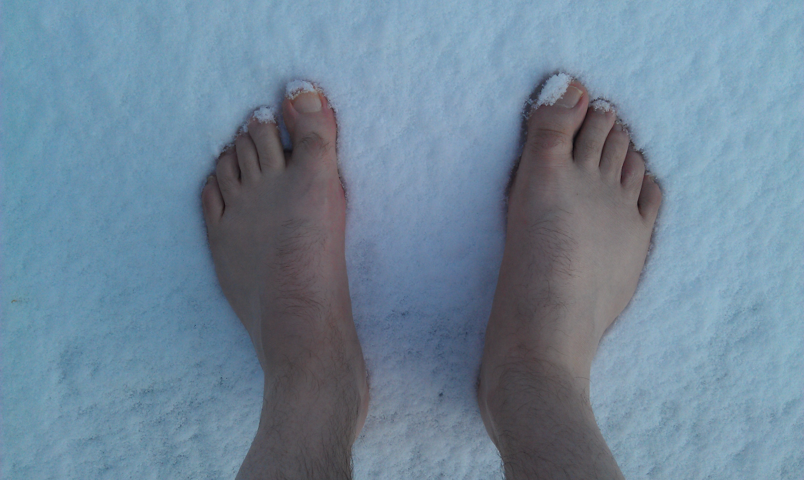  zebou mě nohy - my feet are freezing (lit. feet are chilling me) |   zebou mě ruce - my hands are freezing (lit. hands are chilling me)

Adjectives
Use with the verb být to describe people.

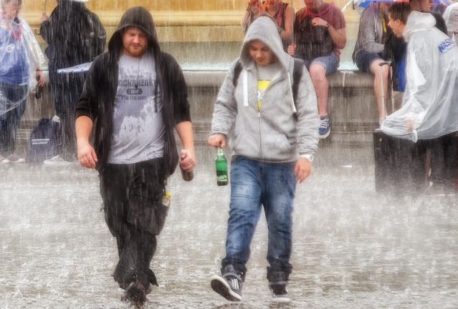  zmoklý/á - soaked |   unavený/á - tired
  zpocený/á - sweaty, covered in sweat  (potit se - to sweat) | 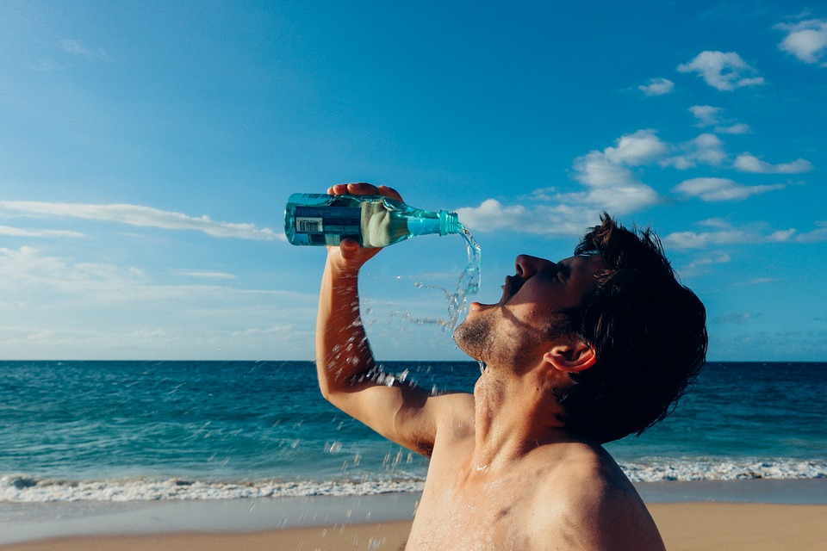  dehydrovaný/á - dehydrated
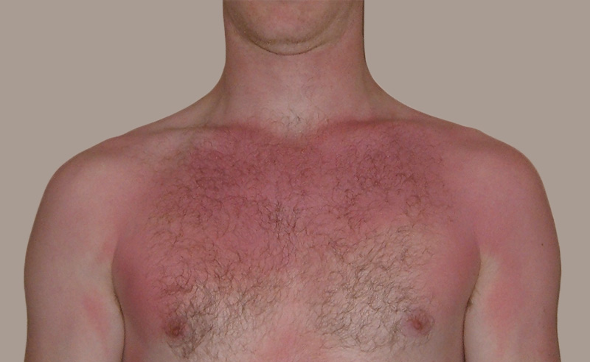  spálený/á - sunburnt | 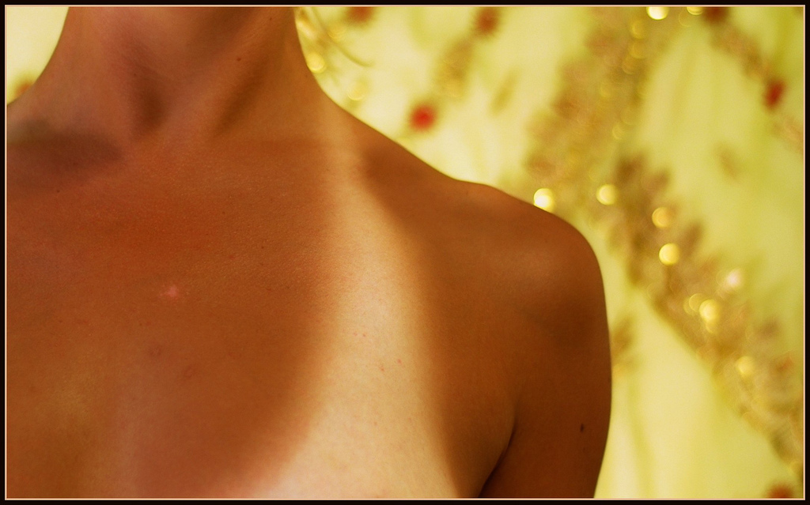  opálený/á - suntanned

zmrzlý/á (na kost) - frozen (to the bone)

Images used in this document come from these sources.

