9.1 - Let's celebrate - slavit / oslavit ‘to celebrate’

Let’s learn how to celebrate – or at least learn the verb to celebrate. It’s slavit / oslavit. They are conjugated perfectly regularly (-í- type verb).

Imperfective slavit ‘to celebrate’
Use the imperfective slavit to talk about:
- what people are currently doing
- what they regularly do or did
- focusing more on the process of celebration
- plans for an upcoming activity
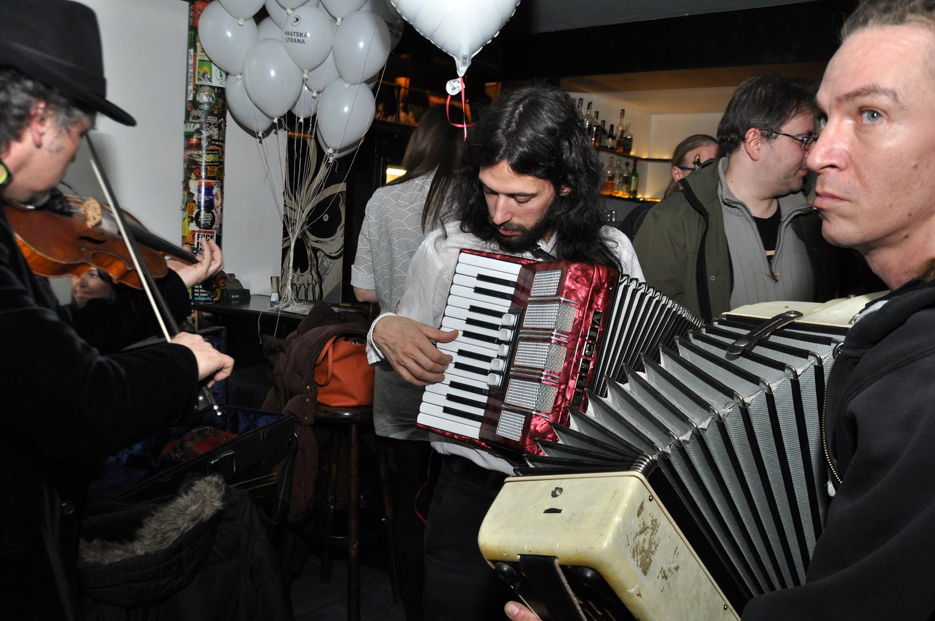 | 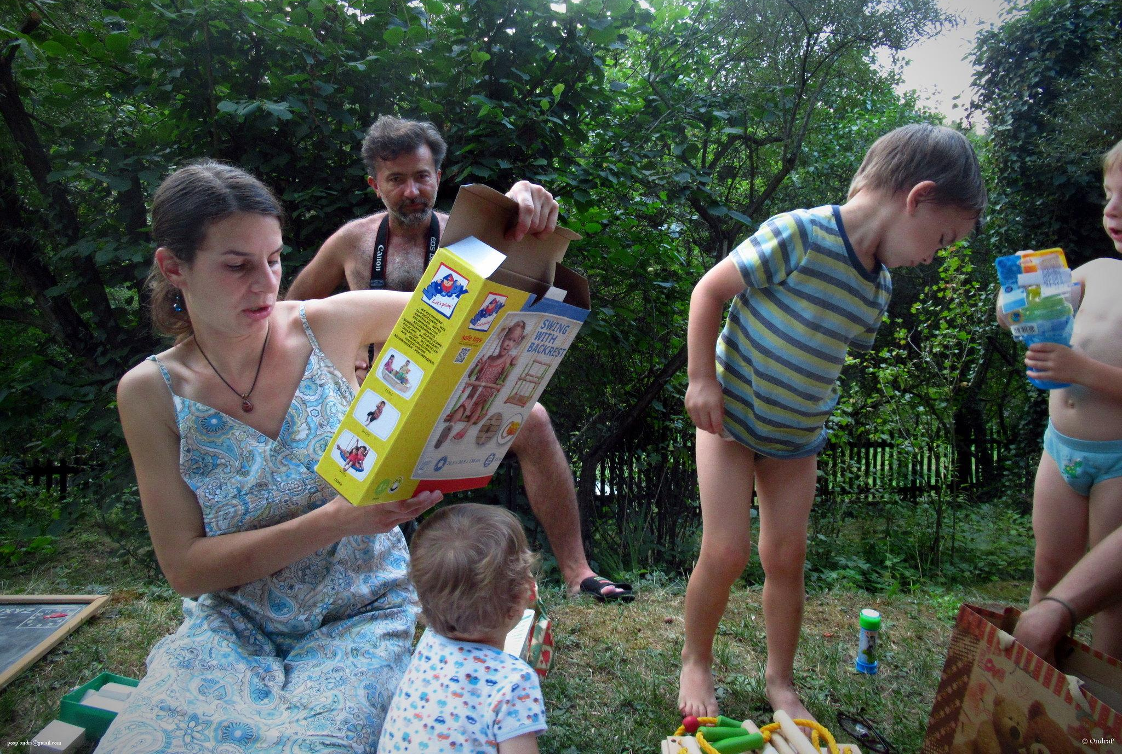
Ivan a Mikuláš dneska slaví narozeniny. | Dneska slavil Tonda první narozeniny a dostal pár dobrých hraček.

Perfective oslavit ‘to celebrate’
You’ll often find oslavit to talk about:
- a completed celebration in the past
- plans for a future celebration
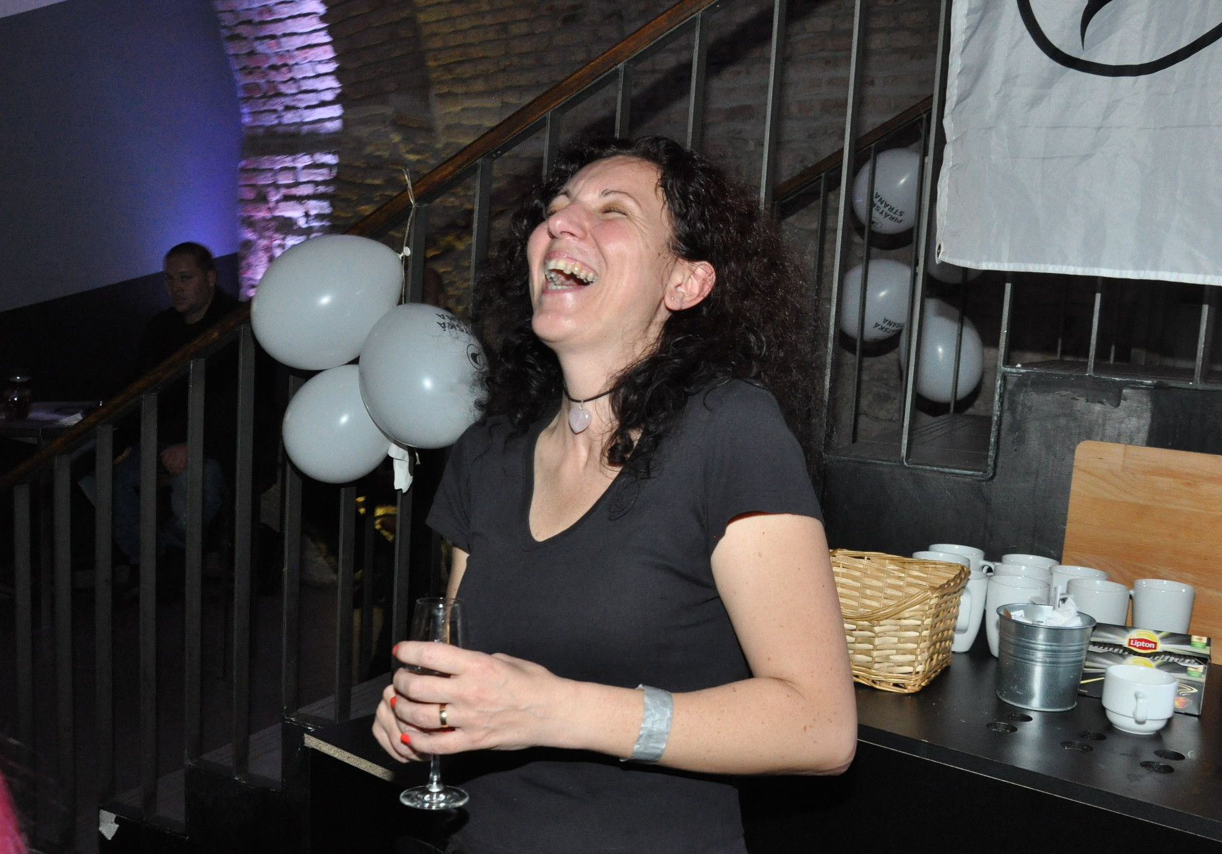 | 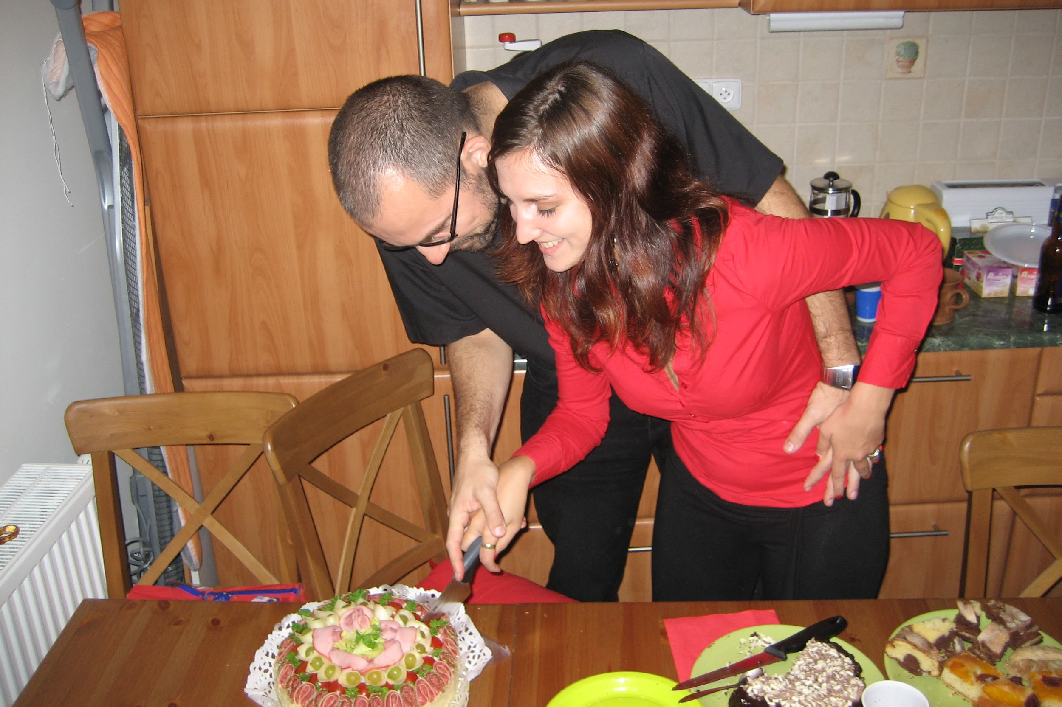
Petra včera večer oslavila velký úspěch v práci s kolegy. | Včera oslavila Zuzana narozeniny na chatě s kamarády.

Future Tense
As you can see from the lists above, both imperfective slavit and perfective slavit are commonly used to talk about future celebrations. Don’t worry too much about the differences here. Perfective oslavit is likely going to be used when there’s a bit more intentionality, but this is only a slight nuance of meaning and not worth worrying too much about the difference.

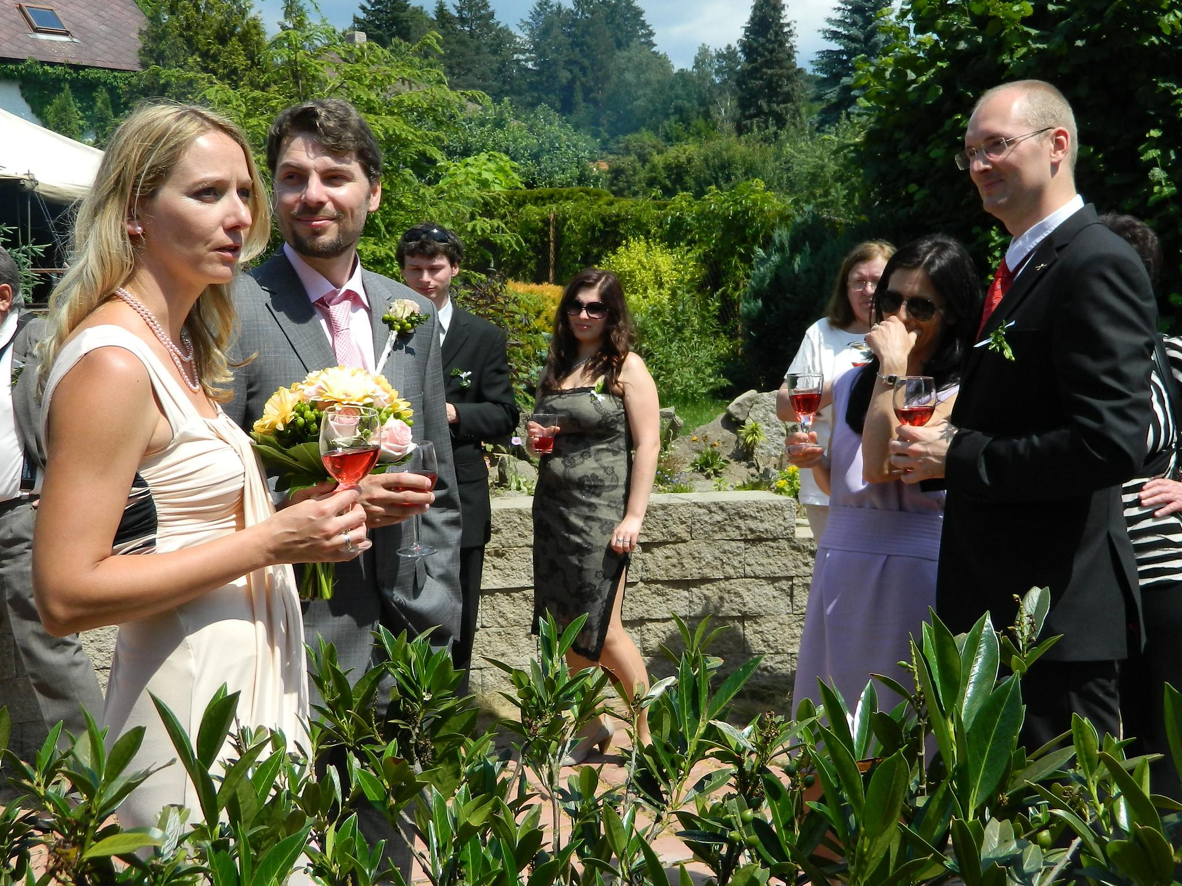 | 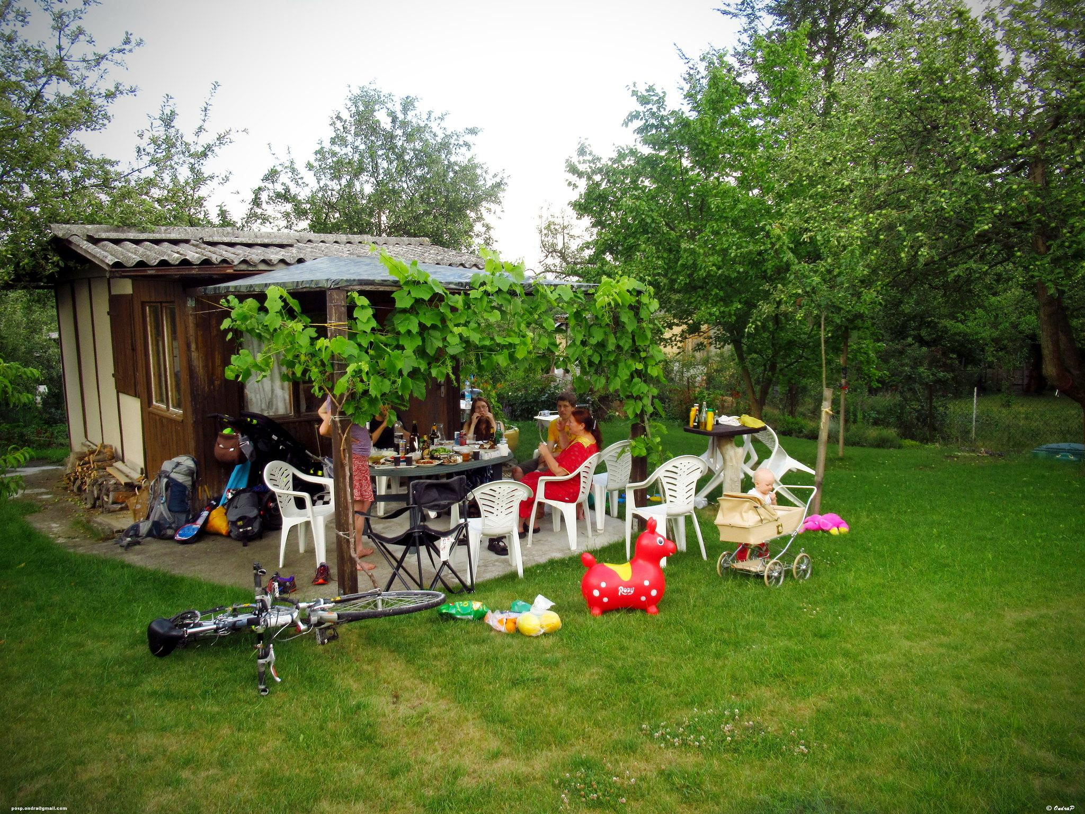
Marek a Julie měli dneska svatbu a dneska odpoledne to oslavíme / budeme slavit. | Dneska má Mirka narozeniny a budeme slavit celý den na chatě.  *Note - here only budeme slavit would work, since we’re focusing on the activity and its duration (celý den - all day )

Images used in this document come from these sources.

