1 | 2 | Lekcija 3: Naše stvari

1.2 Zadatak 7. Moje stvari
💻 Video recording. Submit your video showing us what you have in your room, house, or apartment. Try to focus on things we covered in class so far. If you have multiple items, be sure to use plural forms. Example:
Singular | Ovo je moj [...]. | Ovo je moja [...]. | Ovo je moje [...].
Plural | Ovo su moji [...]. | Ovo su moje [....]. | Ovo su moja [...].
Watch at least one video of your classmates and make a comment on their things. What does each thing they presented look like? This is your personal opinion, but try to use adjectives that we have covered so far. Example*: Njegova torba je lijepa. Njezina torba je lijepa. Be careful – this example is for feminine gender in singular form. 🪞

1.2 Zadatak 8. Njihove stvari
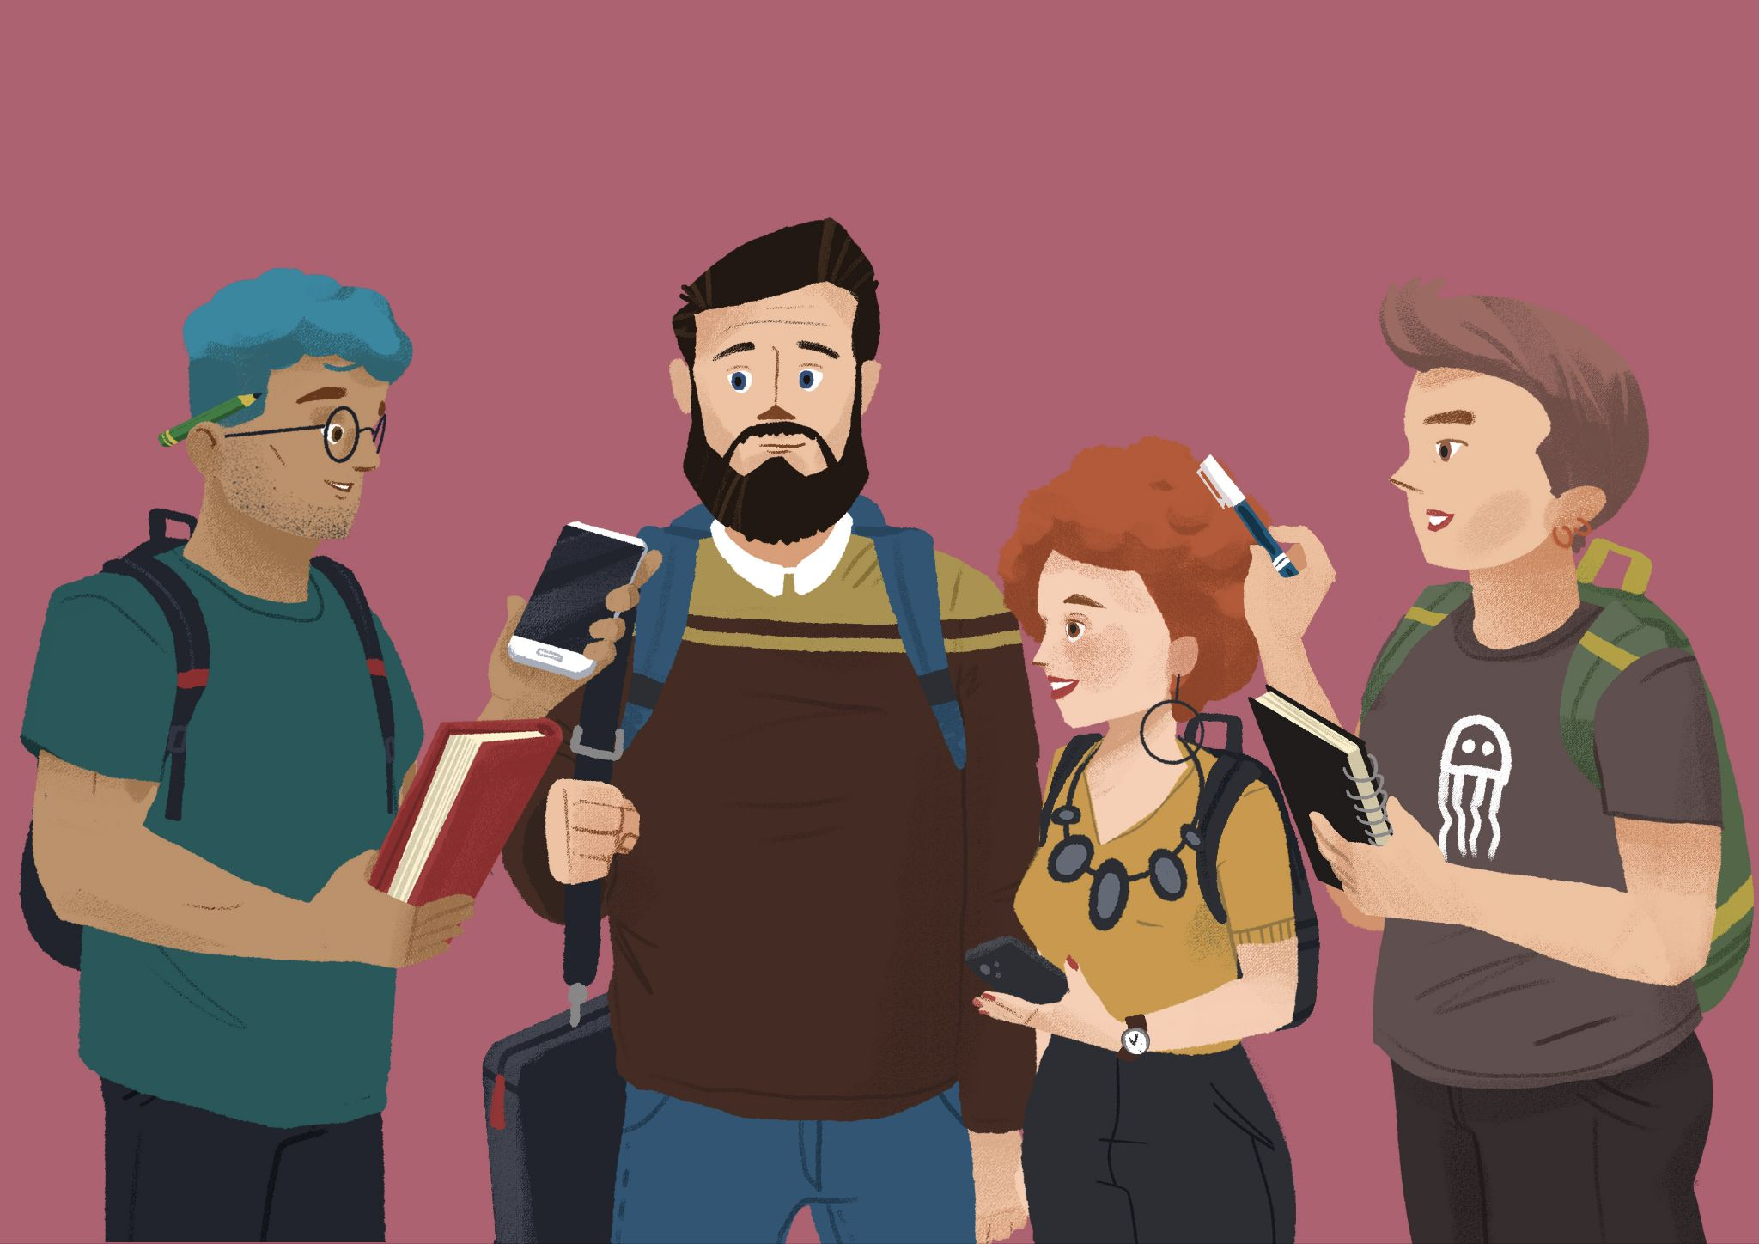 | Read each question that James asked to his new friends. Based on what you see on the picture, provide the answers. Then, in the last column write the name of the person who has a specific object. The first question is done for you.

Pitanje | Odgovor | Čije je?
Čija je knjiga? | To je njegova knjiga. | James
Čiji su ruksaci? | To su njihovi ruksaci. | Luka i Matija
Čiji su mobiteli? | To su njihovi mobitel | James i Ines
Čija je torba? | To je njegova torba | Luka
Čija je bilježnica? | To je njezina bilježnica | Matija
Čija je kemijska? | To je njezina kemijska | Matija
Čiji je sat? | To je njezin sat | Ines
Čije su naušnice? | To su njezine naušnice | Ines

1.2 Zadatak 9. Naše stvari
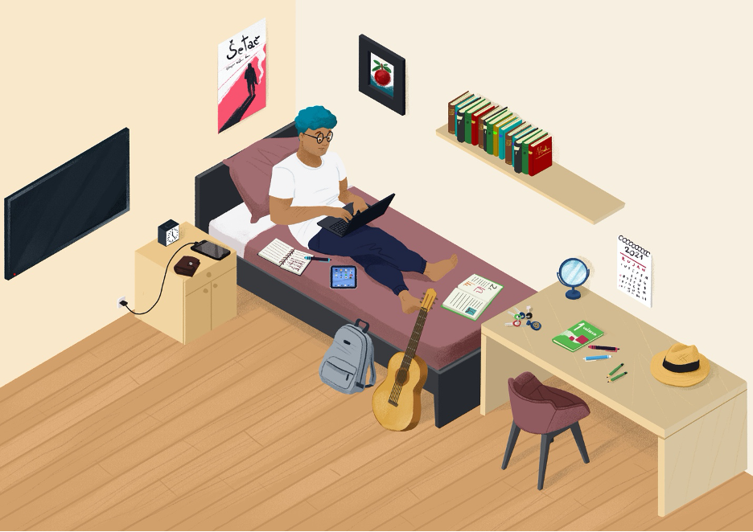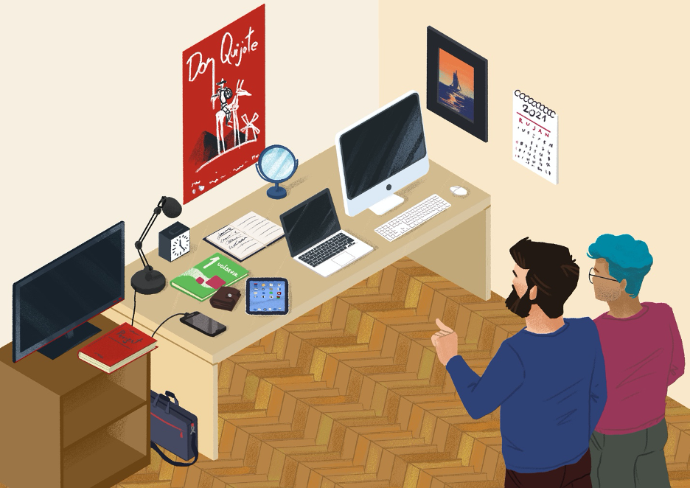
Look at the pictures of James’ and Luka’s apartment. When writing a complete sentence, use the following structure: Those are their books. Answer in Croatian.
1 | What do they have in common?
1 | -

1.2 Zadatak 10. Njegov, njezin, njihov

Step 1 (korak 1)
You have a set of pictures below. In Table 1, give each item to whomever you want. Give some things to Davor and some to Sandra. In other words, place each item wherever you want in the chart below, but copy some items so that both people get some of the same items.

Step 2 (korak 2)
💻 Video recording.Talk with your classmate and try to find out who has what according to your classmate’s version. For example: Your classmate might place a bag in both columns, meaning that Davor and Sandra both have a bag. You will probably ask the question: Čija je torba? Your classmate will answer: To su njihove torbe. This is how you will know that both of them have a bag. In Table 2 place the items according to your classmate’s version of who has what. Take turns asking questions and fill out Table 2 depending on the classmate’s answers.
Submit your recording online.
Table 1 (your version)
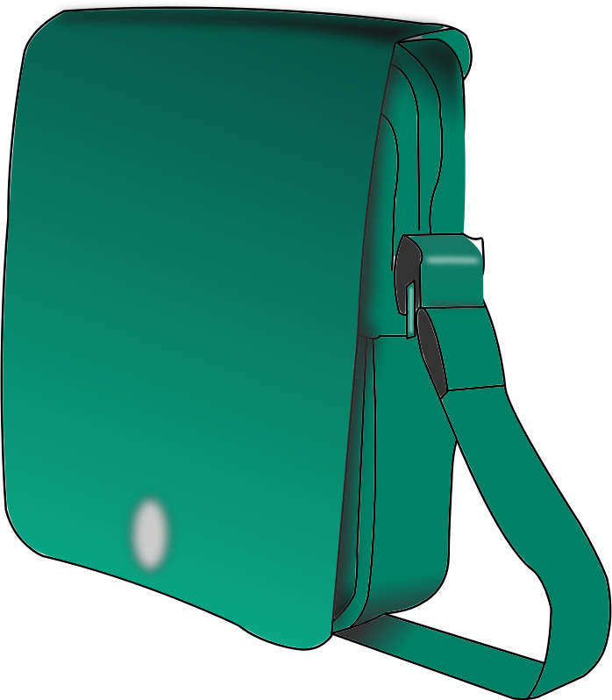 |  |  | 
 |  |  | 
DAVOR |  | SANDRA

Table 2 (your classmate’s version)
DAVOR |  | SANDRA

1.2 Zadatak 11. Kakav je?
💻 Video recording. Work with a classmate and ask each other what each of the following items or people look like. Each of you should share your opinions. Be careful how you formulate the question. It will depend on the gender of each item. Submit your recording online. ℹ️
 |  |  | 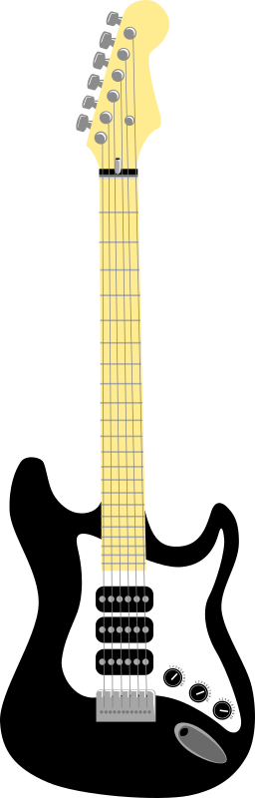
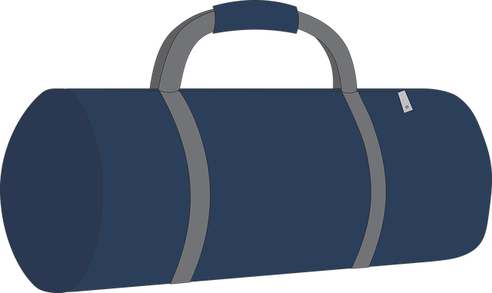 |  |  | 
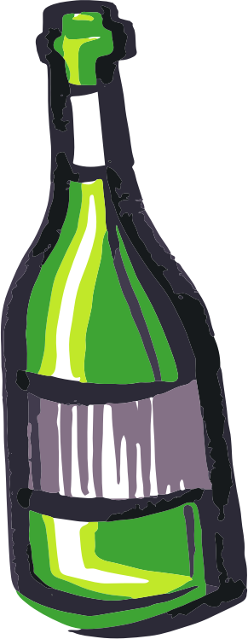 | 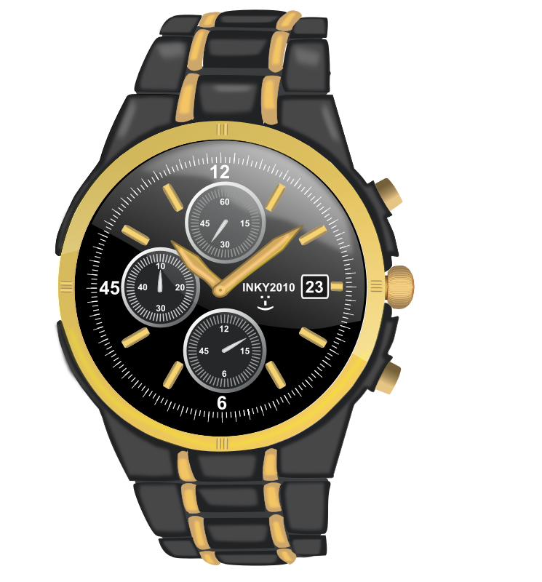 |  | 
 | 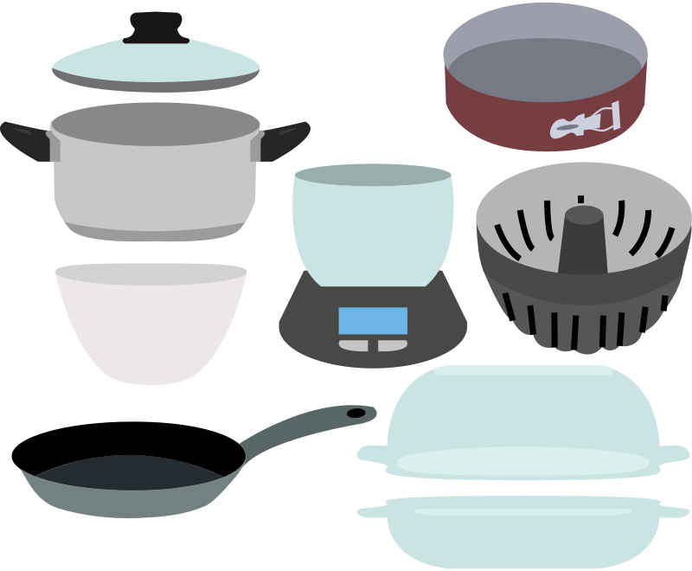 | 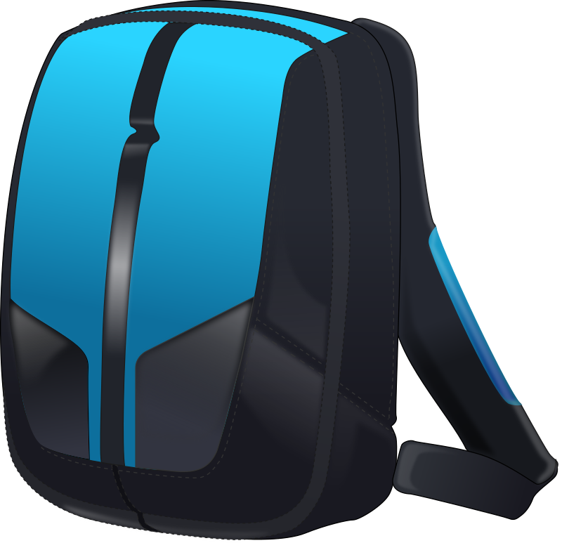 | 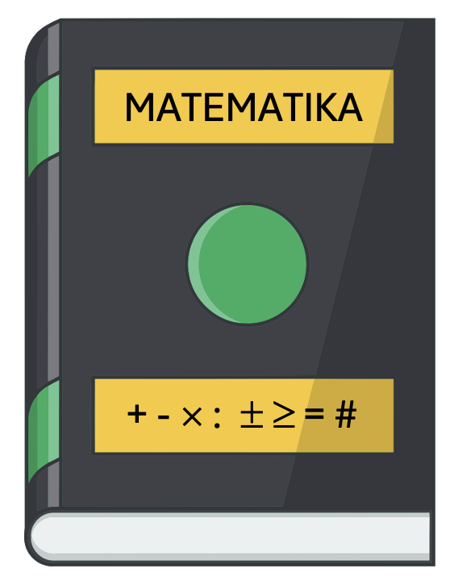

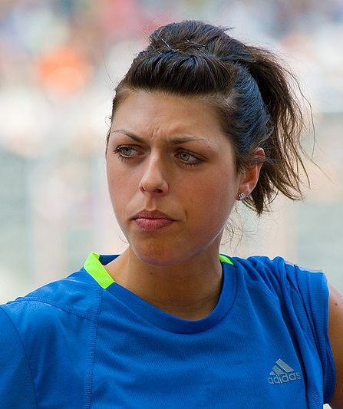 |  | 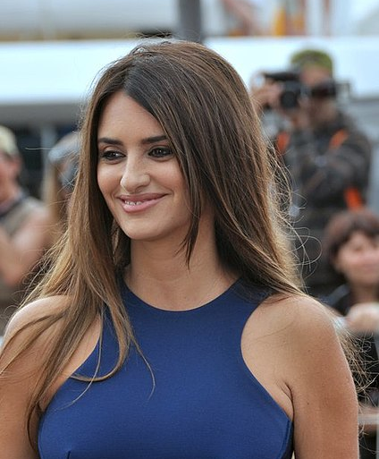

1.2 Zadatak 12. Kako se zove i kakav je?
Answer the following questions so they are true for you.
1 | Kako se zove tvoj dobri prijatelj?
1 | -
2 | Kakav je tvoj prijatelj?
2 | -
3 | Kako se zove tvoja dobra prijateljica?
3 | -
4 | Kakva je tvoja prijateljica?
4 | -
5 | Kako se zove tvoja ulica?
5 | -
6 | Kakva je tvoja ulica?
6 | -
7 | Kako se zove tvoj grad?
7 | -
8 | Kakav je tvoj grad?
8 | -

Bonus question (if applicable)
1 | Kako se zove tvoj pas?
1 | -
2 | Kakav je tvoj pas?
2 | -
3 | Kako se zove tvoja mačka?
3 | -
4 | Kakva je tvoja mačka?
4 | -

1.2 Zadatak 13. Razgovor
💻 Video recording – pair work. Things that you should ask each other include questions about professions, physical characteristics, personal traits, and their interests. Be sure to use the verb ‘biti' in your conversation appropriately.

Scenario
You are at your friend's house. You want to learn more about their family. Ask questions about their professions, physical characteristics, and their interests. Create a cohesive and meaningful dialogue with another classmate in order to get more information about them and their family.

Images used in this document are from these sources.

